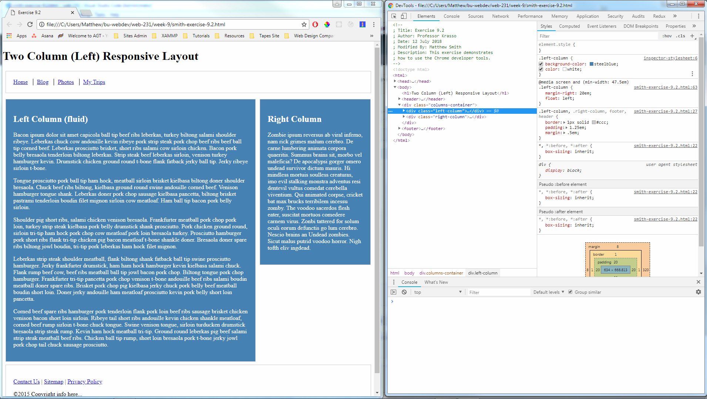

Instructions:

- I opened the page in Google Chrome.
- I pressed F12 to open up the developer tools.
- I looked through the "Elements" section to find the <div class="columns-container"> element and then clicked on it.
- Clicking it opened up a couple more <div> elements. One has a class called "left-column", and the other has a class called "right-column".
- I clicked the "right-column" <div> to see its styles in the "Styles" window.
- At the top right of the styles window, I clicked the "+" button to create a new style rule for "right-column".
- I then clicked on the new style rule ".right-column" to add a "background-color" property.
- I set the background-color to "steelblue".
- I clicked on the ".right-column" style rule again and added a "color" property.
- I set the color to "white".
- Then I repeated steps 5 through 10 on the "left-column" element.

