ACLIM2 CMIP6 ROMSNPZ Indices quick start guide

K. Holsman

# Download the ACLIM2 repo & data

## Clone the ACLIM2 repo

To run this tutorial first clone the ACLIM2 repository to your local drive:

### Option 1: Use R

This set of commands, run within R, downloads the ACLIM2 repository and unpacks it, with the ACLIM2 directory structrue being located in the specified download_path. This also performs the folder renaming mentioned in Option 2.

# Specify the download directory  
 main_nm <- "ACLIM2"  
  
 # Note: Edit download_path for preference  
 download_path <- path.expand("~")  
 dest_fldr <- file.path(download_path,main_nm)  
   
 url <- "https://github.com/kholsman/ACLIM2/archive/main.zip"  
 dest_file <- file.path(download_path,paste0(main_nm,".zip"))  
 download.file(url=url, destfile=dest_file)  
   
 # unzip the .zip file (manually unzip if this doesn't work)  
 setwd(download_path)  
 unzip (dest_file, exdir = download_path,overwrite = T)  
   
 #rename the unzipped folder from ACLIM2-main to ACLIM2  
 file.rename(paste0(main_nm,"-main"), main_nm)  
 setwd(main_nm)

### Option 2: Download the zipped repo

Download the full zip archive directly from the [**ACLIM2 Repo**](https://github.com/kholsman/ACLIM2) using this link: [**https://github.com/kholsman/ACLIM2/archive/main.zip**](https://github.com/kholsman/ACLIM2/archive/main.zip), and unzip its contents while preserving directory structure.

**Important!**\* If downloading from zip, please **rename the root folder** from ACLIM2-main (in the zipfile) to ACLIM2 (name used in cloned copies) after unzipping, for consistency in the following examples.

Your final folder structure should look like this:

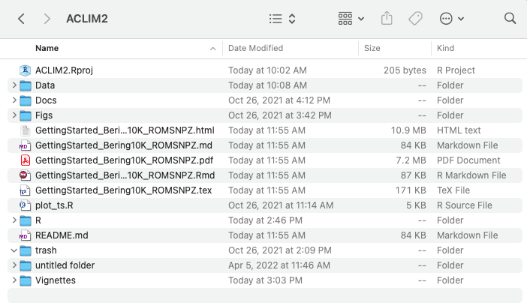

### Option 3: Use git commandline

If you have git installed and can work with it, this is the preferred method as it preserves all directory structure and can aid in future updating. Use this from a **terminal command line, not in R**, to clone the full ACLIM2 directory and sub-directories:

git clone https://github.com/kholsman/ACLIM2.git

## Get the data

Go to the google drive and download the zipped file with the R data ‘2022_03_07_Rdata.zip’:

[00_ACLIM_shared > 02_Data > Newest_Data(use this) > 2022_03_07_Rdata.zip](https://drive.google.com/drive/folders/11BQEfNEl9vvrN-V0LgS67XS4aLE9pNzz)

Move the Zipped folder to your local folder ‘ACLIM2/Data/in’ and unzip. The final folder structure should look like:

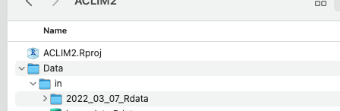

## Set up the Workspace

Open R() and used ‘setwd()’ to navigate to the root ACLIM2 folder (.e.g, ~/mydocuments/ACLIM2)

# set the workspace to your local ACLIM2 folder  
 # e.g., "/Users/kholsman/Documents/GitHub/ACLIM2"  
 # setwd( path.expand("~/Documents/GitHub/ACLIM2") )  
   
 # --------------------------------------  
 # SETUP WORKSPACE  
 tmstp <- format(Sys.time(), "%Y_%m_%d")  
 main <- getwd() #"~/GitHub_new/ACLIM2"  
   
 # loads packages, data, setup, etc.  
 suppressWarnings(source("R/make.R"))

## ------------------------------  
## ALIM2/R/setup.R settings   
## ------------------------------  
## main: : /Users/kholsman/Documents/GitHub/ACLIM2   
## data_path : /Users/kholsman/Documents/GitHub/ACLIM2/Data/in/2022_03_07/roms_for_public   
## Rdata_path : /Users/kholsman/Documents/GitHub/ACLIM2/Data/in/2022_03_07_Rdata/roms_for_public   
## redownload_level3_mox: FALSE   
## update.figs : FALSE   
## load_gis : FALSE   
## update.outputs : TRUE   
## update.figs : FALSE   
## dpiIN : 150   
## update.figs : FALSE   
## ------------------------------  
## ------------------------------  
##   
## The following datasets are public, please cite as Hermann et al. 2019 (v.H16) and Kearney et al. 2020 (v.K20) :  
## B10K-H16_CMIP5_CESM_BIO_rcp85   
## B10K-H16_CMIP5_CESM_rcp45   
## B10K-H16_CMIP5_CESM_rcp85   
## B10K-H16_CMIP5_GFDL_BIO_rcp85   
## B10K-H16_CMIP5_GFDL_rcp45   
## B10K-H16_CMIP5_GFDL_rcp85   
## B10K-H16_CMIP5_MIROC_rcp45   
## B10K-H16_CMIP5_MIROC_rcp85   
## B10K-H16_CORECFS   
## B10K-K20_CORECFS   
##   
## The following datasets are still under embargo, please do not share outside of ACLIM:  
## B10K-K20P19_CMIP6_cesm_historical   
## B10K-K20P19_CMIP6_cesm_ssp126   
## B10K-K20P19_CMIP6_cesm_ssp585   
## B10K-K20P19_CMIP6_gfdl_historical   
## B10K-K20P19_CMIP6_gfdl_ssp126   
## B10K-K20P19_CMIP6_gfdl_ssp585   
## B10K-K20P19_CMIP6_miroc_historical   
## B10K-K20P19_CMIP6_miroc_ssp126   
## B10K-K20P19_CMIP6_miroc_ssp585

# Read this before you start

## Overview

The [**ACLIM2 github repository**](https://github.com/kholsman/ACLIM2) contains R code and Rdata files for working with netcdf-format data generated from the [**downscaled ROMSNPZ modeling**](https://beringnpz.github.io/roms-bering-sea) of the ROMSNPZ Bering Sea Ocean Modeling team; Drs. Hermann, Cheng, Kearney, Pilcher,Ortiz, and Aydin. The code and R resources described in this tutorial are maintained by [Kirstin Holsman](mailto:kirstin.holsman@noaa.gov) as part of NOAA’s [**ACLIM project**](https://www.fisheries.noaa.gov/alaska/ecosystems/alaska-climate-integrated-modeling-project) for the Bering Sea. *See* [*Hollowed et al. 2020*](https://www.frontiersin.org/articles/10.3389/fmars.2019.00775/full) *for more information about the ACLIM project.*

This document provides an overview of accessing, plotting, and creating bias corrected indices for ACLIM2 based on CMIP6 (embargoed for ACLIM2 users until 2023) and CMIP5 (publicly available) simulations. This guide assumes analyses will take place in R() and that users have access to the data folder within the ACLIM2 shared drive. For more information also see the full tutorial (“GettingStarted_Bering10K_ROMSNPZ” available at the bottom of [**this repo page**](https://github.com/kholsman/ACLIM2).

**Important!** A few key things to know before getting started are detailed below. Please review this information before getting started.

## KEY ROMSNPZ versions

**Important!** ACLIM1 CMIP5 and ACLIM2 CMIP5 and CMIP6 datasets use different base models.

There are two versions of the ROMSNPZ model:

1. ACLIM1 an older 10-depth layer model used for CMIP5 (“H-16”)
2. ACLIM2 a new 30-depth layer model used for CMIP6 (“K20” or “K20P19”)

The models are not directly comparable, therefore the projections should be bias corrected and recentered to baselines of hindcasts of each model (forced by “observed” climate conditions). i.e. CMIP5 and CMIP6 have corresponding hindcasts:

1. Hindcast for CMIP5 “H19” –> H16_CORECFS
2. Hindcast for CMIP5 “K20P19” –> H16_CORECFS
3. Hindcast for CMIP6 “K20P19” –> K20_CORECFS

In addition for CMIP6 “historical” runs are available for bias correcting. We will use those below.

For a list of the available simulations for ACLIM enter the following in R():

# list of the climate scenarios  
data.frame(sim_list)

## KEY Data outputs

**Important!** There are 2 types of post-processed data available for use in ACLIM.

The ROMSNPZ team has developed a process to provide standardized post-processed outputs from the large (and non-intuitive) ROMSNPZ grid. These have been characterized as:

1. Level 1 (original ROMSNPZ U,V, grid, not rotated or corrected)
2. Level 2 (lat long bi-weekly high res versions, shouldn’t be needed and are difficult to work with)
3. **Level 3 indices (depth corrected and area weighted means for each model variable; i.e., what we will mostly use)** 
   1. “ACLIMsurveyrep_”: groundifsh survey replicated (replicated in space and time)
   2. “ACLIMregion_”: weekly strata based averages

To get more information about each of these level 3 datasets enter this in R:

# Metadata for Weekly ("ACLIMregion_...") indices  
 head(all_info1)

## name Type B10KVersion CMIP GCM  
## 1 B10K-H16_CMIP5_CESM_BIO_rcp85 Weekly regional indices H16 CMIP5 CESM  
## 2 B10K-H16_CMIP5_CESM_rcp45 Weekly regional indices H16 CMIP5 CESM  
## 3 B10K-H16_CMIP5_CESM_rcp85 Weekly regional indices H16 CMIP5 CESM  
## 4 B10K-H16_CMIP5_GFDL_BIO_rcp85 Weekly regional indices H16 CMIP5 GFDL  
## 5 B10K-H16_CMIP5_GFDL_rcp45 Weekly regional indices H16 CMIP5 GFDL  
## 6 B10K-H16_CMIP5_GFDL_rcp85 Weekly regional indices H16 CMIP5 GFDL  
## BIO Carbon_scenario Start End nvars  
## 1 TRUE rcp85 2006-01-22 12:00:00 2099-12-27 12:00:00 59  
## 2 FALSE rcp45 2006-01-22 12:00:00 2081-02-16 12:00:00 59  
## 3 FALSE rcp85 2006-01-22 12:00:00 2099-12-27 12:00:00 59  
## 4 TRUE rcp85 2006-01-22 12:00:00 2099-12-27 12:00:00 59  
## 5 FALSE rcp45 2006-01-22 12:00:00 2099-12-27 12:00:00 59  
## 6 FALSE rcp85 2006-01-22 12:00:00 2099-12-27 12:00:00 59

# Metadata for Weekly ("ACLIMsurveyrep_...") indices  
 head(all_info2)

## name Type B10KVersion CMIP GCM BIO  
## 1 B10K-H16_CMIP5_CESM_BIO_rcp85 Survey replicated H16 CMIP5 CESM TRUE  
## 2 B10K-H16_CMIP5_CESM_rcp45 Survey replicated H16 CMIP5 CESM FALSE  
## 3 B10K-H16_CMIP5_CESM_rcp85 Survey replicated H16 CMIP5 CESM FALSE  
## 4 B10K-H16_CMIP5_GFDL_BIO_rcp85 Survey replicated H16 CMIP5 GFDL TRUE  
## 5 B10K-H16_CMIP5_GFDL_rcp45 Survey replicated H16 CMIP5 GFDL FALSE  
## 6 B10K-H16_CMIP5_GFDL_rcp85 Survey replicated H16 CMIP5 GFDL FALSE  
## Carbon_scenario Start End nvars  
## 1 rcp85 1970 2100 60  
## 2 rcp45 1970 2100 60  
## 3 rcp85 1970 2100 60  
## 4 rcp85 1970 2100 60  
## 5 rcp45 1970 2100 60  
## 6 rcp85 1970 2100 60

# Create Indices & bias correct projections

The next step creates indices based on the level 3 data for each hind cast, historical run, and CMIP6 projection. The script below then bias corrects each index using the historical run and recenters the projection on the corresponding hindcast (such that projections are $Δ$ from historical mean values for the reference period deltayrs <- 1970:2000 ).

## Water column averaged values

The average water column values for each variable from the ROMSNPZ model strata x weekly Level2 outputs (‘ACLIMregion’) was calculated and used to calculate the strata-area weighted mean value for the NEBS and SEBS weekly, monthly, seasonally, and annually. Similarly, for survey replicated (‘ACLIMsurveyrep’) Level2 outputs the average water column value for each variable at each station was calculated used to calculate the strata-area weighted mean value for the NEBS and SEBS annually. These indices were calculate for hindcast, historical, and projection scenarios, and used to bias correct the projections. More information on the methods for each can be found in the tabs below and the code immediately following this section will re-generate the bias corrected indices. All of the bias corrected outputs can be found in the “Data/out/CMIP6” folder.

*Important!* Note that for projections the ‘mn_val’ represents raw mean values, while ‘val_bias-corrected’ is the bias corrected mn_val (should be used instead of the raw values). In all cases, for variables that are log-normally distributed (cannot be < 0), the ln(mn_val) were used to bias correct and were then back transformed to non-log space after correction:

For normally distributed variables ($Y$):

$$Y_{t,k}^{fut′}={\overset{‾}{Y}}_{k,\overset{‾}{T}}^{hind}+\left(\frac{σ_{k,\overset{‾}{T}}^{hind}}{σ_{k,\overset{‾}{T}}^{hist}}*(Y_{t,k}^{fut}−{\overset{‾}{Y}}_{k,\overset{‾}{T}}^{hist})\right)$$

where ${\overset{‾}{Y}}_{y,k}^{fut′}$ is the bias corrected varable $k$ value for time-step $t$ (e.g., year, month, or season), ${\overset{‾}{Y}}_{k,\overset{‾}{T}}^{hind}$ is the mean value of the variable $k$ during the reference period $\overset{‾}{T}=[1980,2013]$ from the hindcast model, $σ_{k,\overset{‾}{T}}^{hind}$ is the standard deviation of the hindcast during the reference period $\overset{‾}{T}$, $σ_{k,\overset{‾}{T}}^{hist}$ is the standard deviation of the historical run during tje reference period, $Y_{t,k}^{fut}$ is the value of the variable from the projection at time-step $t$ and ${\overset{‾}{Y}}_{k,\overset{‾}{T}}^{hist}$ is the average value from the historical run during reference period $\overset{‾}{T}$.

For log-normally distributed variables($Y$):

$$Y_{y,k}^{fut′}=e^{\text{ln}{\overset{‾}{Y}}_{k,\overset{‾}{T}}^{hind}+\left(\frac{{\hat{σ}}_{k,\overset{‾}{T}}^{hind}}{{\hat{σ}}_{k,\overset{‾}{T}}^{hist}}*(\text{ln}Y_{t,k}^{fut}−\text{ln}{\overset{‾}{Y}}_{k,\overset{‾}{T}}^{hist})\right)}$$

, where ${\hat{σ}}_{k,\overset{‾}{T}}^{hist}$ and ${\hat{σ}}_{k,\overset{‾}{T}}^{hind}$ are the standard deviation of the $\text{ln}{\overset{‾}{Y}}_{k,t}^{hist}$ and $\text{ln}{\overset{‾}{Y}}_{k,t}^{hind}$ during the reference period $\hat{T}$ (respectively).

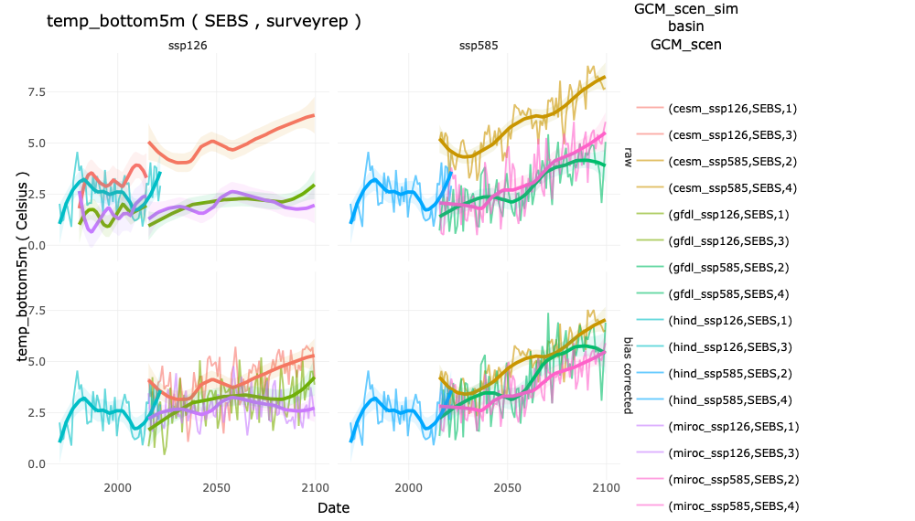

“Raw (top row) and bias corrected (bottom row)bottom temperature indices based on survey replicated Level3 outputs for the SEBS”

### Weekly indices

Uses the strata x weekly data (‘ACLIMregion’) to generate strata-specific averages in order to generate the strata area-weighted averages for each week $w$ each year $y$.

$${\overset{‾}{Y}}_{w,y,k}=\frac{\sum_{l}^{n_{s}}{(}\frac{1}{n_{i}}\sum_{t}^{n_{t}}{Y_{k,w,y,s,t}})*A_{s}}{\sum_{s}^{n_{s}}{A_{s}}}$$

, where $Y_{k,w,y,s,t}$ is the value of the variable $k$ in strata $s$ at time $t$ in year $y$, $A_{s}$ is the area of strata $s$, $n_{i}$ is the number of stations in strata $s$, and $n_{s}$ is the number of strata $s$ in each basin (NEBS or SEBS).

${\overset{‾}{Y}}_{w,y,k}$ was calculated for the hindcast, historical run, and projection time-series. For projections was bias corrected using the corresponding historical and hindcast values such that:

$${\overset{‾}{Y}}_{w,y,k}^{fut′}={\overset{‾}{Y}}_{w,k}^{hind}+\left(\frac{σ_{w,k}^{hind}}{σ_{w,k}^{hist}}*({\overset{‾}{Y}}_{w,y,k}^{fut}−{\overset{‾}{Y}}_{w,k}^{hist})\right)$$

, where ${\overset{‾}{Y}}_{w,k}^{hist}$ and ${\overset{‾}{Y}}_{w,k}^{hind}$ are the average historical weekly values across years in the period (1980, 1981, 1982, 1983, 1984, 1985, 1986, 1987, 1988, 1989, 1990, 1991, 1992, 1993, 1994, 1995, 1996, 1997, 1998, 1999, 2000, 2001, 2002, 2003, 2004, 2005, 2006, 2007, 2008, 2009, 2010, 2011, 2012, 2013; adjustable in R/setup.R).

### Monthly indices

Uses the strata x weekly data (‘ACLIMregion’) to generate strata-specific averages in order to generate the strata area-weighted averages for each month $m$ each year $y$.

$${\overset{‾}{Y}}_{m,y,k}=\frac{1}{n_{w}}\sum_{w}^{n_{w}}{{\overset{‾}{Y}}_{w,y,k}}$$

, where ${\overset{‾}{Y}}_{w,y,k}$ are the weekly average indices for variable $k$ in year $y$ from the previous step , $n_{w}$ is the number of weeks in each month $m$.

${\overset{‾}{Y}}_{m,y,k}$ was calculated for the hindcast, historical run, and projection time-series. For projections ${\overset{‾}{Y}}_{m,y,k}$ was bias corrected using the corresponding historical and hindcast values such that:

$${\overset{‾}{Y}}_{m,y,k}^{fut′}={\overset{‾}{Y}}_{m,k}^{hind}+\left(\frac{σ_{m,k}^{hind}}{σ_{m,k}^{hist}}*({\overset{‾}{Y}}_{m,y,k}^{fut}−{\overset{‾}{Y}}_{m,k}^{hist})\right)$$

, where ${\overset{‾}{Y}}_{m,k}^{hist}$ and ${\overset{‾}{Y}}_{m,k}^{hind}$ are the average historical monthly values across years in the period (1980, 1981, 1982, 1983, 1984, 1985, 1986, 1987, 1988, 1989, 1990, 1991, 1992, 1993, 1994, 1995, 1996, 1997, 1998, 1999, 2000, 2001, 2002, 2003, 2004, 2005, 2006, 2007, 2008, 2009, 2010, 2011, 2012, 2013; adjustable in R/setup.R).

### Seasonal indices

Uses the strata x weekly data (‘ACLIMregion’) to generate strata-specific averages in order to generate the strata area-weighted averages for each season each year $y$.

$${\overset{‾}{Y}}_{l,y,k}=\frac{1}{n_{w}}\sum_{w}^{n_{w}}{{\overset{‾}{Y}}_{w,y,k}}$$

, where ${\overset{‾}{Y}}_{w,y,k}$ are the weekly average indices for variable $k$ in year $y$ from the previous step , $n_{w}$ is the number of weeks in each season $l$.

${\overset{‾}{Y}}_{l,y,k}$ was calculated for the hindcast, historical run, and projection time-series. For projections ${\overset{‾}{Y}}_{l,y,k}$ was bias corrected using the corresponding historical and hindcast values such that:

$${\overset{‾}{Y}}_{l,y,k}^{fut′}={\overset{‾}{Y}}_{l,k}^{hind}+\left(\frac{σ_{l,k}^{hind}}{σ_{l,k}^{hist}}*({\overset{‾}{Y}}_{l,y,k}^{fut}−{\overset{‾}{Y}}_{l,k}^{hist})\right)$$

, where ${\overset{‾}{Y}}_{l,k}^{hist}$ and ${\overset{‾}{Y}}_{l,k}^{hind}$ are the average historical seasonal values across years in the reference period (1980, 1981, 1982, 1983, 1984, 1985, 1986, 1987, 1988, 1989, 1990, 1991, 1992, 1993, 1994, 1995, 1996, 1997, 1998, 1999, 2000, 2001, 2002, 2003, 2004, 2005, 2006, 2007, 2008, 2009, 2010, 2011, 2012, 2013; adjustable in R/setup.R).

### Annual indices

Uses the strata x weekly data (‘ACLIMregion’) to generate strata-specific averages in order to generate the strata area-weighted averages for each season each year $y$.

$${\overset{‾}{Y}}_{y,k}=\frac{1}{n_{w}}\sum_{w}^{n_{w}}{{\overset{‾}{Y}}_{w,y,k}}$$

, where ${\overset{‾}{Y}}_{w,y,k}$ are the weekly average indices for variable $k$ in year $y$ from the previous step , $n_{w}$ is the number of weeks in each year $y$.

${\overset{‾}{Y}}_{y,k}$ was calculated for the hindcast, historical run, and projection time-series. For projections ${\overset{‾}{Y}}_{y,k}$ was bias corrected using the corresponding historical and hindcast values such that:

, where and are the average historical values across years in the reference period (1980, 1981, 1982, 1983, 1984, 1985, 1986, 1987, 1988, 1989, 1990, 1991, 1992, 1993, 1994, 1995, 1996, 1997, 1998, 1999, 2000, 2001, 2002, 2003, 2004, 2005, 2006, 2007, 2008, 2009, 2010, 2011, 2012, 2013; adjustable in R/setup.R).

### Annual survey rep. indices

Uses the station specific survey replicated (in time and space) data (‘ACLIMsurveyrep’) to generate strata-specific averages in order to generate the strata area-weighted averages for each year $y$.

$${\overset{‾}{Y}}_{y,k}=\frac{\sum_{l}^{n_{s}}{(}\frac{1}{n_{i}}\sum_{i}^{n_{i}}{Y_{k,y,s,i}})*A_{s}}{\sum_{s}^{n_{s}}{A_{s}}}$$

, where $Y_{k,y,s,i}$ is the value of the variable $k$ at station $i$ in strata $s$ in year $y$, $A_{s}$ is the area of strata $s$, $n_{i}$ is the number of stations in strata $s$, and $n_{s}$ is the number of strata $s$ in each basin (NEBS or SEBS).

${\overset{‾}{Y}}_{y,k}$ was calculated for the hindcast, historical run, and projection time-series. For projections was bias corrected using the corresponding historical and hindcast values such that:

, where and are the average historical values across years in the reference period (1980, 1981, 1982, 1983, 1984, 1985, 1986, 1987, 1988, 1989, 1990, 1991, 1992, 1993, 1994, 1995, 1996, 1997, 1998, 1999, 2000, 2001, 2002, 2003, 2004, 2005, 2006, 2007, 2008, 2009, 2010, 2011, 2012, 2013; adjustable in R/setup.R).

Appendix A includes the code used to generate the ACLIM2 indices and bias correct them. That code can be run to re-make the indices if you like but takes approx 30 mins a CMIP to run.

# Explore ACLIM2 Indices

The following code will open an interactive shiny() app for exploring the indices. You can also view this online at (kkh2022.shinyapps.io/ACLIM2_indices)[<https://kkh2022.shinyapps.io/ACLIM2_indices/>].

shiny::runApp("/Users/kholsman/Documents/GitHub/ACLIM2/R/shiny_aclim/ACLIM2_indices/app.R")



“Raw (top row) and bias corrected (bottom row)bottom temperature indices based on survey replicated Level3 outputs for the SEBS”

## Annual indices

# --------------------------------------  
 # SETUP WORKSPACE  
 main <- getwd() #"~/GitHub_new/ACLIM2"  
   
 # loads packages, data, setup, etc.  
 suppressMessages(source("R/make.R"))  
   
   
 # load the Indices:  
 fldr <- "Data/out/K20P19_CMIP6/allEBS_means"  
 dirlist <-grep ("annual", dir(fldr))  
 for(d in dirlist)  
 load(file.path(fldr,d))  
 hnd <- ACLIM_annual_fut_mn  
   
````  
  
## Monthly indices  
  
## Seasonal indices  
  
## weekly indices  
  
# Output to .dat file (ADMB/ TMB users)  
  
# Special cases {.tabset}  
  
## monthly indices (Andy)

## NRS indices (André)

## Salmon index (Ellen)

## NFS index (Jeremy )

# APPENDIX A: Create indices and bias correct CMIP6 projections

The following code shows how the ACLIM2 indices and bias correction was done. You do not need to re-run this (it is included so you can if you want to). To explore the indices skep to the next section.

# --------------------------------------  
 # SETUP WORKSPACE  
 # setwd("Documents/GitHub/ACLIM2")  
 tmstp <- format(Sys.time(), "%Y_%m_%d")  
 main <- getwd() #"~/GitHub_new/ACLIM2"  
   
 # loads packages, data, setup, etc.  
 suppressMessages(source("R/make.R"))  
   
 tmstamp1 <- format(Sys.time(), "%Y%m%d")  
 # tmstamp1 <- "20220428"  
   
 update_hind <- TRUE # set to true to update hind and hindS; needed annually  
 update_proj <- TRUE # set to true to update fut; not needed  
 update_hist <- TRUE # set to true to update fut; not needed  
   
 # the reference years for bias correcting in R/setup.R  
 ref_years   
   
 # the year to z-score scale / delta in R/setup.R  
 deltayrs   
   
 # remove these variables:  
 vl1 <- srvy_vars[!srvy_vars%in%c("station_id","latitude",  
 "longitude","stratum","doy",  
 "Iron_bottom5m","Iron_integrated",  
 "Iron_surface5m","prod_Eup_integrated",  
 "prod_NCa_integrated")]  
 vl2 <- weekly_vars[!weekly_vars%in%c("station_id","latitude",  
 "longitude","stratum","doy",  
 "Iron_bottom5m","Iron_integrated",  
 "Iron_surface5m","prod_Eup_integrated",  
 "prod_NCa_integrated")]  
 vl<-unique(c(vl1,vl2))  
 # add in largeZoop (gets generated in make_indices_region_new.R)  
 vl <- c(vl,"largeZoop_integrated")  
  
 # Identify which variables would be normally   
 # distributed (i.e., can have negative values)  
 normvl <- c("shflux","ssflux","temp_bottom5m",  
 "temp_integrated","temp_surface5m",  
 "uEast_bottom5m","uEast_surface5m",  
 "vNorth_bottom5m","vNorth_surface5m")  
  
 normlist <- data.frame(var = vl, lognorm = TRUE)  
 normlist$lognorm[normlist$var%in%normvl] <- FALSE  
  
   
 # generate indices and bias corrected projections   
 # This takes approx 30 mins each  
   
 gcmcmipL <- c("B10K-K20P19_CMIP6_miroc",  
 "B10K-K20P19_CMIP6_gfdl",  
 "B10K-K20P19_CMIP6_cesm")   
 CMIP6_Indices <- suppressMessages(  
 makeACLIM2_Indices(  
 BC_target = "mn_val",  
 hind_sim = "B10K-K20_CORECFS",  
 histLIST = paste0(gcmcmipL,"_historical"),  
 gcmcmipLIST = gcmcmipL,  
 sim_listIN = sim_list[-grep("historical",sim_list)]))  
   
 if("CMIP6_Indices"%in%ls()){   
 save_indices(flIN = CMIP6_Indices,   
 subfl = "allEBS_means",  
 post_txt = "_mn",  
 CMIP_fdlr ="K20P19_CMIP6")  
 fl <- "Data/out/CMIP6_Indices_List.Rdata"  
   
 if(file.exists(fl)) file.remove(fl)  
 save(CMIP6_Indices, file = fl)  
 rm(CMIP6_Indices)  
 gc()  
 }  
 # CMIP5 K20P19  
 gcmcmipL2 <- c("B10K-K20P19_CMIP5_MIROC","B10K-K20P19_CMIP5_GFDL","B10K-K20P19_CMIP5_CESM")   
 CMIP5_K20_Indices <- suppressMessages(  
 makeACLIM2_Indices(  
 BC_target = "mn_val",  
 hind_sim = "B10K-K20_CORECFS",  
 histLIST = paste0(gcmcmipL,"_historical"),  
 gcmcmipLIST = gcmcmipL2,  
 sim_listIN = sim_list[-grep("historical",sim_list)]))  
   
 if("CMIP5_K20_Indices"%in%ls()){  
 save_indices(flIN = CMIP5_K20_Indices,   
 subfl = "allEBS_means",  
 post_txt = "_mn",  
 CMIP_fdlr ="K20P19_CMIP5")  
   
 fl <- "Data/out/CMIP5_K20_Indices_List.Rdata"  
 if(file.exists(fl)) file.remove(fl)  
 save(CMIP5_K20_Indices, file = fl)  
 rm(CMIP5_K20_Indices)  
 gc()  
 }  
 # CMIP5 H16  
 gcmcmipL2 <- c("B10K-H16_CMIP5_MIROC","B10K-H16_CMIP5_GFDL","B10K-H16_CMIP5_CESM")   
 CMIP5_H16_Indices <- suppressMessages(  
 makeACLIM2_Indices(  
 BC_target = "mn_val",  
 hind_sim = "B10K-H16_CORECFS",  
 histLIST = rep("B10K-H16_CORECFS",3),  
 gcmcmipLIST = gcmcmipL2,  
 sim_listIN = sim_list[-grep("historical",sim_list)]))  
 if("CMIP5_H16_Indices"%in%ls()){  
 save_indices(flIN = CMIP5_H16_Indices,   
 subfl = "allEBS_means",  
 post_txt = "_mn",  
 CMIP_fdlr ="H16_CMIP5")  
   
 fl <- "Data/out/CMIP5_H16_Indices_List.Rdata"  
 if(file.exists(fl)) file.remove(fl)  
 save(CMIP5_H16_Indices, file = fl)  
 rm(CMIP5_H16_Indices)  
 gc()  
 }  
 if(1==10){  
 save(CMIP6_Indices, file = "Data/out/CMIP6_Indices_List.Rdata")  
 save(CMIP5_K20_Indices, file = "Data/out/CMIP5_K20_Indices_List.Rdata")  
 save(CMIP5_H16_Indices, file = "Data/out/CMIP5_H16_Indices_List.Rdata")  
 }

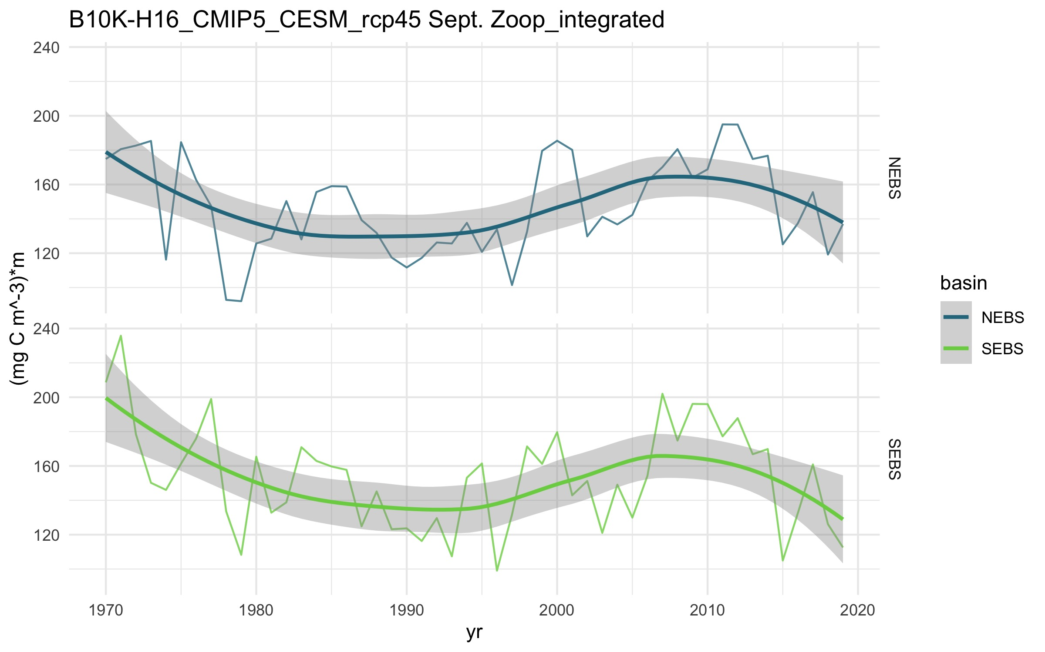

September large zooplankton integrated concentration

# misc

$$B0_{input}^{k}={\overset{‾}{B0}}_{(2004:2014)}^{k}\left(\frac{B0_{2015}^{a}}{{\overset{‾}{B0}}_{(2004:2014)}^{a}}\right)$$

Where B0kinput is the unfished biomass used for setting inputs of (e.g., B0ktarget = 0.4B0kinput) and is determined by re-scaling the spawning stock biomass from the status quo assessment in 2015 (B0a2015) to the average model spawning stock biomass for your model between 2004-2014 (i.e., B0k) using the average unfished biomass from the stock assessment model during the same period (B0a).