GOA SST MHW by depth

Matt Callahan

2022-12-15

## GOA and AI SST and MHW by depth bin

The purpose of this analysis is to compare climatology and heatwave status between depth strata in the Gulf of Alaska and Aleutian Islands. We first query a depth specific sst time series for each ESR subregion. Depth strata are 10-200m, 201-1000m, and >1000m deep. We then plot SST for each depth strata in each subregion. Finally we calculate heatwave status for each depth strata/subregion

## SST download

Here we calculate daily average SST for GOA and AI ESR subregions.

**connect to AKFIN**

**query SST**

## Generate map showing regions

This map is pretty rough. The narrowness of the shelf makes the boundaries difficult to distinguish.

library(lubridate)  
library(heatwaveR)  
library(sf)  
library(akmarineareas2)  
library(tidyverse)  
  
#original version that included aleutians  
# lkp<-readRDS("data/crw_spatial_lookup.RDS") %>%  
# rename_with(tolower)%>%  
# filter(depth <= -10 & ecosystem %in% c("Gulf of Alaska", "Aleutian Islands")) %>%  
# mutate(depth_strata=ifelse(depth>=-200, "-10 to -200", ifelse(depth>= -1000, "-201 to -1000", "< -1000")),  
# lon360=ifelse(longitude>0, longitude, longitude+360))%>%  
# st_as_sf(coords = c('longitude', 'latitude'), crs = 4326, agr = 'constant') %>%  
# st_transform(crs=3338)  
  
#New version with just GOA  
lkp<-readRDS("data/crw_spatial_lookup.RDS") %>%  
 rename_with(tolower)%>%  
 filter(depth <= -10 & ecosystem =="Gulf of Alaska") %>%  
 mutate(depth_strata=ifelse(depth>=-200, "-10 to -200", ifelse(depth>= -1000, "-201 to -1000", "< -1000")),  
 lon360=ifelse(longitude>0, longitude, longitude+360))%>%  
 st_as_sf(coords = c('longitude', 'latitude'), crs = 4326, agr = 'constant') %>%  
 st_transform(crs=3338)  
  
#map  
ggplot()+  
 # geom_sf(data=ak_dd%>%st_shift_longitude())+  
 #geom_point(data=lkp, aes(x=lon360, y= latitude, color=depth_strata, fill= depth_strata))+  
 geom_sf(data=lkp, aes(color=depth_strata, fill= depth_strata), size=0.01)+  
 geom_sf(data=esr%>%  
 filter(Ecosystem_Area == "Gulf of Alaska"),   
 color="black", fill=NA)+  
 scale_x_continuous(breaks = seq(0, 360, 10))+  
 theme_bw()

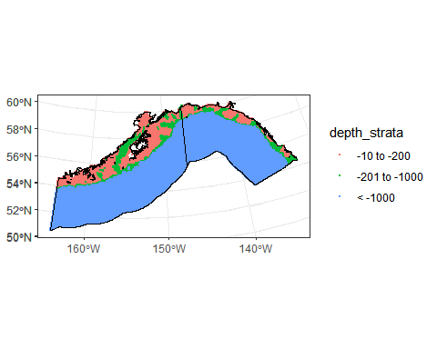

And plot sample sizes for each region/depth

#plot sample sizes  
lkp%>%  
 group_by(ecosystem_sub, depth_strata)%>%  
 summarize(n_sst=n())%>%  
 ggplot()+  
 geom_col(aes(x=depth_strata, y=n_sst, fill=depth_strata))+  
 facet_wrap(~ecosystem_sub)+  
 theme_bw()

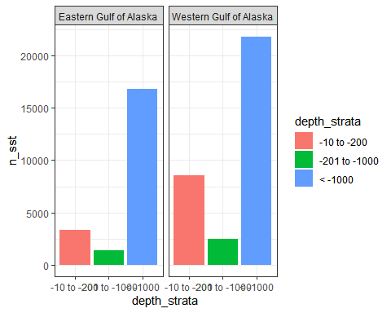

## Plot subregional climatology by depth

First the GOA. This plot shows the average daily temperature for each region by depth. Solid lines are mean temps and dotted lines are standard deviations.

#load data from previous step  
sst_10_200<-readRDS("data/sst_10_200.RDS")  
sst_201_1000<-readRDS("data/sst_201_1000.RDS")  
sst_1001<-readRDS("data/sst_1001.RDS")  
sst<-sst_10_200%>%  
 bind_rows(sst_201_1000)%>%  
 bind_rows(sst_1001)  
  
#summarize for plot  
sst_sum<-sst %>%  
 rename_with(tolower)%>%  
 mutate(day=day(read_date),  
 month=month(read_date),  
 year=year(read_date),  
 newdate=as.Date(paste("2000",month,day,sep="-"),format="%Y-%m-%d"))%>%  
 group_by(ecosystem_sub, depth_strata, newdate)%>%  
 summarise(meansst=mean(mean_sst),  
 sd_sst=sd(mean_sst))  
  
  
#plot goa  
sst_sum%>%  
 filter(ecosystem_sub%in% c("Eastern Gulf of Alaska", "Western Gulf of Alaska"))%>%  
 ggplot()+  
 geom_line(aes(x=newdate, y=meansst, color=depth_strata), size=1)+  
 geom_line(aes(x=newdate, y=meansst+sd_sst, color=depth_strata), lty=2)+  
 geom_line(aes(x=newdate, y=meansst-sd_sst, color=depth_strata), lty=2)+  
 facet_wrap(~ecosystem_sub)+  
 scale_x_date(date_breaks="1 month",  
 date_labels = "%b",  
 expand = c(0.025,0.025)) +   
 xlab("date")+  
 ylab("CRWSST")

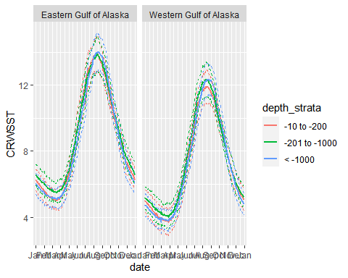

theme_bw()

## List of 93  
## $ line :List of 6  
## ..$ colour : chr "black"  
## ..$ size : num 0.5  
## ..$ linetype : num 1  
## ..$ lineend : chr "butt"  
## ..$ arrow : logi FALSE  
## ..$ inherit.blank: logi TRUE  
## ..- attr(*, "class")= chr [1:2] "element_line" "element"  
## $ rect :List of 5  
## ..$ fill : chr "white"  
## ..$ colour : chr "black"  
## ..$ size : num 0.5  
## ..$ linetype : num 1  
## ..$ inherit.blank: logi TRUE  
## ..- attr(*, "class")= chr [1:2] "element_rect" "element"  
## $ text :List of 11  
## ..$ family : chr ""  
## ..$ face : chr "plain"  
## ..$ colour : chr "black"  
## ..$ size : num 11  
## ..$ hjust : num 0.5  
## ..$ vjust : num 0.5  
## ..$ angle : num 0  
## ..$ lineheight : num 0.9  
## ..$ margin : 'margin' num [1:4] 0points 0points 0points 0points  
## .. ..- attr(*, "unit")= int 8  
## ..$ debug : logi FALSE  
## ..$ inherit.blank: logi TRUE  
## ..- attr(*, "class")= chr [1:2] "element_text" "element"  
## $ title : NULL  
## $ aspect.ratio : NULL  
## $ axis.title : NULL  
## $ axis.title.x :List of 11  
## ..$ family : NULL  
## ..$ face : NULL  
## ..$ colour : NULL  
## ..$ size : NULL  
## ..$ hjust : NULL  
## ..$ vjust : num 1  
## ..$ angle : NULL  
## ..$ lineheight : NULL  
## ..$ margin : 'margin' num [1:4] 2.75points 0points 0points 0points  
## .. ..- attr(*, "unit")= int 8  
## ..$ debug : NULL  
## ..$ inherit.blank: logi TRUE  
## ..- attr(*, "class")= chr [1:2] "element_text" "element"  
## $ axis.title.x.top :List of 11  
## ..$ family : NULL  
## ..$ face : NULL  
## ..$ colour : NULL  
## ..$ size : NULL  
## ..$ hjust : NULL  
## ..$ vjust : num 0  
## ..$ angle : NULL  
## ..$ lineheight : NULL  
## ..$ margin : 'margin' num [1:4] 0points 0points 2.75points 0points  
## .. ..- attr(*, "unit")= int 8  
## ..$ debug : NULL  
## ..$ inherit.blank: logi TRUE  
## ..- attr(*, "class")= chr [1:2] "element_text" "element"  
## $ axis.title.x.bottom : NULL  
## $ axis.title.y :List of 11  
## ..$ family : NULL  
## ..$ face : NULL  
## ..$ colour : NULL  
## ..$ size : NULL  
## ..$ hjust : NULL  
## ..$ vjust : num 1  
## ..$ angle : num 90  
## ..$ lineheight : NULL  
## ..$ margin : 'margin' num [1:4] 0points 2.75points 0points 0points  
## .. ..- attr(*, "unit")= int 8  
## ..$ debug : NULL  
## ..$ inherit.blank: logi TRUE  
## ..- attr(*, "class")= chr [1:2] "element_text" "element"  
## $ axis.title.y.left : NULL  
## $ axis.title.y.right :List of 11  
## ..$ family : NULL  
## ..$ face : NULL  
## ..$ colour : NULL  
## ..$ size : NULL  
## ..$ hjust : NULL  
## ..$ vjust : num 0  
## ..$ angle : num -90  
## ..$ lineheight : NULL  
## ..$ margin : 'margin' num [1:4] 0points 0points 0points 2.75points  
## .. ..- attr(*, "unit")= int 8  
## ..$ debug : NULL  
## ..$ inherit.blank: logi TRUE  
## ..- attr(*, "class")= chr [1:2] "element_text" "element"  
## $ axis.text :List of 11  
## ..$ family : NULL  
## ..$ face : NULL  
## ..$ colour : chr "grey30"  
## ..$ size : 'rel' num 0.8  
## ..$ hjust : NULL  
## ..$ vjust : NULL  
## ..$ angle : NULL  
## ..$ lineheight : NULL  
## ..$ margin : NULL  
## ..$ debug : NULL  
## ..$ inherit.blank: logi TRUE  
## ..- attr(*, "class")= chr [1:2] "element_text" "element"  
## $ axis.text.x :List of 11  
## ..$ family : NULL  
## ..$ face : NULL  
## ..$ colour : NULL  
## ..$ size : NULL  
## ..$ hjust : NULL  
## ..$ vjust : num 1  
## ..$ angle : NULL  
## ..$ lineheight : NULL  
## ..$ margin : 'margin' num [1:4] 2.2points 0points 0points 0points  
## .. ..- attr(*, "unit")= int 8  
## ..$ debug : NULL  
## ..$ inherit.blank: logi TRUE  
## ..- attr(*, "class")= chr [1:2] "element_text" "element"  
## $ axis.text.x.top :List of 11  
## ..$ family : NULL  
## ..$ face : NULL  
## ..$ colour : NULL  
## ..$ size : NULL  
## ..$ hjust : NULL  
## ..$ vjust : num 0  
## ..$ angle : NULL  
## ..$ lineheight : NULL  
## ..$ margin : 'margin' num [1:4] 0points 0points 2.2points 0points  
## .. ..- attr(*, "unit")= int 8  
## ..$ debug : NULL  
## ..$ inherit.blank: logi TRUE  
## ..- attr(*, "class")= chr [1:2] "element_text" "element"  
## $ axis.text.x.bottom : NULL  
## $ axis.text.y :List of 11  
## ..$ family : NULL  
## ..$ face : NULL  
## ..$ colour : NULL  
## ..$ size : NULL  
## ..$ hjust : num 1  
## ..$ vjust : NULL  
## ..$ angle : NULL  
## ..$ lineheight : NULL  
## ..$ margin : 'margin' num [1:4] 0points 2.2points 0points 0points  
## .. ..- attr(*, "unit")= int 8  
## ..$ debug : NULL  
## ..$ inherit.blank: logi TRUE  
## ..- attr(*, "class")= chr [1:2] "element_text" "element"  
## $ axis.text.y.left : NULL  
## $ axis.text.y.right :List of 11  
## ..$ family : NULL  
## ..$ face : NULL  
## ..$ colour : NULL  
## ..$ size : NULL  
## ..$ hjust : num 0  
## ..$ vjust : NULL  
## ..$ angle : NULL  
## ..$ lineheight : NULL  
## ..$ margin : 'margin' num [1:4] 0points 0points 0points 2.2points  
## .. ..- attr(*, "unit")= int 8  
## ..$ debug : NULL  
## ..$ inherit.blank: logi TRUE  
## ..- attr(*, "class")= chr [1:2] "element_text" "element"  
## $ axis.ticks :List of 6  
## ..$ colour : chr "grey20"  
## ..$ size : NULL  
## ..$ linetype : NULL  
## ..$ lineend : NULL  
## ..$ arrow : logi FALSE  
## ..$ inherit.blank: logi TRUE  
## ..- attr(*, "class")= chr [1:2] "element_line" "element"  
## $ axis.ticks.x : NULL  
## $ axis.ticks.x.top : NULL  
## $ axis.ticks.x.bottom : NULL  
## $ axis.ticks.y : NULL  
## $ axis.ticks.y.left : NULL  
## $ axis.ticks.y.right : NULL  
## $ axis.ticks.length : 'simpleUnit' num 2.75points  
## ..- attr(*, "unit")= int 8  
## $ axis.ticks.length.x : NULL  
## $ axis.ticks.length.x.top : NULL  
## $ axis.ticks.length.x.bottom: NULL  
## $ axis.ticks.length.y : NULL  
## $ axis.ticks.length.y.left : NULL  
## $ axis.ticks.length.y.right : NULL  
## $ axis.line : list()  
## ..- attr(*, "class")= chr [1:2] "element_blank" "element"  
## $ axis.line.x : NULL  
## $ axis.line.x.top : NULL  
## $ axis.line.x.bottom : NULL  
## $ axis.line.y : NULL  
## $ axis.line.y.left : NULL  
## $ axis.line.y.right : NULL  
## $ legend.background :List of 5  
## ..$ fill : NULL  
## ..$ colour : logi NA  
## ..$ size : NULL  
## ..$ linetype : NULL  
## ..$ inherit.blank: logi TRUE  
## ..- attr(*, "class")= chr [1:2] "element_rect" "element"  
## $ legend.margin : 'margin' num [1:4] 5.5points 5.5points 5.5points 5.5points  
## ..- attr(*, "unit")= int 8  
## $ legend.spacing : 'simpleUnit' num 11points  
## ..- attr(*, "unit")= int 8  
## $ legend.spacing.x : NULL  
## $ legend.spacing.y : NULL  
## $ legend.key :List of 5  
## ..$ fill : chr "white"  
## ..$ colour : logi NA  
## ..$ size : NULL  
## ..$ linetype : NULL  
## ..$ inherit.blank: logi TRUE  
## ..- attr(*, "class")= chr [1:2] "element_rect" "element"  
## $ legend.key.size : 'simpleUnit' num 1.2lines  
## ..- attr(*, "unit")= int 3  
## $ legend.key.height : NULL  
## $ legend.key.width : NULL  
## $ legend.text :List of 11  
## ..$ family : NULL  
## ..$ face : NULL  
## ..$ colour : NULL  
## ..$ size : 'rel' num 0.8  
## ..$ hjust : NULL  
## ..$ vjust : NULL  
## ..$ angle : NULL  
## ..$ lineheight : NULL  
## ..$ margin : NULL  
## ..$ debug : NULL  
## ..$ inherit.blank: logi TRUE  
## ..- attr(*, "class")= chr [1:2] "element_text" "element"  
## $ legend.text.align : NULL  
## $ legend.title :List of 11  
## ..$ family : NULL  
## ..$ face : NULL  
## ..$ colour : NULL  
## ..$ size : NULL  
## ..$ hjust : num 0  
## ..$ vjust : NULL  
## ..$ angle : NULL  
## ..$ lineheight : NULL  
## ..$ margin : NULL  
## ..$ debug : NULL  
## ..$ inherit.blank: logi TRUE  
## ..- attr(*, "class")= chr [1:2] "element_text" "element"  
## $ legend.title.align : NULL  
## $ legend.position : chr "right"  
## $ legend.direction : NULL  
## $ legend.justification : chr "center"  
## $ legend.box : NULL  
## $ legend.box.just : NULL  
## $ legend.box.margin : 'margin' num [1:4] 0cm 0cm 0cm 0cm  
## ..- attr(*, "unit")= int 1  
## $ legend.box.background : list()  
## ..- attr(*, "class")= chr [1:2] "element_blank" "element"  
## $ legend.box.spacing : 'simpleUnit' num 11points  
## ..- attr(*, "unit")= int 8  
## $ panel.background :List of 5  
## ..$ fill : chr "white"  
## ..$ colour : logi NA  
## ..$ size : NULL  
## ..$ linetype : NULL  
## ..$ inherit.blank: logi TRUE  
## ..- attr(*, "class")= chr [1:2] "element_rect" "element"  
## $ panel.border :List of 5  
## ..$ fill : logi NA  
## ..$ colour : chr "grey20"  
## ..$ size : NULL  
## ..$ linetype : NULL  
## ..$ inherit.blank: logi TRUE  
## ..- attr(*, "class")= chr [1:2] "element_rect" "element"  
## $ panel.spacing : 'simpleUnit' num 5.5points  
## ..- attr(*, "unit")= int 8  
## $ panel.spacing.x : NULL  
## $ panel.spacing.y : NULL  
## $ panel.grid :List of 6  
## ..$ colour : chr "grey92"  
## ..$ size : NULL  
## ..$ linetype : NULL  
## ..$ lineend : NULL  
## ..$ arrow : logi FALSE  
## ..$ inherit.blank: logi TRUE  
## ..- attr(*, "class")= chr [1:2] "element_line" "element"  
## $ panel.grid.major : NULL  
## $ panel.grid.minor :List of 6  
## ..$ colour : NULL  
## ..$ size : 'rel' num 0.5  
## ..$ linetype : NULL  
## ..$ lineend : NULL  
## ..$ arrow : logi FALSE  
## ..$ inherit.blank: logi TRUE  
## ..- attr(*, "class")= chr [1:2] "element_line" "element"  
## $ panel.grid.major.x : NULL  
## $ panel.grid.major.y : NULL  
## $ panel.grid.minor.x : NULL  
## $ panel.grid.minor.y : NULL  
## $ panel.ontop : logi FALSE  
## $ plot.background :List of 5  
## ..$ fill : NULL  
## ..$ colour : chr "white"  
## ..$ size : NULL  
## ..$ linetype : NULL  
## ..$ inherit.blank: logi TRUE  
## ..- attr(*, "class")= chr [1:2] "element_rect" "element"  
## $ plot.title :List of 11  
## ..$ family : NULL  
## ..$ face : NULL  
## ..$ colour : NULL  
## ..$ size : 'rel' num 1.2  
## ..$ hjust : num 0  
## ..$ vjust : num 1  
## ..$ angle : NULL  
## ..$ lineheight : NULL  
## ..$ margin : 'margin' num [1:4] 0points 0points 5.5points 0points  
## .. ..- attr(*, "unit")= int 8  
## ..$ debug : NULL  
## ..$ inherit.blank: logi TRUE  
## ..- attr(*, "class")= chr [1:2] "element_text" "element"  
## $ plot.title.position : chr "panel"  
## $ plot.subtitle :List of 11  
## ..$ family : NULL  
## ..$ face : NULL  
## ..$ colour : NULL  
## ..$ size : NULL  
## ..$ hjust : num 0  
## ..$ vjust : num 1  
## ..$ angle : NULL  
## ..$ lineheight : NULL  
## ..$ margin : 'margin' num [1:4] 0points 0points 5.5points 0points  
## .. ..- attr(*, "unit")= int 8  
## ..$ debug : NULL  
## ..$ inherit.blank: logi TRUE  
## ..- attr(*, "class")= chr [1:2] "element_text" "element"  
## $ plot.caption :List of 11  
## ..$ family : NULL  
## ..$ face : NULL  
## ..$ colour : NULL  
## ..$ size : 'rel' num 0.8  
## ..$ hjust : num 1  
## ..$ vjust : num 1  
## ..$ angle : NULL  
## ..$ lineheight : NULL  
## ..$ margin : 'margin' num [1:4] 5.5points 0points 0points 0points  
## .. ..- attr(*, "unit")= int 8  
## ..$ debug : NULL  
## ..$ inherit.blank: logi TRUE  
## ..- attr(*, "class")= chr [1:2] "element_text" "element"  
## $ plot.caption.position : chr "panel"  
## $ plot.tag :List of 11  
## ..$ family : NULL  
## ..$ face : NULL  
## ..$ colour : NULL  
## ..$ size : 'rel' num 1.2  
## ..$ hjust : num 0.5  
## ..$ vjust : num 0.5  
## ..$ angle : NULL  
## ..$ lineheight : NULL  
## ..$ margin : NULL  
## ..$ debug : NULL  
## ..$ inherit.blank: logi TRUE  
## ..- attr(*, "class")= chr [1:2] "element_text" "element"  
## $ plot.tag.position : chr "topleft"  
## $ plot.margin : 'margin' num [1:4] 5.5points 5.5points 5.5points 5.5points  
## ..- attr(*, "unit")= int 8  
## $ strip.background :List of 5  
## ..$ fill : chr "grey85"  
## ..$ colour : chr "grey20"  
## ..$ size : NULL  
## ..$ linetype : NULL  
## ..$ inherit.blank: logi TRUE  
## ..- attr(*, "class")= chr [1:2] "element_rect" "element"  
## $ strip.background.x : NULL  
## $ strip.background.y : NULL  
## $ strip.placement : chr "inside"  
## $ strip.text :List of 11  
## ..$ family : NULL  
## ..$ face : NULL  
## ..$ colour : chr "grey10"  
## ..$ size : 'rel' num 0.8  
## ..$ hjust : NULL  
## ..$ vjust : NULL  
## ..$ angle : NULL  
## ..$ lineheight : NULL  
## ..$ margin : 'margin' num [1:4] 4.4points 4.4points 4.4points 4.4points  
## .. ..- attr(*, "unit")= int 8  
## ..$ debug : NULL  
## ..$ inherit.blank: logi TRUE  
## ..- attr(*, "class")= chr [1:2] "element_text" "element"  
## $ strip.text.x : NULL  
## $ strip.text.y :List of 11  
## ..$ family : NULL  
## ..$ face : NULL  
## ..$ colour : NULL  
## ..$ size : NULL  
## ..$ hjust : NULL  
## ..$ vjust : NULL  
## ..$ angle : num -90  
## ..$ lineheight : NULL  
## ..$ margin : NULL  
## ..$ debug : NULL  
## ..$ inherit.blank: logi TRUE  
## ..- attr(*, "class")= chr [1:2] "element_text" "element"  
## $ strip.switch.pad.grid : 'simpleUnit' num 2.75points  
## ..- attr(*, "unit")= int 8  
## $ strip.switch.pad.wrap : 'simpleUnit' num 2.75points  
## ..- attr(*, "unit")= int 8  
## $ strip.text.y.left :List of 11  
## ..$ family : NULL  
## ..$ face : NULL  
## ..$ colour : NULL  
## ..$ size : NULL  
## ..$ hjust : NULL  
## ..$ vjust : NULL  
## ..$ angle : num 90  
## ..$ lineheight : NULL  
## ..$ margin : NULL  
## ..$ debug : NULL  
## ..$ inherit.blank: logi TRUE  
## ..- attr(*, "class")= chr [1:2] "element_text" "element"  
## - attr(*, "class")= chr [1:2] "theme" "gg"  
## - attr(*, "complete")= logi TRUE  
## - attr(*, "validate")= logi TRUE

Next the Aleutians

## Marine heatwave calculations

Here I plot presence and absence of heatwaves over time for each of the subregions and deoth

#prepare sst data for heatwaveR code  
sst<-sst %>% rename_with(tolower) %>%  
 filter(ecosystem_sub %in% c("Eastern Gulf of Alaska", "Western Gulf of Alaska"))%>%  
 mutate(t=as.Date(read_date,format="%Y-%m-%d"),  
 temp=mean_sst)  
  
#function to detect mhw events for each region and depth strata  
mhwfun<- function(x, region, strata) {  
 (detect_event(ts2clm(x %>% filter(ecosystem_sub==region & depth_strata==strata)%>%  
 arrange(t), climatologyPeriod = c("1985-01-01", "2014-12-31"))))$clim %>%  
 mutate(ecosystem_sub=region, depth_strata=strata)  
}  
  
#test  
egoa_10_mhw<-mhwfun(sst,"Eastern Gulf of Alaska", "-10 to -200")  
  
#blank dataframe for loop  
mhw_clim<-egoa_10_mhw[0,]  
  
eco_vec<-unique(sst$ecosystem_sub)  
depth_vec<-unique(sst$depth_strata)  
  
#loop function  
for (i in eco_vec) {  
 for (j in depth_vec) {  
mhw_clim<-mhw_clim%>%  
 bind_rows(mhwfun(x=sst, region=i, strata=j))  
 }  
}  
  
hcol<-"#ffc866"  
  
#plotting function  
mhwplotfun<-function(x, region){  
 ggplot(data=x%>%filter(ecosystem_sub==region))+  
 geom_rect(aes(xmin = t, xmax = t,  
 ymin = -Inf, ymax = Inf,  
 color = event)) +  
 geom_line(aes(x=t, y=temp-seas))+  
 facet_grid(rows=vars(depth_strata))+  
 scale_color_manual(values=c("white", "#ffc866"))+  
 # scale_fill_manual(values=c("white", hcol))+  
 ggtitle(paste0(region," heatwaves-CRWSST"))+  
 scale_x_date(#limits=c(xmin, xmax),   
 expand = c(0, 0))+  
 theme(legend.position = "none",  
 panel.border=element_rect(fill=NA))  
}  
  
  
ggplot(mhw_clim%>%filter(ecosystem_sub=="Eastern Gulf of Alaska"), aes(t, temp-seas)) +   
 geom_rect(aes(xmin = t, xmax = t,  
 ymin = -Inf, ymax = Inf,  
 color = event),  
 size = 0.7,  
 show.legend = FALSE) +  
 geom_line()

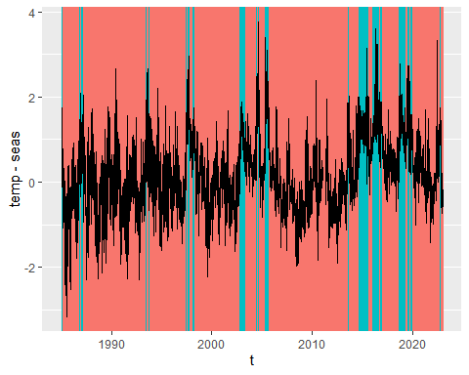

#test  
#mhwplotfun(mhw_clim, "Eastern Gulf of Alaska")  
  
#plot all  
for (i in eco_vec) {  
 print(mhwplotfun(x=mhw_clim, region=i))  
}

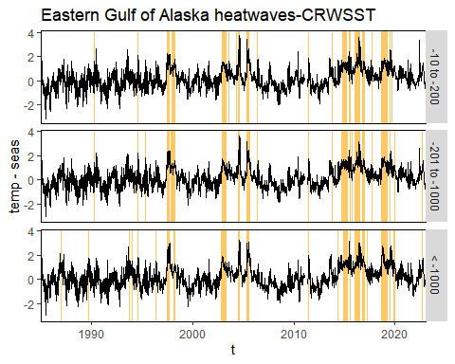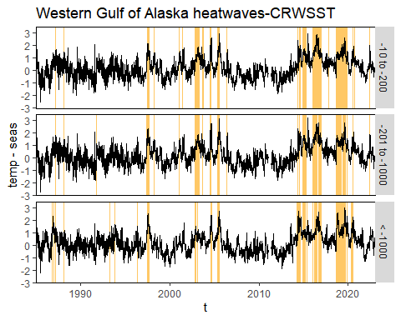

## COMPARISON WITH OISST

#New version with just GOA  
lkp<-readRDS("data/oi_spatial_lookup.RDS") %>%  
 rename_with(tolower)%>%  
 filter(depth <= -10 & ecosystem =="Gulf of Alaska") %>%  
 mutate(depth_strata=ifelse(depth>=-200, "-10 to -200", ifelse(depth>= -1000, "-201 to -1000", "< -1000")),  
 lon360=ifelse(longitude>0, longitude, longitude+360))%>%  
 st_as_sf(coords = c('longitude', 'latitude'), crs = 4326, agr = 'constant') %>%  
 st_transform(crs=3338)  
  
#map  
ggplot()+  
 # geom_sf(data=ak_dd%>%st_shift_longitude())+  
 #geom_point(data=lkp, aes(x=lon360, y= latitude, color=depth_strata, fill= depth_strata))+  
 geom_sf(data=lkp, aes(color=depth_strata, fill= depth_strata), size=1)+  
 geom_sf(data=esr%>%  
 filter(Ecosystem_Area == "Gulf of Alaska"),   
 color="black", fill=NA)+  
 scale_x_continuous(breaks = seq(0, 360, 10))+  
 ggtitle("OISST")+  
 theme_bw()

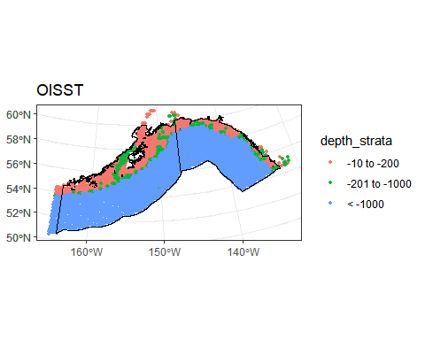

#plot sample sizes  
lkp%>%  
 group_by(ecosystem_sub, depth_strata)%>%  
 summarize(n_sst=n())%>%  
 ggplot()+  
 geom_col(aes(x=depth_strata, y=n_sst, fill=depth_strata))+  
 facet_wrap(~ecosystem_sub)+  
 ggtitle("OISST")+  
 theme_bw()

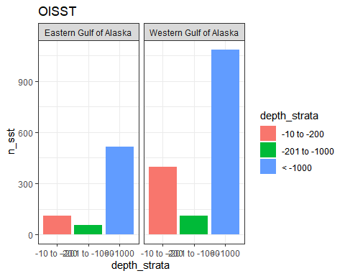

#load data from previous step  
sst_10_200<-readRDS("data/oi_10_200.RDS")  
sst_201_1000<-readRDS("data/oi_201_1000.RDS")  
sst_1001<-readRDS("data/oi_1001.RDS")  
sst<-sst_10_200%>%  
 bind_rows(sst_201_1000)%>%  
 bind_rows(sst_1001)  
  
#summarize for plot  
sst_sum<-sst %>%  
 rename_with(tolower)%>%  
 mutate(day=day(read_date),  
 month=month(read_date),  
 year=year(read_date),  
 newdate=as.Date(paste("2000",month,day,sep="-"),format="%Y-%m-%d"))%>%  
 group_by(ecosystem_sub, depth_strata, newdate)%>%  
 summarise(oisst=mean(oi_sst),  
 sd_sst=sd(oi_sst))  
  
  
#plot goa  
sst_sum%>%  
 filter(ecosystem_sub%in% c("Eastern Gulf of Alaska", "Western Gulf of Alaska"))%>%  
 ggplot()+  
 geom_line(aes(x=newdate, y=oisst, color=depth_strata), size=1)+  
 geom_line(aes(x=newdate, y=oisst+sd_sst, color=depth_strata), lty=2)+  
 geom_line(aes(x=newdate, y=oisst-sd_sst, color=depth_strata), lty=2)+  
 facet_wrap(~ecosystem_sub)+  
 scale_x_date(date_breaks="1 month",  
 date_labels = "%b",  
 expand = c(0.025,0.025)) +   
 xlab("date")+  
 ylab("OISST")+  
 theme_bw()

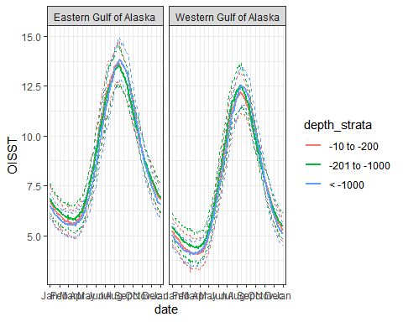

#prepare sst data for heatwaveR code  
sst<-sst %>% rename_with(tolower) %>%  
 mutate(t=as.Date(read_date,format="%Y-%m-%d"),  
 temp=oi_sst)  
  
#function to detect mhw events for each region and depth strata  
mhwfun<- function(x, region, strata) {  
 (detect_event(ts2clm(x %>% filter(ecosystem_sub==region & depth_strata==strata)%>%  
 arrange(t), climatologyPeriod = c("1985-01-01", "2014-12-31"))))$clim %>%  
 mutate(ecosystem_sub=region, depth_strata=strata)  
}  
  
#test  
egoa_10_mhw<-mhwfun(sst,"Eastern Gulf of Alaska", "-10 to -200")  
  
#blank dataframe for loop  
mhw_clim<-egoa_10_mhw[0,]  
  
eco_vec<-unique(sst$ecosystem_sub)  
depth_vec<-unique(sst$depth_strata)  
  
#loop function  
for (i in eco_vec) {  
 for (j in depth_vec) {  
mhw_clim<-mhw_clim%>%  
 bind_rows(mhwfun(x=sst, region=i, strata=j))  
 }  
}  
  
hcol<-"#ffc866"  
  
#plotting function  
mhwplotfun<-function(x, region){  
 ggplot(data=x%>%filter(ecosystem_sub==region))+  
 geom_rect(aes(xmin = t, xmax = t,  
 ymin = -Inf, ymax = Inf,  
 color = event)) +  
 geom_line(aes(x=t, y=temp-seas))+  
 facet_grid(rows=vars(depth_strata))+  
 scale_color_manual(values=c("white", "#ffc866"))+  
 # scale_fill_manual(values=c("white", hcol))+  
 ggtitle(paste0(region," heatwaves-OISST"))+  
 scale_x_date(#limits=c(xmin, xmax),   
 expand = c(0, 0))+  
 theme(legend.position = "none",  
 panel.border=element_rect(fill=NA))  
}  
  
  
ggplot(mhw_clim%>%filter(ecosystem_sub=="Eastern Gulf of Alaska"), aes(t, temp-seas)) +   
 geom_rect(aes(xmin = t, xmax = t,  
 ymin = -Inf, ymax = Inf,  
 color = event),  
 size = 0.7,  
 show.legend = FALSE) +  
 geom_line()

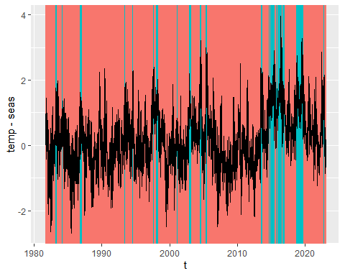

#plot all  
for (i in eco_vec) {  
 print(mhwplotfun(x=mhw_clim, region=i))  
}

