chl-indicator-comparison-calculations

Matt Callahan

6/23/2022

The following document compares MODIS and OC_CCI chlorophyll values in the SEBS, EGOA, and WGOA. Within each region/product, I compare filtered -50 to -200 Federal waters only with unfiltered (SEBS) or -10 to -200m (GOA) values.

## Load data

library(tidyverse)  
library(lubridate)  
library(sf)  
library(AKmarineareas)

**MODIS** MODIS data were downloaded from a google folder where Jordan stored them from previous efforts <https://drive.google.com/drive/u/1/folders/1mhwQ70mjLrkiQYiQ2oNHx08Q7IlL8Q3->

#EBS  
mod_ebs<-readRDS("Data/MODIS/merged_8day_2003_2021_EBS.RDS")  
#GOA  
mod_goa<-readRDS("Data/MODIS/merged_8day_2003_2021_GOA.RDS")

**Load oc-cci** This took a couple hundred lines of codes to make, found in chla-indicator-comparison-data.Rmd

occ_esp<-readRDS("Data/OCCCI/occ8_esp_strata.RDS")

**Create function for plotting MODIS and OC indicators over time**

chla_timeplot<-function(x1,x2,x3,x4,indicator) {  
 ggplot()+  
 geom_line(data=x1, aes(x=YEAR,y=OCCCI_VALUE), color="red")+  
 geom_line(data=x2, aes(x=YEAR,y=OCCCI_VALUE), color="red", lty=2)+  
 geom_line(data=x3, aes(x=YEAR,y=MODIS_VALUE), color="blue")+  
 geom_line(data=x4, aes(x=YEAR,y=MODIS_VALUE), color="blue", lty=2)+  
 ylab("chla")+  
 ylim(c(0,5))+  
 ggtitle(paste(indicator, "\n OC-CCI=red, MODIS=blue, dashed=depth filtered"))  
}

## 3

**SEBS** I first look at the BSIERP “super region” consisting of the South Middle shelf, Alaska Peninsula, Pribilofs, and Central Middle Shelf regions.

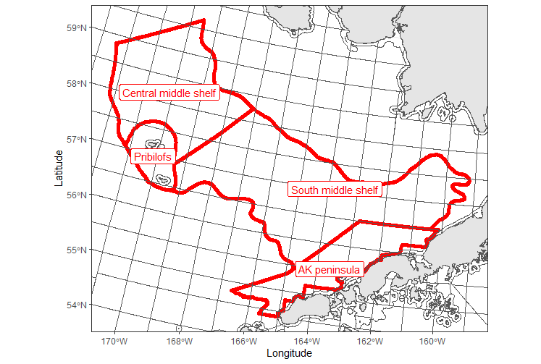

selected BSEIRP regions

#define indicator  
indicator<-"BSIERP middle shelf regions"  
  
#MODIS with a 50-200 depth filter and limited to federal waters.   
mod_esr_df<-mod_ebs%>%  
 mutate(month=month(date),  
 YEAR=year(date),  
 ) %>%  
 filter(bsierp_id %in% c(1,3,5,6) & month %in% c(4,5,6) & depth <(-50) & depth>(-200) & statefed == "FED"  
 )%>%  
 group_by(YEAR)%>%  
 summarise(MODIS_VALUE=round(mean(chlorophyll, na.rm=T),2))  
  
#no depth filter  
mod_esr_ndf<-mod_ebs%>%  
 mutate(month=month(date),  
 YEAR=year(date),  
 ) %>%  
 filter(bsierp_id %in% c(1,3,5,6) & month %in% c(4,5,6) #& depth <(-50) & depth>(-200)  
 )%>%  
 group_by(YEAR)%>%  
 summarise(MODIS_VALUE=round(mean(chlorophyll, na.rm=T),2))  
  
  
#oc-cci depth filter  
occci_esr_df<-occ_esp%>%  
 filter(BSIERP_ID %in% c(1,3,5,6) & month %in% c(4,5,6) & depth <(-50) & depth>(-200) & WATERS_COD== "FED"  
 )%>%  
 mutate(YEAR=year) %>%  
 group_by(YEAR)%>%  
 summarise(OCCCI_VALUE=round(mean(chlorophyll, na.rm=T),2))  
  
#oc-cci no depth filter  
occci_esr_ndf<-occ_esp%>%  
 filter(BSIERP_ID %in% c(1,3,5,6) & month %in% c(4,5,6) #& depth <(-50) & depth>(-200)  
 )%>%  
 mutate(YEAR=year) %>%  
 group_by(YEAR)%>%  
 summarise(OCCCI_VALUE=round(mean(chlorophyll, na.rm=T),2))  
  
#plot  
chla_timeplot(occci_esr_ndf, occci_esr_df, mod_esr_ndf, mod_esr_df, indicator)

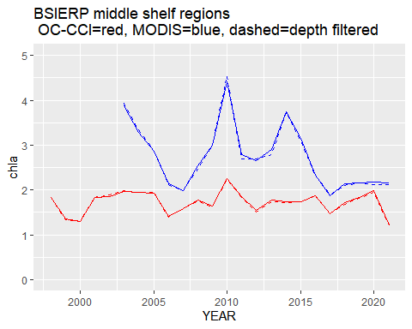

#how much was filtered out?  
mod_ebs%>%  
 mutate(month=month(date) ) %>%  
 filter(bsierp_id %in% c(1,3,5,6) & month %in% c(4,5,6))%>%  
 summarise(no_filter=n())%>%  
 bind_cols(mod_ebs %>%  
 mutate(month=month(date) ) %>%  
 filter(bsierp_id %in% c(1,3,5,6) & month %in% c(4,5,6) & depth <(-50) & depth>(-200) & statefed == "FED")%>%  
 summarise(depth_filter=n())) %>%   
 mutate(percent_remaining=depth_filter/no_filter*100)

## # A tibble: 1 x 3  
## no_filter depth_filter percent_remaining  
## <int> <int> <dbl>  
## 1 1557978 1373314 88.1

#<12% removed by filter... didn't make much of a difference here.

**Spring_Chlorophylla_Biomass_EGOA_Satellite** The next two indicators are the eastern and western Gulf of Alaska

ak<-AK_basemap()  
nmfs<-AK_marine_area()%>%filter(NMFS_REP_AREA>600)  
  
ggplot()+  
 geom_sf(data=ak)+  
 geom_sf(data=nmfs, fill=NA, size=1, color="black")+  
 geom_sf_label(data=nmfs, aes(label=NMFS_REP_AREA))+  
 xlab("")+ylab("")+  
 coord_sf(xlim=c(-170, -130), ylim=c(49, 63))+  
 theme_bw()

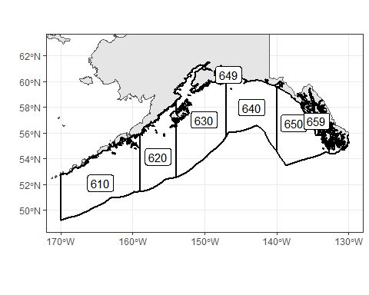

#define indicator  
indicator<-"Spring_Chlorophylla_Biomass_EGOA_Satellite"  
#MODIS  
#recalculate indicator  
mod_EGOA_10 <- mod_goa %>%  
 mutate(month=month(date),  
 YEAR=year(date)) %>%  
 filter(nmfsarea %in% c(640,650) & month%in% c(4:6) & depth<(-10) & depth>(-200)) %>%  
 group_by(YEAR) %>%  
 summarise(MODIS_VALUE=mean(chlorophyll,na.rm=TRUE))  
  
#50m filter  
mod_EGOA_50 <- mod_goa %>%  
 mutate(month=month(date),  
 YEAR=year(date)) %>%  
 filter(nmfsarea %in% c(640,650) & month%in% c(4:6) & depth<(-50) & depth>(-200) & statefed=="FED") %>%  
 group_by(YEAR) %>%  
 summarise(MODIS_VALUE=mean(chlorophyll,na.rm=TRUE))  
  
  
#OCC  
occci_EGOA_10<-occ_esp%>%  
 filter(NMFS_REP_AREA%in% c(640, 650) & month %in% c(4:6) & depth<(-10) & depth>(-200))%>%  
 mutate(YEAR=year) %>%  
 group_by(YEAR)%>%  
 summarise(OCCCI_VALUE=mean(chlorophyll,na.rm=TRUE))  
  
occci_EGOA_50<-occ_esp%>%  
 filter(NMFS_REP_AREA%in% c(640, 650) & month %in% c(4:6) & depth<(-50) & depth>(-200) & WATERS_COD== "FED")%>%  
 mutate(YEAR=year) %>%  
 group_by(YEAR)%>%  
 summarise(OCCCI_VALUE=mean(chlorophyll,na.rm=TRUE))  
  
#plot  
chla_timeplot(occci_EGOA_10, occci_EGOA_50, mod_EGOA_10, mod_EGOA_50, indicator)

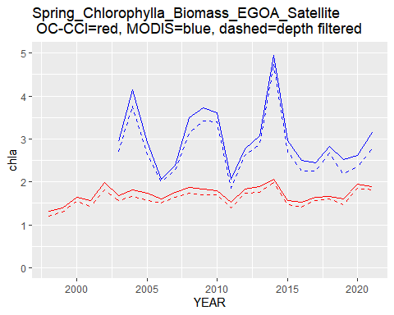

#how much was filtered out?  
mod_goa%>%  
 mutate(month=month(date) ) %>%  
 filter(nmfsarea %in% c(640, 650) & month %in% c(4,5,6) & depth <(-10) & depth>(-200))%>%  
 summarise(ten_m_filter=n())%>%  
 bind_cols(mod_goa %>%  
 mutate(month=month(date) ) %>%  
 filter(nmfsarea %in% c(640, 650) & month %in% c(4,5,6) & depth <(-50) & depth>(-200) & statefed == "FED")%>%  
 summarise(fifty_m_filter=n())) %>%   
 mutate(percent_remaining=fifty_m_filter/ten_m_filter*100)

## # A tibble: 1 x 3  
## ten_m_filter fifty_m_filter percent_remaining  
## <int> <int> <dbl>  
## 1 710296 612793 86.3

#<14% removed by filter... didn't make much of a difference here.

**Spring_Chlorophylla_Biomass_WCGOA_Satellite**

#define indicator  
#define indicator  
indicator<-"Spring_Chlorophylla_Biomass_WCGOA_Satellite"  
#MODIS  
#recalculate indicator  
mod_WGOA_10 <- mod_goa %>%  
 mutate(month=month(date),  
 YEAR=year(date)) %>%  
 filter(nmfsarea %in% c(610, 620, 630) & month%in% c(4:6) & depth<(-10) & depth>(-200)) %>%  
 group_by(YEAR) %>%  
 summarise(MODIS_VALUE=mean(chlorophyll,na.rm=TRUE))  
  
#50m filter  
mod_WGOA_50 <- mod_goa %>%  
 mutate(month=month(date),  
 YEAR=year(date)) %>%  
 filter(nmfsarea %in% c(610, 620, 630) & month%in% c(4:6) & depth<(-50) & depth>(-200) & statefed=="FED") %>%  
 group_by(YEAR) %>%  
 summarise(MODIS_VALUE=mean(chlorophyll,na.rm=TRUE))  
  
#OCC  
occci_WGOA_10<-occ_esp%>%  
 filter(NMFS_REP_AREA%in% c(610, 620, 630) & month %in% c(4:6) & depth<(-10) & depth>(-200))%>%  
 mutate(YEAR=year) %>%  
 group_by(YEAR)%>%  
 summarise(OCCCI_VALUE=mean(chlorophyll,na.rm=TRUE))  
  
occci_WGOA_50<-occ_esp%>%  
 filter(NMFS_REP_AREA%in% c(610, 620, 630) & month %in% c(4:6) & depth<(-50) & depth>(-200) & WATERS_COD== "FED")%>%  
 mutate(YEAR=year) %>%  
 group_by(YEAR)%>%  
 summarise(OCCCI_VALUE=mean(chlorophyll,na.rm=TRUE))  
  
#plot  
chla_timeplot(occci_WGOA_10, occci_WGOA_50, mod_WGOA_10, mod_WGOA_50, indicator)

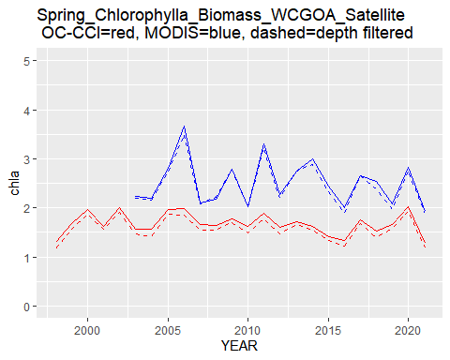

#how much was filtered out?  
mod_goa%>%  
 mutate(month=month(date) ) %>%  
 filter(nmfsarea %in% c(610, 620, 630) & month %in% c(4,5,6) & depth <(-10) & depth>(-200))%>%  
 summarise(ten_m_filter=n())%>%  
 bind_cols(mod_goa %>%  
 mutate(month=month(date) ) %>%  
 filter(nmfsarea %in% c(610, 620, 630) & month %in% c(4,5,6) & depth <(-50) & depth>(-200) & statefed == "FED")%>%  
 summarise(fifty_m_filter=n())) %>%   
 mutate(percent_remaining=fifty_m_filter/ten_m_filter*100)

## # A tibble: 1 x 3  
## ten_m_filter fifty_m_filter percent_remaining  
## <int> <int> <dbl>  
## 1 1954772 1584651 81.1

#<19% removed by filter.