Notes on the combined haul and crab files (crabhaul_species) created from the 1975 - 2016 eastern Bering Sea trawl survey data

Haul selection
- All hauls were selected from the RACEBASE database located on raja.afsc.noaa.gov (Oracle server at the AFSC-Seattle).
- Only good performance hauls were included. Non-standard tows (e.g. test tows and special project tows) were excluded from the data set, except where necessary to ensure appropriate survey coverage: 1976 (4 haul type 0 tows), 1981 (36 haul type 4 tows), 1982 (8 haul type 4 tows), and 2006 (1 haul type 20 tow).
- Bristol Bay was re-surveyed in 1999, 2000, and 2006-2012. Data from the retow stations was used to replace the leg 1 survey station data for Bristol Bay red king crab females only.
- There are no multiple tows at stations.
Calculated fields in the crabhaulyyyy_species files
- There are 5 new columns in addition to the standard columns associated with racebase.haul and crab data:
  - mid_latitude, mid_longitude are calculated from the original haul table as start_latitude – end_latitude/2 and start_longitude – end_longitude/2. area_swept_variable is the distance fished (from the haul table, in kilometers) multiplied by the net width (from the haul table, in meters). Area swept is expressed in terms of square nautical miles. The net width (meters) is divided by 1000 to convert to kilometers, then multiplied by the distance fished. This number is multiplied by 0.29155335 to convert from square kilometers to square nautical miles.
  - area_swept_fixed50 is the distance fished (from the haul table, in kilometers) multiplied by a fixed net width of 50 feet. Area swept is expressed in terms of square nautical miles. Convert feet to kilometers (0.01524 for 50-foot net width), then multiply by the distance fished. This number is multiplied by 0.29155335 to convert from square kilometers to square nautical miles.
  - gis_station is the station id of the haul calculated via Oracle. Using Oracle Locator, the standard EBS station grid is converted to a spatial table. Using point-in-polygon analysis through an Oracle query, hauls falling anywhere within the station square (20x20 nm grid cell) are assigned that station’s alphanumeric id. Corner stations (areas of higher density sampling in the Pribilof and St. Matthew Island regions) are located approximately 10 nautical miles from standard stations: 7 nautical mile buffers were established in the EBS station grid to allow station assignment to these corner stations.
  - calculated_weight is the estimated weight of individual crab (grams) using carapace size-weight parameters updated in 2010 and 2016. Detailed information (parameters, equation) can be found on the last page of this document.
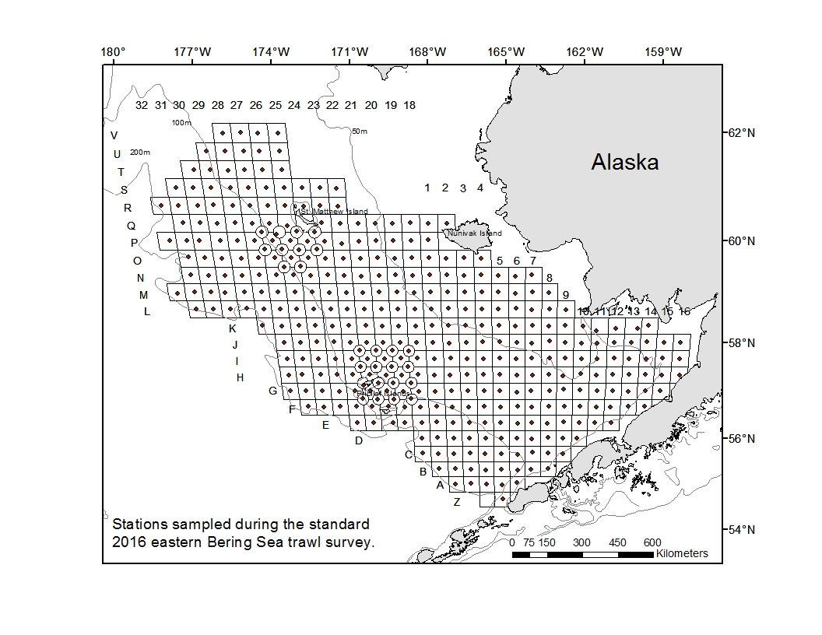

Miscellaneous Notes
- Every record in the crabhaulyyyy_species file = 1 crab measurement, or 1 haul record with no crab data if no crab of that species was caught in that haul. To calculate the total number of crab in a given haul, sum the sampling_factor.
- Records for tows with no catch are included.
- The high density area for the Pribilof District (Pribilof Multiple Core Tow Area) began in 1981, and the St. Matthew Multiple Tow Core Area began in 1983.
- Description of columns and codes from the haul table are provided in the document adpcodebook.pdf.
- Description of columns and codes from the crab table are provided in the document CrabCodeInstructions.pdf, with the following exceptions: station id is not used in the crabhaul_species file (station id calculated as described above), and species_code is the 5-digit RACE species code. Refer to species_codebook.pdf for a description of the species_codes.

The size-weight relationships are described by the expression: W = a L^{b}
where W is the total weight in grams, L is either carapace length (CL) or carapace width (CW) in mm, a is the intercept in log scale and b is the slope. Parameters a and b for the size-weight relationships are estimated from a linear regression fitted to the natural logarithm transformed size-weight data.¹

Species | a | b
Red king crab males | 0.000403 | 3.141334
Ovigerous red king crab | 0.003593 | 2.666076
Non-ovigerous RKC | 0.000408 | 3.127956
Blue king crab males  St Matthew  ²Blue king crab females | 0.000508  0.000502  0.02065 | 3.106409  3.107158  2.27
Tanner crab males | 0.00027 | 3.022134
Ovigerous Tanner crab | 0.000441 | 2.898686
Non-ovigerous Tanner | 0.000562 | 2.816928
Snow crab males | 0.000267 | 3.097253
³Ovigerous snow crab | 0.001158 | 2.708793
Non-ovigerous snow crab | 0.001047 | 2.708367
⁴Hair crab males  ⁴Hair crab females | 0.00071731  0.001194533 | 3.02  2.86

¹ Chilton, E.A, and R.J. Foy. Draft. Growth and size-weight relationships of commercial crab in the eastern Bering Sea.
² Otto, Robert S. Unpublished data
³ New b value calculated July 2016, applied to time series biomass output August 2016
⁴ Armetta, T.M., and B.G. Stevens. 1987. Aspects of the biology of the hair crab, Erimacrus isenbeckii, in the eastern Bering Sea. Fishery Bulletin 85(3):523-545

