## Site Purpose:

**Scoots**is a fictitious 🛵 motor scooter rental company located on the island of Cozumel off the coast of Mexico in the western Caribbean Sea. This owner-operator company caters to locals, walk-in tourists, enthusiasts, and cruise-based touring groups and partnerships. The company has two physical rental locations on Cozumel. One is near the Playa del Carmen-Cozumel Ferry dock in el Centro de Cozumel and the other is near the Terminal Puerta Maya further south along the coast which caters to the cruise lines and patrons. The company promotes friendly and easy to rent services of motor scooters, jeeps, and side-by-sides ATVs. The overall goal of the website project is to promote the rental services for those customers that like to do their homework before getting to the island and to provide information about the services, requirements, and rental process. The website should reflect the fun and carefree attitude of the island and the ability to escape the touristy western part of the island by exploring the vast coasts and inlets on the southern and eastern shores.

## Target Audience:

Locals, walk-in tourists, enthusiasts, and cruise-based touring groups and partnerships. Ages 18+

## Personas:

Vacation Couple Steven and Cari. Steven and Cari are on vacation and are looking to get out of their resort for some non-structured fun and a taste of local flavors. They like the idea of being able to explore on their own, with the option to do a self-guided tour.

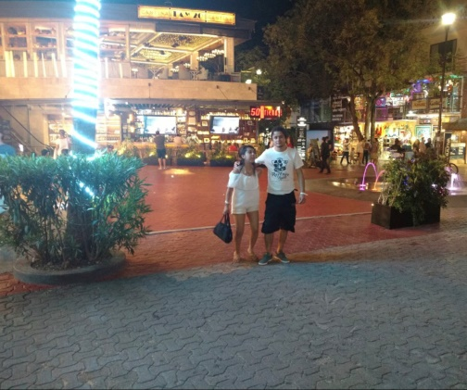Victor and Vimary are a local couple who want to make the most of their weekends. They enjoy day-trip destinations around Playa Del Carmen and enjoy getting out and about. They enjoy the flexibility of being able to rent scooters, as opposed to owning and maintaining their own.

## Color Scheme:

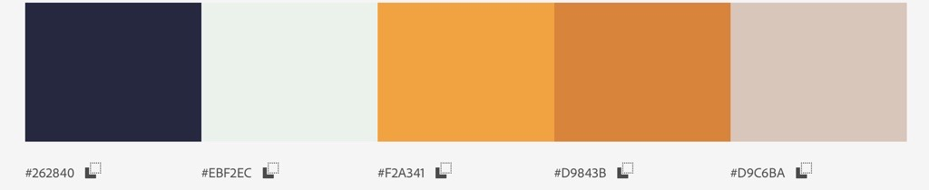

## Typography:

This font will be used for H1, H2, H3, H4, as well as slogans and titles

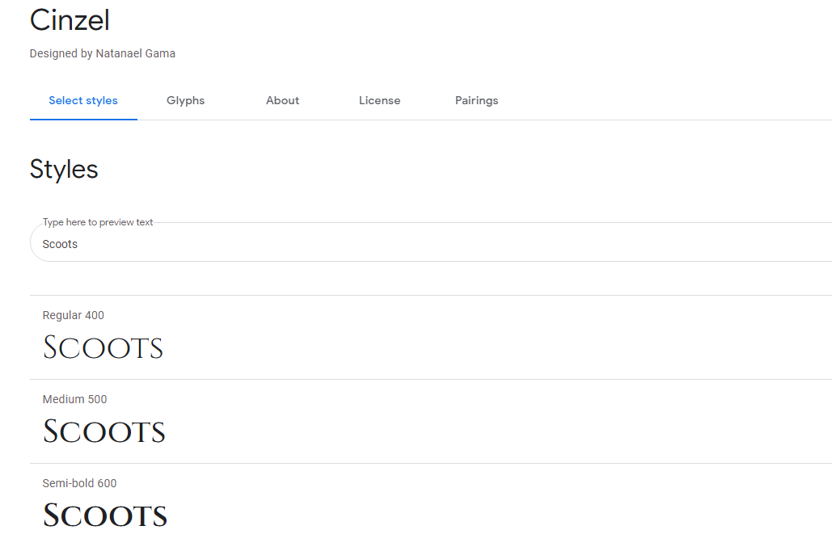

This font will be used for paragraphs and general informational text, including links and footers.

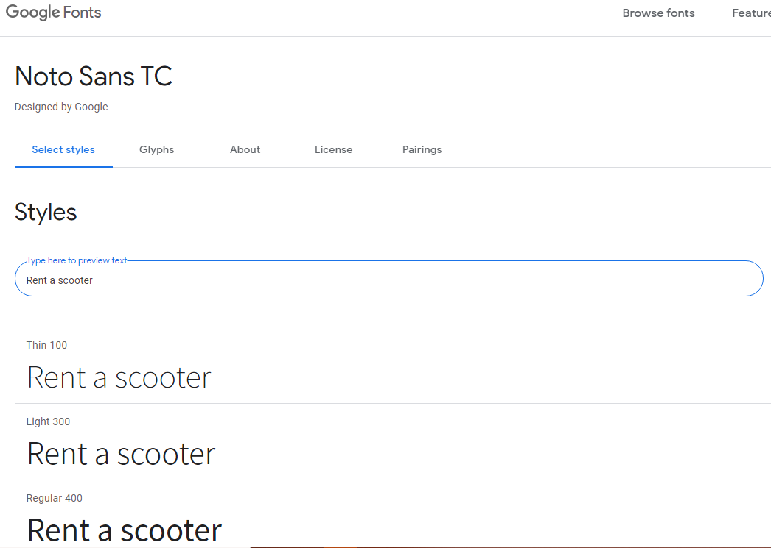

## Logo and Slogan:



“Why Walk When You Can Scoot!”