**Web Development CA2**

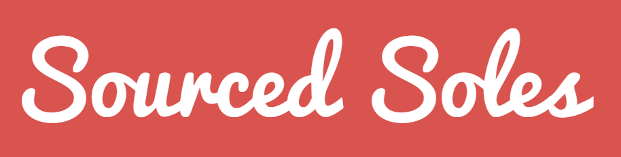

Part 1 : Report

Shane Cotter X00131736

Ian Daly X00132250

Matthew Cleary X00130277

**Index Page**

Page

2 Introduction

3 Site Structure and Organisation

5 Navigation

6 Page Structure

7 Colour Scheme

8 Media/Images

9 Contribution

**Introduction**

The website we chose to create for CA2 is a website called Sourced Soles. Sourced Soles is the brand name for the online store we chose to create. Sourced Soles is an online store which sells high end hard to find ‘runners’ or ‘sneakers’. We also provide the option for our customer to request for us to ‘source’ a pair for them which may be hard to find. This is a very specific area and due to this we had to do a lot of research on our target audience and other similar sites in the same market. A lot of thought went into the planning and design of the website before we even started to programme. You can see some information about how we planned and designed the website below.

**Site Structure & Organisation**

User Types

Our website has two intended users, administrators and normal users. Administrators can modify the site i.e. Create, Read, Update and Delete products. To do this, Administrators will be forced to login, via the Admin page (to be added). Normal Users are only authorised to view and interact with the site. They can freely browse the site but to order products and submit a Source Request, they are required to login, via the login tab. If a user does not have an account, the must register for an account. This can be accessed via Login > Register.

Target Audience

Sourced Soles is an online store which sells the latest trends of shoes and runners. We provide a service like no other footwear site. We sell products that may be deadstock, or no longer sold in other online footwear stores. We use our world-wide contacts to source the runners that you want, whether they are brand new or second hand. No sneaker is too hard for us to find.

Our Target Audience is the avid shoe collector. Our site will attract anyone who has the simplest interest in buying and/or collecting footwear. Anyone who keeps up to date with the newest releases in fashionable footwear, or who still admires pre-released products, who buys footwear regularly, will have a keen interest in our website. In terms of target audience age, we have aimed for anyone in their young teens to mid-twenties.

We designed our website with the user in mind, making it easy to navigate and easy to use. In our research, we found that other shoe sites were congested and contained a lot of data per one page. The navigation was awkward as there are so many links to choose from. To avoid this, we used a simple interface and links that are only highly useful.

Site Information

Sourced Sole’s online store had been designed without using a Bootstrap Template. The site has been built using HTML, CSS and Twitter Bootstrap. The site has five visible links in the Navigation bar, Home (the first page you are directed on), Products and buttons for Search Store, Login and Shopping Cart. The site is easy to use and follows the three-click system, is quite colourful and vibrant to attract the eye. As required, all pages have been designed and implemented into play although we have no products available to view just yet.

Required Pages

When designing Sourced Soles, we didn’t want to overload our store with unnecessary pages, like some of the pages we came across while researching, for example [https://www.jdsports.ie](https://www.jdsports.ie/). We found this site was cramped and included too many options in the drop-down menu. To avoid this, we only implemented a single product navigation option, which displays all our products under one title. We believe all our pages are user requires pages. User need to browse products under the products page, the can search via the search button, login via the login button, see what is in their basket via the shopping cart button, and return home via the home page.

**Navigation**



From the Home page (Index.html), a user can easily navigate through each page with easy. Visible links on the homepage are Home, Products, Search button, Login Button and Shopping Cart Button.

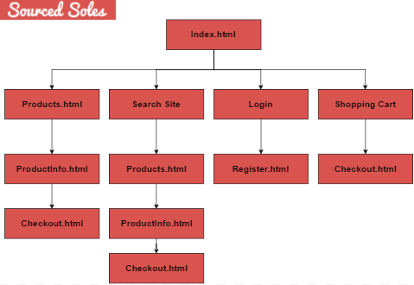

We designed the navigation this way to make it as easy for the user to navigate as possible, therefore choosing to use Hierarchical website navigation as it provides a clear simple path to all web pages from anywhere on the website. This makes navigating easier for the user to get to the main content of the website. The structure is built from general to specific navigation. We used a navigation bar to group all links together horizontally on the default site. Using this method brings consistency throughout the website. It also allows users to learn how to navigate through the website through repetition. Grouping the links altogether in a simple navigation bar reduces clutter which also bringing an advantage to the website by making it easier to read. A major factor we considering during design was the Three-click rule. We have made sure that a user can find what they are looking for within three-clicks or less. For example, a user can view and purchase a product: Products > Product Info > Checkout.

**Page Structure**

The page structure of a website is a very important factor in the design process of a website. A good page structure can help all pages on a website look consistent throughout.

We tried to choose a page structure for our website that keeps the content of the page central while keeping the navigation clearly visible always. Due to this we decided to have a page structure grant most of the space on the page to the content with the navigation bar staying static at the top of the page. As we did not plan to put too much information in the footer we decided that the footer would only show when the user had reached the very end of the page’s content. Through using the above page structure, we could make sure the content was always had the most focus on it, regardless of what page it was on.

Before finalising our page structure, we checked other website which would have a similar target audience to ours for ideas and to see did any websites have a similar page structure to ours. We did not end up changing the site structure after viewing other websites as we found that websites with a similar page structure also had the same approach as the page structure we had decided upon.

Page Structure sketch

The below sketch is a rough sketch of the final page structure that we chose. This sketch shows the general page structure that will be common on each page of the website.

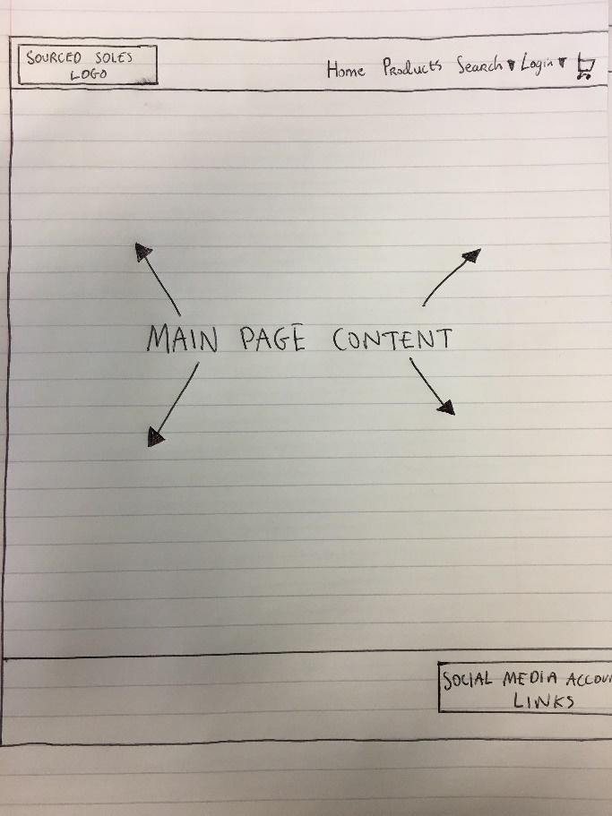

**Colour Scheme**

The colour scheme is very is very important on any website. Due to this we put a lot of thought into picking our colour scheme while keeping in mind the user, branding and colour schemes of similar sites.

The User

We needed to keep in mind the user while picking our colour scheme. Things we had to consider were not picking a colour scheme that was too highly saturated and would be hard on a user’s eyes. We also had to consider if colour schemes that were too vibrant would take the user’s focus away from the main content of the page?

Branding

Using a consistent colour scheme throughout a website helps build a sense of the brand on the webpage and helps maintain consistency throughout the various pages on the site.

Similar sites

Before picking our colour scheme we did research to see what colour schemes websites in a similar market to ours were using and what way they used the colour scheme throughout their website. We found that successful sites in the same market as ours never used colours that were too highly saturated and we also used our research of similar sites to help us chose a colour scheme that no other similar site had.

Taking into consideration all the above points we came to a conclusion and picked a colour scheme of red and white. We chose a red that was not too saturated so it would not be harsh on the user’s eyes or take their attention away from the main content of the page. We also found that the colour scheme we picked was not used on any of the other similar sites in the same market to ours.

The red we chose is: #d9534f;/ rgb(217,83,79)

We used a standard white colour to accompany this red.

We used this colour scheme on the navigation bar, footer, buttons, and forms. We decided to keep the main content background of all pages white so the focus was mainly on the content and the background colour would not be taking any attention away from the content.

**Media/Images**

Media and images are very important on a site as they are aesthetically pleasing. Images also help to break up the webpage as users do not like to be presented with blocks of writing and images are what is used to break this images are what is used to break this up.

As of right now we have images on the main page on the carousel which have the option to be clicked on to ‘shop now’. We chose these images as we felt that these images were clean images which were appropriate for where they were being used as they are images of sneakers stores. These images also display well in a carousel as they are large enough that they fill the large carousel without the image becoming distorted.

We also have an image on the homepage of a pair of popular sneakers called ‘Adidas – Yeezy 350 Boost’. We chose this image because it blends in well with the rest of the content on the home page as it has a white background and it also gives the user a sense of the product we offer without the user visiting the products page it gives the user a sense of the product we offer.

Other than the above we only plan to add in more images for the products we will be selling on the products page.

**Contribution by Team Members**

When building our website, we wanted to make sure that everyone had a good idea how each page was constructed. Due to this no one page was assigned to one person only.

We worked collectively on each aspect of the site. As we started this project as early as possible we had enough time to sit down together and programme our site together in the same room and help each other fix errors that another team member may encounter. Through doing this we could teach each other different things we knew and work through errors or aspects of the site that were not working a lot quicker. Through programming the website together, we also introduced each other to different libraries that are useful and different websites that can be helpful to reference while building a website. For example, one team member Ian knew about jQuery and media queries and he was able to show the rest of the team how it is used and how we could use implement it in our site.