Exercise 1 Report
This report summarizes cross-validation training behavior, baseline comparisons, depth experiments, and final test performance for the warehouse picking-time task.

1. Confirmation of implementation
The PyTorch pipeline includes: cross-validation training, final test evaluation, linear normal-equation baseline, and a depth experiment with variable hidden layers.

2. CV loss curves
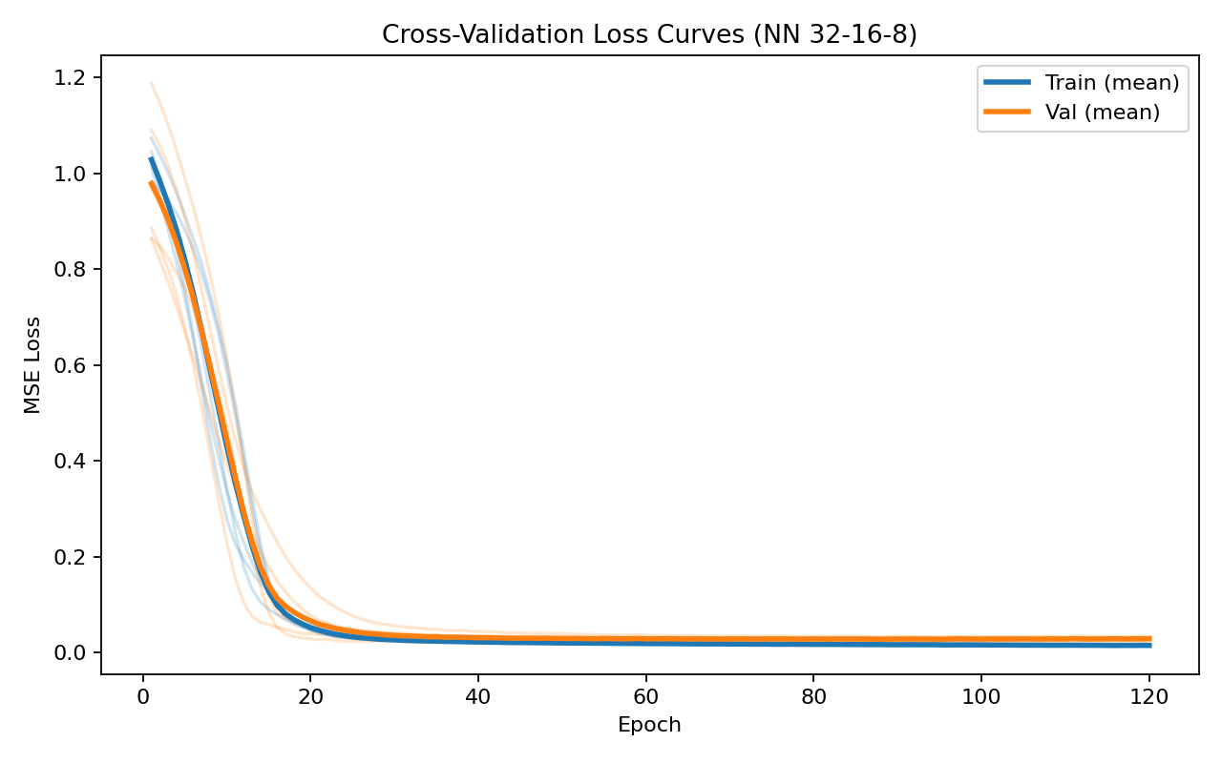

3. Predicted vs actual
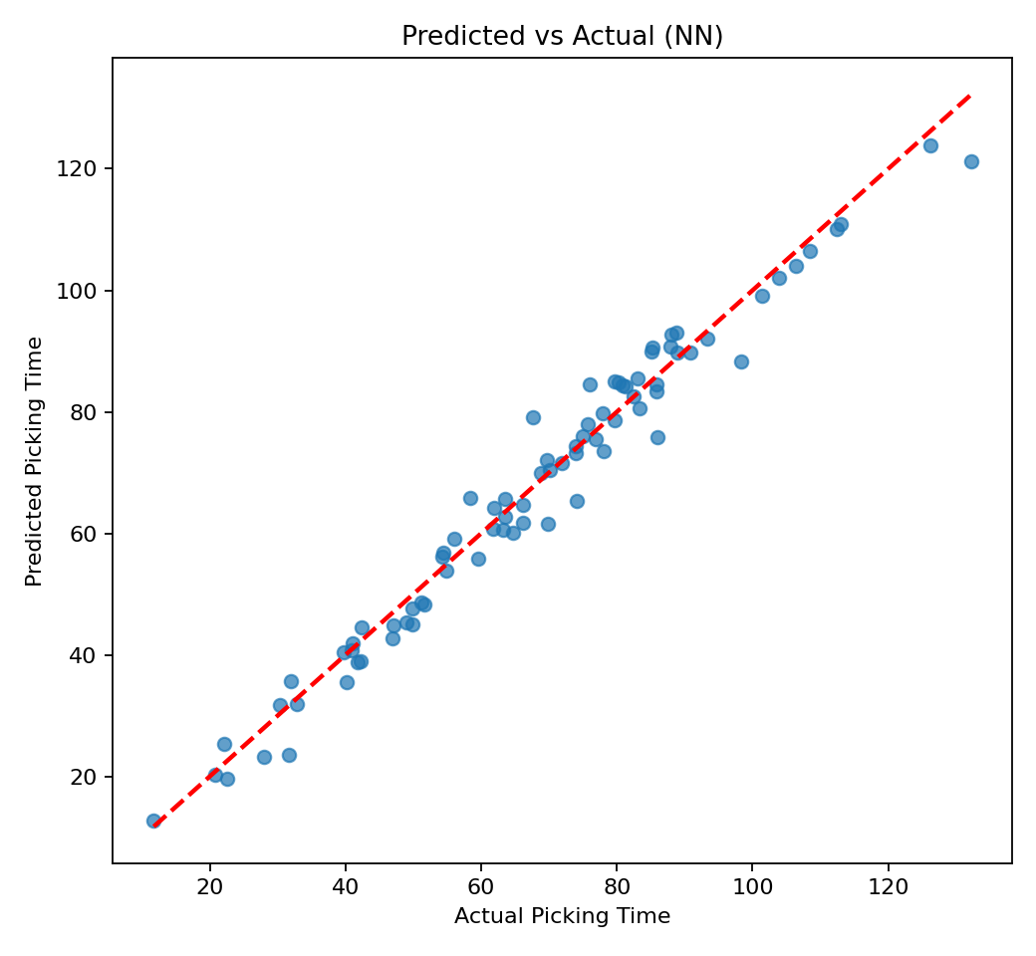

4. Linear vs NN RMSE comparison
Model | Mean RMSE | Std RMSE
Linear baseline | 4.6178 | 0.0506
NN (32-16-8) | 4.2917 | 0.0588

5. Depth experiment
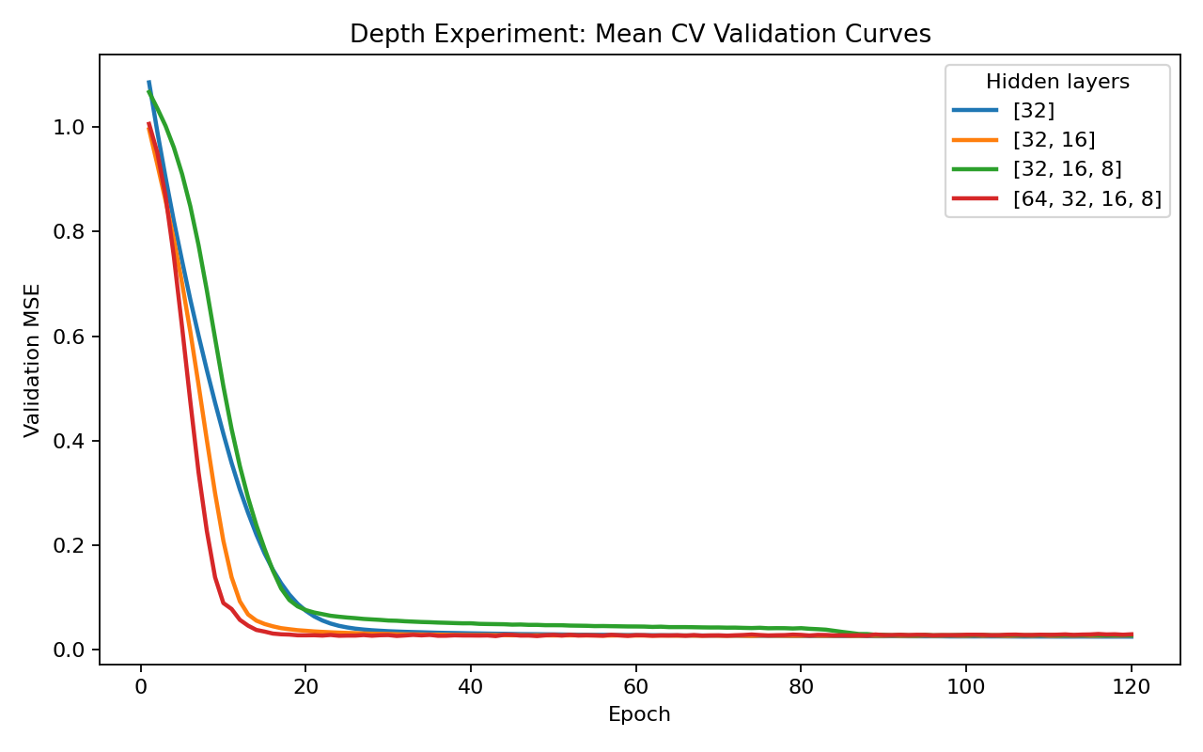
Hidden layers | Mean RMSE | Std RMSE
[32] | 4.0958 | 0.1130
[32, 16] | 4.2837 | 0.0706
[32, 16, 8] | 4.3548 | 0.0899
[64, 32, 16, 8] | 4.4750 | 0.1388

6. Discussion
The neural network captures nonlinear interactions in the data that are difficult for linear regression to represent. Compared with linear baseline, the 32-16-8 NN changed RMSE by 7.06% on average. The depth experiment shows how capacity affects generalization; very shallow models can underfit while overly deep models may not improve validation loss. The best tested depth was [32] with mean RMSE 4.0958.

