DJPR Labour Force Summary

DJPR SPP Data + Analytics

13 July, 2021

# Victorian labour force summary

## R Markdown

This is an R Markdown document. Markdown is a simple formatting syntax for authoring HTML, PDF, and MS Word documents. For more details on using R Markdown see <http://rmarkdown.rstudio.com>.

When you click the **Knit** button a document will be generated that includes both content as well as the output of any embedded R code chunks within the document. You can embed an R code chunk like this:

|  | **Current figures** | **Change in past month** | **Change in past year** | **Change during govt** |
| --- | --- | --- | --- | --- |
|  | MAY 2021 | SINCE APR 2021 | SINCE MAY 2020 | SINCE NOV 2014 |
| **Employed (persons)** | 3.454m | 29,800 (0.9%) | 209,400 (6.5%) | 533,000 |
| **Unemployed total** | 173,200 | -24,700 (-12.5%) | -62,000 (-26.3%) | -38,100 |
| **Unemployment rate** | 4.8% | -0.7 ppts | -2.0 ppts | -2.0 ppts |
| **Participation rate** | 66.6% | 0.1 ppts | 3.0 ppts | 1.9 ppts |
| **Employed full-time** | 2.345m | 31,400 (1.4%) | 83,000 (3.7%) | 369,300 |
| **Monthly hours worked in all jobs** | 474.8m | 5.475m (1.2%) | 55.637m (13.3%) | 74.674m |
| **Underemployment rate** | 7.7% | 0.1 ppts | -6.9 ppts | -1.8 ppts |
| **Underutilisation rate** | 12.5% | -0.6 ppts | -8.8 ppts | -3.8 ppts |
| **Employed part-time** | 1.109m | -1,500 (-0.1%) | 126,400 (12.9%) | 163,700 |

## Including Plots

You can also embed plots, for example:

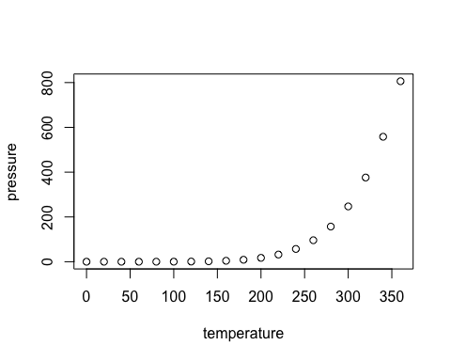

Note that the echo = FALSE parameter was added to the code chunk to prevent printing of the R code that generated the plot.