RMarkdown Template

Matt Cowgill

09/06/2019

Table of Contents

1.1R Markdown 2

1.2Including Plots 2

1.2.1 Subtitle 3

2Bibliography 4

## R Markdown

This is an R Markdown document. Markdown is a simple formatting syntax for authoring HTML, PDF, and MS Word documents. For more details on using R Markdown see <http://rmarkdown.rstudio.com>.[1]

When you click the **Knit** button a document will be generated that includes both content as well as the output of any embedded R code chunks within the document. You can embed an R code chunk like this:

summary(cars)

## speed dist   
## Min. : 4.0 Min. : 2.00   
## 1st Qu.:12.0 1st Qu.: 26.00   
## Median :15.0 Median : 36.00   
## Mean :15.4 Mean : 42.98   
## 3rd Qu.:19.0 3rd Qu.: 56.00   
## Max. :25.0 Max. :120.00

## Including Plots

You can also embed plots, for example:

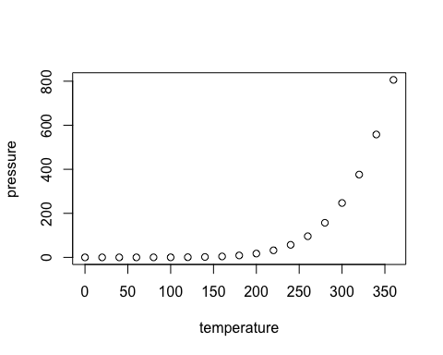

Note that the echo = FALSE parameter was added to the code chunk to prevent printing of the R code that generated the plot.

### Subtitle

This is another subsection with some text in it.

### Lists

This is a list.

1. This is the first element in the list
2. Second element
3. And third.

# Bibliography

Duckett, S., Cowgill, M., & Swerissen, H. (2019). *Filling the gap: A universal dental scheme for Australia.* Melbourne: Grattan Institute.

1. A footnote goes here. (Duckett, Cowgill, & Swerissen, 2019)