Grattan Institute Word Template for RMarkdown

Live that all-RStudio lifestyle you’ve always dreamed of

Matt Cowgill

Created 2019-06-11

Table of Contents

RPLACEHOLDER

# This is a section header

This is a template for an R Markdown document that you can Knit to a Word document. It will produce a document that is consistent with the basic elements of the Grattan Institute style. Note that the [redoc package](https://noamross.github.io/redoc/index.html) is required to generate Word documents that can be re-converted to R Markdown. If you don’t have redoc, and don’t want to install it for some reason, amend the output listed in the YAML header above from redoc::redoc: to word_document:.

You can add footnotes.[1]

If you have a bib file, you can add citations. 3

You can use things like inline RPLACEHOLDER comments.

## Chunks with plots

You can also embed plots, for example:

#### This is a plot title

##### This is a plot subtitle

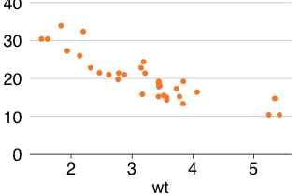

###### This is a plot caption

Some text goes here.

### This is a heading with Heading 3 styling

More text goes here

## This is a second-level heading

Lorem grattsum

## This is a heading with the underline style

## Track Changes

**redoc** supports [Critic Markup](http://criticmarkup.com/users-guide.php) syntax for comments. You can include edits and they will be converted to tracked changes in your Word document . By default , your system username is used as the author of changes, but this can be set with the comment_author argument in redoc() or your document YAML.

1. Test footnote.