Greenworks Admin Manual

Introduction

The purpose of this document is to provide the necessary information that an admin would require to access and engage in data-related operations for the project.

Scope

This manual will not explain front-end features that are primarily crafted for the end user. This document is intended to highlight the features that are solely relegated to the admin.

Contents

Login and Credential Validation 3

Layout of Admin Board 4

Adding a New Entry 5

Deleting an Entry 6

Editing an Entry 7

Initiating a Database Clean 9

# Login and Credential Validation

An admin will be unable to gain access to the database through the GUI if the admin does not have valid login credentials. The credentials will be compared to saved credentials in the database.

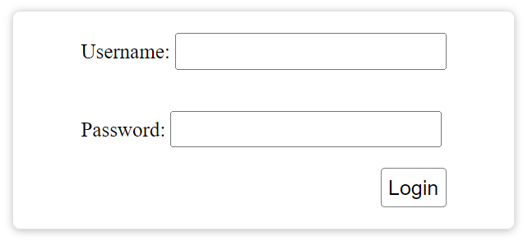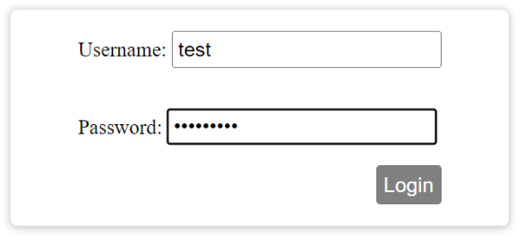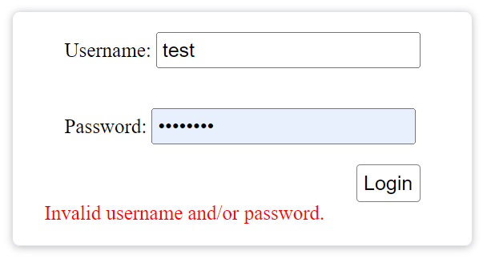

The admin must first navigate to the login screen by adding /admin.jsp to the base URL.

The admin must provide valid user credentials. The admin must press the button.

If the credentials are not valid, then the admin will not login and the login box will display an ‘Invalid username and/or password.’ message on the bottom.

A successful login should take a few seconds at the most.

# Layout of Admin Board

After successful login, the admin will be presented with the admin panel. The panel consists of four sections:

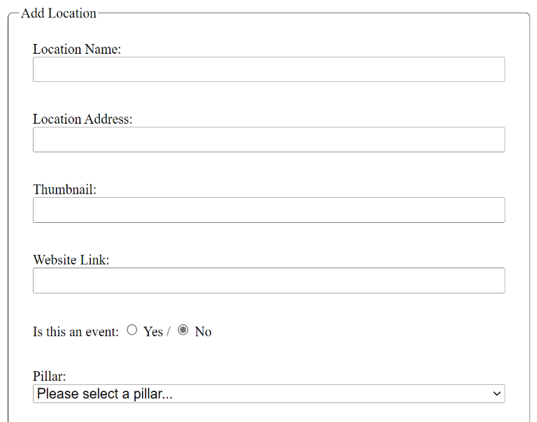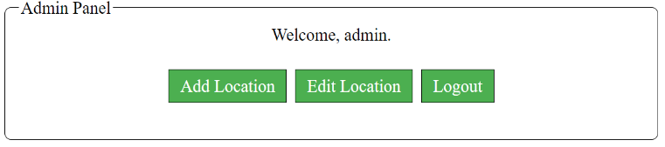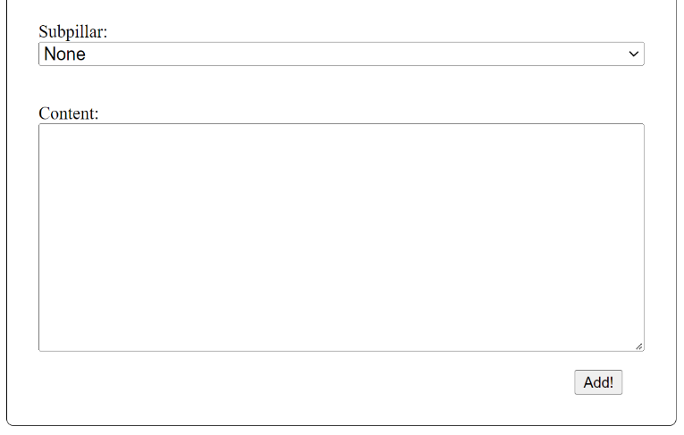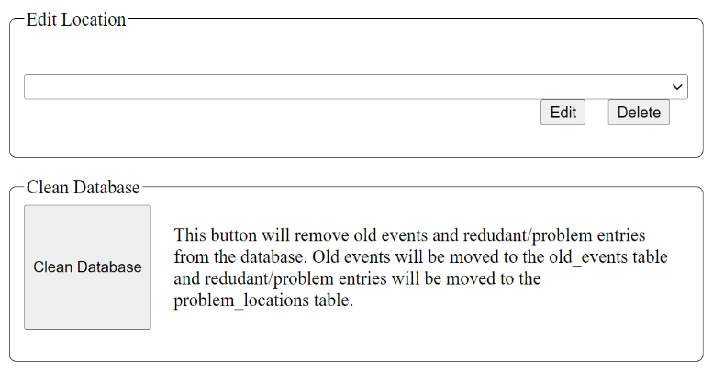

Admin Panel – this section provides the admin with shortcuts to the various sections. Shortcuts are represented by buttons.

Add Location – this section is utilized by the admin to add new data points into the database.

Edit Location – this section is used to edit and delete existing points from the database.

Clean Database – this section is used to initiate the database cleaner. The database cleaner will remove events that are of a past date, and it will also remove pins that are not located within the city of Orlando.

# Adding a New Entry

To add an entry, the admin must add the Location Name, Location Address, Thumbnail, Website Link, Event Date (if applicable), Pillar, Subpillar, and Content.

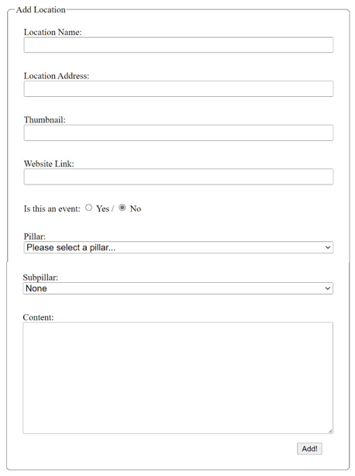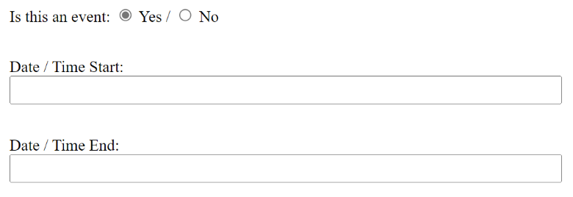

The Location Name can be virtually any format.

The Location Address must be in the following format: STREET ADDRESS, CITY, STATE ZIP CODE.

Location Address example: 1918 W Princeton St, Orlando, FL 32804

The Thumbnail should be the link to the image. The link should be a URL, for example: <https://google/image/test.png>

The Event Date is required if the data point is an event. Selecting Yes, will trigger the date selection interface to open. Specifying that the data point is an event and then selecting the date of the event is how the system identifies it as an event. A location without a date is simply a location. A location with a date is an event.

The admin should then select the Pillar and the corresponding Subpillar.

The admin must then add the content of the data point. The format of the content should be a single line.

Finally, the admin must press the Button. If the entry has no errors, the entry should be added to the database very quickly, and the page will refresh. If an error has occurred, then the page will not refresh.

# Deleting an Entry

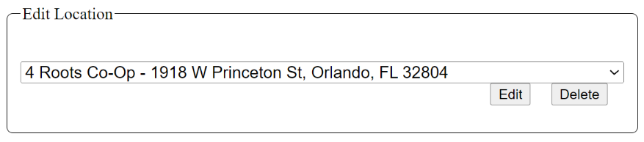The admin must navigate to the Edit Location section. Deleting an entry requires the admin to first find the entry to delete. It should be observed that the entries are organized first in numerical (0-9) order and then in alphabetical (a-z) order. For quick searching the admin should press the key that corresponds to the first initial of the data entry.

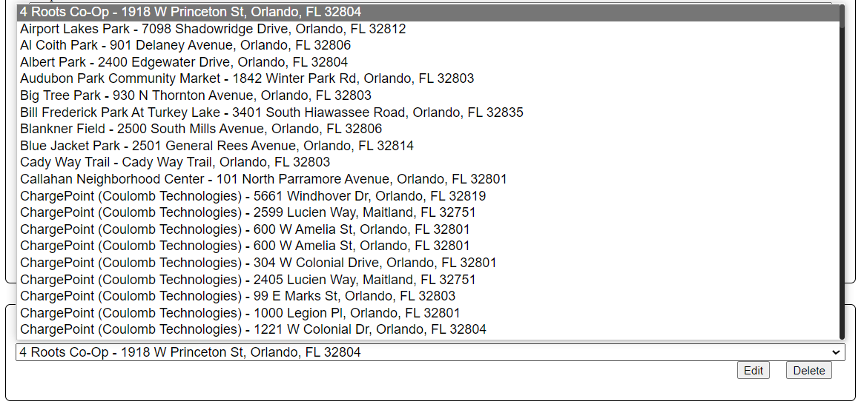

Finally, the admin may click the button and the entry will be deleted. This operation should be performed almost instantly.

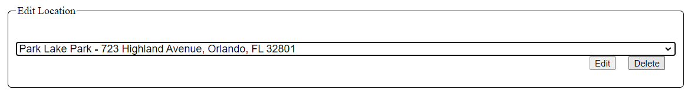

# Editing an Entry

This section is most likely to be used by an admin for the purpose of conducting grammatical corrections.

The admin must navigate to the Edit Location section. Editing an entry requires the admin to first find the entry to edit. It should be observed that the entries are organized first in numerical (0-9) order and then in alphabetical (a-z) order. For quick searching the admin should press the key that corresponds to the first initial of the data entry.

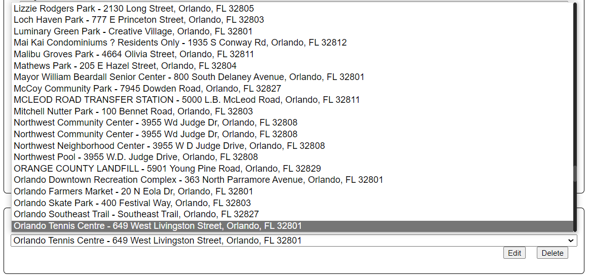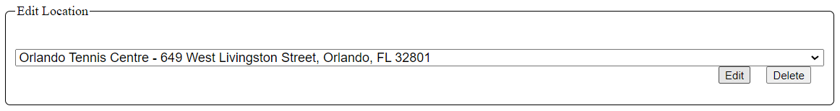

After the admin selects the entry that has been targeted for editing, the admin will press the button. When the edit button is pressed, the page will reload to an expanded Edit Location section. This behavior should be almost instant.

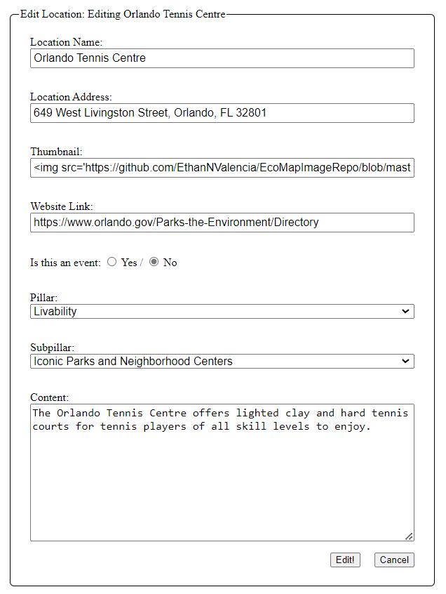The expanded Edit Location section will look like the Add Location section, except the fields will all be populated.

The admin should verify that the section name is the correct name. The admin should visually verify that the data set is the correct data set. If the data set is not the data set the admin intended to edit, then the admin should click the button.

From here, the admin may modify any of the fields. When the admin has finished implementing their changes, the admin will click the button to have the changes saved.

# Initiating a Database Clean

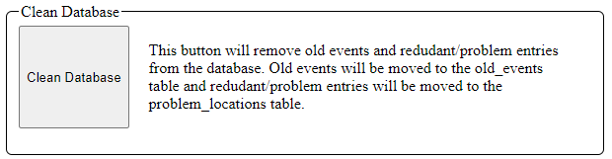The final feature of the admin board is the Clean Database section. This section is used to remove data points that are not useful on the front-end of the application. It will remove redundant data points, old events, and entries that do not have an Orlando-based address. This is an action that must be done manually. The system will not outright delete any data, but rather it will move problem data to another area in the database. The database clean is initiated by clicking the button. This action will likely take a few seconds to complete.

What are redundant data points? Redundant data points are data points that exist in the same location on the map.

What are old events? Old events are data points with a date that has passed the current date. For example, if the event happened yesterday, it is an old event.

What is an Orlando-based address? An Orlando based address is a full address that explicitly has Orlando in its name.