**­­SOFTWARE DESIGN DOCUMENT**

**Design Team**

Matthew Droege

Will Purviance

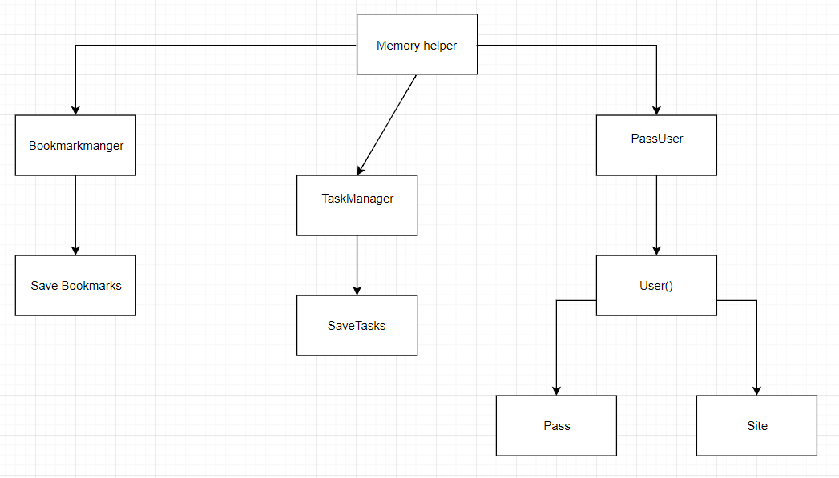**Class Diagrams**

This diagram sets up the most basic classes we intend to use in the development of the web application. Sets up the initial tabs planned of bookmarkmanager, passUser and taskManager.

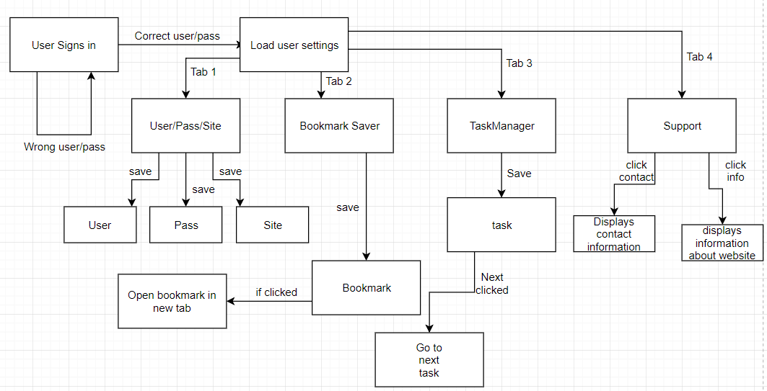**State Diagrams**

**Activity Diagrams**

This diagram shows the plan for the application and how each part of it will run. It shows the process used to access each class and keep and what id planned to be saved in the database.

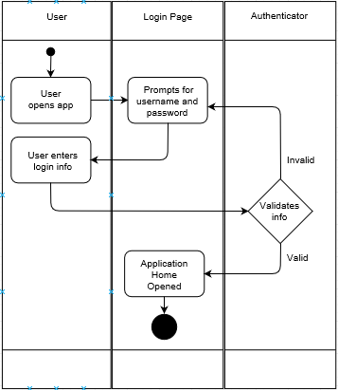Login Diagram:

# Save pass/user diagram:

The pass/user diagram shows the plan for saving information for external sites to keep track of your passwords/usernames.

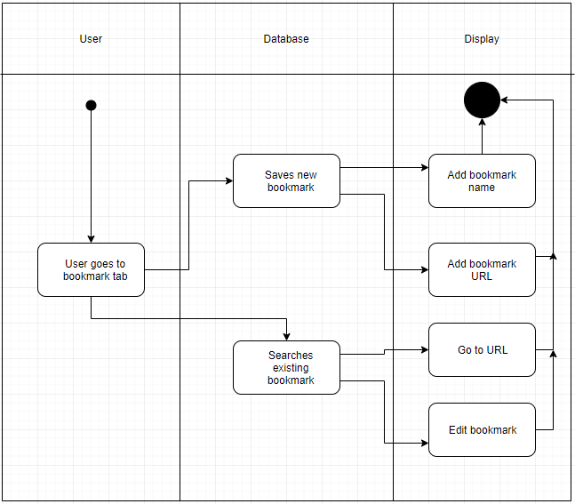Bookmark diagram:

# Task manager Diagram: