**­­SOFTWARE DESIGN DOCUMENT**

**Design Team**

Matthew Droege

Will Purviance

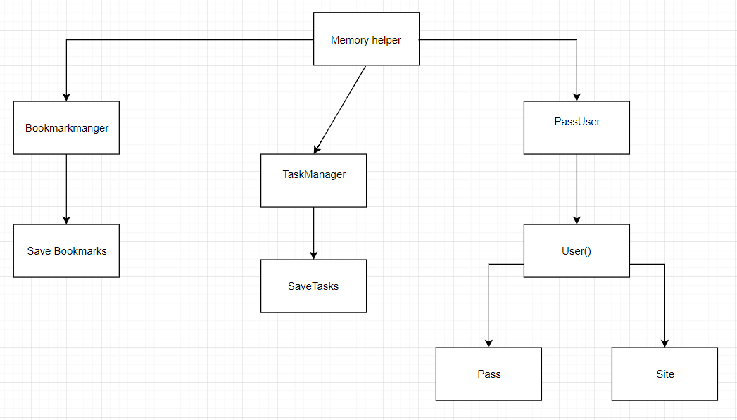**Class Diagrams**

Diagram 1: The above diagram outlines basic classes for the application ‘Egnog’. It displays the initial tabs/pages to be implemented, including: bookmarkmanager, passUser and taskManager.

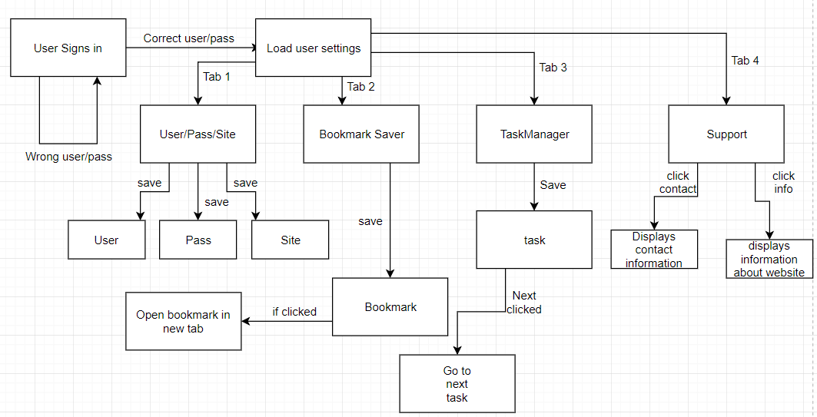**State Diagram**

**Activity Diagrams**

Diagram 2: This diagram outlines Egnog’s basic functionality, listing each state. It shows the process used to access each class.

**Activity Diagrams:**

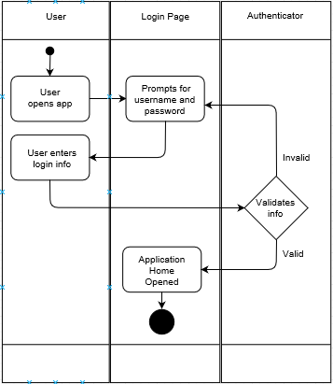Login Diagram:

Diagram 3: Activity Diagram displaying the user interaction with the password manager.

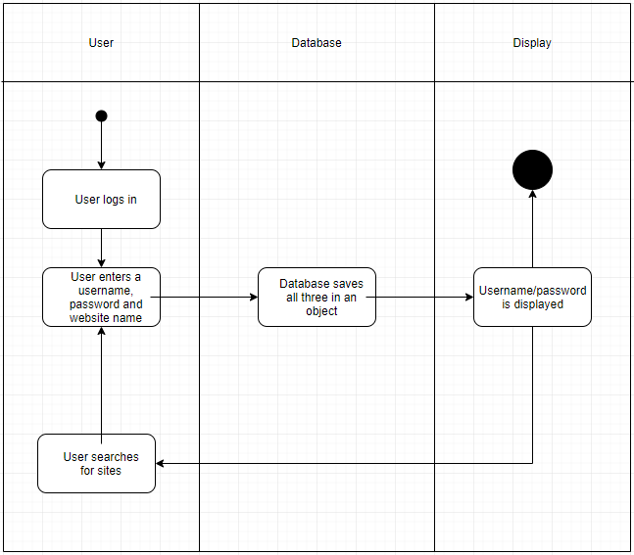Save pass/user diagram:

Diagram 4: Activity diagram for saving information to keep track of the user’s passwords/usernames.

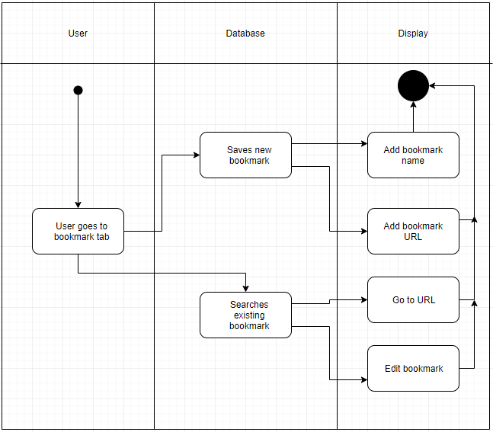Bookmark diagram:

Diagram 5: Displays user activity when managing bookmarks.

# Task manager Diagram:

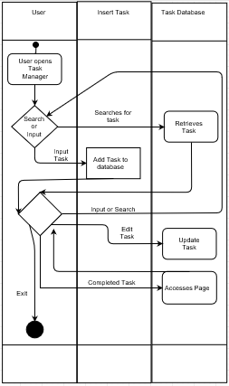

Diagram 6: Displays user activity when utilizing the password manager functionality in Egnog.