Chemotherapy results

### Results table 1. Meta-analysis summaries for percent treated with chemotherapy in the first year post-diagnosis, overall and by site (all patients).

These results are not adjusted for sex, age, cancer site, or any other variable. See also Appendix D.

| Cancer site | Average treatment % | (95% confidence interval) | 95% prediction interval * | *Tau*, log-odds scale ** | *I2* *** | Observed jurisdictional range |
| --- | --- | --- | --- | --- | --- | --- |
| All 8 cancers | 34.7% | (30.9%, 38.7%) | 22.0%-50.0% | 0.266 | 99.9 | 28.1%-43.9% |
| Oesophageal | 47.2% | (44.0%, 50.4%) | 34.9%-59.8% | 0.229 | 96.4 | 34.6%-66.0% |
| Stomach | 39.6% | (35.9%, 43.4%) | 25.7%-55.5% | 0.288 | 98.0 | 28.7%-50.2% |
| Colon | 29.8% | (26.8%, 33.0%) | 19.4%-43.0% | 0.248 | 99.4 | 20.2%-38.2% |
| Colon, stage III | 60.1% | (54.3%, 65.6%) | 38.5%-78.4% | 0.376 | 99.0 | 46.2%-71.2% |
| Rectal | 39.0% | (33.0%, 45.2%) | 19.2%-63.2% | 0.430 | 99.5 | 23.7%-53.3% |
| Liver | 16.5% | (11.5%, 23.1%) | 4.0%-48.3% | 0.663 | 99.4 | 6.6%-33.1% |
| Pancreatic | 34.1% | (29.4%, 39.2%) | 17.2%-56.3% | 0.411 | 99.2 | 24.4%-52.0% |
| Lung | 31.4% | (27.7%, 35.3%) | 17.9%-49.0% | 0.334 | 99.7 | 22.9%-45.3% |
| Ovarian | 66.4% | (61.8%, 70.7%) | 47.5%-81.2% | 0.345 | 98.5 | 48.7%-75.3% |
| Age 15-64 | 52.0% | (49.2%, 54.9%) | 41.9%-62.0% | 0.171 | 99.2 | 44.5%-58.3% |
| Age 65-74 | 40.4% | (36.0%, 44.9%) | 25.6%-57.2% | 0.284 | 99.7 | 32.2%-49.9% |
| Age 75-84 | 20.1% | (16.0%, 24.9%) | 8.4%-40.7% | 0.421 | 99.8 | 13.1%-31.7% |
| Age 85-99 | 3.3% | (1.7%, 6.3%) | 0.3%-26.7% | 0.987 | 99.7 | 0.0%-14.0% |
| Men | 34.5% | (30.6%, 38.5%) | 21.8%-49.9% | 0.268 | 99.8 | 28.1%-43.7% |
| Women | 34.9% | (31.1%, 38.9%) | 22.2%-50.1% | 0.263 | 99.8 | 28.1%-44.2% |

*the prediction interval shows the range we would expect 95% of new jurisdictions to fall into, and incorporates both the uncertainty around the overall average and the spread of the included jurisdictions

**Tau is the estimated standard deviation of the included jurisdictional estimates, directly measuring the spread of jurisdictions

*** I2 measures the proportion of total variation not due to sampling variation

### Results table 2. Meta-analysis summaries for jurisdiction-specific associations with chemotherapy use.

Results are mutually adjusted for all variables shown (sex, age group, cancer site) and diagnosis year

|  | Average odds ratio | (95% confidence interval) | 95% prediction interval * | *Tau*, log-odds scale ** | *I2* *** | Observed jurisdictional range |
| --- | --- | --- | --- | --- | --- | --- |
| Women vs Men | 0.97 | (0.95, 1.00) | 0.89-1.07 | 0.040 | 76.0 | 0.91-1.07 |
| 15-64 vs 65-74 | 1.54 | (1.46, 1.64) | 1.23-1.94 | 0.102 | 94.2 | 1.31-1.89 |
| 75-84 vs 65-74 | 0.37 | (0.34, 0.41) | 0.25-0.55 | 0.174 | 97.3 | 0.28-0.50 |
| 85-99 vs 65-74 | 0.05 | (0.04, 0.07) | 0.01-0.19 | 0.595 | 98.6 | 0.02-0.17 |
| Oesophageal vs Lung | 1.94 | (1.69, 2.23) | 1.11-3.39 | 0.249 | 95.8 | 1.33-3.52 |
| Stomach vs Lung | 1.55 | (1.40, 1.71) | 1.05-2.28 | 0.173 | 92.9 | 1.23-2.24 |
| Colon vs Lung | 0.95 | (0.82, 1.11) | 0.51-1.79 | 0.282 | 99.0 | 0.54-1.32 |
| Rectal vs Lung | 1.30 | (0.98, 1.72) | 0.40-4.22 | 0.530 | 99.5 | 0.31-2.74 |
| Liver vs Lung | 0.35 | (0.27, 0.45) | 0.13-0.96 | 0.447 | 98.4 | 0.15-0.67 |
| Pancreatic vs Lung | 1.20 | (1.06, 1.35) | 0.74-1.93 | 0.213 | 96.1 | 0.80-1.63 |
| Ovarian vs Lung | 3.91 | (2.93, 5.22) | 1.20-12.70 | 0.525 | 99.0 | 1.11-8.44 |

*the prediction interval shows the range we would expect 95% of new jurisdictions to fall into, and incorporates both the uncertainty around the overall average and the spread of the included jurisdictions

**Tau is the estimated standard deviation of the included jurisdictional estimates, directly measuring the spread of jurisdictions

*** I2 measures the proportion of total variation not due to sampling variation

### Results table 3. Meta-analysis summaries for time-to-starting-chemotherapy in patients who received chemotherapy, overall and by site (median-of-medians method, see McGrath 2020).

See also Appendices E and F.

| Cancer site | Average days-to-treatment | (95% confidence interval) | 95% prediction interval * | *Tau*, natural scale (days) ** | *I2* *** | Observed jurisdictional range |
| --- | --- | --- | --- | --- | --- | --- |
| All 8 cancers | 53.5 | (47.8, 59.3) | 32.6-74.5 | 8.8 | 99.9 | 39.0-65.0 |
| Oesophageal | 55.7 | (49.7, 61.7) | 30.9-80.6 | 11.2 | 99.4 | 34.0-71.0 |
| Stomach | 51.3 | (45.7, 56.9) | 28.4-74.2 | 10.3 | 99.0 | 31.0-67.0 |
| Colon | 76.6 | (67.1, 86.0) | 40.2-112.9 | 15.8 | 99.8 | 55.0-113.0 |
| Rectal | 85.6 | (59.4, 111.7) | -15.5-186.6 | 43.9 | 99.9 | 47.0-167.5 |
| Liver | 57.0 | (48.4, 65.7) | 27.0-87.1 | 12.8 | 94.9 | 40.5-84.0 |
| Pancreatic | 50.6 | (44.2, 57.0) | 24.2-77.0 | 11.9 | 98.9 | 28.0-74.0 |
| Lung | 44.5 | (39.2, 49.9) | 22.1-67.0 | 10.1 | 99.7 | 27.0-66.0 |
| Ovarian | 38.0 | (32.7, 43.3) | 16.8-59.2 | 9.3 | 99.5 | 28.0-62.0 |

*the prediction interval shows the range we would expect 95% of new jurisdictions to fall into, and incorporates both the uncertainty around the overall average and the spread of the included jurisdictions

**Tau is the estimated standard deviation of the included jurisdictional estimates, directly measuring the spread of jurisdictions

*** I2 measures the proportion of total variation not due to sampling variation

### Results table 4. Meta-analysis summary for differences in median time-to-starting-chemotherapy in patients who received chemotherapy by sex, age group and cancer site.

Results are mutually adjusted for all variables shown (sex, age group, cancer site) and diagnosis year

|  | Difference in median days-to-treatment | (95% confidence interval) | 95% prediction interval * | *Tau*, natural scale (days) ** | *I2* *** | Observed jurisdictional range |
| --- | --- | --- | --- | --- | --- | --- |
| Women vs Men | -0.4 | (-0.9, 0.0) | -1.2-0.4 | 0.3 | 12.9 | -1.5-5.5 |
| 15-64 vs 65-74 | -2.2 | (-2.8, -1.6) | -3.9--0.6 | 0.7 | 54.7 | -3.7-0.5 |
| 75-84 vs 65-74 | -0.1 | (-0.5, 0.3) | -0.7-0.4 | 0.2 | 2.6 | -3.5-6.0 |
| 85-99 vs 65-74 | -3.7 | (-5.6, -1.8) | -7.6-0.1 | 1.5 | 20.5 | -9.5-36.5 |
| Oesophageal vs Lung | 11.3 | (7.0, 15.5) | -5.8-28.4 | 7.7 | 97.7 | -1.0-33.1 |
| Stomach vs Lung | 7.7 | (3.6, 11.7) | -8.4-23.8 | 7.2 | 97.1 | -6.0-19.0 |
| Colon vs Lung | 31.6 | (26.1, 37.1) | 8.9-54.3 | 10.2 | 99.1 | 18.0-55.5 |
| Rectal vs Lung | 35.1 | (16.6, 53.5) | -42.1-112.3 | 34.7 | 99.9 | 2.0-122.1 |
| Liver vs Lung | 14.1 | (8.8, 19.5) | -5.0-33.3 | 8.4 | 89.7 | -11.2-36.3 |
| Pancreatic vs Lung | 6.3 | (1.0, 11.7) | -15.5-28.2 | 9.8 | 98.1 | -10.0-25.5 |
| Ovarian vs Lung | -4.2 | (-11.0, 2.6) | -31.9-23.5 | 12.3 | 99.2 | -24.0-14.5 |

*the prediction interval shows the range we would expect 95% of new jurisdictions to fall into, and incorporates both the uncertainty around the overall average and the spread of the included jurisdictions

**Tau is the estimated standard deviation of the included jurisdictional estimates, directly measuring the spread of jurisdictions

*** I2 measures the proportion of total variation not due to sampling variation

### Results figure 1. Overall crude proportion of patients treated by chemotherapy in each jurisdiction, by cancer site.

When estimating treatment proportion for stage 3 colon cancer in New South Wales, ‘Regional spread (lymph nodes)’ was viewed as corresponding to TNM 3. Estimates for Norway are not shown as ‘Regional’ could correspond to either TNM 2 or TNM 3.

Black circles show jurisdictional proportions, and black lines the associated confidence interval.

Grey diamonds show the meta-analysis estimate and its confidence intervals. Wider grey lines show the associated prediction interval.

Estimates not included in producing meta-analysis estimates are shown as hollow light grey circles.

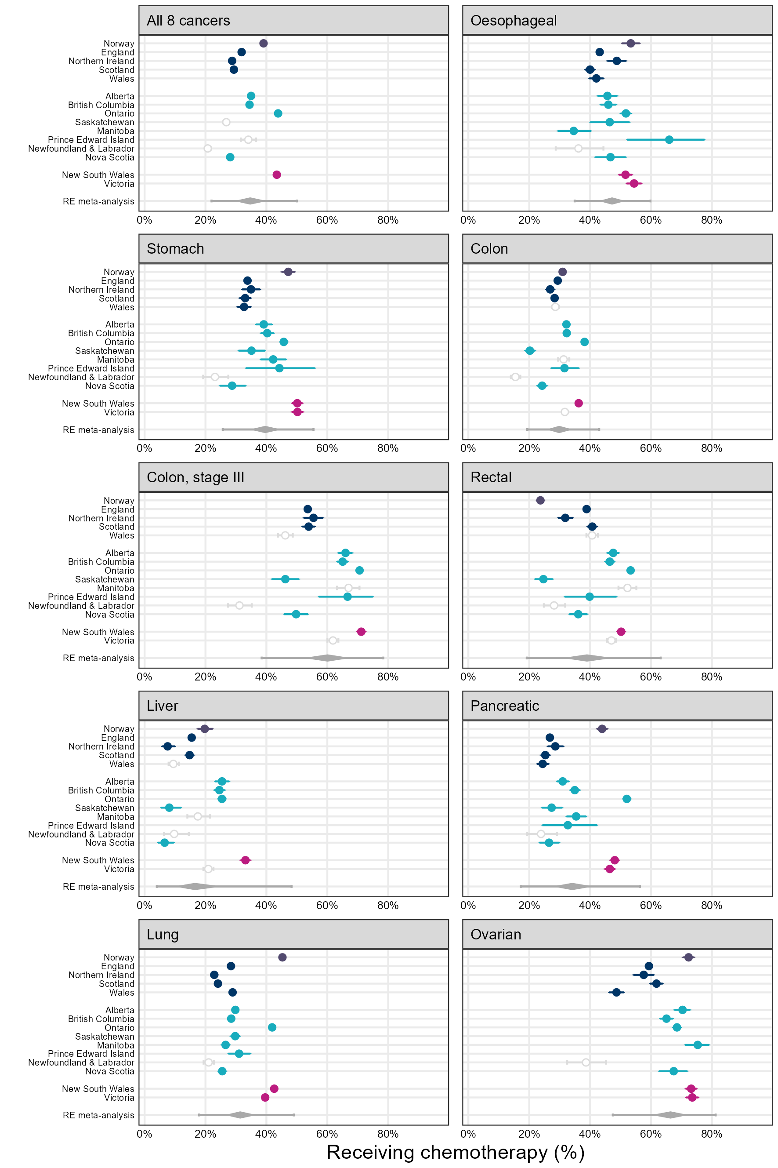

#### Results figure 1 - appendix version 1. Overall crude proportion of patients treated by chemotherapy for each cancer site, by jurisdiction.

When estimating treatment proportion for stage 3 colon cancer in New South Wales, ‘Regional spread (lymph nodes)’ was viewed as corresponding to TNM 3. Estimates for Norway are not shown as ‘Regional’ could correspond to either TNM 2 or TNM 3.

Black circles show jurisdictional proportions, and black lines the associated confidence interval.

Grey diamonds show the meta-analysis estimate and its confidence intervals. Wider grey lines show the associated prediction interval.

Estimates not included in producing meta-analysis estimates are shown as hollow light grey circles.

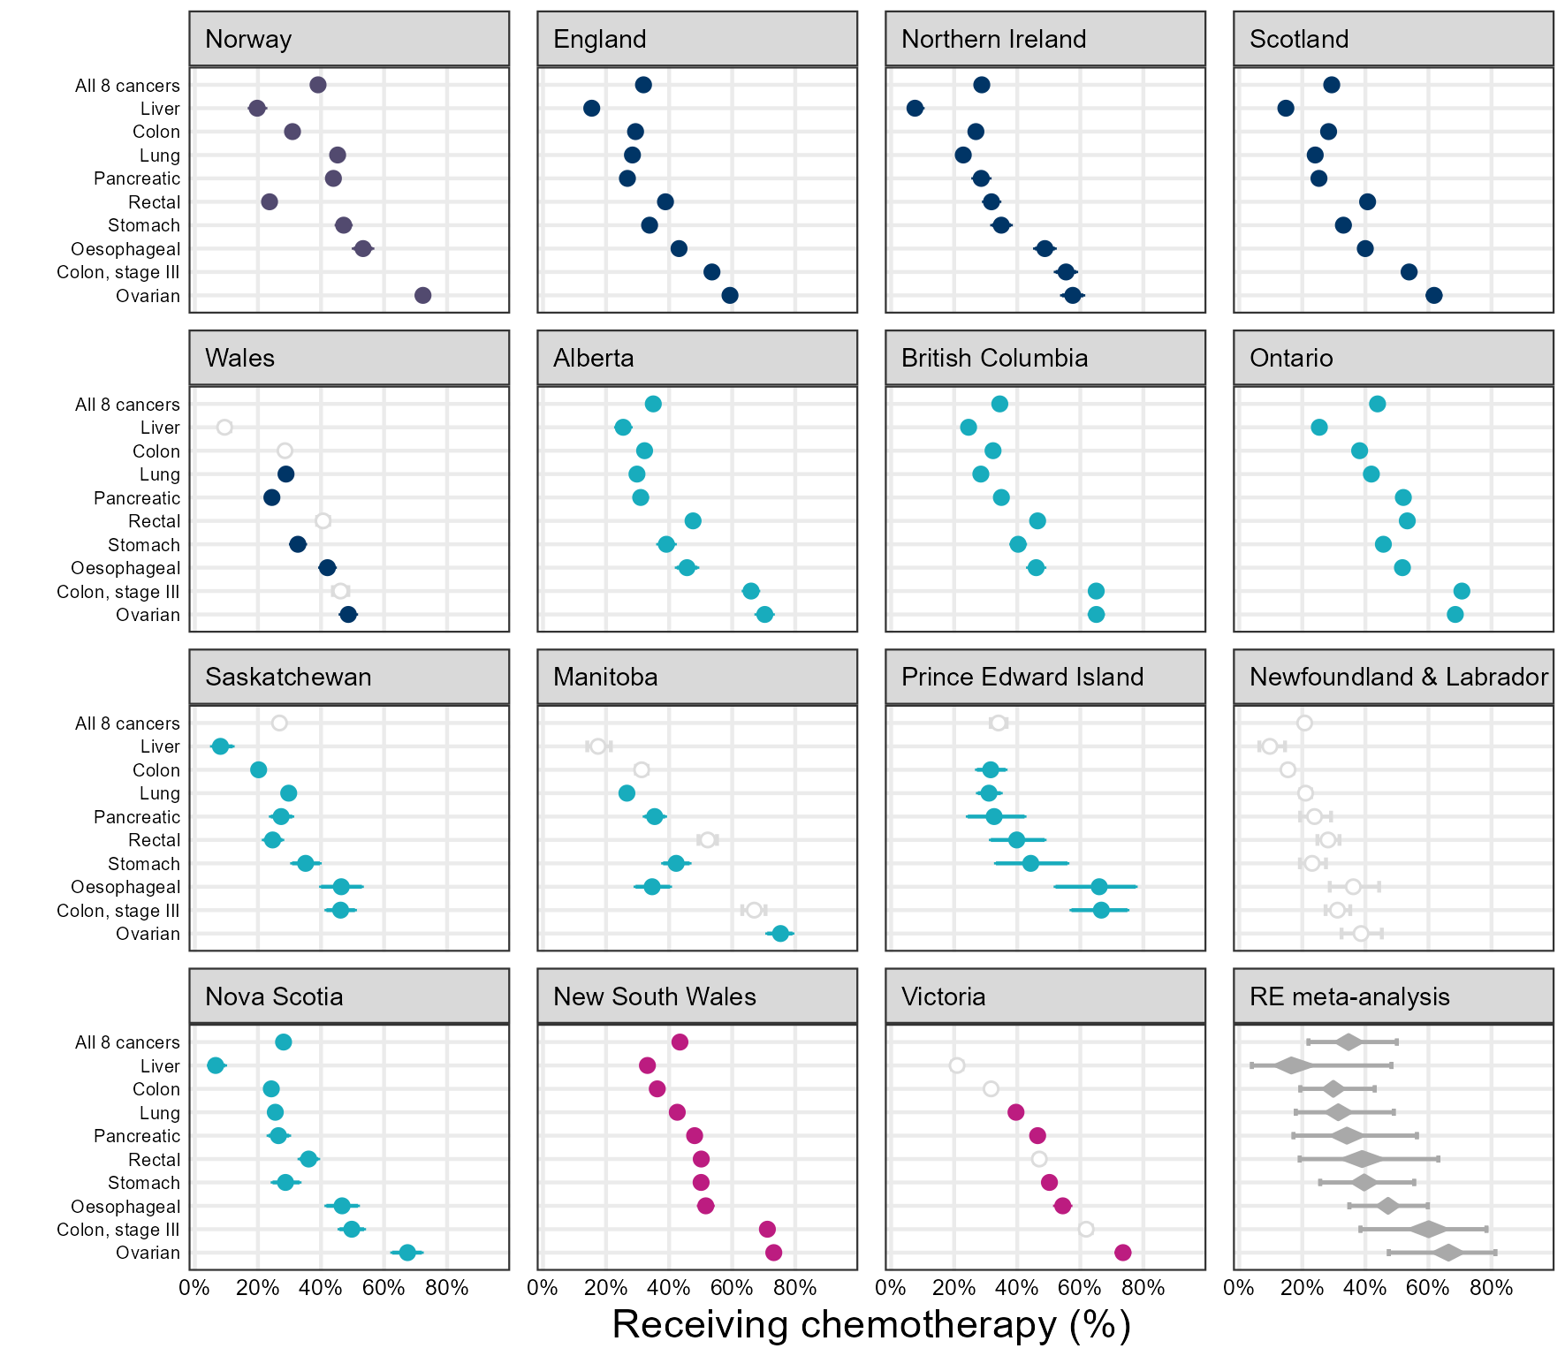

#### Results figure 1 - appendix version 2. Proportions of patients treated by chemotherapy in the first year post-diagnosis (y axis) plotted as a continuous line by cancer site (x-axis).

When estimating treatment proportion for stage 3 colon cancer in New South Wales, ‘Regional spread (lymph nodes)’ was viewed as corresponding to TNM 3. Estimates for Norway are not shown as ‘Regional’ could correspond to either TNM 2 or TNM 3.

In each figure panel, the jurisdiction-specific estimate is shown in bold black line, whereas all other jurisdiction lines are shown in grey. Cancer sites on the x-axis appear in order of increasing chemotherapy use across the total analysis sample comprising all jurisdictions.

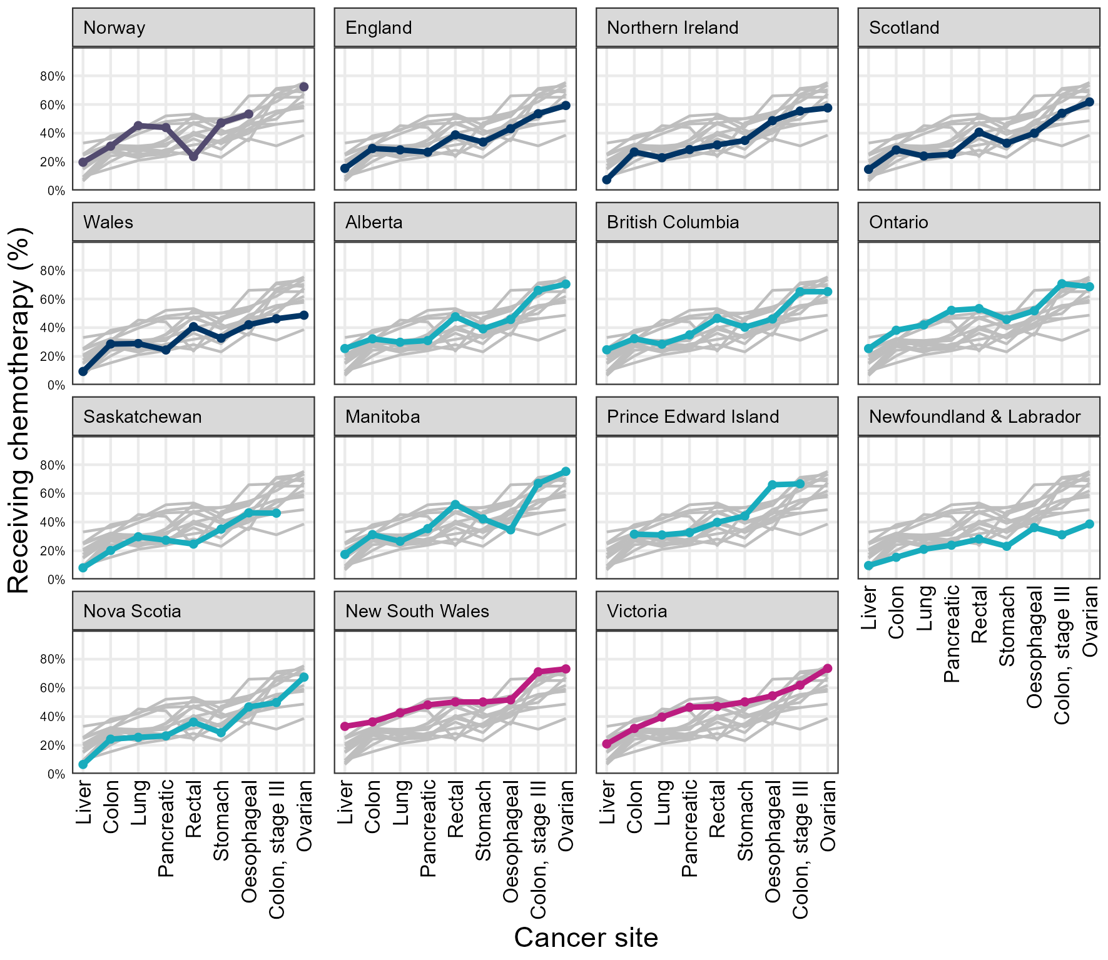

### Results figure 2. Variation in use of chemotherapy by sex and age group, by jurisdiction (black dots).

Results are mutually adjusted for all variables shown (sex, age group, cancer site). Black circles show jurisdictional odds ratios, and black lines the associated confidence interval.

White circle estimates are adjusted for stage at diagnosis are only shown for jurisdictions with >70% completeness of information on stage at diagnosis for each of the 8 cancer sites. These adjust for stage categories used by the jurisdiction including a missing stage indicator (TNM 1, 2, 3, 4, and missing, except for New South Wales where the categories were Localised, Regional (adjacent organs), Regional (lymph nodes), Distant, and missing).

Grey diamonds show the meta-analysis estimate and its confidence intervals. Wider grey lines show the associated prediction interval.

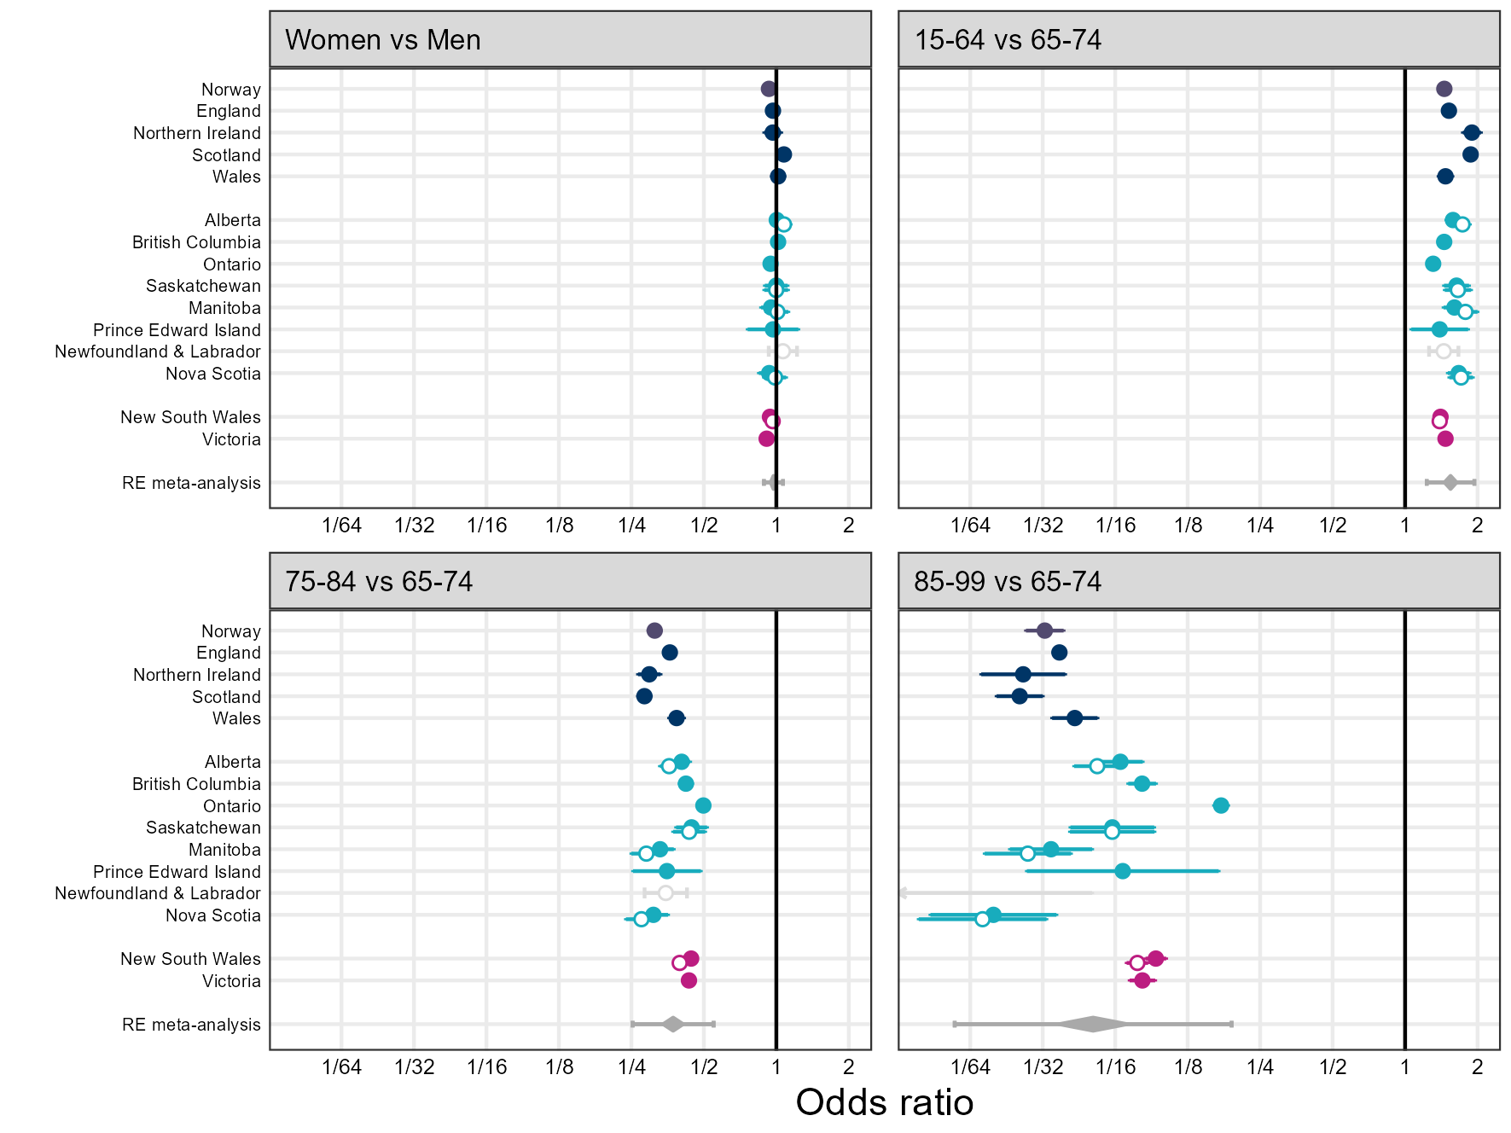

### Results figure 3. Median time-to-first chemotherapy course and inter-quartile range for each jurisdiction, by cancer site.

Highly uncertain estimates have been suppressed from the plot but were included in meta-analysis.

Black circles show medians and black lines show inter-quartile ranges.

Grey diamonds show the meta-analysis estimate and its confidence intervals. Wider grey lines show the associated prediction interval.

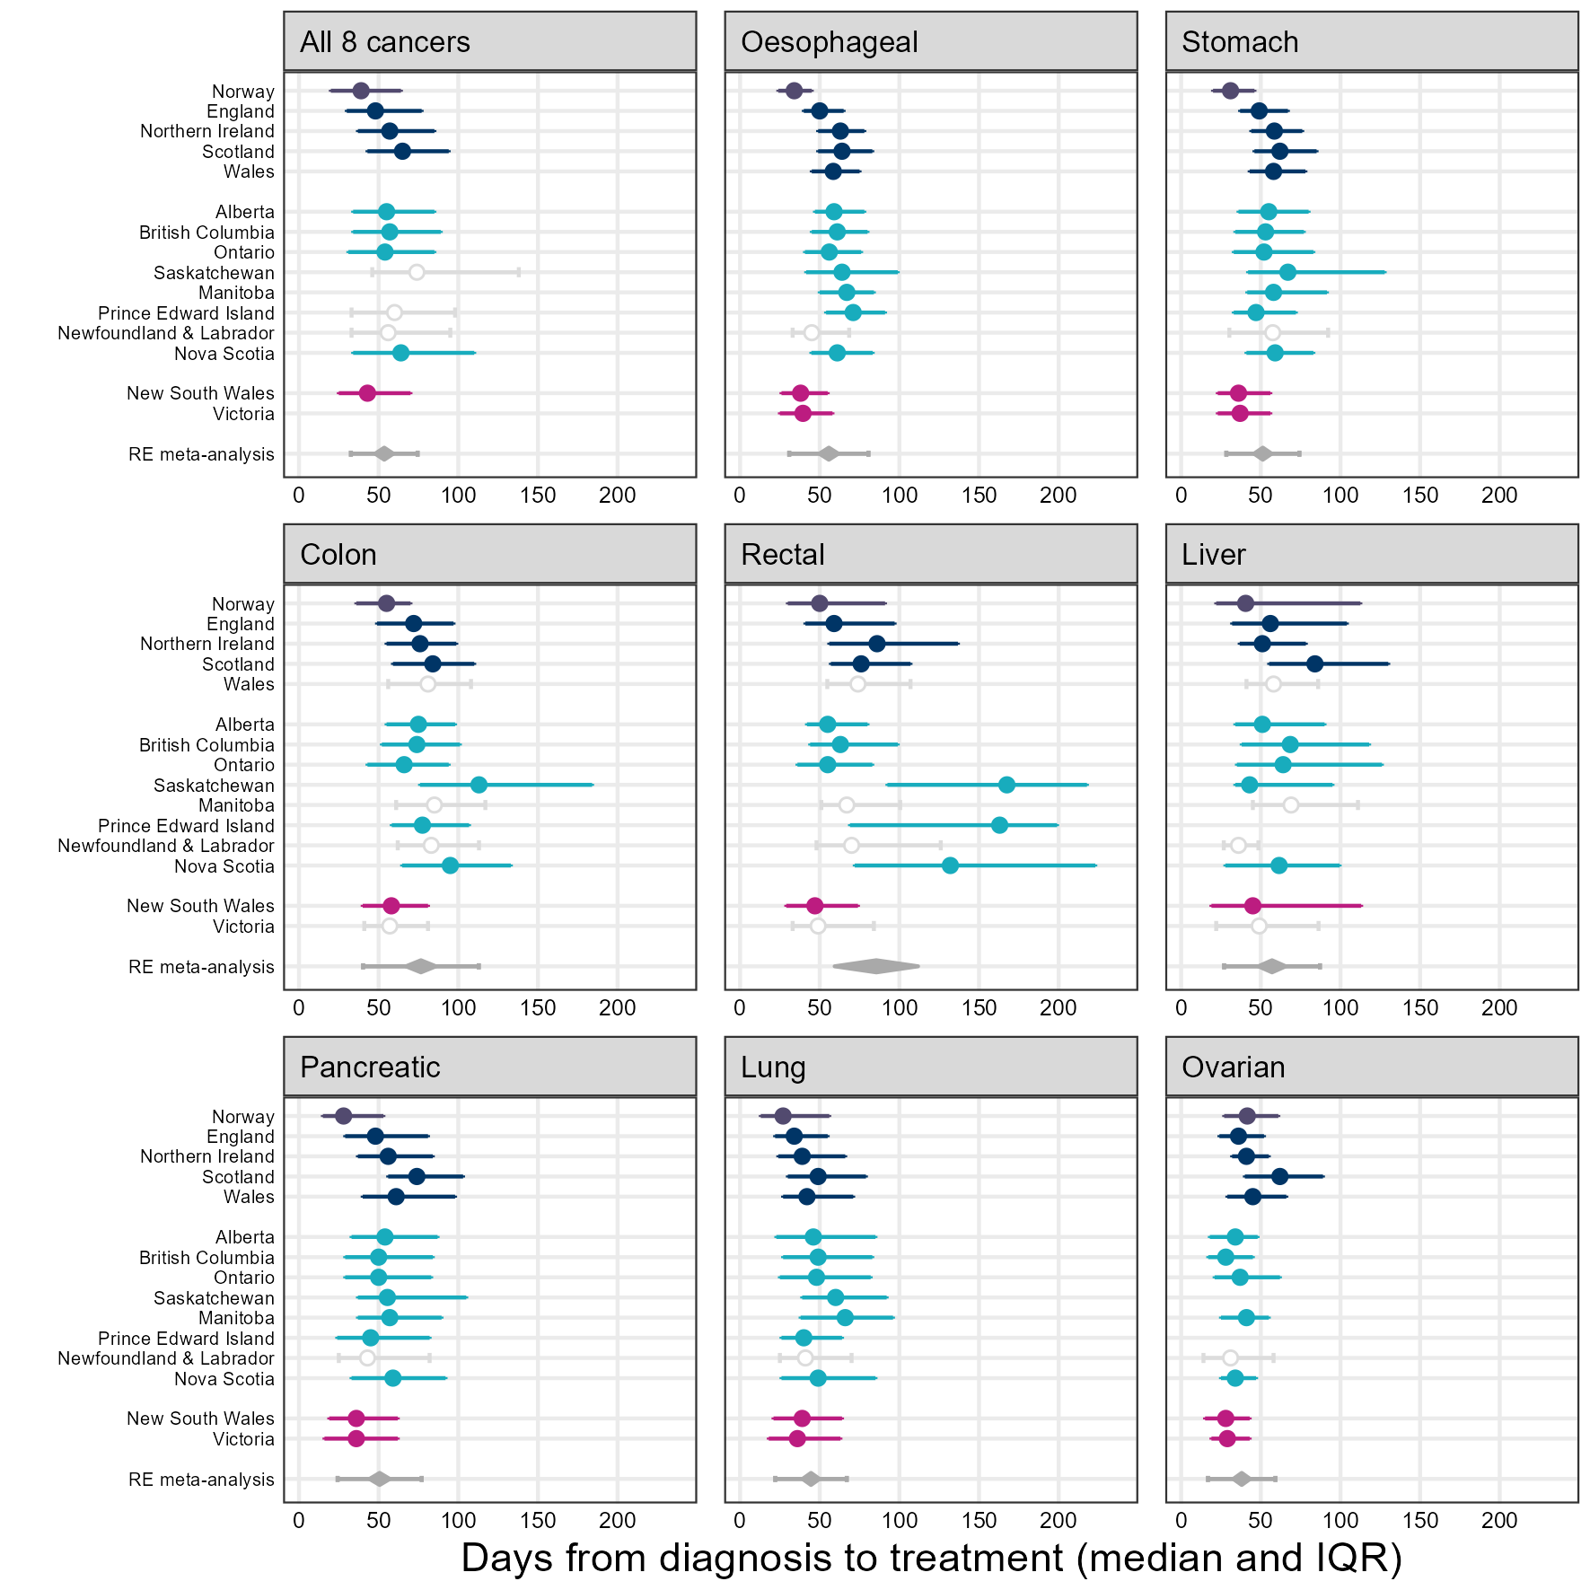

#### Results figure 3 - appendix version. Median time-to-first chemotherapy course and inter-quartile range for each cancer site, by jurisdiction.

Highly uncertain estimates have been suppressed from the plot but were included in meta-analysis.

Black circles show medians and black lines show inter-quartile ranges.

Grey diamonds show the meta-analysis estimate and its confidence intervals. Wider grey lines show the associated prediction interval.

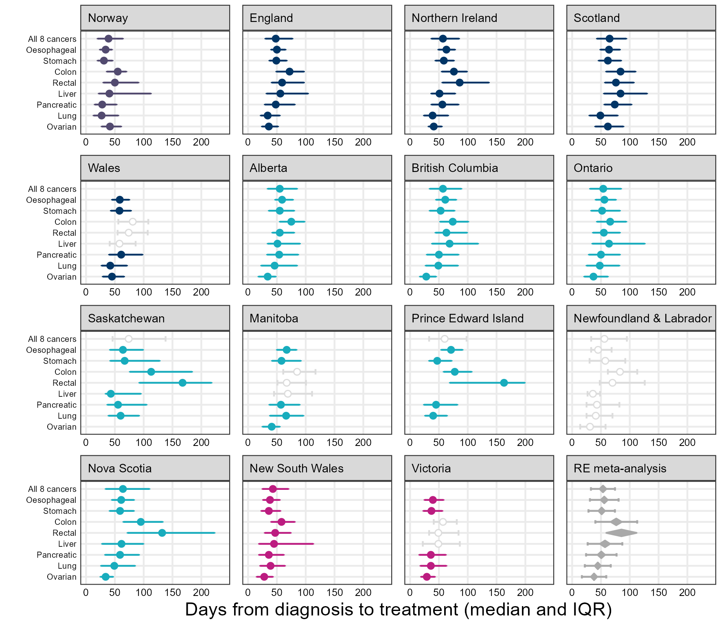

### Results figure 4. Estimated differences in median-time-to-treatment by sex and age, from quantile regression.

Highly uncertain estimates have been suppressed from the plot but were included in meta-analysis.

Black circles show median differences and black lines show 95% confidence intervals.

Grey diamonds show the meta-analysis estimate and its confidence intervals. Wider grey lines show the associated prediction interval.

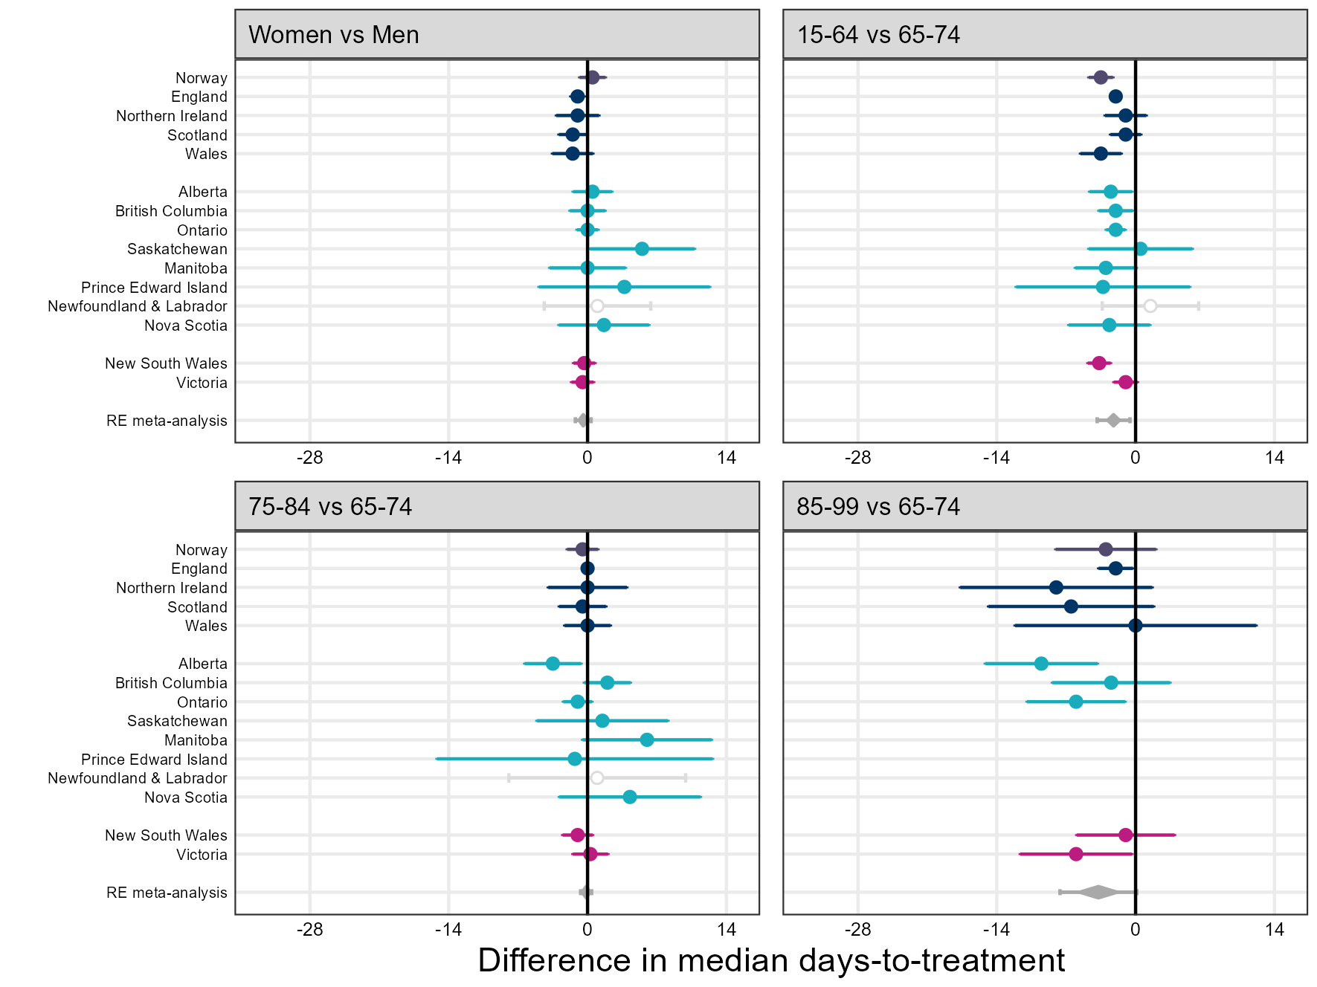

### Results figure 5 / appendix. Meta-analysis estimates of average use vs meta-analysis estimates of median time-to-treatment.

No clear association between time-to-treatment and use.

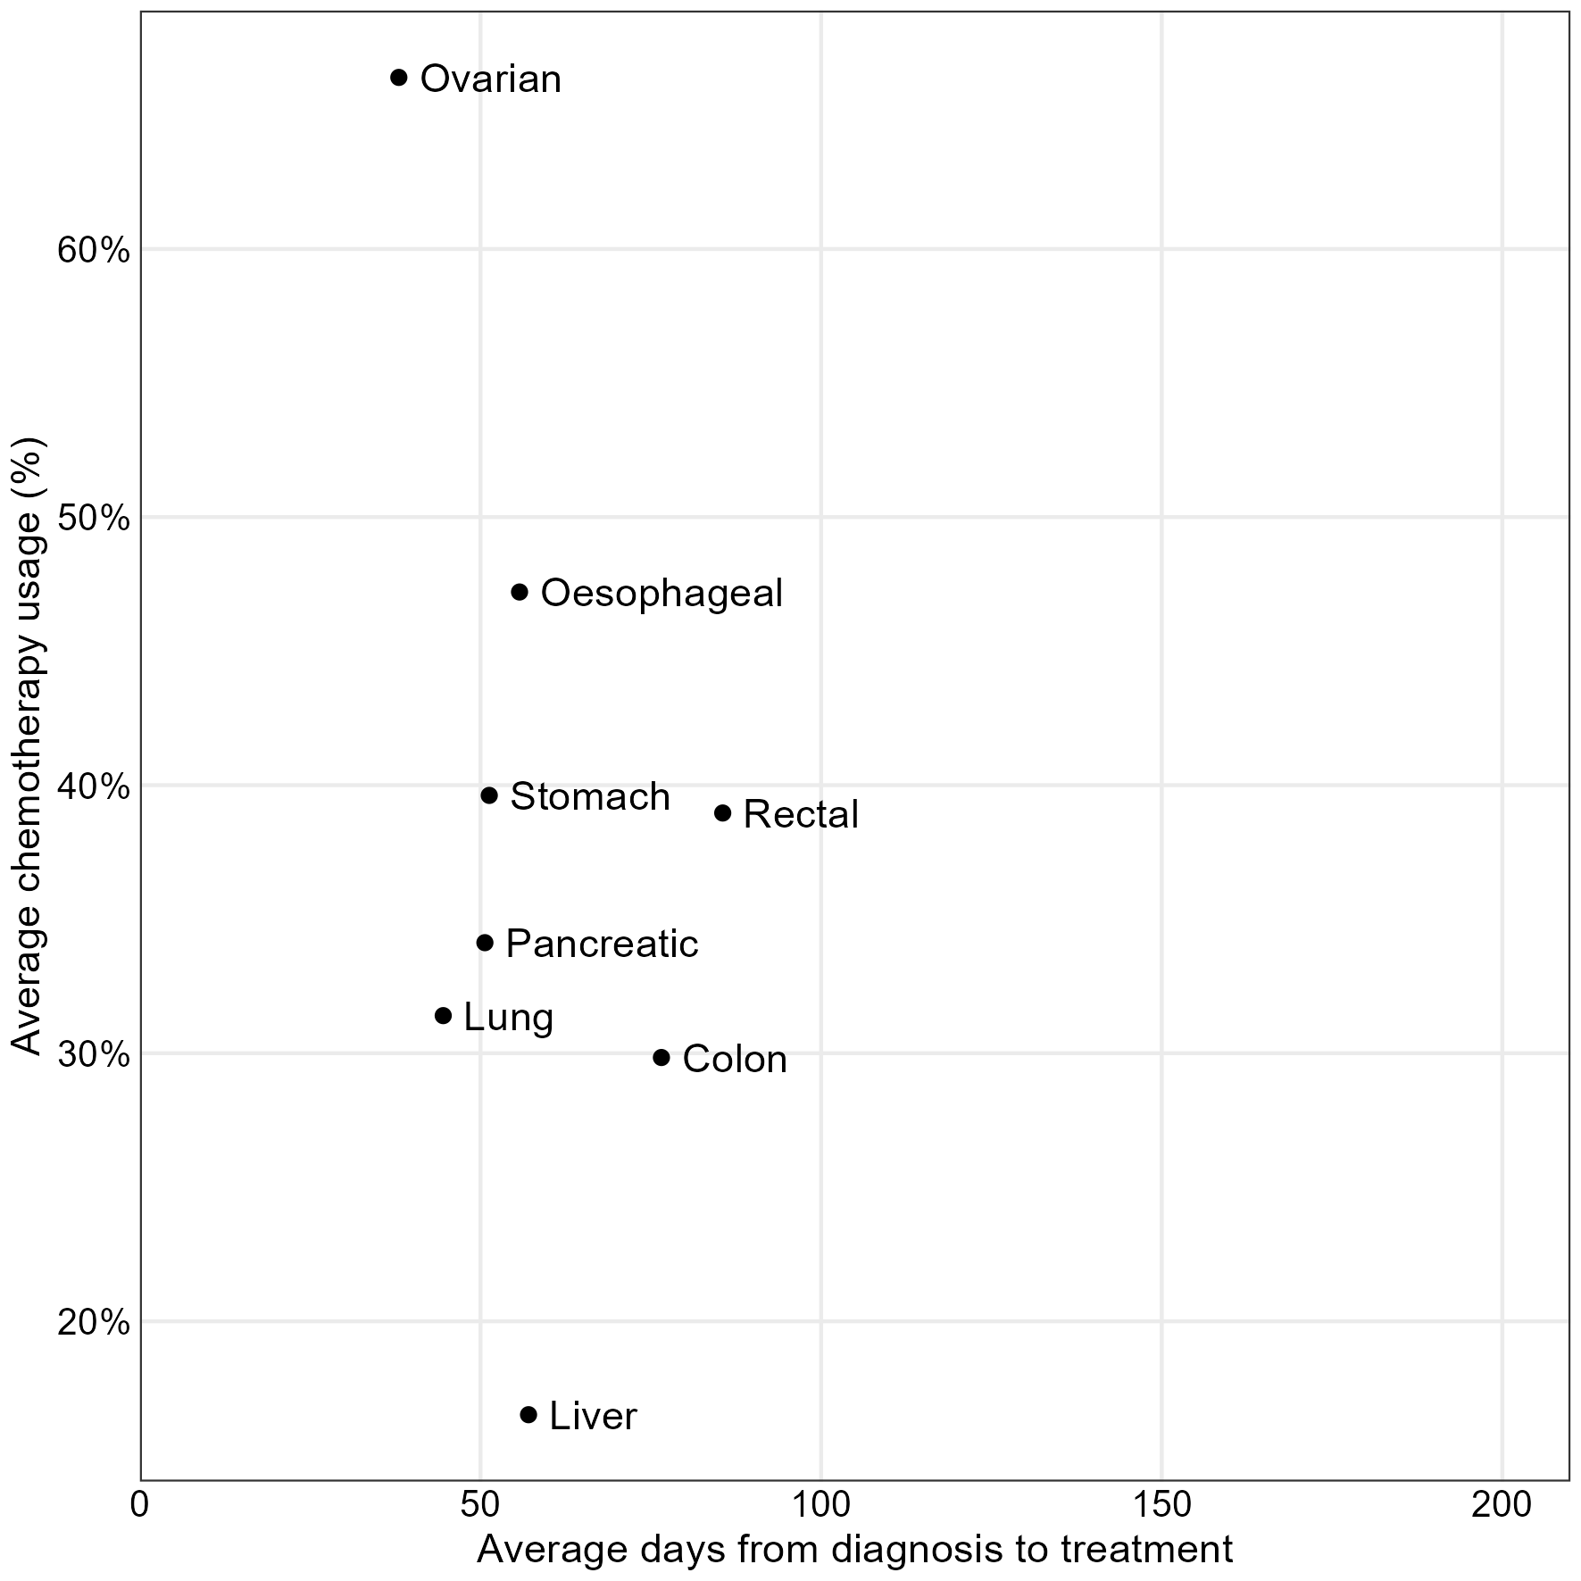

## Data appendices

### Data appendix 1. Overall proportions treated in each jurisdiciton.

| Jurisdiction | Patients | Received chemotherapy | Average treatment % | (95% confidence interval) |
| --- | --- | --- | --- | --- |
| All 8 cancers | | | | |
| Norway | 37,185 | 14,527 | 39.1% | (38.6%, 39.6%) |
| England | 373,194 | 118,954 | 31.9% | (31.7%, 32.0%) |
| Northern Ireland | 15,501 | 4,457 | 28.8% | (28.0%, 29.5%) |
| Scotland | 45,027 | 13,207 | 29.3% | (28.9%, 29.8%) |
| Alberta | 25,093 | 8,777 | 35.0% | (34.4%, 35.6%) |
| British Columbia | 40,064 | 13,808 | 34.5% | (34.0%, 34.9%) |
| Ontario | 92,447 | 40,546 | 43.9% | (43.5%, 44.2%) |
| Saskatchewan | 8,220 | 2,206 | 26.8% | (25.9%, 27.8%) |
| Prince Edward Island | 1,365 | 465 | 34.1% | (31.6%, 36.6%) |
| Newfoundland & Labrador | 6,160 | 1,278 | 20.7% | (19.8%, 21.8%) |
| Nova Scotia | 10,130 | 2,849 | 28.1% | (27.3%, 29.0%) |
| New South Wales | 53,198 | 23,101 | 43.4% | (43.0%, 43.8%) |
| Oesophageal | | | | |
| Norway | 1,089 | 581 | 53.4% | (50.4%, 56.3%) |
| England | 27,274 | 11,766 | 43.1% | (42.6%, 43.7%) |
| Northern Ireland | 972 | 474 | 48.8% | (45.6%, 51.9%) |
| Scotland | 3,377 | 1,350 | 40.0% | (38.3%, 41.6%) |
| Wales | 1,703 | 716 | 42.0% | (39.7%, 44.4%) |
| Alberta | 889 | 406 | 45.7% | (42.4%, 49.0%) |
| British Columbia | 1,398 | 643 | 46.0% | (43.4%, 48.6%) |
| Ontario | 3,099 | 1,604 | 51.8% | (50.0%, 53.5%) |
| Saskatchewan | 224 | 104 | 46.4% | (40.0%, 53.0%) |
| Manitoba | 286 | 99 | 34.6% | (29.3%, 40.3%) |
| Prince Edward Island | 50 | 33 | 66.0% | (52.2%, 77.6%) |
| Newfoundland & Labrador | 141 | 51 | 36.2% | (28.7%, 44.4%) |
| Nova Scotia | 377 | 176 | 46.7% | (41.7%, 51.7%) |
| New South Wales | 1,970 | 1,017 | 51.6% | (49.4%, 53.8%) |
| Victoria | 1,576 | 858 | 54.4% | (52.0%, 56.9%) |
| Stomach | | | | |
| Norway | 1,884 | 889 | 47.2% | (44.9%, 49.4%) |
| England | 19,813 | 6,698 | 33.8% | (33.2%, 34.5%) |
| Northern Ireland | 990 | 346 | 34.9% | (32.0%, 38.0%) |
| Scotland | 2,337 | 772 | 33.0% | (31.2%, 35.0%) |
| Wales | 1,656 | 541 | 32.7% | (30.5%, 35.0%) |
| Alberta | 1,293 | 506 | 39.1% | (36.5%, 41.8%) |
| British Columbia | 1,934 | 779 | 40.3% | (38.1%, 42.5%) |
| Ontario | 6,465 | 2,955 | 45.7% | (44.5%, 46.9%) |
| Saskatchewan | 450 | 158 | 35.1% | (30.8%, 39.6%) |
| Manitoba | 528 | 223 | 42.2% | (38.1%, 46.5%) |
| Prince Edward Island | 70 | 31 | 44.3% | (33.2%, 55.9%) |
| Newfoundland & Labrador | 398 | 92 | 23.1% | (19.2%, 27.5%) |
| Nova Scotia | 428 | 123 | 28.7% | (24.7%, 33.2%) |
| New South Wales | 3,179 | 1,594 | 50.1% | (48.4%, 51.9%) |
| Victoria | 2,597 | 1,304 | 50.2% | (48.3%, 52.1%) |
| Colon | | | | |
| Norway | 12,091 | 3,744 | 31.0% | (30.1%, 31.8%) |
| England | 88,219 | 25,896 | 29.4% | (29.1%, 29.7%) |
| Northern Ireland | 3,846 | 1,034 | 26.9% | (25.5%, 28.3%) |
| Scotland | 9,599 | 2,720 | 28.3% | (27.4%, 29.2%) |
| Wales | 6,142 | 1,755 | 28.6% | (27.5%, 29.7%) |
| Alberta | 6,403 | 2,063 | 32.2% | (31.1%, 33.4%) |
| British Columbia | 10,501 | 3,394 | 32.3% | (31.4%, 33.2%) |
| Ontario | 24,481 | 9,347 | 38.2% | (37.6%, 38.8%) |
| Saskatchewan | 2,180 | 441 | 20.2% | (18.6%, 22.0%) |
| Manitoba | 2,445 | 765 | 31.3% | (29.5%, 33.2%) |
| Prince Edward Island | 399 | 126 | 31.6% | (27.2%, 36.3%) |
| Newfoundland & Labrador | 2,077 | 321 | 15.5% | (14.0%, 17.1%) |
| Nova Scotia | 2,541 | 616 | 24.2% | (22.6%, 25.9%) |
| New South Wales | 16,316 | 5,913 | 36.2% | (35.5%, 37.0%) |
| Victoria | 11,747 | 3,724 | 31.7% | (30.9%, 32.5%) |
| Colon, stage III | | | | |
| England | 21,088 | 11,300 | 53.6% | (52.9%, 54.3%) |
| Northern Ireland | 896 | 497 | 55.5% | (52.2%, 58.7%) |
| Scotland | 2,270 | 1,223 | 53.9% | (51.8%, 55.9%) |
| Wales | 1,597 | 738 | 46.2% | (43.8%, 48.7%) |
| Alberta | 1,588 | 1,048 | 66.0% | (63.6%, 68.3%) |
| British Columbia | 2,698 | 1,755 | 65.0% | (63.2%, 66.8%) |
| Ontario | 6,590 | 4,653 | 70.6% | (69.5%, 71.7%) |
| Saskatchewan | 463 | 214 | 46.2% | (41.7%, 50.8%) |
| Manitoba | 621 | 416 | 67.0% | (63.2%, 70.6%) |
| Prince Edward Island | 105 | 70 | 66.7% | (57.2%, 75.0%) |
| Newfoundland & Labrador | 536 | 167 | 31.2% | (27.4%, 35.2%) |
| Nova Scotia | 629 | 313 | 49.8% | (45.9%, 53.7%) |
| New South Wales | 3,690 | 2,626 | 71.2% | (69.7%, 72.6%) |
| Victoria | 2,800 | 1,732 | 61.9% | (60.0%, 63.6%) |
| Rectal | | | | |
| Norway | 4,556 | 1,079 | 23.7% | (22.5%, 24.9%) |
| England | 33,905 | 13,170 | 38.8% | (38.3%, 39.4%) |
| Northern Ireland | 1,376 | 438 | 31.8% | (29.4%, 34.3%) |
| Scotland | 3,535 | 1,439 | 40.7% | (39.1%, 42.3%) |
| Wales | 2,577 | 1,048 | 40.7% | (38.8%, 42.6%) |
| Alberta | 2,486 | 1,183 | 47.6% | (45.6%, 49.6%) |
| British Columbia | 3,913 | 1,818 | 46.5% | (44.9%, 48.0%) |
| Ontario | 7,845 | 4,181 | 53.3% | (52.2%, 54.4%) |
| Saskatchewan | 819 | 202 | 24.7% | (21.8%, 27.7%) |
| Manitoba | 1,108 | 579 | 52.3% | (49.3%, 55.2%) |
| Prince Edward Island | 123 | 49 | 39.8% | (31.6%, 48.7%) |
| Newfoundland & Labrador | 632 | 178 | 28.2% | (24.8%, 31.8%) |
| Nova Scotia | 1,000 | 361 | 36.1% | (33.2%, 39.1%) |
| New South Wales | 5,459 | 2,740 | 50.2% | (48.9%, 51.5%) |
| Victoria | 4,438 | 2,086 | 47.0% | (45.5%, 48.5%) |
| Liver | | | | |
| Norway | 972 | 192 | 19.8% | (17.4%, 22.4%) |
| England | 17,699 | 2,737 | 15.5% | (14.9%, 16.0%) |
| Northern Ireland | 582 | 44 | 7.6% | (5.7%, 10.0%) |
| Scotland | 2,340 | 346 | 14.8% | (13.4%, 16.3%) |
| Wales | 1,155 | 109 | 9.4% | (7.9%, 11.3%) |
| Alberta | 1,333 | 339 | 25.4% | (23.2%, 27.8%) |
| British Columbia | 2,377 | 584 | 24.6% | (22.9%, 26.3%) |
| Ontario | 4,129 | 1,049 | 25.4% | (24.1%, 26.8%) |
| Saskatchewan | 271 | 22 | 8.1% | (5.4%, 12.0%) |
| Manitoba | 395 | 69 | 17.5% | (14.0%, 21.5%) |
| Newfoundland & Labrador | 206 | 20 | 9.7% | (6.4%, 14.5%) |
| Nova Scotia | 365 | 24 | 6.6% | (4.5%, 9.6%) |
| New South Wales | 3,155 | 1,045 | 33.1% | (31.5%, 34.8%) |
| Victoria | 2,323 | 486 | 20.9% | (19.3%, 22.6%) |
| Pancreatic | | | | |
| Norway | 2,945 | 1,294 | 43.9% | (42.2%, 45.7%) |
| England | 30,442 | 8,151 | 26.8% | (26.3%, 27.3%) |
| Northern Ireland | 1,162 | 332 | 28.6% | (26.0%, 31.2%) |
| Scotland | 3,054 | 772 | 25.3% | (23.8%, 26.9%) |
| Wales | 1,965 | 480 | 24.4% | (22.6%, 26.4%) |
| Alberta | 2,114 | 655 | 31.0% | (29.0%, 33.0%) |
| British Columbia | 3,286 | 1,149 | 35.0% | (33.4%, 36.6%) |
| Ontario | 6,456 | 3,360 | 52.0% | (50.8%, 53.3%) |
| Saskatchewan | 658 | 180 | 27.4% | (24.1%, 30.9%) |
| Manitoba | 833 | 295 | 35.4% | (32.2%, 38.7%) |
| Prince Edward Island | 101 | 33 | 32.7% | (24.3%, 42.3%) |
| Newfoundland & Labrador | 289 | 69 | 23.9% | (19.3%, 29.1%) |
| Nova Scotia | 698 | 185 | 26.5% | (23.4%, 29.9%) |
| New South Wales | 4,498 | 2,163 | 48.1% | (46.6%, 49.5%) |
| Victoria | 3,172 | 1,474 | 46.5% | (44.7%, 48.2%) |
| Lung | | | | |
| Norway | 11,547 | 5,228 | 45.3% | (44.4%, 46.2%) |
| England | 135,396 | 38,410 | 28.4% | (28.1%, 28.6%) |
| Northern Ireland | 5,752 | 1,316 | 22.9% | (21.8%, 24.0%) |
| Scotland | 18,662 | 4,496 | 24.1% | (23.5%, 24.7%) |
| Wales | 9,365 | 2,707 | 28.9% | (28.0%, 29.8%) |
| Alberta | 9,408 | 2,804 | 29.8% | (28.9%, 30.7%) |
| British Columbia | 14,739 | 4,194 | 28.5% | (27.7%, 29.2%) |
| Ontario | 35,092 | 14,706 | 41.9% | (41.4%, 42.4%) |
| Saskatchewan | 3,239 | 964 | 29.8% | (28.2%, 31.4%) |
| Manitoba | 3,920 | 1,043 | 26.6% | (25.2%, 28.0%) |
| Prince Edward Island | 622 | 193 | 31.0% | (27.5%, 34.8%) |
| Newfoundland & Labrador | 2,197 | 462 | 21.0% | (19.4%, 22.8%) |
| Nova Scotia | 4,340 | 1,107 | 25.5% | (24.2%, 26.8%) |
| New South Wales | 16,334 | 6,955 | 42.6% | (41.8%, 43.3%) |
| Victoria | 10,620 | 4,206 | 39.6% | (38.7%, 40.5%) |
| Ovarian | | | | |
| Norway | 2,101 | 1,520 | 72.3% | (70.4%, 74.2%) |
| England | 20,446 | 12,126 | 59.3% | (58.6%, 60.0%) |
| Northern Ireland | 821 | 473 | 57.6% | (54.2%, 60.9%) |
| Scotland | 2,123 | 1,312 | 61.8% | (59.7%, 63.8%) |
| Wales | 1,576 | 767 | 48.7% | (46.2%, 51.1%) |
| Alberta | 1,167 | 821 | 70.4% | (67.7%, 72.9%) |
| British Columbia | 1,916 | 1,247 | 65.1% | (62.9%, 67.2%) |
| Ontario | 4,880 | 3,344 | 68.5% | (67.2%, 69.8%) |
| Manitoba | 442 | 333 | 75.3% | (71.1%, 79.1%) |
| Newfoundland & Labrador | 220 | 85 | 38.6% | (32.4%, 45.2%) |
| Nova Scotia | 381 | 257 | 67.5% | (62.6%, 72.0%) |
| New South Wales | 2,287 | 1,674 | 73.2% | (71.3%, 75.0%) |
| Victoria | 1,739 | 1,279 | 73.5% | (71.4%, 75.6%) |
| Age 15-64 | | | | |
| Norway | 10,657 | 6,059 | 56.9% | (55.9%, 57.8%) |
| England | 98,419 | 50,494 | 51.3% | (51.0%, 51.6%) |
| Northern Ireland | 4,432 | 2,192 | 49.5% | (48.0%, 50.9%) |
| Scotland | 12,024 | 6,215 | 51.7% | (50.8%, 52.6%) |
| Alberta | 9,703 | 4,847 | 50.0% | (49.0%, 50.9%) |
| British Columbia | 13,164 | 6,598 | 50.1% | (49.3%, 51.0%) |
| Ontario | 33,177 | 18,504 | 55.8% | (55.2%, 56.3%) |
| Saskatchewan | 2,808 | 1,118 | 39.8% | (38.0%, 41.6%) |
| Prince Edward Island | 392 | 191 | 48.7% | (43.8%, 53.7%) |
| Newfoundland & Labrador | 2,121 | 651 | 30.7% | (28.8%, 32.7%) |
| Nova Scotia | 3,226 | 1,435 | 44.5% | (42.8%, 46.2%) |
| New South Wales | 17,708 | 10,332 | 58.3% | (57.6%, 59.1%) |
| Age 65-74 | | | | |
| Norway | 12,455 | 6,058 | 48.6% | (47.8%, 49.5%) |
| England | 112,970 | 45,416 | 40.2% | (39.9%, 40.5%) |
| Northern Ireland | 4,965 | 1,650 | 33.2% | (31.9%, 34.6%) |
| Scotland | 14,233 | 5,018 | 35.3% | (34.5%, 36.0%) |
| Alberta | 7,208 | 2,685 | 37.3% | (36.1%, 38.4%) |
| British Columbia | 11,975 | 4,745 | 39.6% | (38.8%, 40.5%) |
| Ontario | 28,027 | 13,551 | 48.3% | (47.8%, 48.9%) |
| Saskatchewan | 2,381 | 727 | 30.5% | (28.7%, 32.4%) |
| Prince Edward Island | 498 | 202 | 40.6% | (36.3%, 44.9%) |
| Newfoundland & Labrador | 2,096 | 485 | 23.1% | (21.4%, 25.0%) |
| Nova Scotia | 3,332 | 1,074 | 32.2% | (30.7%, 33.8%) |
| New South Wales | 16,085 | 8,024 | 49.9% | (49.1%, 50.7%) |
| Age 75-84 | | | | |
| Norway | 9,903 | 2,280 | 23.0% | (22.2%, 23.9%) |
| England | 110,521 | 21,767 | 19.7% | (19.5%, 19.9%) |
| Northern Ireland | 4,408 | 590 | 13.4% | (12.4%, 14.4%) |
| Scotland | 13,397 | 1,891 | 14.1% | (13.5%, 14.7%) |
| Alberta | 5,856 | 1,150 | 19.6% | (18.6%, 20.7%) |
| British Columbia | 10,158 | 2,211 | 21.8% | (21.0%, 22.6%) |
| Ontario | 23,184 | 7,359 | 31.7% | (31.1%, 32.3%) |
| Saskatchewan | 2,031 | 331 | 16.3% | (14.8%, 18.0%) |
| Prince Edward Island | 354 | 59 | 16.7% | (13.1%, 20.9%) |
| Newfoundland & Labrador | 1,497 | 139 | 9.3% | (7.9%, 10.9%) |
| Nova Scotia | 2,506 | 328 | 13.1% | (11.8%, 14.5%) |
| New South Wales | 13,802 | 4,250 | 30.8% | (30.0%, 31.6%) |
| Age 85-99 | | | | |
| Norway | 4,170 | 130 | 3.1% | (2.6%, 3.7%) |
| England | 51,284 | 1,277 | 2.5% | (2.4%, 2.6%) |
| Northern Ireland | 1,696 | 25 | 1.5% | (1.0%, 2.2%) |
| Scotland | 5,373 | 83 | 1.5% | (1.2%, 1.9%) |
| Alberta | 2,326 | 95 | 4.1% | (3.4%, 5.0%) |
| British Columbia | 4,767 | 253 | 5.3% | (4.7%, 6.0%) |
| Ontario | 8,059 | 1,132 | 14.0% | (13.3%, 14.8%) |
| Saskatchewan | 1,000 | 11 | 1.1% | (0.6%, 2.0%) |
| Prince Edward Island | 115 | 0 | 0.0% | (0.0%, 3.2%) |
| Newfoundland & Labrador | 446 | 0 | 0.0% | (0.0%, 0.9%) |
| Nova Scotia | 1,066 | 0 | 0.0% | (-0.0%, 0.4%) |
| New South Wales | 5,603 | 495 | 8.8% | (8.1%, 9.6%) |
| Men | | | | |
| Norway | 18,733 | 7,264 | 38.8% | (38.1%, 39.5%) |
| England | 197,003 | 62,787 | 31.9% | (31.7%, 32.1%) |
| Northern Ireland | 8,134 | 2,346 | 28.8% | (27.9%, 29.8%) |
| Scotland | 23,041 | 6,604 | 28.7% | (28.1%, 29.2%) |
| Alberta | 13,185 | 4,544 | 34.5% | (33.7%, 35.3%) |
| British Columbia | 20,916 | 7,122 | 34.1% | (33.4%, 34.7%) |
| Ontario | 48,146 | 20,968 | 43.6% | (43.1%, 44.0%) |
| Saskatchewan | 4,255 | 1,162 | 27.3% | (26.0%, 28.7%) |
| Prince Edward Island | 735 | 262 | 35.6% | (32.3%, 39.2%) |
| Newfoundland & Labrador | 3,361 | 687 | 20.4% | (19.1%, 21.8%) |
| Nova Scotia | 5,287 | 1,488 | 28.1% | (26.9%, 29.4%) |
| New South Wales | 29,037 | 12,700 | 43.7% | (43.2%, 44.3%) |
| Women | | | | |
| Norway | 18,452 | 7,263 | 39.4% | (38.7%, 40.1%) |
| England | 176,191 | 56,167 | 31.9% | (31.7%, 32.1%) |
| Northern Ireland | 7,367 | 2,111 | 28.7% | (27.6%, 29.7%) |
| Scotland | 21,986 | 6,603 | 30.0% | (29.4%, 30.6%) |
| Alberta | 11,908 | 4,233 | 35.5% | (34.7%, 36.4%) |
| British Columbia | 19,148 | 6,686 | 34.9% | (34.2%, 35.6%) |
| Ontario | 44,301 | 19,578 | 44.2% | (43.7%, 44.7%) |
| Saskatchewan | 3,965 | 1,044 | 26.3% | (25.0%, 27.7%) |
| Prince Edward Island | 630 | 203 | 32.2% | (28.7%, 36.0%) |
| Newfoundland & Labrador | 2,799 | 591 | 21.1% | (19.6%, 22.7%) |
| Nova Scotia | 4,843 | 1,361 | 28.1% | (26.9%, 29.4%) |
| New South Wales | 24,161 | 10,401 | 43.0% | (42.4%, 43.7%) |

### Data appendix 2. Odds ratio for treatment by sex and age group in each jurisdiction.

| Jurisdiction | Odds ratio | (95% confidence interval) |
| --- | --- | --- |
| Women vs Men | | |
| Norway | 0.93 | (0.89, 0.98) |
| England | 0.97 | (0.95, 0.98) |
| Northern Ireland | 0.97 | (0.89, 1.05) |
| Scotland | 1.07 | (1.03, 1.13) |
| Wales | 1.02 | (0.96, 1.08) |
| Alberta | 1.00 | (0.95, 1.06) |
| British Columbia | 1.02 | (0.97, 1.07) |
| Ontario | 0.95 | (0.92, 0.97) |
| Saskatchewan | 1.00 | (0.90, 1.11) |
| Manitoba | 0.95 | (0.86, 1.05) |
| Prince Edward Island | 0.97 | (0.76, 1.23) |
| Newfoundland & Labrador | 1.06 | (0.93, 1.22) |
| Nova Scotia | 0.93 | (0.85, 1.03) |
| New South Wales | 0.94 | (0.91, 0.98) |
| Victoria | 0.91 | (0.87, 0.95) |
| 15-64 vs 65-74 | | |
| Norway | 1.46 | (1.38, 1.54) |
| England | 1.52 | (1.49, 1.55) |
| Northern Ireland | 1.89 | (1.74, 2.07) |
| Scotland | 1.87 | (1.78, 1.97) |
| Wales | 1.47 | (1.38, 1.57) |
| Alberta | 1.58 | (1.48, 1.69) |
| British Columbia | 1.45 | (1.38, 1.53) |
| Ontario | 1.31 | (1.27, 1.35) |
| Saskatchewan | 1.63 | (1.45, 1.84) |
| Manitoba | 1.60 | (1.44, 1.78) |
| Prince Edward Island | 1.39 | (1.06, 1.83) |
| Newfoundland & Labrador | 1.45 | (1.26, 1.67) |
| Nova Scotia | 1.67 | (1.50, 1.85) |
| New South Wales | 1.40 | (1.34, 1.47) |
| Victoria | 1.47 | (1.40, 1.55) |
| 75-84 vs 65-74 | | |
| Norway | 0.31 | (0.29, 0.33) |
| England | 0.36 | (0.35, 0.37) |
| Northern Ireland | 0.30 | (0.27, 0.33) |
| Scotland | 0.28 | (0.27, 0.30) |
| Wales | 0.39 | (0.36, 0.41) |
| Alberta | 0.40 | (0.37, 0.44) |
| British Columbia | 0.42 | (0.40, 0.45) |
| Ontario | 0.50 | (0.48, 0.52) |
| Saskatchewan | 0.44 | (0.38, 0.52) |
| Manitoba | 0.33 | (0.29, 0.37) |
| Prince Edward Island | 0.35 | (0.25, 0.49) |
| Newfoundland & Labrador | 0.35 | (0.28, 0.43) |
| Nova Scotia | 0.31 | (0.27, 0.36) |
| New South Wales | 0.44 | (0.42, 0.46) |
| Victoria | 0.43 | (0.41, 0.46) |
| 85-99 vs 65-74 | | |
| Norway | 0.03 | (0.03, 0.04) |
| England | 0.04 | (0.03, 0.04) |
| Northern Ireland | 0.03 | (0.02, 0.04) |
| Scotland | 0.03 | (0.02, 0.03) |
| Wales | 0.04 | (0.03, 0.05) |
| Alberta | 0.07 | (0.05, 0.08) |
| British Columbia | 0.08 | (0.07, 0.09) |
| Ontario | 0.17 | (0.16, 0.18) |
| Saskatchewan | 0.06 | (0.04, 0.09) |
| Manitoba | 0.03 | (0.02, 0.05) |
| Prince Edward Island | 0.07 | (0.03, 0.17) |
| Newfoundland & Labrador | 0.01 | (0.00, 0.05) |
| Nova Scotia | 0.02 | (0.01, 0.04) |
| New South Wales | 0.09 | (0.08, 0.10) |
| Victoria | 0.08 | (0.07, 0.09) |

### Data appendix 3. Quantiles of time to treatment in each jurisdiction.

| Jurisdiction | 25th centile | Median (50th centile) | 75th centile | 90th centile |
| --- | --- | --- | --- | --- |
| All 8 cancers | | | | |
| Norway | 20.0 | 39.0 | 64.0 | 98.0 |
| England | 30.0 | 48.0 | 77.0 | 114.0 |
| Northern Ireland | 37.0 | 57.0 | 85.0 | 126.0 |
| Scotland | 43.0 | 65.0 | 94.0 | 134.0 |
| Alberta | 34.0 | 55.0 | 85.0 | 127.0 |
| British Columbia | 34.0 | 57.0 | 89.0 | 132.0 |
| Ontario | 31.0 | 54.0 | 85.0 | 129.0 |
| Saskatchewan | 46.0 | 74.0 | 138.0 | 224.0 |
| Prince Edward Island | 33.0 | 60.0 | 98.0 | 159.6 |
| Newfoundland & Labrador | 33.0 | 56.0 | 95.0 | 166.3 |
| Nova Scotia | 34.0 | 64.0 | 110.0 | 180.0 |
| New South Wales | 25.0 | 43.0 | 70.0 | 109.0 |
| Oesophageal | | | | |
| Norway | 24.0 | 34.0 | 45.0 | 58.0 |
| England | 40.0 | 50.0 | 65.0 | 86.0 |
| Northern Ireland | 49.0 | 63.0 | 78.0 | 105.0 |
| Scotland | 49.0 | 64.0 | 83.0 | 107.0 |
| Wales | 45.0 | 58.5 | 75.0 | 91.5 |
| Alberta | 47.0 | 59.0 | 78.0 | 111.0 |
| British Columbia | 45.0 | 61.0 | 80.0 | 106.8 |
| Ontario | 40.8 | 56.0 | 76.0 | 110.7 |
| Saskatchewan | 41.5 | 64.0 | 99.0 | 195.4 |
| Manitoba | 50.0 | 67.0 | 84.0 | 130.2 |
| Prince Edward Island | 54.0 | 71.0 | 91.0 | 114.6 |
| Newfoundland & Labrador | 33.0 | 45.0 | 68.5 | 112.0 |
| Nova Scotia | 44.8 | 61.0 | 83.2 | 128.0 |
| New South Wales | 26.0 | 38.0 | 55.0 | 82.4 |
| Victoria | 25.0 | 39.5 | 58.0 | 87.0 |
| Stomach | | | | |
| Norway | 20.0 | 31.0 | 46.0 | 73.0 |
| England | 37.0 | 49.0 | 67.0 | 96.0 |
| Northern Ireland | 44.0 | 58.5 | 76.0 | 100.0 |
| Scotland | 46.0 | 62.0 | 85.0 | 120.0 |
| Wales | 43.0 | 58.0 | 78.0 | 100.0 |
| Alberta | 36.0 | 55.0 | 80.0 | 120.0 |
| British Columbia | 34.0 | 53.0 | 77.0 | 117.0 |
| Ontario | 33.0 | 52.0 | 83.0 | 125.0 |
| Saskatchewan | 42.0 | 67.0 | 127.8 | 210.3 |
| Manitoba | 41.5 | 58.0 | 91.5 | 118.0 |
| Prince Edward Island | 33.0 | 47.0 | 72.0 | 108.0 |
| Newfoundland & Labrador | 30.2 | 57.5 | 92.2 | 128.5 |
| Nova Scotia | 41.0 | 59.0 | 83.0 | 143.8 |
| New South Wales | 23.0 | 36.0 | 56.0 | 86.0 |
| Victoria | 23.0 | 37.0 | 56.0 | 87.0 |
| Colon | | | | |
| Norway | 36.0 | 55.0 | 70.0 | 98.0 |
| England | 49.0 | 72.0 | 97.0 | 129.0 |
| Northern Ireland | 55.0 | 76.0 | 98.8 | 137.0 |
| Scotland | 59.0 | 84.0 | 110.0 | 150.0 |
| Wales | 56.0 | 81.0 | 108.0 | 142.0 |
| Alberta | 55.0 | 75.0 | 98.0 | 125.8 |
| British Columbia | 52.0 | 74.0 | 101.0 | 136.0 |
| Ontario | 43.0 | 66.0 | 94.0 | 133.0 |
| Saskatchewan | 76.0 | 113.0 | 184.0 | 261.0 |
| Manitoba | 61.0 | 85.0 | 117.0 | 147.6 |
| Prince Edward Island | 58.2 | 77.5 | 106.8 | 130.0 |
| Newfoundland & Labrador | 62.0 | 83.0 | 113.0 | 185.0 |
| Nova Scotia | 64.8 | 95.0 | 133.0 | 183.0 |
| New South Wales | 40.0 | 58.0 | 81.0 | 114.8 |
| Victoria | 41.0 | 57.0 | 81.0 | 114.0 |
| Rectal | | | | |
| Norway | 30.0 | 50.0 | 91.0 | 195.0 |
| England | 41.0 | 59.0 | 97.0 | 147.0 |
| Northern Ireland | 56.0 | 86.0 | 136.8 | 216.0 |
| Scotland | 57.0 | 76.0 | 107.0 | 146.0 |
| Wales | 54.8 | 74.0 | 107.0 | 173.6 |
| Alberta | 42.0 | 55.0 | 80.0 | 128.0 |
| British Columbia | 44.0 | 63.0 | 99.0 | 148.0 |
| Ontario | 36.0 | 55.0 | 83.0 | 137.0 |
| Saskatchewan | 92.5 | 167.5 | 217.8 | 272.8 |
| Manitoba | 51.0 | 67.0 | 100.5 | 148.0 |
| Prince Edward Island | 69.0 | 163.0 | 199.0 | 234.4 |
| Newfoundland & Labrador | 48.0 | 70.0 | 126.0 | 195.0 |
| Nova Scotia | 72.0 | 132.0 | 223.0 | 263.0 |
| New South Wales | 29.0 | 47.0 | 74.0 | 121.2 |
| Victoria | 33.0 | 49.0 | 84.0 | 169.0 |
| Liver | | | | |
| Norway | 22.0 | 40.5 | 112.5 | 224.8 |
| England | 32.0 | 56.0 | 104.0 | 199.4 |
| Northern Ireland | 36.8 | 51.0 | 78.2 | 274.1 |
| Scotland | 55.2 | 84.0 | 130.0 | 205.5 |
| Wales | 41.0 | 58.0 | 86.0 | 153.6 |
| Alberta | 34.0 | 51.0 | 90.0 | 150.4 |
| British Columbia | 38.0 | 68.5 | 118.0 | 216.7 |
| Ontario | 35.0 | 64.0 | 126.0 | 219.2 |
| Saskatchewan | 34.0 | 43.0 | 95.0 | 181.8 |
| Manitoba | 45.0 | 69.0 | 111.0 | 157.2 |
| Newfoundland & Labrador | 26.8 | 36.0 | 48.5 | 254.4 |
| Nova Scotia | 27.8 | 61.5 | 99.5 | 125.2 |
| New South Wales | 19.0 | 45.0 | 113.0 | 204.6 |
| Victoria | 22.0 | 49.0 | 86.2 | 188.0 |
| Pancreatic | | | | |
| Norway | 15.0 | 28.0 | 53.0 | 86.0 |
| England | 29.0 | 48.0 | 81.0 | 126.0 |
| Northern Ireland | 37.0 | 56.0 | 84.0 | 118.9 |
| Scotland | 56.0 | 74.0 | 103.0 | 148.0 |
| Wales | 40.0 | 61.0 | 98.0 | 136.1 |
| Alberta | 33.0 | 54.0 | 87.0 | 119.0 |
| British Columbia | 29.0 | 50.0 | 84.0 | 121.0 |
| Ontario | 29.0 | 50.0 | 83.0 | 125.0 |
| Saskatchewan | 37.0 | 55.5 | 105.0 | 163.1 |
| Manitoba | 37.0 | 57.0 | 89.5 | 118.2 |
| Prince Edward Island | 24.0 | 45.0 | 82.0 | 116.0 |
| Newfoundland & Labrador | 25.0 | 43.0 | 82.0 | 188.0 |
| Nova Scotia | 33.0 | 59.0 | 92.0 | 122.4 |
| New South Wales | 19.0 | 36.0 | 62.0 | 95.0 |
| Victoria | 16.0 | 36.0 | 62.0 | 94.0 |
| Lung | | | | |
| Norway | 13.0 | 27.0 | 56.0 | 97.0 |
| England | 22.0 | 34.0 | 55.0 | 96.0 |
| Northern Ireland | 24.0 | 39.0 | 66.0 | 106.0 |
| Scotland | 30.0 | 49.0 | 79.0 | 121.0 |
| Wales | 27.0 | 42.0 | 71.0 | 122.4 |
| Alberta | 22.8 | 46.0 | 85.0 | 142.0 |
| British Columbia | 27.0 | 49.0 | 83.0 | 132.0 |
| Ontario | 25.0 | 48.0 | 82.0 | 130.0 |
| Saskatchewan | 39.0 | 60.0 | 92.0 | 162.7 |
| Manitoba | 38.0 | 66.0 | 96.0 | 139.8 |
| Prince Edward Island | 26.0 | 40.0 | 64.0 | 126.4 |
| Newfoundland & Labrador | 25.0 | 41.0 | 70.0 | 126.9 |
| Nova Scotia | 26.0 | 49.0 | 85.0 | 143.4 |
| New South Wales | 21.0 | 39.0 | 64.0 | 107.0 |
| Victoria | 18.0 | 36.0 | 63.0 | 108.0 |
| Ovarian | | | | |
| Norway | 27.0 | 41.5 | 61.0 | 86.0 |
| England | 24.0 | 36.0 | 52.0 | 78.0 |
| Northern Ireland | 32.0 | 41.0 | 55.0 | 79.0 |
| Scotland | 40.0 | 62.0 | 89.0 | 121.9 |
| Wales | 29.0 | 45.0 | 66.0 | 98.0 |
| Alberta | 18.0 | 34.0 | 48.0 | 70.0 |
| British Columbia | 17.0 | 28.0 | 45.0 | 71.0 |
| Ontario | 21.0 | 37.0 | 62.0 | 98.0 |
| Manitoba | 25.0 | 41.0 | 55.0 | 76.0 |
| Newfoundland & Labrador | 14.0 | 31.0 | 58.0 | 99.6 |
| Nova Scotia | 25.0 | 34.0 | 47.0 | 68.4 |
| New South Wales | 15.0 | 28.0 | 43.0 | 64.0 |
| Victoria | 19.0 | 29.0 | 43.0 | 62.0 |

### Data appendix 4. Median difference in time to treatment by sex and age group in each jurisdiction.

| Jurisdiction | Median difference | (95% confidence interval) |
| --- | --- | --- |
| Women vs Men | | |
| Norway | 0.5 | (-0.8, 1.8) |
| England | -1.0 | (-1.7, -0.3) |
| Northern Ireland | -1.0 | (-3.2, 1.2) |
| Scotland | -1.5 | (-2.9, -0.1) |
| Wales | -1.5 | (-3.5, 0.5) |
| Alberta | 0.5 | (-1.5, 2.5) |
| British Columbia | 0.0 | (-1.8, 1.8) |
| Ontario | 0.0 | (-1.1, 1.1) |
| Saskatchewan | 5.5 | (0.2, 10.8) |
| Manitoba | 0.0 | (-3.8, 3.8) |
| Prince Edward Island | 3.7 | (-4.9, 12.3) |
| Newfoundland & Labrador | 1.0 | (-4.4, 6.4) |
| Nova Scotia | 1.6 | (-2.9, 6.2) |
| New South Wales | -0.3 | (-1.4, 0.8) |
| Victoria | -0.5 | (-1.6, 0.6) |
| 15-64 vs 65-74 | | |
| Norway | -3.5 | (-4.7, -2.3) |
| England | -2.0 | (-2.3, -1.7) |
| Northern Ireland | -1.0 | (-3.1, 1.1) |
| Scotland | -1.0 | (-2.5, 0.5) |
| Wales | -3.5 | (-5.6, -1.4) |
| Alberta | -2.5 | (-4.6, -0.4) |
| British Columbia | -2.0 | (-3.7, -0.3) |
| Ontario | -2.0 | (-3.0, -1.0) |
| Saskatchewan | 0.5 | (-4.7, 5.7) |
| Manitoba | -3.0 | (-6.1, 0.1) |
| Prince Edward Island | -3.3 | (-12.0, 5.5) |
| Newfoundland & Labrador | 1.5 | (-3.4, 6.4) |
| Nova Scotia | -2.6 | (-6.7, 1.5) |
| New South Wales | -3.7 | (-4.8, -2.5) |
| Victoria | -1.0 | (-2.2, 0.2) |
| 75-84 vs 65-74 | | |
| Norway | -0.5 | (-2.1, 1.1) |
| England | 0.0 | (-0.4, 0.4) |
| Northern Ireland | 0.0 | (-4.0, 4.0) |
| Scotland | -0.5 | (-2.9, 1.9) |
| Wales | 0.0 | (-2.3, 2.3) |
| Alberta | -3.5 | (-6.4, -0.6) |
| British Columbia | 2.0 | (-0.3, 4.3) |
| Ontario | -1.0 | (-2.4, 0.4) |
| Saskatchewan | 1.5 | (-5.1, 8.1) |
| Manitoba | 6.0 | (-0.5, 12.5) |
| Prince Edward Island | -1.3 | (-15.2, 12.6) |
| Newfoundland & Labrador | 1.0 | (-7.9, 9.9) |
| Nova Scotia | 4.3 | (-2.8, 11.4) |
| New South Wales | -1.0 | (-2.5, 0.5) |
| Victoria | 0.3 | (-1.5, 2.1) |
| 85-99 vs 65-74 | | |
| Norway | -3.0 | (-8.1, 2.1) |
| England | -2.0 | (-3.7, -0.3) |
| Northern Ireland | -8.0 | (-17.7, 1.7) |
| Scotland | -6.5 | (-14.8, 1.8) |
| Wales | 0.0 | (-12.2, 12.2) |
| Alberta | -9.5 | (-15.2, -3.8) |
| British Columbia | -2.5 | (-8.4, 3.5) |
| Ontario | -6.0 | (-11.0, -1.0) |
| Saskatchewan | 36.5 | (-5.5, 78.4) |
| Manitoba | 2.0 | (-18.3, 22.3) |
| Prince Edward Island | 8.6 | (-128.2, 145.4) |
| Newfoundland & Labrador | 30.7 | (1.6, 59.8) |
| Nova Scotia | -6.3 | (-69.4, 56.8) |
| New South Wales | -1.0 | (-5.9, 3.9) |
| Victoria | -6.0 | (-11.6, -0.4) |