1. I want to create a fitness app for users to create workouts and track their progress in the gym easily. In my experience with exercise/fitness apps, they fall into one of two categories. The first is that you log your workout as you go. The drawback is that it is usually not convenient to do so since you need to log each exercise and set as you go. The second, is an app where you can pre-template your workouts and follow your preplanned workout in the gym. The drawback to this is that it is rather inflexible and if you want to change something in your workout it involves going into the template to change. This makes it difficult to track progress. I’ve even downloaded workout programs that come with an excel sheet to make up for the deficiencies of both of these models. But an excel sheet is rather impractical to use on a mobile device. I plan to make an app where users can build off of templates for each of their workouts, but keep it flexible enough for users to change mid workout.
2. This app is for people who like to workout in the gym. It will be geared more towards weightlifting/body building type workouts.
3. The app will contain a list of different exercises from the wger API. There will be data containing templates for exercises or workout routines that users complete regularly. Additionally there will be data tracking user workouts so that progress can be tracked and summary statistic can be calculated.
4. Approach:
   1. Database schema:

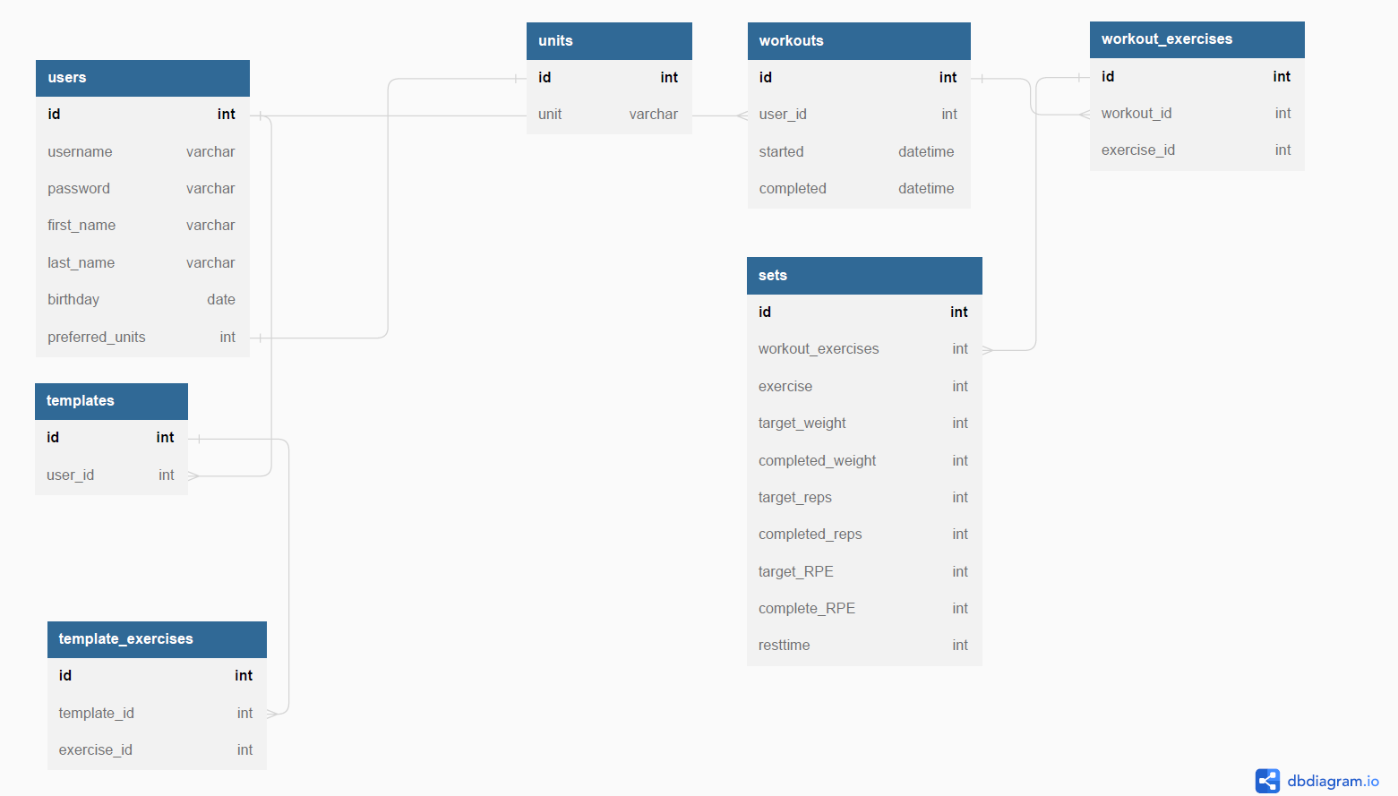

* 1. Potential API issues: I plan to use image links from the API for exercises. Some of the exercises don’t have any image links.
  2. Sensitive information: There will be user login information that will be encrypted then stored in the database.
  3. Functionality:
     1. Creation of workout templates. Templates can be created from scratch or modified from previous templates.
     2. Workouts created either from templates or from scratch. Can also be edited on the fly, i.e. edited during the workout has started. Workouts can also be scheduled ahead of time.
     3. Progression tracking and workout/exercise statistics.
     4. Rest timer to keep workouts on track.
  4. The user will login and be presented with a calendar of their scheduled workouts. From there, the user can start/manage their workouts, manage their templates. Exercises can be selected (added to workouts and templates) by category of muscle or by search of exercise name. During the workout users can log their complete weight and reps and start the rest timer after completion of a set.

WGER API

https://wger.de/en/software/api

* There are many public endpoints on the API, but I think I will mostly be using the exercise, exercise category, exercise image, and muscle endpoints. Below are images of the data

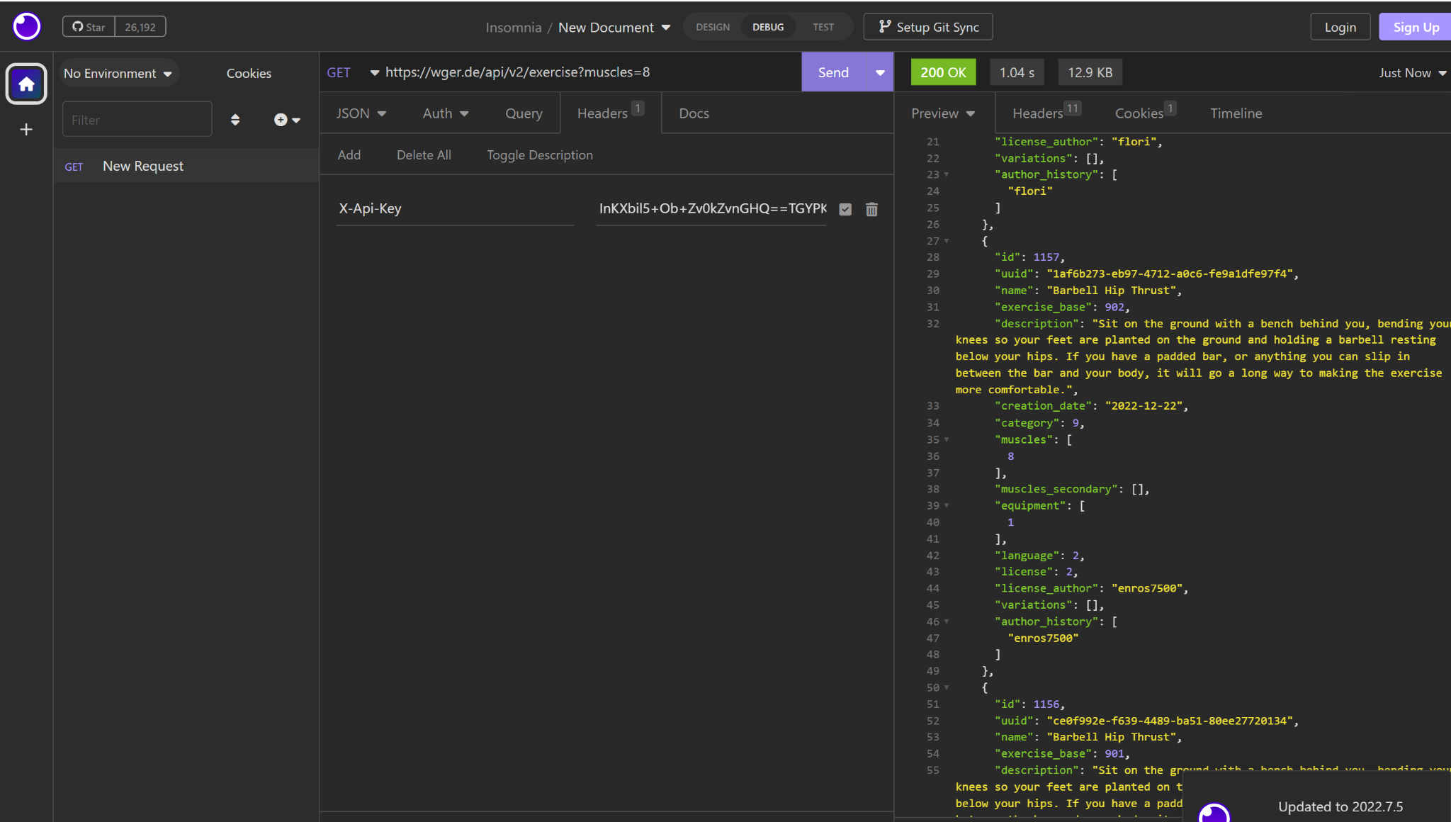

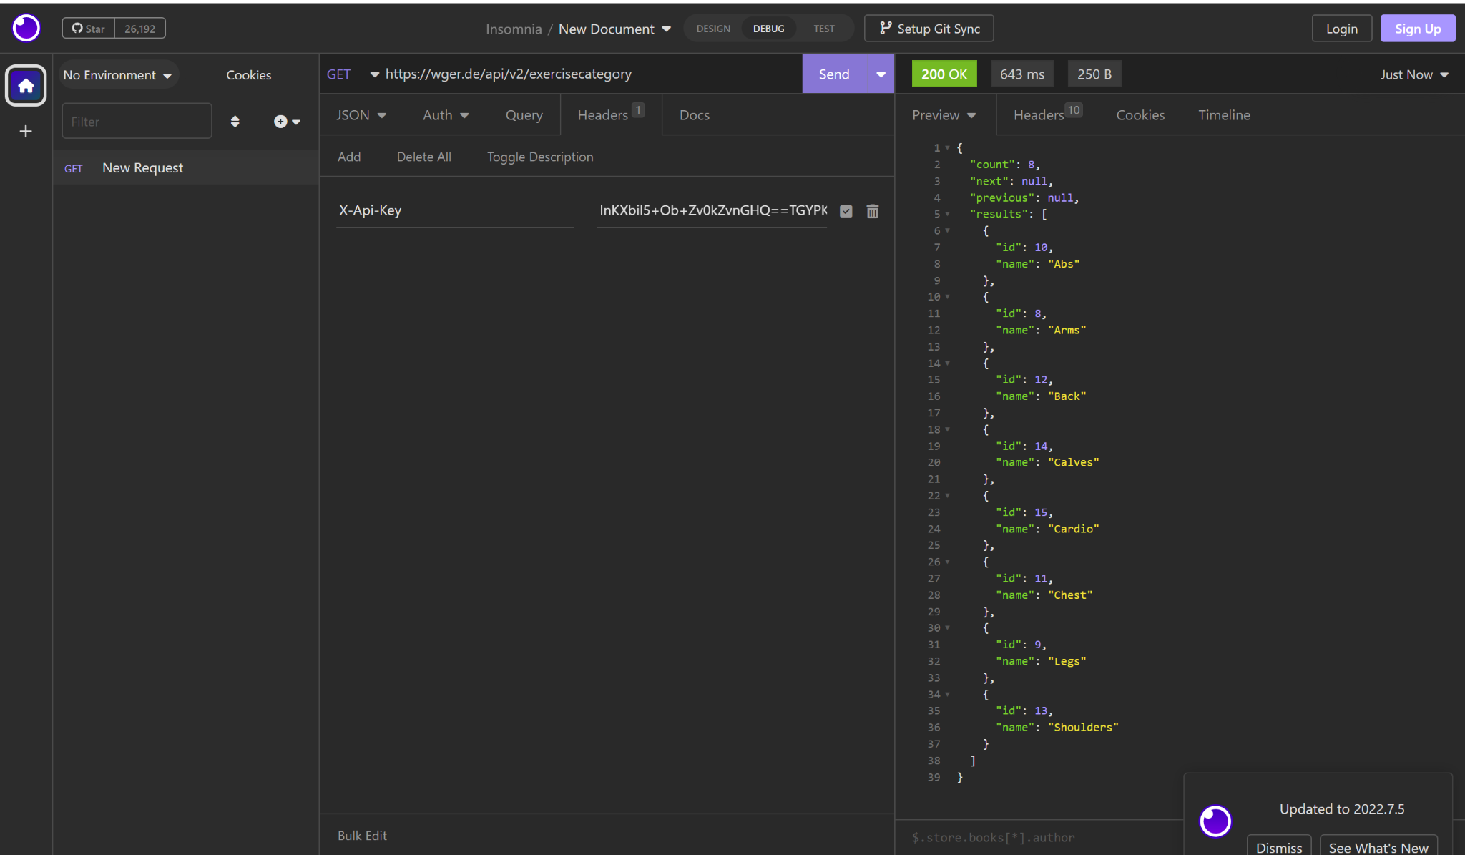

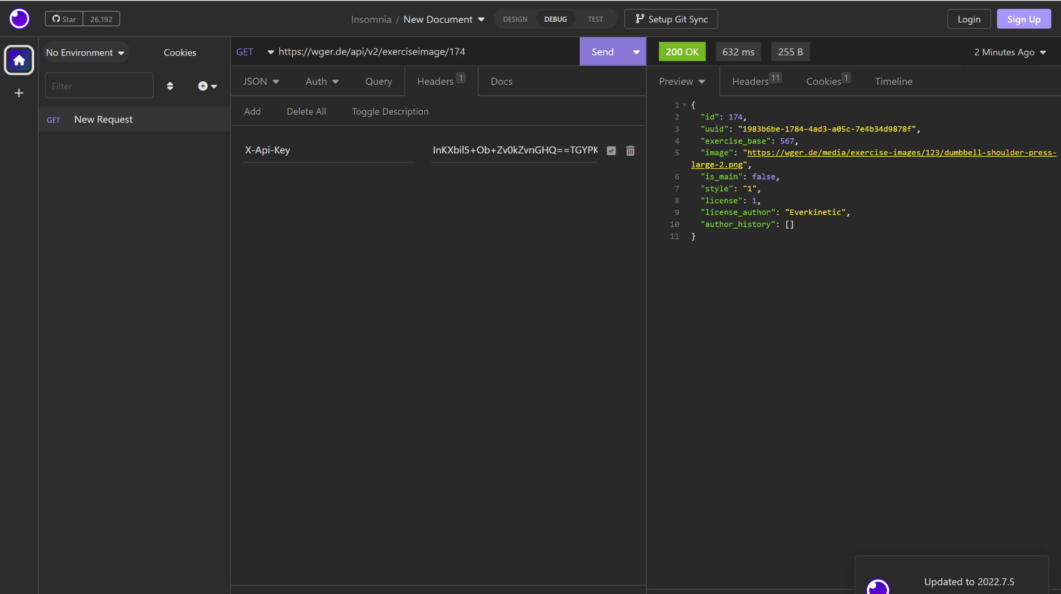

* The API data is formatted in JSON
* The data does not seem too messy. There are some incomplete data for some exercises, e.g. exercise images, and that will have to be worked around.