Matt Geyer
Geyerm3@unr.edu
Dr. Bebis CS 302
Lab Assignment #1

Introduction: This objective of this assignment was to familiarize myself with the manipulation of grayscale PGM images by implementing various transformation techniques in C++. The program was designed to be able to load an image and perform one or more manipulations, and then save that image back to a file.

Use of my code: I wrote my program using Visual Studio, which automatically generates an .exe file for you. The basic flow of my program in use is to:

- Load an image.
- Select from the menu one or more operations with the option given to load a second image if necessary for the operation i.e. adding and subtracting.
- Save the image to file with a specified filename.

Class Description: The ImageType class used in my program is based on the ImageType class, given to us by Dr. Bebis, with some minor modifications. The main modification I made was implementing a second array in the class called temp. The purpose of the temp array is to make it possible to do transformations that require an unmodified version of the main pixelValue array. Having a temp array inside the image class made it possible to do these types of transformations as member functions without having a second instance of the ImageType class to hold the results. The temp class helped with abstracting several of the transformation operations. I also wrote and implemented a few functions to deal specifically with the temp array and copying it over to the main pixelValue array that I will go into more detail on below.

The majority of the member functions that I implemented for the ImageType class follow a basic pattern for modifying the image data. First, the temp array is cleared and resized where appropriate. Then the desired modification is made with the result being stored in the temp array. The main array is then cleared and resized if necessary, and the values in the temp are copied over. In my opinion, this process is superior to instantiating a second ImageType object and having to do allocation, resizing, and copying in the main driver.

Function Descriptions: The functions below are all member functions of the ImageType class with a return type void, unless otherwise specified. Functions that were provided by Dr. Bebis are omitted. These include the constructors and destructor, getImageInfo(), setImageInfo(), setPixelVal(), and getPixelVal().

rotateBilinear( double angle ): This function rotates the image by the given angle in degrees, represented as a double. The function works by looping through every pixel location in the temp array and finding the best match from the source array. That solves the problem of having holes in your image where a valid pixel could not be found. The rotation is performed by converting the pixel coordinates from Raster, to Cartesian, and finally to Polar. The rotation is then performed in polar coordinates and then the coordinates are converted back to Raster coordinates. As the name suggests, I also implemented Bilinear Interpolation into this function. I first interpolate in the horizontal direction above and below the pixel, then vertically between the two values found by the previous interpolation. The formula I use is for the linear interpolation is

f(x) = (1 – t)*(p0) + (t) * (p1)

Rotate( double angle) : Same as rotateBilinear only without Bilinear Interpolation implemented. I kept it to make comparisons.

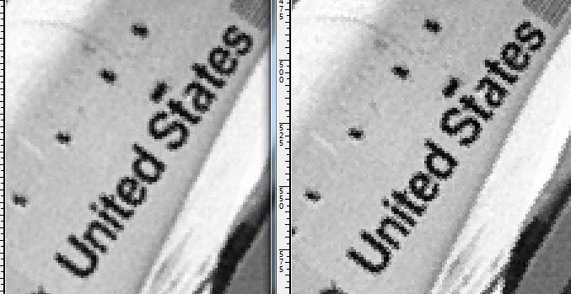
The image on the left is with Bilinear Interpolation, and the one on the right isn’t. I think that the Bilinear Interpolation image has clearer letters and less pixilated lines. It was admittedly hard to tell the difference in a few of the images I tried though. I think there are probably ways in which my algorithm could be improved some.

Enlarge( int s ): This function enlarges an image by the passed factor s. The temp array is re-allocated with the new calculated dimensions. The function loops through and adds pixels from the pixelValue array to the temp array in S x S blocks. This function could have been improved with some form of interpolation. I did not get the chance to implement any type of interpolation on it, however.

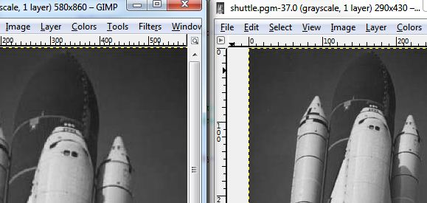
Image Enlarged by a factor of 2

Shrink( int s ): This function shrinks an image by a factor s. The temp array is allocated with the appropriate dimensions and then ever s pixel from the pixelValue array is added to the temp array. This function could have been improved by implementing a method of interpolation, but I did not have time. See extra credit section for more explanation.

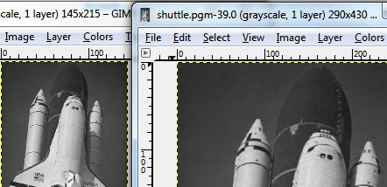
Image shrunk by a factor of 2

negate(): This function negates the image by looping through for every pixel and using the formula: temp(r, c) = -pixelValue(r, c) + Q.

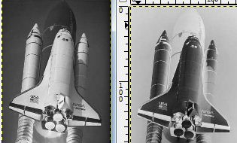
Negated Image.

reflectH() and reflectV(): Since the code for reflecting an image was relatively small, I decided to make a separate function for vertical and horizontal reflection. Reflection is accomplished by reversing the pixels on the specified axis. No resizing is necessary so I just looped through every pixel and put pixels from pixelValue into the temp array in reverse order. This could have been accomplished without the use of a temporary array, but I decided to stay consistent with my model for modifying the images in other functions instead.

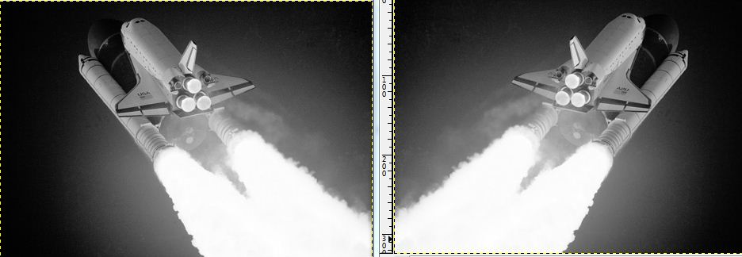
Image reflected along the horizontal axis.

int getMeanGray(): This function computes the average gray level of the image. The gray level is returned as an integer. The average gray level an image is computed by adding up the value of every pixel and dividing that sum by the number of pixels. An example result for the image dimes.pgm is 54.

subImage( int tlx, int tly, int brx, int bry ): This function creates a sub image based on the passed top left and bottom right coordinates. The precondition for this function is that the passed values fall within the image. The temp array is resized, and then the temp array is filled with pixels that fall within the bounds of the passed coordinates. Once it is filled, the pixelValue is resized and filled with the values from the temp array.

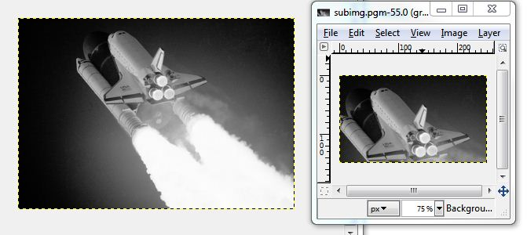

The result of creating a sub image of the first image.

Translate( int offsetX, int offset Y): This function translates an image by the given offsets. The precondition for this function is that the offsets in either direction do not exceed the dimensions of the image. The pixels that, once offset, fall outside of the image dimensions are cut off. It is my understanding that this is the intention of the function, but if you wanted to preserve those values, then you could do so by increasing the image dimensions in the x and y directions as width + offsetX and height + offsetY.

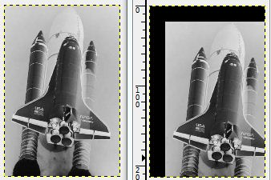
Image Translated 20 x 20 pixels.
ImageType Operator + ( ImageType& rhs ): This is the overloaded addition operator. This function instantiates a new ImageType object with dimensions sized so that the larger of the two images with fit in its entirety. The pixel values of the new image are computed with the function : sum( r, c) = ( 0.5 * pixelValue(r, c) + 0.5 * rhs(r, c) ). The function returns the new sum image.

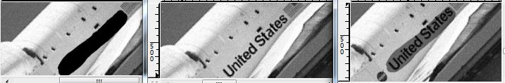
The third image is the sum of the first plus the second.

ImageType Operator – (ImageType & rhs ): This function acts similar to the addition operator, except that it finds the difference of two images. The diff ImageType object is instantiated with dimensions large enough to fit the bigger of the two images being subtracted. The values for the diff array are computed with the function: diff(r,c) = | pixelValue(r,c) – rhs(r,c) |. The function returns the new diff image.

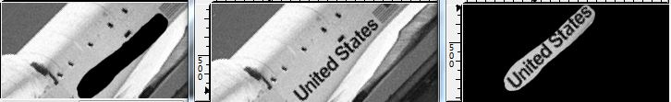

The third image is the difference of the first minus the second.

Errors and Bugs: I wasn’t able to get my overloaded = operator working properly. For some reason, when I didn’t have a destructor for my ImageType class, adding and subtracting using the overloaded operators worked fine but with shallow copies I assume. However, once I implemented the destructor I would get a write error when trying to save the image to a file. I suspect that this is because of the = operator. Another problem I had was confusing my x , y coordinates with their i, j counterparts. I often wrote my program with i corresponding to height, but mentally always associated i with x, even though it corresponded to j. This caused quite a few out of bounds errors, but usually I was quick to realize my error.

Conclusion: I had a lot of fun with some of the aspects of this program. I wish that I had more time to implement some of my ideas for a couple of the functions. Specifically the Enlarge and Shrink functions. I spent a lot of time researching ways to rotate and improve the quality of my rotated image. That lead me to do a lot of reading about Interpolation which is a concept that I found to be very interesting. I was able to get bilinear interpolation working on my rotation which was easier for me to understand conceptually than with Enlarge or Shrink. I spent some time working out how to interpolate with Enlargement but didn’t have enough time to make an algorithm that implemented it. I really enjoyed the challenge of trying to learn these math concepts that were new to me and felt a lot of satisfaction when my rotated image was visibly improved after I implemented the Bilinear Interpolation. I will probably go back after this project is turned in and try to get Bilinear Interpolation set up with the enlarge and shrink functions. I also read about some more complex forms of interpolation such as BiCubic Interpolation and Lanczos resampling.

Extra Credit:

- When you shrink an image with the method given, then some pixel data is lost outright. One way to improve it would be to take a weighted average of the pixels being deleted to come up with a new value that better represented the pixels being deleted. From my understanding, this is also a form of interpolation. That way you would get a better representation of the pixels being deleted and it should hopefully preserve some of the image data instead of just losing it entirely.

- For the first problem, where the transformed pixels fall outside of the image the solution could be to perform the rotation calculation on each corner of the image. You would then find the length between the largest and smallest vertical values for the four corners, and the largest and smallest horizontal values for the corners in the raster coordinate system. I say between the corners because the corners will always be the most extreme values of the image. That way every other pixel will be inside the dimensions of the new image.

The reason there are holes with the given formula for rotating is that when you get a non-integer result for the new location of the pixel then you have to round down or up to place it in the destination array. To solve this, instead of rounding to approximate where a pixel should go on the destination array, I looped through every pixel of the destination array and approximated a pixel from the source array that belonged there. This ensured that there was a value for every place in the destination array and thus, no holes. I also implemented Bilinear Interpolation to better estimate what the value of the pixel on the destination array should be. The interpolated pixel is a weighted combination of the known pixels surrounding it. The result was a clearer image with less aliasing in most cases.

- To solve this problem you would figure out an acceptable threshold for your application. The slight changes from illumination change, and sensor noises would fall below that threshold. That way only non-trivial changes in the photograph would show up.

Division of Work: I wrote 100% of the program and report. My partner had to drop out of school at the last minute due to financial issues.

