Paratext

Version 8  
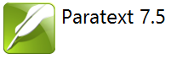

Participant’s Manual   
Stage 1–2

**Drafting and Team Checking**

SIL International

Paratext

Version 8

Participant’s Manual   
Stage 1-2

**Drafting and Team Checking**

SIL International

Title: Paratext Version 8, Participant’s Manual Stage 1-2

Genre: Teaching material

Trial Edition : electronic

© SIL International 2017

**Table of contents**

Introduction 11

Goal 11

Course Objectives 11

Stage 1 : Drafting 15

OD : Organising your desktop 16

Load the Paratext program 17

Open a saved text combination 17

Create a new text combination 18

Open and arrange the windows 18

Save the text combination 18

Delete a text combination 18

Open resources in a Text collection [◙ SD05] 19

Open a dictionary 19

[Make a list of verses of a specific term from the source language text   
[◙ SD06] 20](#_Toc477779331)

Recall 21

PP1 : Project Plan and progress 22

Make sure your project is active 23

View tasks that need to be done 23

Identify the next task 23

Mark a task as complete 24

Mark a book task as completed 24

Mark a chapter task as completed 24

Checks 25

Checks - setup required 25

Checks – issues 25

KD: Keyboarding your draft 26

Load the Paratext program 27

Go to a Biblical verse [◙ SD01] 27

Check that the project is editable 27

Changing the view [◙ SD02] 28

Typing special characters 28

Adding text in another marker such as title or introduction [◙ SD03a] 28

Add paragraph breaks 29

Saving your work 29

Insert Footnotes [◙ SD03] 29

Send/receive to a USB stick to backup your data [◙ SD04] 30

Moving your cursor efficiently. 31

Recall : 31

GL: Glossary 32

Open the Biblical Terms tool 33

Add an entry [◙ GL01] 33

Link an existing entry [◙ GL02] 34

View the glossary 34

Edit an entry – in the GLO book [◙ GL03] 34

Edit an entry – in the Biblical Terms [◙ GL04] 34

Add a Biblical Term 35

Recall 35

BC1 : Basic checks (from Project Plan or Checking menu) 36

Running checks from the project plan 37

Running the checks from the menus 38

« Chapter/ Verse » [◙ VT01] 38

Markers check 38

PP2 : Project progress 39

How to make sure the progress of the plan is up to date 40

Change an assignment 40

Produce a progress report 40

View team progress charts 40

Stage 2 : Team Checking 41

PN: Proper Names 42

Introduction 42

Run the Biblical Terms tool 43

Open list of terms [◙ VC01] 43

Choose your reference text as a comparative text [◙ VC01] 43

Change various settings [◙ VC01] 43

Choose the type of terms [◙ VC01] 44

Adapt names 44

Enter the changes for the individual letters (or letter clusters) 44

Then revise and approve the Adapted Name 44

Ensure your text is consistent [◙ VC02] 45

Add an alternative rendering 45

Dealing with verses that don’t have the name translated [◙ VC05] 45

Recall 46

SP : Spell Checking 47

Approve the spelling of common words [◙ VO01a] 48

Check the words that Paratext thinks are incorrect [◙ VO01b] 48

Check similarly spelled words [◙ VO01c] 49

Spell checking [◙ VO02] 49

Making corrections [◙ VO02] 50

Spell checking – current book [◙ VO02b] 51

Using the new checks 52

All checks 52

Missing Capitals 53

Single Character Typos 53

Unusual Letter Combinations 53

Diacritic Errors 53

Common Typos 53

Unknown 53

Find incorrectly joined or split words 54

Correct a word which was incorrectly marked 54

BT : A 4-Step process for consistent Biblical Terms 55

Open the Biblical terms rending window [◙ VT01] 57

Find the terms for the current verse 57

Add another rendering 57

Find other verses in the current book with the same Biblical term 58

Add renderings from the other verses 58

Dealing with verses that don’t use the term [◙ VC05] 58

Identify the best term 59

Reject all the others 59

Document the reason for the change 59

If you need more than one rendering 59

Clean up other books (as time permits) 60

Add the Biblical terms notes (ongoing discussion) 60

Add the decision to the renderings description 60

Add a term 61

FC: Formatting checks 62

Using the checklists – generic 63

Using checklist – Section headings (\s1) 63

Paragraph breaks 64

Layout and indents 65

Add USFMs to format special text 65

PD : Printing Drafts 66

Create a PDF file [◙ IE01] 67

Print PDF [◙ IE02] 68

Copy PDF file to a USB stick 68

BC2 : Basic checks 69

Confirm the setup 70

Using inventories to setup checks [◙ VT02] 70

Characters [◙ VT02] 71

Punctuation [◙ VT03] 71

Repeated words [◙ VT05] 72

Capitalization [◙ VT06] 72

Making minor corrections 73

UN : Using Notes 75

Different types of project notes 76

Setup additional note types 77

(One must be an Administrator) 77

Inserting a project note [◙ UR01] 77

Open notes [◙ UR05] 78

Add comments to an existing note [◙ UR02] 78

Add comments from a notes window 78

Assign a note to someone [◙ UR03] 79

Apply notes to multiple texts 79

Reattach note 79

Resolve a note [◙ UR04] 79

Print a notes report [◙ UR06] 80

Delete notes 80

Notes window 80

Notes filter 80

Define a new filter 81

Save a filter 81

Appendix – Bible Books 82

Three letter abbreviations 82

Chad special characters 83

Common USFM Markers 84

Special text 85

# Introduction

## Goal

The participants will process their translation with the help of Paratext 8, a program created for entering, storing, and checking the translated texts. They will also print drafts for revision. The course will explain the procedures and will also hightlight any differences between Paratext 7.5 et 8.

## Course Objectives

At the end of the course, the participant will be able to:

Start Paratext

* Start the Paratext program using a desktop icon.

Stage 1 : Drafting

Open projects and resources to understand the text before translating

* Open projects and additional resources, for example an English Bible, a source text, a source text dictionary etc.
* Organise these windows on the screen and save as a text combination.

Enter the translation

* Effectively use the navigation toolbar to move to the desired book, chapter, and verse.
* Type the text in an open project with the help of USFM markers such as \c, \v, etc. in an suitable view.
* Use a keyboarding system (MS-keyboards or Keyman) to type special characters.
* Add additional markers for section headings, introductions etc.
* Add footnotes.
* Draft glossary entries and add using the Biblical terms tool.
* Use the Send/Receive feature to share and backup their project to the Internet or a USB key.

Basic checks

* Run the chapter/verses check to make sure that all the chapters/verses are present.
* Run the markers check to make sure all the text has the correct markers.

Project progress

* Update the project plan with any completed tasks.

Stage 2 : Team checking

Proper names

* Transliterate proper names.
* Check that proper names are consistent.

Biblical terms consistent

* Use the Biblical terms rendering window and tool to ensure you are consistent in the use of terms.

Checks

* Use Checklists to correct any formatting problems in section breaks and headings, paragraph breaks, layout and indents.
* Run various checks to make sure all the characters, punctuations, capitalisation and repeated words are valid. (Administrators need to setup the inventories/settings as required).
* Correct any spelling mistakes using the spell checking function and/or checks from the Wordlist.

Using notes

* Add project notes as needed to communicate with other team members and/or consultants.
* Add project, Spelling and Biblical term notes to discuss various issues and record the decisions made.

Print draft

* Produce and print PDF file for revisors.

# 

Introductions, setup

Introduce yourself

The participant and facilitators should introduce themselves giving:

* their name
* their language
* their town
* what was the first and last (most recent) version of Paratext that you have used.

|  |  |  |  |  |  |  |  |  |  |
| --- | --- | --- | --- | --- | --- | --- | --- | --- | --- |
| 5.0 | 6.0 | 6.1 | 6.2 | 7.0 | 7.1 | 7.2 | 7.3 | 7.4 | 7.5 |
| 1998 | 2003 |  |  | 2008 | 2010 | 2011 | 2012 | 2013 | 2014 |

While the facilitators install Paratext on the computers, the participant should read the introductory material and tick (check) the objectives that they feel confident doing in the most recent version of Paratext they have used.

For each module

* Do a revision activity of the previous module.
* Present the introduction (read, sketch, PowerPoint, etc.)
* If a skill is quite simple, ask a participant to come and demonstrate the skill.
* Follow the summary for the other skills:
* Demonstration
* Do it together
* Let the participants redo it themselves
* Ask a participant to demonstrate the skill.
* Ask questions.
* Do a revision activity.
* Give the participant time to reflect, fill in the recall exercise, add to Anki.

Stage 1 : Drafting

Introduction

There are several stages in a translation project. In this first stage you will use many of the resources to ensure that you understand the source text, then you will draft and keyboard the text of the translation along with other materials and also begin the preliminary checks.

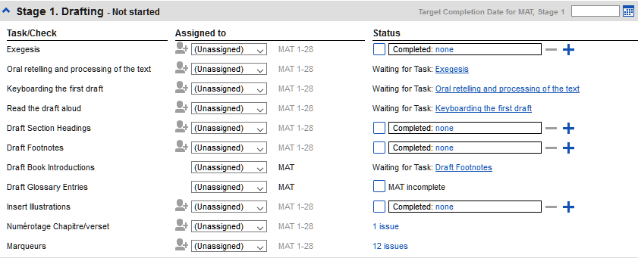

The following modules will help you in this stage :

* OB: Organising your desktop
* PP1: Project plan – the next task
* KD: Keyboarding your draft
* GL: Adding glossary items
* BC1: Basic checks – chapter/verse and markers.
* PP2 : Project plan – complete a task

# OD : Organising your desktop

|  |  |  |  |  |
| --- | --- | --- | --- | --- |
| Start  Paratext | Use combinations of windows | Open your project | Open resources (source text, texts collection…) | Create a list of verses from the source text |

Introduction

As you work with your text in Paratext you will want to see a variety of resources. In this module, you will learn how to open resources and organise your desktop.

Where we are

We are about to type text into an existing project. Before you can do this, someone must have already installed the program, created a project for your data and installed resources for you.

Why this is important

The translator who organises his/her desktop well has all the resources necessary for his/her work.

What are you going to do?

You will start the Paratext program and open a saved combination. If needed you will open other resources, change the arrangement of the windows and resave the text combination.

Summary

This module shows you how to:

## Load the Paratext program

* Double-click on Paratext 8 icon on the desktop OR
* (From the Start menu, choose Paratext 8)

## Open a saved text combination

* Click on the Window menu
* Choose a saved text combination.
* Your screen should look like the picture below   
  (if not, see the following page).

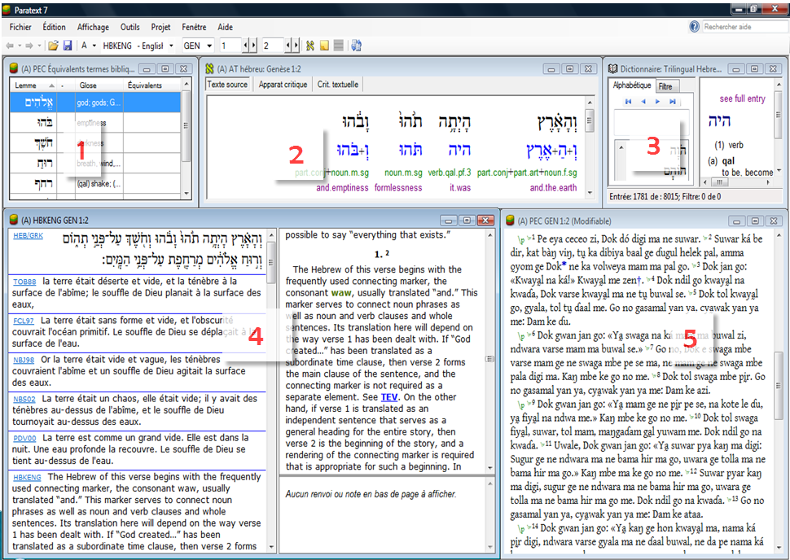

## Create a new text combination

If you haven’t already saved a text combination, then we recommend you do the following:

## Open and arrange the windows

* Window > Unstacked
* Open the 5 windows as follows:

5 =your project   
(**File > Open project/resource**

1 = Renderings   
(**File > Open Biblical Terms renderings**)

2 = Source text   
(**File > Open Source language text**)

3 = Dictionary   
(**File > Open source language dictionary** )

4= Text collection   
(**File > Open project/resource in Text Collection**)

* Arrange the windows as desired.

## Save the text combination

Once the windows are arranged as desired:

* Window > Saved text combination
* Type a name   
  [or to replace an existing combination, choose the existing name]
* Click **OK**

## Delete a text combination

If you want to delete a saved combination,

* Window – Delete text combination
* Choose the name of the saved combination.
* Click **Delete**

## Open resources in a Text collection [◙ SD05]

With Paratext, it is possible to have several project/resources open at the same time. However, rather than having too many windows, it is better to have severals text in one window.

* File > Open Project/Resource in Text collection

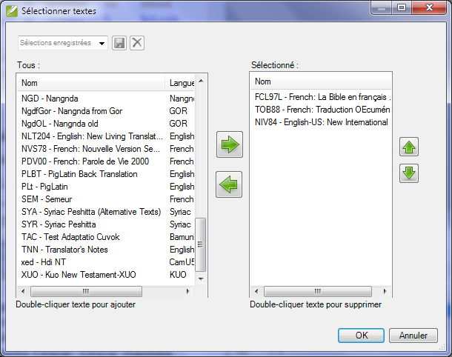

* Click on a resource (at the left).
* Click the right arrow.
* Repeat as necessary.
* If necessary, change the order using the up/down arrow buttons.
* Click **OK**

You can change the text in the seond pane by clicking on the blue link of the abbreviation for the text. You can also change the view (preview, unformatted or standard.

## Open a dictionary

You can open a source language dictionary with glosses in other languages.

* File > Open Source Language Dictionary
* Choose « A Concise Greek-English Dictionary of the New Testament »
* View > choose a language (e.g. Français)

## Make a list of verses of a specific term from the source language text [◙ SD06]

You can have a list of verses for a specific greek word

* Right-click on a lemma (blue word) in the source language text window

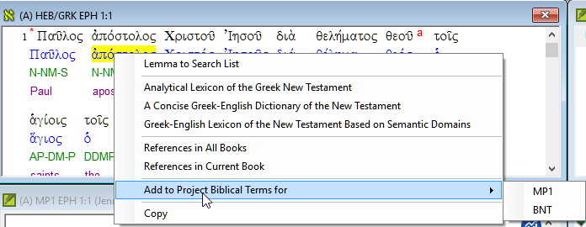

* Choose Add to project biblical terms for
* Choose your project
* Edit the gloss if necessary
* Click **OK**
* Change to the Biblical Terms Tool
* Double-click on the term.

## Recall

* The translators who ________ their desktops have all the _________ they need for their work.
* You use the __________ menu to save or delete _____________ of text.
* To open windows you use the __________ menu.

*Open Biblical terms equivalents*

*Open Source language text*

*Open Source language dictionary*

*Open Project/resource in collection of texts*

*Open Project/resource*

* You can make a list of verses which have a word from the source language text by clicking _____ (right/left) clicking on a ________ in the source language, the choosing _____ the your project .

# PP1 : Project Plan and progress

Introduction

You use the Project Plan to help organise your work and see which tasks to do next. Once you have finished the task you mark it as completed so that you can report on what has been achieved. [If you have used an earlier version of you will see that it has dramatically improved in Paratext 8.]

Where are we?

Before you can use the plan it must have been configured. [This is usually done by your project administrator who will add the appropriate organisational plan and configure it for your team.]

Why is this important?

There are so many tasks to be done in a translation project. It is important to have a system to make sure these are all done. Now that your plan has been configured, you can use the plan to see what tasks have been assigned to you to be done next. Then when you finish the task, you can mark the task as completed and see the next task to do. You can use this information to generate reports for supervisers and donors (see PP2: Project plan reporting).

What are we going to do?

You will mark a variety of tasks as complete. The exact steps will vary slightly depending on whether the task is set to once per project, once per book, or by chapter.  The place to mark progress for all types of tasks is the **Status** column.

Summary

This module shows you how to:

## Make sure your project is active

* Click in your project.

## View tasks that need to be done

* Click "Assignments and Progress" button C:\Users\User\AppData\Local\ParatextHelp\HelpSystemImages\progress.png

OR  
[From the Project menu, select Assignments and progress]

* From the first dropdown menu, choose either **My tasks** or **All tasks**

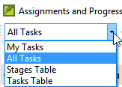

A list of the various tasks and checks are displayed.

## Identify the next task

The list of tasks shows the uncompleted tasks.-

* Identify the next task for you need to do.
* Check that it is not waiting for another task.
* Do the task (see other modules if necessary).

## Mark a task as complete

## Mark a book task as completed

* Click on the checkmark to the left of the status.

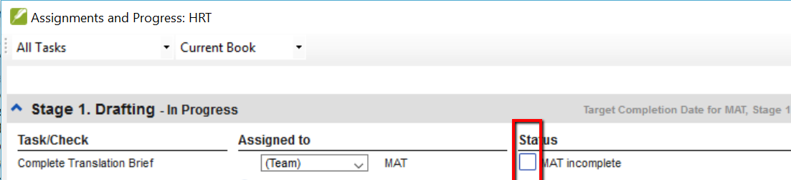

It should turn solid to show it is completed.

## Mark a chapter task as completed

* Click + to mark the next chapter as complete

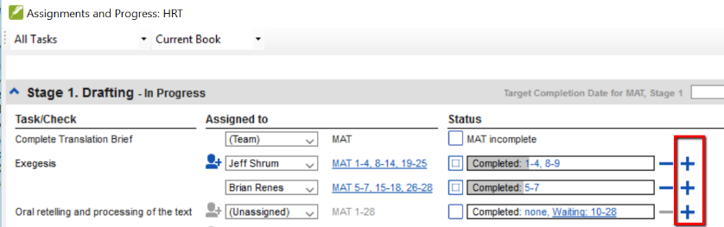

* 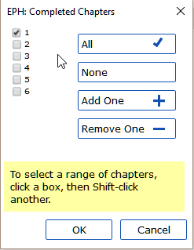To mark other chapters as complete you can click on the word **Completed**.

A dialog box is displayed with a list of the chapters.

* Check the chapters that have been completed.
* To mark some verses only, click to the right and check the individual verses.

## Checks

* If the task is a check, the status of the check will either say *setup required* or it will show number of remaining *issues*.

A check is complete when there are **No issues**.

## Checks - setup required

* Click the blue link Setup required

Paratext with run the appropriate inventory or open the settings for that check.

* Complete the setup as appropriate.
* Close the window when finished.

If there is more than one inventory you will need to set them up manually from the Checking menu.

## Checks – issues

* Click on the blue link “ …. issues”
* Make the necessary corrections.
* Close the list result.
* Return to the Project plan.
* The check is considered complete with there are 0 issues.

# KD: Keyboarding your draft

|  |  |  |  |  |  |  |  |
| --- | --- | --- | --- | --- | --- | --- | --- |
| Run Paratext | Add text | Views | Add other USFM | Save | Footnotes | Moving your cursor | Send/Receive |

Introduction

This module explains how to keyboard your draft translations into a project which has already been created in Paratext.

Where we are

We are about to keyboard text into an existing project. Before you can do that, someone must have already installed the program and created a project for your data.

Why this is important

This is the first stage of putting your translation into the computer. Once the text has been typed, you can run various checks on the content and format of the text.

Summary

This module shows you how to:

## Load the Paratext program

* Double-click on Paratext 8 icon on the desktop OR
* (From the Start menu, choose Paratext 8)

## Go to a Biblical verse [◙ SD01]

Before you can start typing your text, you need to move your cursor to the right book, chapter and verse. You use the toolbar to do this.

* Using the icons on the toolbar, change the project, book, chapitre, verse as needed.

**project book chapter verse**



## Check that the project is editable

Look at the titlebar of your project.



The titlebar should either have your name or the word **(Editable)**.

* If it is not editable, try changing the view (see below).
* If your project is shared and your name is not on the titlebar, you should talk with your project administrator.

## Changing the view [◙ SD02]

Paratext 8 has five views. All but the Preview view are editable.

* Ctrl  +  E  -or-
* From the View menu, choose the view (usually Standard).

## Typing special characters

Some orthographic characters are not found on the keyboard. To type these characters you need to press more than one key.

* Change your keyboard system as needed on your computer.
* If you are using keyman then choose Tchad Unicode   
  (or for MS-Keyboards choose TR or SQ/TZ/AF…)
* Type the keys as in the table on page 83.

**Note** : You can use View> Highlight Invalid Characters to highlight invalide characters.

## Adding text in another marker such as title or introduction [◙ SD03a]

Each piece of text needs to have a marker. The markers for the chapters and verses are already in your project. When you want to add text such as headings, or introductions etc you need to also add the appropriate marker as follows:

* Move your cursor to the end of the previous paragraph :
* Type Enter ou type « \ »
* Type the marker (e.g. s1 or ip) « Enter » (or select it from the list).
* Type the text
* Add a paragraph marker after the text  
  (for example : \p)

You must always have a USFM marker after a title and before the verse. This is usually \p (paragraph), but it can be different (for example \q1).

## Add paragraph breaks

Dividing the text into paragraphs:

* Press « **Enter** »
* Type p « **Enter** »

## Saving your work

It is important to save your work regularly.

* **File**>**Save All** –or-  Ctrl  +  S

## Insert Footnotes [◙ SD03]

You add footnotes in the text at the place where you want the reference to appear.

* Insert > Footnote
* A set of footnote markers is added in the box below the text

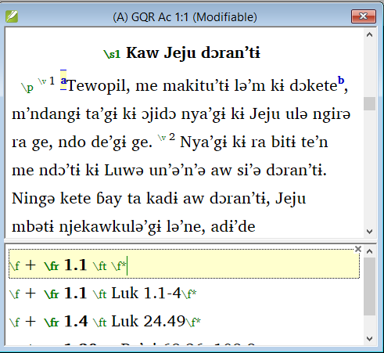

* Type the text after the \ft

If you hover your mouse over the superscript letter the text of the footnote will be displayed in a tip box.

To change the footnote, click the superscript letter in the text. To delete the footnote you can delete the superscript letter.

## Send/receive to a USB stick to backup your data [◙ SD04]

It is essential to have a second copy of your translation. This is done by doing a send/receive to a USB key as follows:

*Insert your USB key into your computer.*

* Click the Send/Receive icon 

or

* File > Send/Receive project(s)
* Check that the USB key is chosen
* Click Send/Receive.

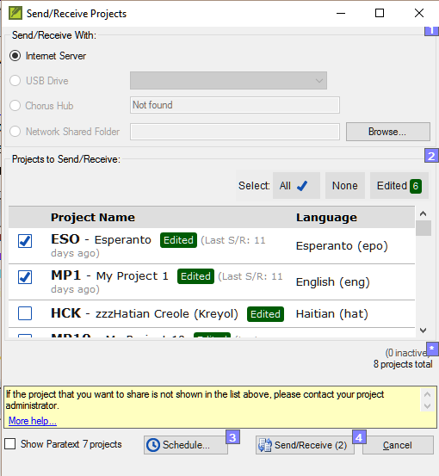

The computer will make a copy of your files onto your USB key. A progress meter will be displayed. A message box will only appear if there are any problems.

## Moving your cursor efficiently.

A lot of time is spent moving your cursor to the place where you need to add text or make corrections. Here are some useful keystrokes to move your cursor quickly.

* The arrow keys, ← ↑ → ↓   
  Home, End, PgUp, et PgDn,   
  F8 (chapter), F9 (book)
* or Ctrl + any of those keys

## Recall :

If the titlebar doesn’t say (Editable), you should try changing the __________.

To add a different marker (such as section heading) you press _______.

To add paragraph marker you type ________.

To insert a footnote, you use the _______ menu and choose ______________.

To send/receive, you use the ________ menu then ________________.

Answers : view, enter, enter, Insert, Footnote, File, Send/receive

# GL: Glossary

|  |  |
| --- | --- |
| Add an entry | Edit an entry |

Introduction

This module explains how to add entries to the glossary using the Biblical terms tool.

Where we are

You have drafted and entered your text in Paratext. Now you will draft and enter some glossary entries to explain some terms.

Why this is important

It is good to have a list of important words and their explanations so that the readers can understand the text well. Rather than typing directly into the glossary, it is better to use the Biblical terms tool as it keeps the Glossary in alphabetical order. The tools also keeps track of the changes to the glossary.

What you are going to do

You will use the Biblical terms tool to add a rendering for the term and then use the glossary tab to enter the citation form and the definition.

Summary

This module shows you how to:

## Open the Biblical Terms tool

* Tools > Biblical terms ...

## Add an entry [◙ GL01]

* Move to a verse which contains the terms you want to add to the glossary.
* Right-click and choose « View Biblical Terms », then « Current Verset(s) »
* Check that you have the correct list open *(p.ex. NT Key Biblical Terms [SIL])*
* Double-click on the term in the list in the top pane
* Click the « Glossary » tab

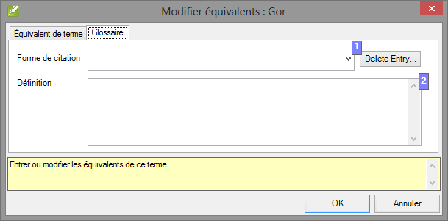

* Type the citation form of the term [1]
* Type the Definition [2]
* Click OK

The word and the definition will be added to the glossary in alphabetical order.

## Link an existing entry [◙ GL02]

If the word is already in the glossary, you can link a term to the existing entry.

* Check that you have the correct list *(ex. NT Key Biblical terms [SIL])*
* Double-click on the word in the list in the top pane
* Click the « Glossary » tab
* Click the down arrow near the citation form [1]
* Choose the entry from the glossary
* Click **OK**

## View the glossary

In Paratext

* Use the navigation bar to change the book



* Choose the GLO book

## Edit an entry – in the GLO book [◙ GL03]

In Paratext

* Open the GLO book
* Edit the text as normal.

## Edit an entry – in the Biblical Terms [◙ GL04]

* Tools > Biblical terms...
* Double-click on the word in the list in the top pane.
* Click the « Glossary » tab
* Edit la définition
* Click **OK**.

## Add a Biblical Term

* see page 61

## Recall

* You open the Biblical Terms tool from the ________ menu.
* The « glossary » tab is on the ________ dialogue. To open this dialogue you ________-click on the term in the _____ pane.
* To view the glossary your change to the _____ book (after Revelation).

Answers: Tools, Edit Rendering, double-click, top, GLO

# BC1 : Basic checks (from Project Plan or Checking menu)

|  |  |
| --- | --- |
| Basic checks: Chapter/verse | Basic checks: markers |

Introduction

In this module, you will check the chapters/verses and the markers.

Where we are

You have typed your text in Paratext. Now you want to start checking. In this module we start with the first two basic checks.

Why this is important

These checks allow you to be sure that you have all the chapters and verses and that the other markers are correct. Doing these checks allows you to complete the Drafting stage. It is important to run the chapter/verse check first because all the other checks depend on it.

What you are going to do

You are going to run the first two basic checks using two different methods.

* In Paratext 8 the easiest way to run check is from the project plan.
* It is also possible to do the checks from the checking menu. You use this method if you need to run the checks on more than one book at a time.

Summary

This module shows you how to:

## Running checks from the project plan

It is easier to run the checks from the project plan.

* View the project plan by clicking on the icon   
  (at the top right of your project window).
* If there are any « issues » (errors), click the blue link to the right



A windows appears with a list of the errors.

* Double-click a line in the list.
* Correct the error in your project.
* Double-click the next line in the list.
* Continue for all the errors.
* Click « Rerun » button to check that all the errors have been corrected.
* Close the results list window.
* Continue with the markers check.

## Running the checks from the menus

If you want to check more than one book at a time, you can run the checks from the checking menu.

## « Chapter/ Verse » [◙ VT01]

* Click on your project window
* Checking > Run basic checks
* Check the Chapter/verse numbers
* Uncheck any other checks
* Click the button beside Choose Books
* If necessary, click Choose… and choose the book you want to check
* Click OK

A windows appears with a list of the errors.

* Double-click a line in the list.
* Correct the error in your project.
* Double-click the next line in the list.
* Continue for all the errors.
* Click « Rerun » button to check that all the errors have been corrected.
* Close the results list window.

## Markers check

* Checking > Markers Inventory

The list shows an overview of the markers in your text.

* Close the marker inventory.
* Checking > Run Basic Checks
* Check the Markers
* Click OK
* Correct any errors.

# PP2 : Project progress

Introduction

In this module, you will learn how to update your progress and create a progress report.

Where we are

You have been working on your translation and have finished a task. You now want to update your progress.

Why this is important

For the project plan to work well, you need to mark the tasks you have finished. This allows Paratext to make the next task available for the other team members. Creating a progress reports helps you prepare a report for your supervisors and funders.

What you are going to do

You will open the assignments and progress window and update the progress made. You will then produce a report.

Summary

This module shows you how to:

## How to make sure the progress of the plan is up to date

* Open the project plan (using the button)
* Update the progress on any task (see PP1 for instructions on each type of task).

## Change an assignment

C:\Users\User\AppData\Local\ParatextHelp\HelpSystemHtml\warning.gifThis can only be done by a project administrator.

* From the Project menu, select Assignments and Progress....
* From the *first drop-down list* at the top left of the dialog, select **All Tasks**.
* In the **"Assigned to"** column, use the drop-down list to **choose who** will have responsibility for the task or check (listed in the "Task/Check" column at the far left).

## Produce a progress report

* From the Tools menu, select Project Health Report....
* Choose the project(s) to report
* Click **OK**.   
  The report will contain a column for each project you selected.

## View team progress charts

* From the Project menu, select View team progress charts....
* Use the first dropdown box to choose the type of chart
* Choose the books as necessary.

Stage 2 : Team Checking

Introduction

The second stage of a translation project involves checking by the team. In this second stage you will use many tools to ensure that you have been consistent in your translation. You will read through your text, work on proper names, Biblical key terms, spell checking, and formatings checks. You will also print out a draft and use a variety of notes: project notes, spelling notes, Biblical terms notes to record your questions, discussions and decisions.

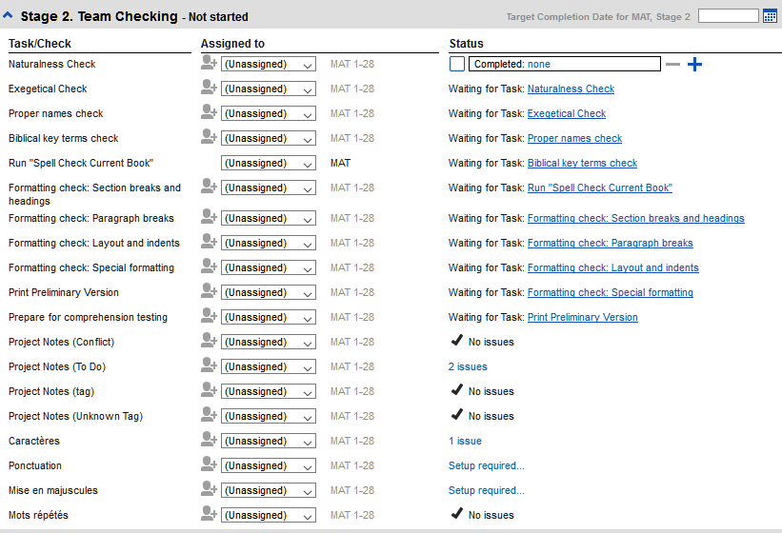

The following modules will help you in this stage :

* PN: Proper nouns
* SP: Spell checking
* BT: Biblical terms Checks
* FC: Format checks
* BC: Basic checks
* PD: Print draft
* UN: Using notes

# PN: Proper Names

## Introduction

In this module, you will check that the proper names have been transliterated consistently.

Where we are

You have (or are working on) the rules for transliterating the names.

Why this is important

You want to be consistent so that is clear who is being refered to in the text.

What you are going to do

You will

* **filter** the Major Biblical terms list on Names.
* use the **Adapt Names tool** to enter your transliteration rules for each letter.
* edit and **approve** the individual names.
* add the approved names as **proposed** names in the Biblical terms list
* work through the Biblical Terms list to ensure that all the verses are consistent.

Summary

This module shows you how to:

## Run the Biblical Terms tool

* Click in your project
* Tools > Biblical Terms ...

## Open list of terms [◙ VC01]

* File > Select Biblical terms list
* Double-click the « Major Biblical Terms (Current Project Setting » list

## Choose your reference text as a comparative text [◙ VC01]

* Click the « Comparative Texts » button on the toolbar.
* Choose your reference text, then click  🡪 .
* Click OK.

## Change various settings [◙ VC01]

* Click the second filter button
* Choose Chapters Assigned to Me
* Click OK

Note : The terms column is in Greek (or Hebrew) by default. You can see the terms in a roman script by using the View menu and choose Transliterate terms.

## Choose the type of terms [◙ VC01]

* Click the first filter button
* Choose « New Filter »
* In the dialog box, under Categories…
* Select « Names »
* Click OK

## Adapt names

* Tools > Adapt Names
* Choose the langue of your reference text (e.g. English or français)

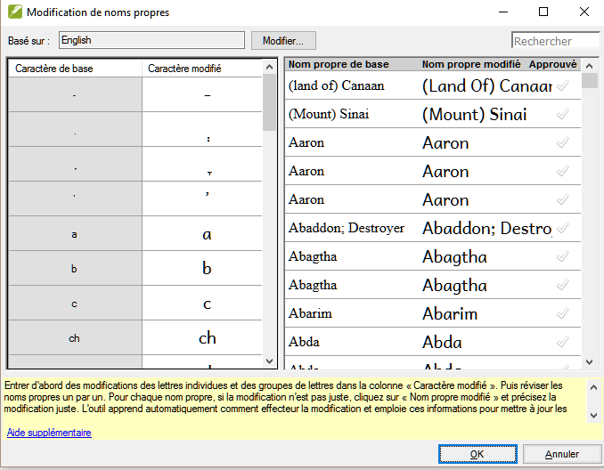

## Enter the changes for the individual letters (or letter clusters)

* In the left pane, fill in the “Adapted Character” column for individual letters or letter clusters.

## Then revise and approve the Adapted Name

* Work through the « Adapted name » column in the right pane.
* For each name,
* if the adapted name is incorrect, click on the name in the Adapted Name column,
* edit the name and click OK
* Once the name is correct, click in the « Approved » column.
* Click OK.

Paratext will propose a name (in red) in the rendering column.

## Ensure your text is consistent [◙ VC02]

You need to work through the list and confirm that all the verses use the name consistently.

* Click the name in the top pane.
* Click on a verse in the lower pane which doesn’t have the proposed form of the name.
* Click on the Edit link
* Correct as necessary, click OK
* Repeat for each name.

## Add an alternative rendering

* Click on the term in the list
* Selecte the word(s) in your text
* Click on Add rendering button or Ctrl+A

## Dealing with verses that don’t have the name translated [◙ VC05]

There are times when a verse is correctly translated even though you haven’t used the name. For example, a pronoun is used instead of the name. In this case you need to tell Paratext that it is correct (that is, deny that the rendering is missing).

* Click red cross at the left of the verse reference .
* The cross turn into green tick with a red cross  (and/or the verse dispears from the list).
* If you clicked on the red cross by mistake, click again on the icon  to turn it back into the red X.

Note : Paratext doesn’t find names in the introductions, headings, footnotes, captions or glossary.

## Recall

* To transliterate proper names, you **______** the **_________________** list on **names**.
* Then use the **_______** menu and **____________** command.
* After entering the **_______** changes then **__________** the adapted names.
* Paratext then enters a **__________**  rendering for all the names.
* You then work through the list **___________** and/or adding renderings and making sure that all verses are **_______________**.
* You can add a rendering by selecting the text and pressing Ctrl+__.
* If a pronoun is used you can ______ the rending by clicking on the X.

Answers: filter, Major Biblical Terms, names, Tools, Adapt Names, character approve, proposed, correcting, consistent, A, deny

# SP : Spell Checking

|  |  |  |  |  |  |
| --- | --- | --- | --- | --- | --- |
| Configuring the word list | | | Spell checking | | |
| Approve spelling of common words | Check the words that Paratext thinks are wrong | Check similar words | Display the red squiggly lines | Check the current book | Various checks on the word list |

Introduction

This module explains how to check for spelling mistakes in the text you have typed into you project in Paratext 8.

Where we are

You have type your text in Paratext and have done some checks but there may still be spelling mistakes in the text.

Why is this important?

It is important the correct any spelling mistakes so that your text will comunicate clearly.

What you are going to do

Firstly you need to configure the worlist to build up a base of correct words. Then you can get Paratext to show red squiggly lines under the words it does not know. You can then work through your text, either correcting mistakes or telling Paratext that the words are correct.

What has changed in Paratext 8

Paratext 8 has a number of specific checks that you can run on the wordlist. It can also highlight invalid characters in you text.

Summary

This module shows you how to:

Configure the word list

Before you can check the spelling, it is important to have a base of words that are known to be correct. There are three things we can do:

## Approve the spelling of common words [◙ VO01a]

*In Paratext*

* Tools > Wordlist

*In the Wordlist*

* Tools > Approve spelling of common words
* Enter a number

The number is the number of times the words must appear to automatically mark it as being spelled correctly. The default is 100 but you can choose more (if you have doubts about the text) or less (if you are confident about the acuracy of the typist).

* Click OK
* Click Yes (to confirm that you can’t undo)

## Check the words that Paratext thinks are incorrect [◙ VO01b]

In the Wordlist

* Tools > Check spelling

A list of words is displayed.

* Tools > Spell check > All checks
* Click on a word in the top pane.
* If the word is correct – click the green checkbox 
* If the word is incorrect, but Paratext has suggested the correct word, then click the blue link for the correct word.
* If the word is incorrect, and Paratext hasn’t suggested the correct word, click on the red checkbox X and correct the word.

## Check similarly spelled words [◙ VO01c]

In the Wordlist

* Tools > Find Similar Words
* Enter letters which sound alike separated by / (e.g. s/sh/z)

Depending on your language, tick or untick « **Ignore all diacritics when comparing words ».**

* Click **OK**

A list of words is displayed.

* Correct the words (as described above).

Spell checking – from the text

## Spell checking [◙ VO02]

In Paratext

* Checking > Display spelling

A progress meter is displayed initially then all the words that are either unknown or incorrect have red squiggly lines underneath.

## Making corrections [◙ VO02]

* 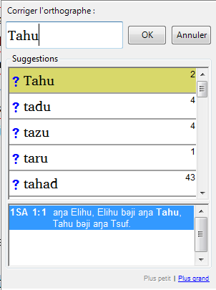Right-click a word which is underlined in either red or grey
* Either type the correction in the box or select the correct word   
  from the list
* Click **OK**

When possible, it is better to use the spelling check even when making minor corrections as Paratext will remember the correction and can apply the correction if it happens again.

When there is more than one correction, a dialog box is displayed. Choose as appropriate:   
**Yes =** changes this verse and looks for the next **No =** skips this verse and looks for the next  
**Yes to all – is too dangerous, DON’T use it  
Cancel =** stops changing any more

Spell checking – current book

## Spell checking – current book [◙ VO02b]

* Checking > Spell Check Current Book

A window appears with a list of some words in the current book.

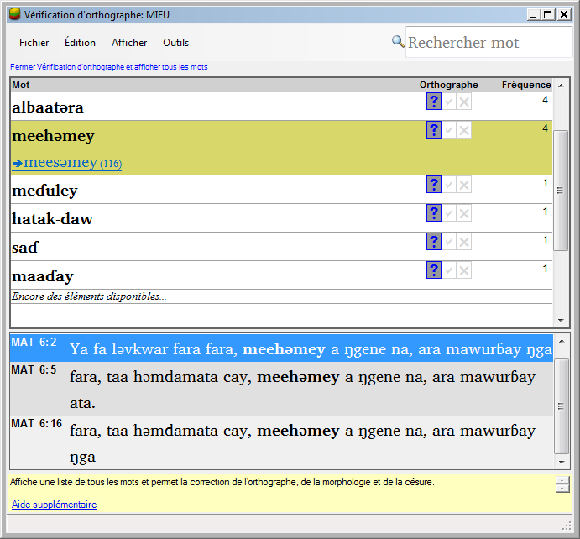

* Make corrections as explained above
* Click «*More items available*» to see additional words.
* Continue as needed.

Spell checking – from the wordlist

## Using the new checks

In the Wordlist

* Tools > Spell check >
* Choose the desired check (see descriptions below)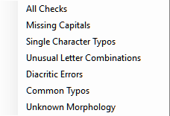

A list of words is displayed.

* Make the corrections as needed.
* Click «*More items available* » to see more words.
* Continue as needed.
* When the list is finished, a message is displayed

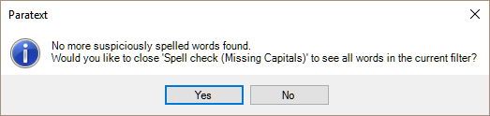

* Click **Yes**.

## All checks

This runs all of the checks. This is very useful as it will find all types of errors and even words with multiple types of errors.

## Missing Capitals

*A list of words is displayed with links to the capitalised form.*



* Click the blue link to the capitalised form



* Click the appropriate blue link
* Show incorrect (to see the verses)
* The two forms are acceptable (to accept both forms)
* Capitalise All (to correct all the words)

## Single Character Typos

A list of words is displayed with links to other words which are similar but only have one letter different.

## Unusual Letter Combinations

A list of words is displayed which have unsual combination of letters (such as consonant or vowel clusters …).

## Diacritic Errors

A list of words is displayed with links to other words which are the same except for the diacritics.

## Common Typos

A list of words is displayed which have the *same type of problem* ***which have already been corrected*** *in other words*. E.g. if you have already corrected "teh" as "the", and it finds "tehm" it will suggest "them".

## Unknown

A list of words is displayed which the computer has not been able to guess the morphology based on other words.

## Find incorrectly joined or split words

In the Wordlist (Tools – Wordlist)

* Tools > Find Incorrectly Joined or Split Words

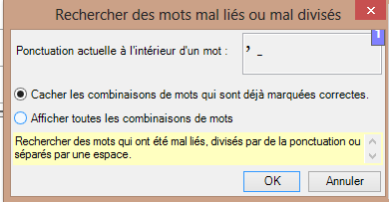

* Type in any word medial punctuation
* Click **OK**

A list of words is displayed with similar words grouped together.

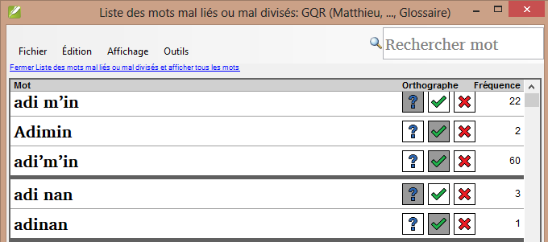

## Correct a word which was incorrectly marked

* Find the word in the list (using the filter if necessary)
* Click on the line
* Click the correct spelling status.

# BT : A 4-Step process for consistent Biblical Terms

Introduction

The Biblical terms rendering window and the separate Biblical terms tool are very useful to make sure you are consistent in the use of terms, especially key terms. This module explains a simple 4-step process to make your Biblical Terms consistent. This process should be considered part of the translation process and not a check.

Where we are

You are translating a verse in Paratext and you want to see what renderings have already been chosen for the terms in the current verse and then make sure they are consistent with other verses.

Why this is important

For your readers to understand your text, you need to be consistent in your use of terms. It is a big task to make them completely consistent. If you start from the verse you are translating and work from there the task is more manageable. **The goal is to have consistently rendered Biblical Terms and well documented decisions on why changes were made.**

What you are going to do

This method boils down to a short list of steps:

**1.** **Find** all the ways you have rendered this term, and enter them in the renderings dialog.

**2.** **Choose** which rendering is/are best, and record why it is best.

**3.** **Document** why you rejected the other renderings.

**4.** **Clean up** your translation by making this rendering consistent throughout your translation. (Make Consistent, Standardise, Normalise, Harmonise).

**Repeat** with next Biblical Term you find in the Biblical Terms Renderings window.

In Paratext you will

* + - 1. Find the way your have rendered the term in the verse and then expand to find all the ways you have rendered this term, and enter them in the renderings dialog.
      2. Choose which renderings are best, and record why.
      3. Document why you rejected the other renderings.
      4. Clean up your translation by making this rendering consistent throughout your translation.
      5. Repeat with next Biblical Term you find in the Biblical Terms Renderings **window**.

Summary

This module shows you how to:

## Open the Biblical terms rending window [◙ VT01]

* Click in your project
* File > Open Biblical terms rendering
* File > Select Biblical terms list
* Choose the desired list
* Click OK.

## Find the terms for the current verse

* Is there a tick in the found column?
* If there is a tick, your verse uses the term and you can continue with the next term.
* If not, you need to either correct your text or add the new term you have used (see below).

## Add another rendering

If the term you have used needs to be added to the list:

* Select the rendering of the term in your text.
* Copy it (ctrl+c)
* Double-click in the renderings cell.

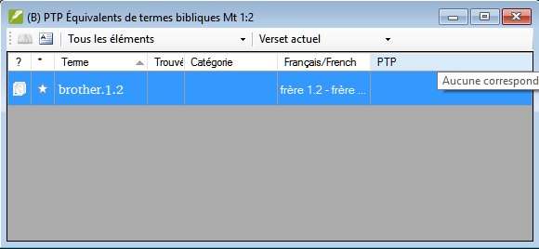

The edit renderings dialog is displayed.

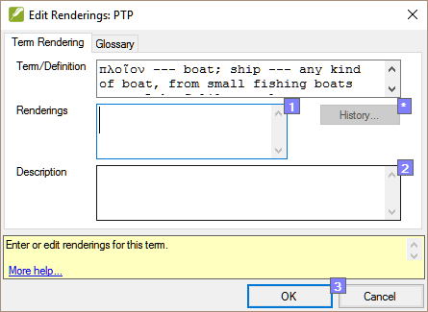

* Paste (ctrl+v) the rendering in the dialog box.
* Click OK.

## Find other verses in the current book with the same Biblical term

* Double-click on a word in the term column

The Biblical Terms Tool opens

* From the second filter button choose current book
* Add renderings for the term from the verses until the terms in all verses are been identified (see below).

## Add renderings from the other verses

* Select the rendering in the verse
* Add the rendering using Ctrl+A
* Continue until all terms for those verses have been identified.

## Dealing with verses that don’t use the term [◙ VC05]

There are times when a verse is translated without using the actual term. For example when a pronoun is used. In this case you need to deny that it is an error.

* Click red cross  to the left of the verse reference link.

The red cross turns into a green tick with a small red x  (and/or the verse disappears from the list).

If you click on the cross by mistake, click on it again and it will return to a red X.

## Identify the best term

* Double-click on the term in the top pane.

The edit rendering dialog is displayed listing all the renderings that have been added.

* Decide on the best rendering
* Cut (ctrl+x) and paste (ctrl+v) it to the top of the dialogue box
* Add * as necessary to combine similar renderings

## Reject all the others

* Select and cut the other renderings.

## Document the reason for the change

* Click on the History button
* Type in the reason why the others were rejected and why the first was the best.
* Click OK
* Click OK

## If you need more than one rendering

You can add more than one rendering if appropriate. In this case it is good to add a back translation in brackets after then rendering. For example,   
 slave (slave)  
 guy * work fo (guy that works for)

* Open the Edit renderings dialog box
* Edit the renderings as needed.

## Clean up other books (as time permits)

* Change the filter so that all the published books are displayed.
* Clean up verses as necessary.

## Add the Biblical terms notes (ongoing discussion)

If you are still deciding on the rendering you should add a rendering discussion note

* Double-click on the note icon (in the second column)

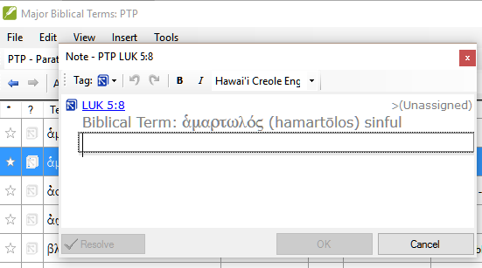

* Type in the note
* Assign the note as necessary.
* Click OK.

## Add the decision to the renderings description

* Double-click on the term
* Type the agreed on rendering in the description field



* Click OK.

## Add a term

In Paratext

* From your reference text, do a find (using Edit>Find) and search for the term.

A list is displayed showing the verses with that term.

From the list of results

* Edit > Add to Project Biblical Terms, then choose *your project*

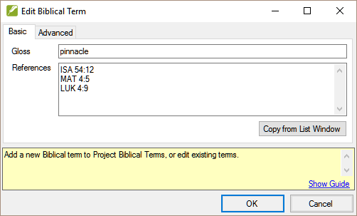

* Edit the gloss if necessary
* Click on the Advanced tab
* Type in a name for the term
* Click **OK**

# FC: Formatting checks

Introduction

In this module, you will find and correct formatting and layout errors.

Where we are

You have typed your draft into a project in Paratext. You will use the checklists to find and correct errors related to the formatting and layout errors.

Why this is important

A New Testament contains more than just chapters and verses. There are also titles, section headings, and several types of paragraphs. These checks allow you to be sure that the layout of your text is correct, and your titles etc. are consistent.

What you are going to do

You will use the checklists to

* compare your titles and section headings
* check your paragraph breaks
* compare the paragraph markers in your text with those of your reference text
* add markers for special text formatting

Summary

This module shows you how to:

## Using the checklists – generic

There are a number of checklists which differ slightly but they have the following in common:

How to display the checklist

* Tools > Checklists > choose the desired list
* Add a comparative text (if desired) by clicking on the Comparative Texts button.
* Select the verses/books (as necessary) using the Select Range button.

Making corrections

* Click the Edit link to correct any errors
* OR Click the reference link to see more context

Close the list

* When you have finished with the list, close it by clicking the X at the top right corner of the window.

## Using checklist – Section headings (\s1)

Check that

* The headings are consistent with your reference text
* All headings start with a capital.
* There is no punctuation at the end.
* They are not too long.

## Paragraph breaks

* Tools > Checklists > Markers
* Choose your reference text as the comparative text
* Click Settings

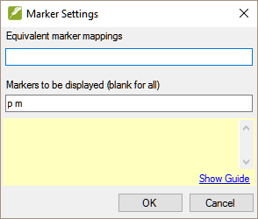

* Type the paragraph makers to be displayed   
  (e.g. p m)
* Click OK.
* Make any corrections by clicking on the blue Editlink.

OR

* Click on the blue verse reference link.
* Make the necessary corrections in Paratext.
* Return to the checklist by clicking on the icon on the taskbar.

## Layout and indents

* Tools > Checklists > Markers
* Choose your reference text as a comparative text.
* Click on Settings

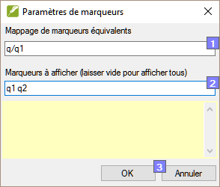

* Look for new paragraph markers such as q1 and q1
* Click OK.
* Make any corrections as shown above.

## Add USFMs to format special text

* See the list of passages with special formatting (in appendix taken from Logos)
* Add the USFM as necessary (see module KD or help if necessary).

# PD : Printing Drafts

Introduction

In this module you will learn how to print a draft of your translation for checking and revising.

Where we are

You have entered and checked your translation in Paratext and are now ready to print out a copy. Your project must be registered before you can print.

Why this is important

It is much easier to revise and check your work on paper than on the computer. You can also give it to more people if it is on paper.

What you are going to do

You will first produce a PDF version of your translation, which you can print or share with non-Paratext users. If necessary your can copy the PDF file onto your USB stick and take it to a computer with a printer.

Summary

This module shows you how to:

## Create a PDF file [◙ IE01]

Make sure you have completed a markers check before printing a draft.

* File > Print Draft
* Check that your project is selected.
* Choose which book(s) and chapters to print.
* Choose the page settings as follows :
* Page size:   
  210mm, 297mm (A4) ou   
  148mm, 210mm (A5)
* Columns : **1**
* Margins :   
  **25** mm (for A4) or   
  12 mm for A5
* Text body font: Charis SIL (or Charis SIL Compact)
* Size: **10** (or 11)
* Line spacing:   
  1.0 (for single spacing)
* Click **OK** and wait, the file will open in your PDF reader.

If there are marker error a message box will appear. Click **No,** then correct the errors and try again.

## Print PDF [◙ IE02]

*In Adobe Reader*

* File > Print.
* For A5
* Choose **Booklet**
* Orientation : portrait

*To print double-sided*

* Click the **Properties** button
* Choose Finition/Finishing
* Choose Print on both sides
* Orientation **Landscape**
* Click **OK**

If you need to use spaces before complex punctuation the ask for changes to be made in your PrintDraftChanges.txt

## Copy PDF file to a USB stick

Paratext saves the PDF file in the PrintDrafts folder or your project folder. For example, C:\Users\**User**\Documents\My Paratext 8 Projects\**XXX**\PrintDraft

There are many ways to copy files. One method is described below.

* Hold the Windows Key ()and type E

Window Explorer opens.

* Go to your My Paratext 8 Projects folder.
* Double-click on your project folder
* Double-click the PrintDraft folder
* Right-click on the desired PDF file
* Choose Send to
* Choose your USB stick.

# BC2 : Basic checks

|  |  |  |
| --- | --- | --- |
| Setup | Using  Inventories | Basic  checks |

Introduction

In this module you will learn how to run several more basic checks (characters, punctuation, capitalisation and repeated words). As in the first module, it is easier to run the checks from the project plan. However, if you want to check more than one book then you need to run the checks from the checking menu.

Where we are

You have typed your translation into Paratext. Make sure you have checked the chapter/verse numbers and markers as described in module BC1 before continuing.

Why this is important

Paratext has eleven basic checks. You have already seen the first two (chapter/verses and markers). The next set of checks help you find errors related the characters, punctuation, capitalisation, repeated words. Although these errors may not affect the content of the text is makes the text easier to read.

What you are going to do

Most of the checks require some setup to be done by your administrator. In this module you will:

* Confirm that the setup has been done
* Run the basic check
* Correct any errors.

Summary

This module shows you how to:

## Confirm the setup

**Note**: Before you can run the other basic checks some form of setup must be done by your Administrator.

The setup may be either an inventory, rules or settings.

## Using inventories to setup checks [◙ VT02]

These inventories show what is currently in your text, that is, both the good and the bad. You need to work through the inventory and tell Paratext which elements are correct (valid) and which are errors (invalid).

Once you have finished the inventory you will be ready to do the check.

* From the **Checking** menu, choose the appripriate inventory (for example ***Character inventory***).
* Click on an element in the list in the top pane.

The verses are shown in the bottom pane.

* For each element in the top pane, choose either Valid or Non valid.
* Repeat for the next element.
* Click OK when finished.

Details for the checks

## Characters [◙ VT02]

This inventory helps you identify all the incorrect characters, **i.e. the characters which are not in your alphabet.**

* Checking > Character inventory
* For each element, choose either Valid or Non valid.
* Click OK
* Checking > Run Basic Checks
* Check « Characters »
* Click OK.
* Make any corrections as needed.

## Punctuation [◙ VT03]

Identify all the incorrect or misplaced punctuation marks. (Use the Unicode character column to clearly identify the punctuation.)

* Checking > Punctuation Inventory
* Check each punctuation mark and its context.

The contexts can be: word initial, word medial, word final or isolated (space before and after).

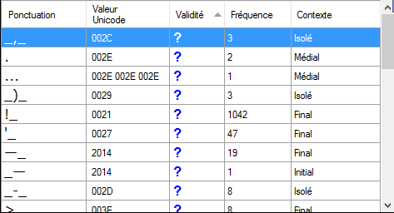

* Checking > Run Basic Checks
* Click beside « Punctuation»
* Click OK.
* Make any corrections as needed.

## Repeated words [◙ VT05]

This check finds the words which have been immediately repeated in the text.

* Checking > Repeated words inventory:
* For each item on the list, choose Valid or Non valid.
* Checking > Run Basic Checks
* Check « Repeated words »
* Click OK.
* Make any corrections as needed.

## Capitalization [◙ VT06]

There are four inventories needed for the capitalisation check but only one check. You may need to click the Options button to add markers or punctuation.

* Checking> Markers Missing Final Sentence Punctuation
* Checking> Markers followed by a lower case letter
* Checking>Punctuation Followed by a Lower Case letter
* Checking> Mixed Capitalization
* For each item on the list, choose Valid or Non valid.
* Checking > Run Basic Checks
* Check « Capitalization »
* Click OK.
* Make any corrections as needed.

## Making minor corrections

It is possible to make minor corrections from within a displayed inventory.

* Click on a verse in the low pane
* Hold the Shift and double-click
* Make the correction
* Click *OK*.

However it is preferable to use the wordlist or the spell checker to correct all the errors at once.

**Revision** :

There are many basic checks in Paratext 8. The table below summarizes the setup needed for each of the checks.

|  |  |
| --- | --- |
| **Check** | **Setup** |
| Chapter/verse numbers | **none** |
| Markers | Marker inventory |
| Characters (Combinations) | Character inventory |
| Punctuation | Punctuation inventory |
| Capitalization | 4 inventories   * Markers Missing Final Sentence Punctuation * Markers followed by a lower case letter * Punctuation Followed by a Lower Case letter * Mixed Capitalization |
| Repeated words | Repeated words inventory |
| Unmatched pairs of punctuation | Unmatched pairs of punctuation inventory |
| Quotations | Quotation rules (from Checking menu) |
| Numbers | Number settings (from checking menu) |
| References | Scripture reference settings (from project menu) |
| Quoted text | **none** |

It is possible to run all the checks at the same time, however when running the checks for the first time it is better to run them one at a time to avoid large list of errors.

# 

# UN : Using Notes

|  |  |  |  |  |
| --- | --- | --- | --- | --- |
| Inserting and editing notes | Resolving notes | Filtering notes | Printing notes | Checking notes |

Introduction

As you are translating and checking you may want to make comments on various errors or issues. You may also want to record your discussions on key terms and spelling issues. Paratext allows you to record these comments either in the text, the Biblical terms list or the wordlist.

Where we are

You are typing or revising your text, wordlist or keyterms and need to make comments on an issue you have seen.

**Attention** : **Notes** and **footnotes**  are very different. Footnotes are printed in the New Testament whereas notes are for questions and comments and are not printed in the New Testament.

What you are going to do

You will

* **create** notes in the text using different icons,
* **edit** the notes and **resolve** notes
* open a note window from the text
* filter the list
* **print** a list of the notes
* add **rendering discussion notes** to a Biblical terms list
* add **spelling notes** to the wordlist.

## Different types of project notes

You can choose from many different icons for your project notes in Paratext :

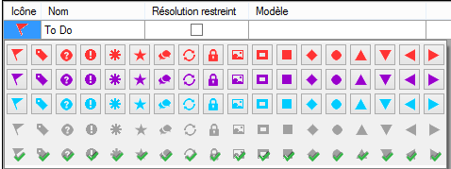

An icon can have four different colours or shapes

|  |  |  |
| --- | --- | --- |
| **Icon** | **Description** | **Meaning** |
| C:\Users\User\AppData\Local\ParatextHelp\HelpSystemImages\Notes.UnreadNote.jpg | Icon has a border and a yellow background color. | The note has a least one unread comment. |
| C:\Users\User\AppData\Local\ParatextHelp\HelpSystemImages\Notes.01flag1.png | Icon is red, purple, or light blue. | A **project** note assigned to you, or to the whole team, or unassigned. |
| C:\Users\User\AppData\Local\ParatextHelp\HelpSystemImages\Notes.01flag4.png | Icon is gray. | A **project** note assigned to someone else. |
| C:\Users\User\AppData\Local\ParatextHelp\HelpSystemImages\Notes.01flag5.png | Icon is gray with a green tick. | A **project** note with resolved status. |
| C:\Users\User\AppData\Local\ParatextHelp\HelpSystemImages\Notes.spelling1.png | Icon is a white question mark on the cover of a book. | There is a **spelling discussion note** for this word. (Wordlist only.) |
| C:\Users\User\AppData\Local\ParatextHelp\HelpSystemImages\Notes.spelling4.png | Icon is gray with a question mark on the cover of a book. | There is NOT a spelling discussion note for this word. (Wordlist only. ) |
| C:\Users\User\AppData\Local\ParatextHelp\HelpSystemImages\Notes.consultant3.png | Icon is a light blue plus. | A **consultant** note. |
| C:\Users\User\AppData\Local\ParatextHelp\HelpSystemImages\Notes.globalconsultant3.png | Icon is a light blue globe. | A **global consultant note**. |
| C:\Users\User\AppData\Local\ParatextHelp\HelpSystemImages\Notes.conflict1.png | Icon is a black exclamation point within a red triangle. | There is a Send/Receive merge **conflict** because two users have made different changes to the same verse. |
| C:\Users\User\AppData\Local\ParatextHelp\HelpSystemImages\Notes.biblicalterm1.png | Icon is a white arrow on a blue background. | There is a **rendering discussion note** for this Biblical Term. (Biblical terms window or tool only) |
| C:\Users\User\AppData\Local\ParatextHelp\HelpSystemImages\Notes.biblicalterm4.png | Icon is gray with an arrow on the cover of a book. | There is NOT a rendering discussion note for this Biblical Term. (Biblical terms window or tool only) |

Summary

This module shows you how to:

## Setup additional note types

## (One must be an Administrator)

* Project > Propject proprities and settings
* Click the Notes tab
* Click the Add Tab button

A new line is added

* Click the icon on the new tag line
* Choose the desired icon
* Click « Name »
* Type a name
* Repeat for any other new tags.

## Inserting a project note [◙ UR01]

* Click in the text where you want the note.
* If desired, select the word or phrase in question
* Insert > Note
* Choose the desired tage from the list
* Type the text for the note
* Click OK.

An icon is displayed beside the text.

## Open notes [◙ UR05]

* File > Open Notes...
* Select your project.
* Click OK.

A note window opens.

* Adjust the filters as needed.

If the window is blank then change the filters – the first filter is for the type of note, the second is for the location (verse, chapter, book …).

## Add comments to an existing note [◙ UR02]

* Click the icon() in the texte.
* Type the comment
* Click OK

## Add comments from a notes window

* Click arrow to expand the note (
* Type your comments in the textbox.

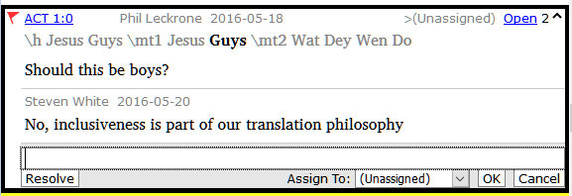

* Resolve or assign the note as needed.
* Click the arrow to collapse the note.

## Assign a note to someone [◙ UR03]

* Click the icon () in the text.
* Type your comments
* Click « Assign to »
* Choose as desired
* Click OK

## Apply notes to multiple texts

* Open the note from the text
* Click the « Multiple » button
* Choose the projects
* Click OK
* Click OK again to close the dialog box.

## Reattach note

If the text you select when you insert a project note is later changed or deleted, the note icon moves to another location in the verse.

* Click the note icon in the text.
* Click the Reattach Note button C:\Users\User\AppData\Local\ParatextHelp\HelpSystemImages\Notes.ReattachNote.pngon the toolbar.
* Select the word(s) to attach it to.
* Click OK.

## Resolve a note [◙ UR04]

* Click on the icon () in the text.
* Type another comment if necessary.
* Click Resolve button 
* Click OK

## Print a notes report [◙ UR06]

* Click in a notes window.
* Filter the list as desired.
* File > Print
* Choose the printer.
* Click OK.
* Close the window.

## Delete notes

* Click the note icon
* Click the small red x
* Click Yes to permanently delete you comment.
* If there are more comments, continue to delete the next comment.

## Notes window

* There are four dropdown boxes on the toolbar
* Notes filter
* Verse filter
* Search
* Sort by [verse, date, assigned to]

## Notes filter

* Click the first button/list
* Choose an existing filter as appropriate

## Define a new filter

* Click the first button/list

Choose New filter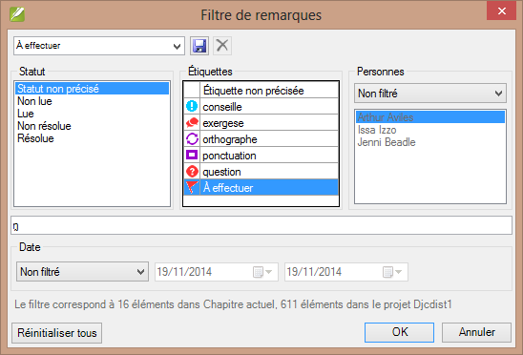

* Choose the status, tag, person and date as desired.
* Click OK.

## Save a filter

* Define the filter as needed.
* Click in the textbox at the top left.
* Type a name for the filter
* Click the save icon.

# Appendix – Bible Books

## Three letter abbreviations

**Old Testament**

|  |  |  |
| --- | --- | --- |
| [Genesis] [GEN] | [Exodus] [EXO] | [Leviticus] [LEV] |
| [Numbers] (NUM) | [Deuteronomy] (DEU) | [Joshua] [JOS] |
| [Judges] (JDG) | Ruth [RUT] | 1 Samuel [1SA] |
| 2 Samuel [2SA] | [1 Kings] [1KI] | [2 Kings] [2KI] |
| [1 Chronicles] [1CH] | [2 Chronicles] [2CH] | [Ezra] [EZR] |
| [Nehemiah] [NEH] | Esther [EST] | Job [JOB] |
| [Psalms] [PSA] | [Proverbs] [PRO] | [Ecclesiastes] (ECC) |
| Song of Songs] [SNG] | [Isaiah] [ISA] | [Jeremiah] [JER] |
| Lamentations [LAM] | [Ezekiel] [EZK] | Daniel [DAN] |
| [Hosea] [HOS] | Joël [JOL] | Amos [AMO] |
| [Obadiah] (OBA) | [Jonah] (JON) | [Micah] (MIC) |
| [Nahum] (NAM) | [Habakkuk] [HAB] | [Zephaniah] [ZEP] |
| [Haggai] [HAG] | [Zechariah] [ZEC] | [Malachi] [MAL] |

**New Testament**

|  |  |  |
| --- | --- | --- |
| [Matthew] [MAT] | [Mark] [MRK] | [Luke] [LUK] |
| [John] [JHN] | [Acts] [ACT] | [Romans] [ROM] |
| [1 Corinthians] [1CO] | [2 Corinthians] [2CO] | [Galatians] [GAL] |
| [Ephesians] [EPH] | [Philippians] (PHP | Colossians (COL) |
| [1 Thessalonians] (1TH) | [2 Thessalonians] (2TH) | [1 Timothy] (1TI) |
| [2 Timothy] (2TI) | [Titus] (TIT) | [Philemon] (PHM) |
| [Hebrews] (HEB) | [James] (JAS) | [1 Peter] (1PE) |
| [2 Peter] (2PE) | [1 John] (1JN) | [2 John] (2JN) |
| [3 John] (3JN) | Jude (JUD) | [Revelation] (REV) |

# 

# Chad special characters

Certain characters used in Chadian languages are not found on the keyboard. To type these, you need to type more than one key.

The table below shows the special characters in Chad and the combination of keys needed for each character.

|  |  |  |  |
| --- | --- | --- | --- |
| **Les caractères du Tchad** | | **The tones** | |
| Type … to have | | Type … to have | |
| ;’  ’ | ;n ŋ | ] | à low tone |
| ;b ɓ | ;o ɔ | [ | á high tone |
| ;c ç | ;p œ | = | ā mid tone |
| ;d ɗ | ;y ƴ | ^ | â falling tone |
| ;e ɛ |  | | | ǎ rising tone |
| ;f ə |  | # | ä umlaut |
| ;h ɦ |  | ~ | ã tilda |
| ;k ɨ |  | _ | a̰ under tilda |
| ;m ɲ |  | ` | a̧ cédille |

To type the other characters as below:

|  |  |  |  |  |
| --- | --- | --- | --- | --- |
| **Type** | **to have** |  | **type** | **to have** |
| ;] | ] |  | ;; | ; |
| ;[ | [ |  | ;{ | “ |
| ;= | = |  | ;} | ” |
| ;^ | ^ |  | ;( | ’ |
| ;| | | |  | ;) | ’ |
| ;# | # |  | ;<[1] | « |
| ;~ | ~ |  | ;> | » |
| ;_ | _ |  | ;, | ‹ |
| ;` | ` |  | ;. | › |

# Common USFM Markers

\c chapter

\v verse

\p paragraph (small indent)

\m same paragraph (return to the margin)

\s1 section title

\r parallel references

\q1 quotation (poetry level 1)

\q2 quotation (poetry level 2)

\h header

\mt1 main title

\mt2 secondary title

\k .... \k* keyword (in the glossary)

\w ... \w* indicates a word in the glossary (in the text)

**Introductions**

\**i**p paragraph

\**i**s section heading

\**i**o1 outline 1

\**i**li1 list level 1

\**i**li2 list level 2

# Special text

* Matt 1.2-16: The genealogy, which is not normal prose. Often set in a special poetic form so the fathers line up and the form indicates this is a special list (with comments).
* Matt 5.3-10; The beatitudes. Often set in poetic form.
* Matt 6.9-13; The Lord's prayer. Often set in poetic form.
* Matt 21.9: The greeting to Jesus. Often set in poetic form.
* Matt 27.37: The sign on the cross. Often set in small caps.
* Matt 27.46: The scream of Jesus. Sometimes set in italics (because it is in another language).
* Mark 5.41: The command to the dead girl. Sometimes set in italics (because it is in another language).
* Mark 11.9: The greeting to Jesus. Often set in poetic form.
* Mark 14.36: *"Abba."* Sometimes set in italics (because it is in another language).
* Mark 15.26: The sign on the cross. Often set in small caps.
* Mark 15.34: The scream of Jesus. Sometimes set in italics (because it is in another language).
* Mark 16.9: A note indicating another ending of Mark. Sometimes separated by a horizontal rule.
* Luke 1.46-55: The song of Mary (or Elizabeth; the Magnificat). Often set in poetic form.
* Luke 1.68-79: The song of Zechariah. Often set in poetic form.
* Luke 2.14: The chant of the angelic choir. Often set in poetic form.
* Luke 2.29-32: The praise of Simeon. Often set in poetic form.
* Luke 3.23-38: The genealogy. Often set in a special poetic form similar to the genealogy in Matthew.
* Luke 6.20-22: The beatitudes (blessings). Often set in poetic form.
* Luke 6.24-26: The beatitudes (woes). Often set in poetic form.
* Luke 11.2-4: The Lord's prayer. Often set in poetic form.
* Luke 19.38: The greeting to Jesus. Often set in poetic form.
* Luke 23.38: The sign on the cross. Often set in small caps.
* John 7.53-8.11: The story of the woman caught in the act. The section head usually occurs prior to verse 53. Sometimes, although rarely, separated by a horizontal rule before and after the text.
* John 12.13: The greeting to Jesus. Often set in poetic form.
* John 17.1-27: The prayer of Jesus. Sometimes, although rarely, set in paragraphs with added indentation from the left margin.
* John 19.19: The sign on the cross. Often set in small caps.
* Acts 15.23-29: The letter. Often set in paragraphs with added indentation from the left margin.
* Acts 23.26-30: The letter to Claudius Lysias. Often set in paragraphs with added indentation from the left margin.
* Rom 8.15: *"Abba."* Sometimes set in italics (because it is in another language).
* Rom 11.33-36: The doxology. Often set in poetic form.
* Rom 16.3-16: The special greetings. Sometimes set in a special poetic form similar to the genealogies.
* Gal 4.6: *"Abba."* Sometimes set in italics (because it is in another language).
* Phil 2.6-11: The attitudes. Sometimes set in poetic form.
* 1 Tim 2.5-6: A creed. Sometimes set in poetic form.
* 1 Tim 3.16: A creed. Often set in poetic form.
* 2 Tim 2.11-13: A creed. Often set in poetic form.
* 1 John 2.12-14: I write to you. Sometimes set in poetic form.
* Rev 1.4-7: The greeting and doxology. Sometimes set as poetry and prose.
* Rev 2-3: The seven letters. Often set in paragraphs with added indentation from the left margin.
* Rev 4.8: A chant. Sometimes set in centered poetic form.
* Rev 4.11: A chant. Often set in poetic form.
* Rev 5.9-10, 12, 13: Songs. Often set in poetic form.
* Rev 7.5-8: A list. Often set in a special poetic form.
* Rev 7.10, 12: Chants. Often set in poetic form.
* Rev 7.15-17: A declaration. Sometimes set in poetic form.
* Rev 11.15, 17-18: Chants. Often set in poetic form.
* Rev 12.10-12: A declaration. Often set in poetic form.
* Rev 15.3-4: A song. Often set in poetic form.
* Rev 16.5-7: A declaration. Often set in poetic form.
* Rev 17.5: A sign. Often set centered, in small caps.
* Rev 18.2-8: A declaration. Often set in poetic form.
* Rev 18.10-24: A series of woes. Often set in poetic form.
* Rev 19.1-8: A series of declarations. Often set in poetic form.
* Rev 19.16: A sign. Often set centered, in small caps.
* Rev 21.19-20: A list. Sometimes, although rarely, set in poetic form[2]

1. For Keyman << for « and >> for », ;< for ‹ and ;> for ›
2. Eppler, D., Goller, T., Wendland, E. R., Culy, M. M., Harold Greenlee, J., & Deibler, E. (July 2008). *NOT No. 3* (Vol. 7, Mt 1:2–Re 21:19). SIL International.