ParaTExt 8  
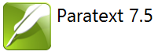

Participant’s Manual   
Administrators/Supporters

SIL International

ParaTExt

Version 8

Participant’s Manual   
Administrators/Supporters

SIL International

Titre: ParaTExt Version 8, Participant’s Manual Administrators/Supporters

Genre: Teaching material

1st Edition: xx copies

© SIL International 2016

# Table of Contents

Table of Contents 5

Introduction 7

Goal 7

Course Objectives 7

IS: Install ParaTExt 8 8

Install Paratext 8 9

Register a Paratext 7 user (first time run Paratext) 10

Manually updating your existing version of ParaTExt 10

MD: Migrate Data 11

Migrate Shared project 13

Prepare a Paratext 7 project for migration 13

Register a project (before migrating the project) 14

Migrating a registered project 16

Additional Project settings 17

Reg: Registration 19

Register for Paratext 8 (with a Google account) 20

Filling in the registration 20

Register for Paratext with a non-google account 21

Change your Paratext code 21

Register a new user (who does not have an email address) 23

Translation project by an unrecognised organisation 24

Creating a new project 25

Create a new project 26

Name for the project 26

Specify language 27

Type of project 29

Register the new project 29

Editing your registration 29

IR: Installing Resources 30

Installer resources – Internet (DBL) 31

Installer resources – files 32

PP1: Setup Project Plan 33

Add the organisational base plan 34

Remove current plan (if necessary) 34

Configure – assigning checks to a stage 35

Configure - Reordering tasks / Move tasks to another stage 36

Configure - Delete tasks 36

Configure - Assign tasks to team members 37

Configure - Books to include 37

Copy a task from one project to another 38

Setting up a project for success 40

Convert project 42

To convert a project 43

Changing the short name of the project 43

Removing deleted files from the project history 43

Clean up Paratext Live history 43

Convert encoding to 65001 – Unicode (UTF8) 44

Normalising – composed or decomposed 44

Replacing old User names 44

Convert the project 44

Cross-references 45

Extract the references from the model text 46

Check your scripture reference settings 46

Check your Language Settings 46

Insert Cross references 47

Make your own xrf file 47

# Introduction

## Goal

The participants will perform various administrative tasks involved in installing Paratext 8 and migrating users and projects from Paratext 7 (including setup of the project plan).

## Course Objectives

At the end of the course, the participant will be able to:

* + 1. Install ParaTExt 8
    2. Migrate projects from ParaTExt 7
* Prepare a ParaTExt 7 project and its users for migration to ParaTExt 8
* Migrate both a shared and non-shared project
  + 1. Configure the Project Plan
* Add an organisational base plan
* Customise the plan
* Assign tasks
  + 1. Register users and projects
    2. Create a new project
    3. Convert a project

# 

# IS: Install ParaTExt 8

* 1. Introduction

Paratext 8 is the result of a concerted effort to streamline the process of managing translation projects and accessing resources.  As a result, both the data and the servers had to change. People wanted less hassle with registration and waiting for codes to be approved. They wanted access to more resources. They wanted a free version of Paratext that didn’t need a license in order to use. Now we have that in Paratext 8.

* + 1. Where we are

You may already have Paratext 7 installed and now want to install Paratext 8.

* + 1. Why this is important

Paratext 7 and 8 can both be installed at the same time but you need to understand the limitation of using them together.

* Both may be installed
* They use different data directories
  + My Paratext Projects (Paratext 7)
  + My Paratext 8 Projects (Paratext 8)
* They use different data servers
  + 1. What are you going to do?

You will install Paratext 8 (without uninstalling Paratext 7). You will also install an update from a MSP file.

Summary

This module shows you how to:

## Install Paratext 8

Note: you do not need to uninstall Paratext 7 or earlier. But you may need to uninstall and earlier version of Paratext 8.

* Double-click on the installer file.
* After you agree to the license terms, click Install.

This step might take a few minutes if the installer needs to install the .NET 4.5 Framework on your computer.

* If a dialog appears and asks for your permission, click Yes or provide the credentials as required.

The Destination Folder step appears.

* Accept the defaults for the folder.

Note: Paratext 8 data may not share the same directory as Paratext 7 data.

* Click Finish and then Close.
* The first time you launch Paratext 8 you will need to enter your Paratext 8 registration code. Information on how to obtain this code is on the [Registration](http://pt8.paratext.org/registration/) page.

## Register a Paratext 7 user (first time run Paratext)

All users need a new registration for ParaTExt 8.

* Run Paratext (for the first time)
* Choose the interface language

A dialogue box is displayed asking for your registration code.

* Go to <http://p8.paratext.org/registration>
* Log-in with a gmail work account
* Click on the Register link
* Type in the user name
* Type in the user’s Paratext 7 registration code
* Copy the new code
* Return to Paratext
* Paratext will paste the code

Paratext is ready for use.

## Manually updating your existing version of ParaTExt

New update files have a .**msp** extension instead of PUD or SPUD as in the past.

* Make sure Paratext is closed.
* Double-click on the msp file to install the update.

# 

# MD: Migrate Data

* 1. Introduction

Migration is the process of moving a project (including all settings files) from Paratext 7 to Paratext 8. This is similar to the process of setting up S/R for the first time in ParaTExt 7.x. Note: all users of a project have to migrate at the same time.

* + 1. Where we are

You have already installed ParaTExt 8 and you have a ParaTExt 7 project that you want to use in ParaTExt 8.

* + 1. Why this is important

In order to get the full functionality of ParaTExt 8 your project needs to be migrated. Paratext 7 and Paratext 8 use different send/receive servers so there is no way for a project to be shared with some users on Paratext and some users on Paratext 8.

Users can have both Paratext 7 and Paratext 8 on their computers at the same time, and run one or the other, but no project can be shared simultaneously with users in Paratext 7 and other users in Paratext 8.

Once you have migrated the project, everyone on the team needs to get the migrated project, and only do work in Paratext 8 from then on.

You need to have a good Internet connection to migrate the project, but if you usually work without an internet connection, you can keep working that way in Paratext 8 once the project is migrated.

* + 1. What are you going to do?

To migrate a shared project:

* You must do a send and receive in Paratext 7 from all team members in Paratext 7 prior to migration to Paratext 8.0.
* Get the most authoritative data on one computer by doing send and receive between all the computers.
* One computer on the team initiates the migration
* The rest of the team gets the project in Paratext 8 via Send/Receive.
* Once the project is shared, all team members should only use PT 8 for that project from then on.

To migrate a non-shared project:

* Open the project
* Click Migrate

Summary

This module shows you how to:

## Migrate Shared project

If you administer a project that is shared in Paratext 7 and you want to migrate it to Paratext 8, this is how you need to proceed.

## Prepare a Paratext 7 project for migration

All your users have to migrate at the same time.

* ***All users*** must do send/receive in Paratext 7 (then cease working in Paratext 7).
* The **Administrator** then confirms that the text is in a good state.
* The **Administrator** then loads Paratext 8.
* File > Open Project/Resource
* Click the box at the bottom left to show Paratext 7 projects
* 
* Choose the project to migrate.

It will likely be described as “v7, unregistered.”

Some active Paratext 7 projects have been registered already for Paratext 8. If yours is one of them, Paratext 8 will show the project as P7 but show it as registered. You can skip the registration step we’ll show you if your project is already registered.

* Click OK to start migrating the project.

The ‘Migrate shared project’ dialog is displayed.

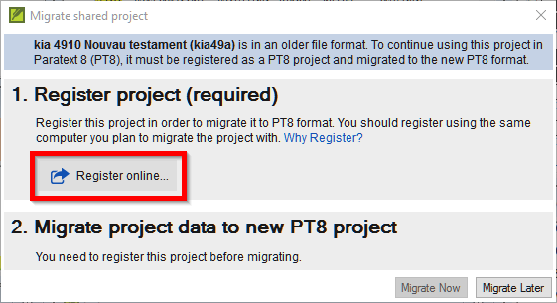

Paratext 8 may tell you the project must be registered (if it is not preregistered) and it must be migrated to Paratext 8.

## Register a project (before migrating the project)

* Click the Register online button
* Fill in the web form. (Fields with an asterisk [red star] are required.)
* **Short name:** You cannot change the project short name,
* **Long project name:** You can change the long project name.
* Paratext 8 requires a language identifier for your language. Use the search in the language name to find the **ethnologue** code for your language. You can modify the language name, or use the “advanced” to specify or create additional information about the language.
* **Scope** refers to whether the project will be a complete Bible, or complete Bible including apocrypha, or New Testament, or some other grouping of books. You can add more books to your project scope later as this can be changed after registration.
* **Translation type** refers to whether it is the first translation for this language, a revision of an existing translation, or a new translation, or a translation including study materials, such as a study Bible. For a revision, you have to specify that you have permission from the rights holders of the translation you are revising.
* Specify the **country** where the language is spoken. You can type a few letters of the name then pick the desired country. You can specify more than one country if the language spreads across borders
* The **rights holder** would be the organization you expect will have the copyright for a print edition. This too can be changed if it needs to be later on.
* The last four fields allow you to add more information if it is relevant for describing your project. (None of these are required.)
* You can mark if your project is **confidential** or not. Only Paratext 8 registered users can view the name of standard projects, a confidential project will be hidden even from other Paratext 8 users.
* Another option is to mark a project as a **test or training project**. You can use this option for test projects you create, or for projects you use for practice in a training course.
* The last requirement to register is stating that you agree to follow the **FOBAI guidelines** in your translation project, and you agree to store a backup copy of your project in the Digital Bible Library.

The Digital Bible Library is a tool for making translations available online or for mobile users, but your project will not be available to anyone until you agree to make it available.

* To submit the registration, click Submit.

The registry should tell you that the project registered successfully. (You may need to scroll to the top of the page to see this).



* Or click Migrate later to back out of migrating and finish your preparations.

When you are ready, go through the migration again. Clicking “Migrate later” will not cancel the project registration if you just submitted it, you can skip the registration steps and go on to migration

## Migrating a registered project

* Go back to Paratext

It should detect that the project is now registered, and inform you of that.

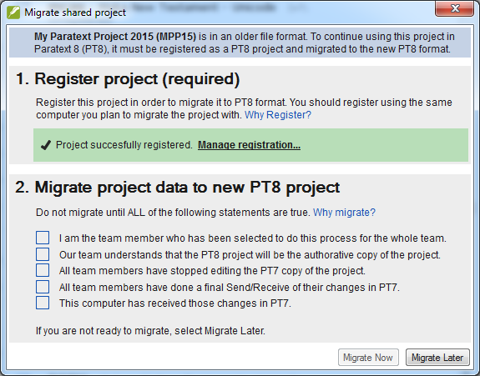

* The migration step has several boxes you have to check off to verify that you understand what is involved.
* Put a check in these boxes if they are true, then click Migrate now to proceed.

If you need to do something else before you are ready to migrate, click “Migrate Later,” and go finish your preparations.

When you click “Migrate now,” Paratext will copy the project from your Paratext 7 into your Paratext 8, and will also do a send/receive to the Internet.

* Now your colleagues can go to Paratext 8 and do a Send/Receive to receive the migrated project.

If they do not have an Internet connection, you can do a send/receive to USB or a network folder, and they can receive the project into Paratext 8 that way.

## Additional Project settings

* Language identifier: After you click “Migrate now”, Paratext 8 may tell you that need to specify a language identifier for your project.

You can verify what the language name and language identifier are for your project by going to Project > Project Properties and settings, and looking at the language settings. The language identifier is in brackets after the language name.

* Books: The *project properties and settings* has a “Books” tab, you specify here the books that you plan to track their progress in your project.

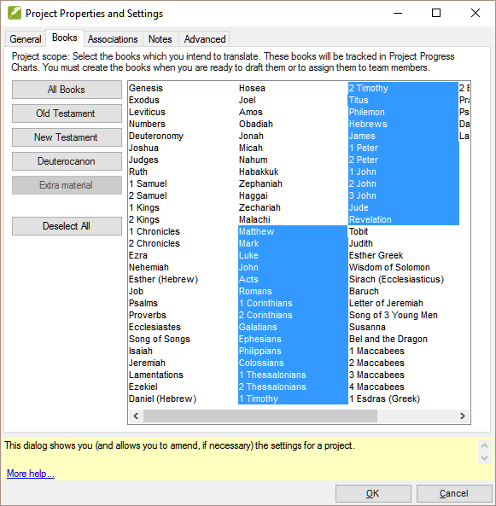

You can choose book by book, or specify Old Testament, New Testament, Deuterocanon by using the buttons. You can change this list of books later on in the project if your plans for the project change.

Migrate Non-shared project

If a project was not shared in Paratext 7 then you do not have to register it in order to migrate.

* File > Open Project
* Click ““Show Paratext 7 Projects”
* Choose the desired project
* Click Migrate Now

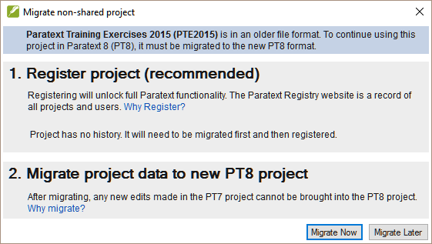

When you click “Migrate” the project will be migrated to the Paratext 8 folder and ready to be used. The registration status will determine what functionality exists for the project.

* Note: Non-shared projects don’t have to be registered but it is recommended.

**Remember, no one should edit the project anymore in Paratext 7.** That would be wasted effort as no one else will see their changes. To help your team members remember this, you could have them remove the project from their Paratext 7 once they have gotten it in Paratext 8. Or maybe they can uninstall Paratext 7 from their computer if they don’t need it for other projects.

# 

# Reg: Registration

* 1. Introduction

Starting with P8 it is a requirement that projects share their basic metadata information with the translation community. It is strongly encouraged that they share progress information [some organizations and/or donors may require this].

* + 1. Where we are

Paratext 8 has been installed on your computer and you have the Paratext 7 registration codes for your team members.

* + 1. Why this is important

In Paratext 8 both users and projects should to be registered. Access to specific text resources, e.g. TEV, is determined by what organization you are a part of

Projects may be registered by the administrator (or a consultant serving as an administrator)

Other organizations/users are notified and may object to BoG. Basic project metadata information is available to all in ParaTExt community

If your project is not registered you will not have access to

* Interlinearizer
* Internet Send/Receive
* Statistical glossing tools (guess translation)
* Print Draft
  + 1. What are you going to do?
* You will register a P8 user
* You will register a new P8 project
* You will see what information is displayed in the ParaTExt Registry for a registered project.

Summary

This module shows you how to:

## Register for Paratext 8 (with a Google account)

* Go to[**registry.paratext.org**](https://registry.paratext.org/) in your web browser.

The “Sign in” screen is displayed.

* Enter your email account.

The site will check if your account exists, and if it is on a Google server, you will have the choice of authenticating with Google.

* Choose to authenticate with Google

A new screen is displayed asking for your password.

* Enter your Google account password.
* Click yes to authorize the Paratext site to use your profile information.

You are then ready to start filling in your Paratext registration.

If you do not have a Google address see page xx)

## Filling in the registration

* + - 1. Click the appropriate circle to choose your registration type (new registration, previous Paratext 7 registration, or previous Paratext 8 registration).
      2. Choose your organization from the list, or if you are not a member you can leave this blank.

Anyone can register to use Paratext, but people who are not members of a translation organization and who are not members of a registered project will not be able to use all the features of Paratext and will have access to only a few resources.

* + - 1. Select your country.
      2. Enter if relevant your field entity and your supervisor
      3. Explain why you want to use Paratext.
      4. Check the box at the bottom if you want to get email announcements about Paratext updates and news.
      5. When finished, click “Register”

The server will give you a code. It will also send this to your email.

Hang on to that email, or to the code that is displayed here, because if you lose it, there is no way to look it up again. (This is a security feature, user codes are not stored on the server so they cannot be stolen if someone hacks onto the server)

## Register for Paratext with a non-google account

* If your email account is not on a Google server, or **if** it is but **you choose to not use Google to authenticate**, the registry server will ask you to enter a password.

This does not have to be your email password, you can choose a different password for your Paratext registration.

* Enter the password you want to set up
* Enter it again as a confirmation

The server will send an email to **your** account with a link to verify.

* Open your email, go to the link, and proceed to register for Paratext (see above).

## Change your Paratext code

(Generate a new code)

* Go to the registration website, [**registry.paratext.org**](https://registry.paratext.org/).
* 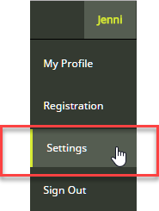Log in (if you are not logged in)
* Click on your user name at the top left.
* Click on Settings.
* 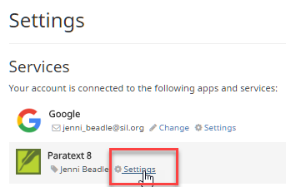Besides Paratext 8, click ‘Settings”.

The registration Details screen is displayed.

* Click on the Generate button to generate a new code

The code will be sent to your email address.

* Start Paratext

If it connects to the Internet it will detect that the old code is no longer valid, and it will ask you to update your registration info.

* Go to your email, and copy the new code.
* Go back to Paratext

It may already have pasted in your new code.

* If it has not, paste in the new code into the registration form, and click OK.

You should be reregistered.

You will need to do this on any other computer that you have Paratext installed on as well.

If Paratext is not connecting to the Internet to detect that you need to give a new code, go to

* Tools > Registration Information and paste the code there.

## Register a new user (who does not have an email address)

Any administrator of a registered project can create new user registrations if they need to add people to their project. These users do not need to have an email address.

* Go to registry.paratext.org
* Log in if you are not already.
* Click on Users

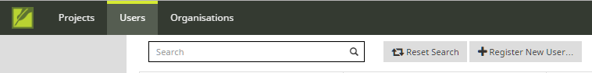

* Click the “+ Register new user” button.

The new user registration form is displayed.

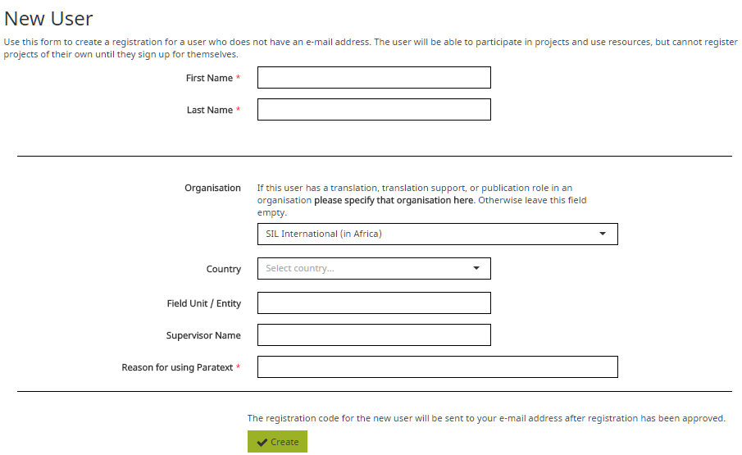

* Fill in their name, and the rest of their information.
* You do not need to supply their email address.

A user added by someone else cannot be made an administrator of a project, nor a consultant. If you would like to make someone a consultant or administrator they can register themselves for Paratext, then you can add their name to the project.

* When competed, click “Create”

The server should respond by emailing you the user code for the new user.

Hang onto this code, because it cannot be recovered again if you lose it.

## Translation project by an unrecognised organisation

* If a translator is not part of a recognised organisation, she can apply to the BoG ([boardofgovernors@paratext.org](mailto:boardofgovernors@paratext.org)) to be members of "Independent Translators" pseudo organization

It is unclear how many text resource owners will grant access to this group

# 

# Creating a new project

* 1. Introduction

In this module you will create and register a new project.

* + 1. Where we are

You have already installed Paratext and registered a user.

* + 1. Why this is important

A new aspect in Paratext 8 is that projects need to be registered as well as users. This may feel like an extra complication, but it does offer benefits to users.

As we saw in the user registration section, the project administrator can create registrations for users they want to be part of their project.

* + 1. What are you going to do?

We will create and register a new project.

Summary

This module shows you how to:

## Create a new project

* File > New Project

The New project dialog is displayed.

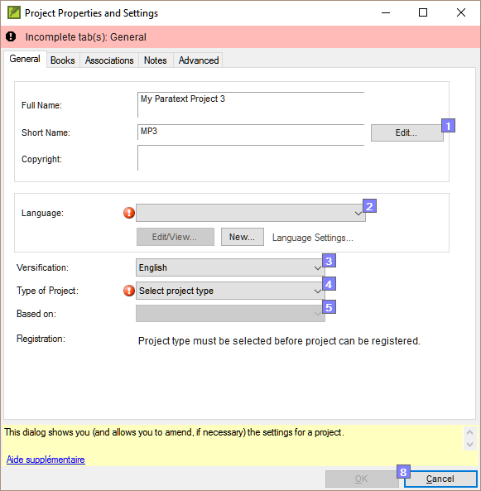

## Name for the project

* Click the Edit button

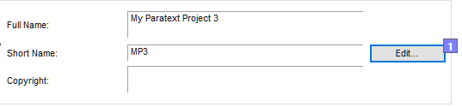

The “edit name” dialog is displayed

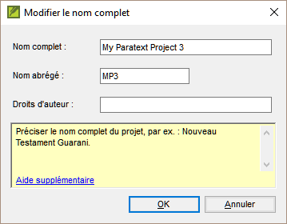

* In the name section, give the project a name and a matching short name.

Once you create a project name, the short name cannot be changed, because this is the name Paratext will give to the folder containing the project files, and also the name given to the project on the Internet server.

## Specify language

* If you have another Paratext project in the same language, you can just pick the language from the list in Paratext [2]. If not, you will need to create a new language.
* Click on New

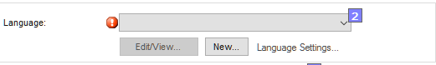The Choose language identifier box is displayed.

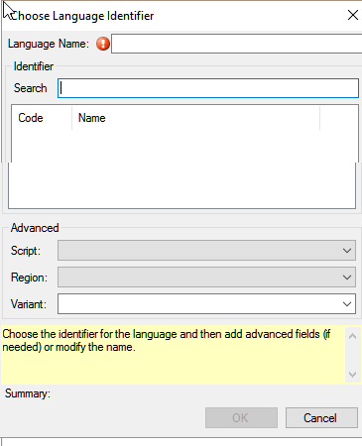

* Click in the Search box
* Start typing the name of your language

Paratext will display matching names.

* Click on your language in the list.

Paratext will add the language name.

* Click OK.

You can also specify additional information if needed in the “advanced” section of the language settings dialog.

## Type of project

* Click the drop-down list beside “Type of Project”

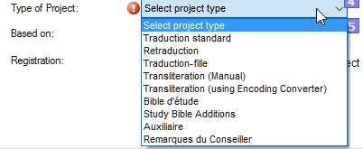

* Choose the appropriate type for your project.

If it is a back translation, or a daughter or transliteration project, you will need to define the source.

## Register the new project

* Make sure you have given the project a name and chosen the project type.
* Click Register online to go to the registration page
* Fill in the information (see above)
* Click Register to submit.

Paratext should detect that the project is now registered,

* Click OK to create the new project.

## Editing your registration

As you work in your project, you can change your registration information later on.

* From Paratext, make sure you are connected to the Internet,
* Project > Project Properties and settings
* Click the “Manage registration” link.

This will bring up the project registration info and you can edit it. Any project administrator can edit the registration info.

# IR: Installing Resources

* 1. Introduction

In this module you will learn how to install resources.

* + 1. Where are we?

You have already installed Paratext 8 and registered a user.

* + 1. Why is this important?

In Paratext 8, the resources are downloaded from the DBL (Digital Bible Library). Each user can download them directly, but if your Internet connection is limited, you can share the downloaded files with other users.

* + 1. What are we going to do?
* Download resources from the Internet
* Install resources from a file.

Summary

This module show how to:

## Installer resources – Internet (DBL)

* From the File menu, choose Download/Install resources.

A dialogue box is displayed

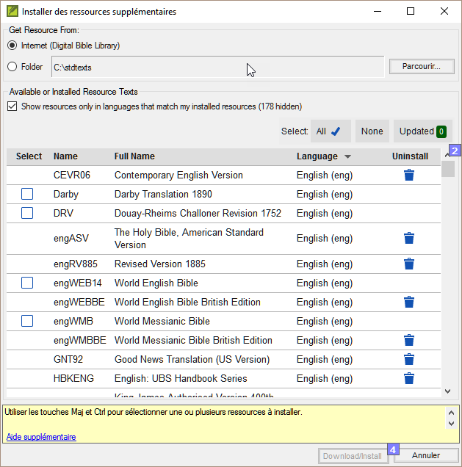

* Make sure Internet has been chosen.
* Click the check boxes to the left of the desired resources.
* Click Download/Install

## Installer resources – files

* From the File menu, choose Download/Install resources.

A dialogue box is displayed

* Click Folder
* Click Browse.
* Go to the folder which contains the downloaded resource files.
* Select the desired resources.
* Click Download/Install

# PP1: Setup Project Plan

* 1. Introduction

“Progress tracking” based on a Project Plan and Assignments and Progress is a new feature in Paratext 8 that will impact the day-to-day work of translation teams.

* + 1. Where are we?

Before you can add the plan the project must have been created/or migrated.

* + 1. Why is this important?

The Project Plan feature allows the administrator to define a set of translation tasks that your translation project will follow. Paratext comes with sets of pre-defined plans from the various Bible translation organisations that you can use a starting point. However, every project is different and therefore after adding the base plan it will need to be modified for the team.

Typically, organizations want conformity at the “Stage” level in order to facilitate meaningful tracking of the progress of project across the entire organization. However, **every plan will need to be customized at the task level.**

If a task is important to you and your team and you want to track its progress, then it can be included in the project plan (even if it doesn’t require Paratext to do the task).

* + 1. What are we going to do?

You will use a combination of two features: the *Project Plan* and the *Assignments and Progress* (sometimes referred to as “progress tracking”) to manage the plan by assigning team members to tasks, and tracking their progress in completing those tasks.

* Add the organizational base plan to the project (remove an old plan if necessary)
* Customize the plan for the team by adding/deleting and moving tasks
* Assign the tasks to the various team members.

Summary

This module shows you how to:

## Add the organisational base plan

If you have an existing plan, you need to remove that plan before you can add another plan. (See below for instructions.)

* Project > Project plan settings
* Click Manage plans
* Click below Show Base Plan

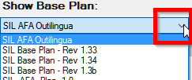

* Choose your organisational base plan
* Click the Copy Plan arrow.



* Click OK.

The plan and its tasks are added to the project.

## Remove current plan (if necessary)

If the project has an old plan, you need to delete each of the current stages before adding a new base plan.

* [Project > Project plan settings
* Click Manage plans]
* Click on the last stage

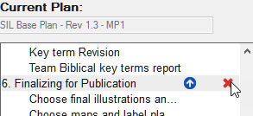

* Click the X to remove the stage
* Confirm you want to modify the plan.
* Confirm you want to delete the stage.
* Repeat for remaining stages
* Add the new plan (see above)

## Configure – assigning checks to a stage

* From the Project menu, choose Project plan
* Click on the Checks tab

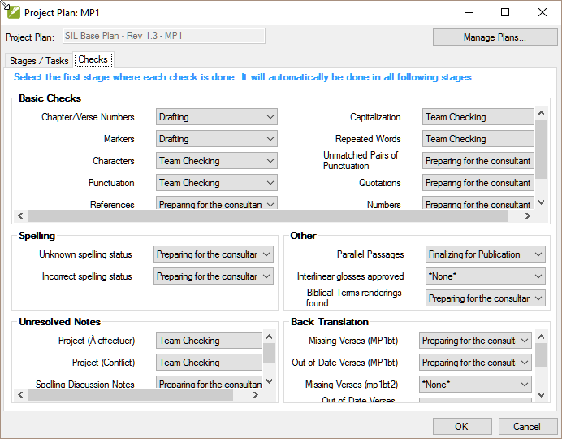

* For the desired check, drop down the list

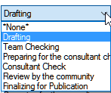

* Choose the new stage or *none*

## Configure - Reordering tasks / Move tasks to another stage

It is possible to reorder tasks and even move tasks to another stage. However, not all organisations permit this.

* From the Project menu, choose Project Plan
* Click the Stages / Tasks tab.
* Select the task you want to move.
* Click the up arrow or the down arrow to move the task to a different point with respect to the other tasks, or to move it to a different stage.

You may get a messages asking to confirm.

* Click OK.

## Configure - Delete tasks

* Click on the Stage/Tasks tab
* Click on the task to delete

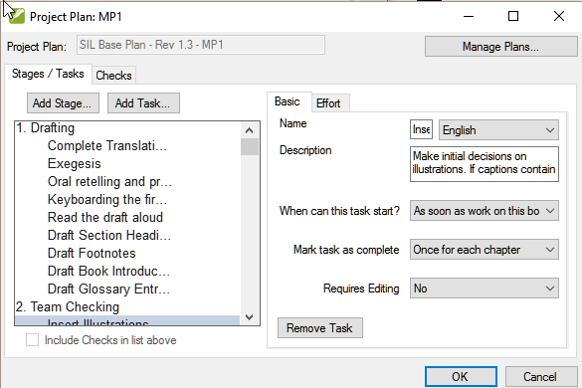

* Click the Remove Task button
* Click OK.

## Configure - Assign tasks to team members

* From the Project menu, choose Assignments and Progress
* For the task to assign, click to dropdown the menu
* Choose the team member to assign

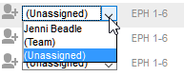

* Repeat as necessary
* Click OK.

## Configure - Books to include

* Project > Project properties and settings
* Click the Books tab
* Choose the books that you want to track progress.
* Click OK

## Copy a task from one project to another

Note: Follow the steps below to copy a task from the project plan for project ORIG (the "origin project") to the project plan for project DEST (the "destination project").

* + - 1. From the File menu, select Open Project/Resource.
      2. Select project DEST and click OK.
      3. From the Project menu, select Project Plan....
      4. At the upper right of the dialog, click Manage Plans....
      5. From the "Show Base Plan" drop-down, select the project plan for the ORIG project.
      6. On the Current Plan side of the dialog (the DEST project side), click the row that has the task which you want to precede the added task.   
         *If you want the added task to be the first task in the stage, select the stage name.*
      7. On the Base Plan side of the dialog (the ORIG project side), hover over the task you want to add and click the solid arrow that appears.

The task is copied to the project plan for the DEST project and becomes unavailable to be copied again to the project plan for the DEST project.

* **Optional**: To move the task, click the up arrow or the down arrow that appears when you hover over a task on the Current Plan side of the dialog.
* Click OK to close the "Manage Plans" dialog.
* Click OK to close the "Project Plan" dialog.

The copied task has the same name and progress rate as it had in the project plan for project ORIG.

## Updating the project plan (for a migrated project)

For projects that have already completed a number of stages at the time of switching to Paratext 8 the **Tasks table view** and/or  the **Stage table view** of Assignments and Progress can be helpful in marking multiple books, stages or tasks, complete.

* Click on your project.
* From the Project menu, choose Assignments and Progress.
* Choose *Stages table* view.

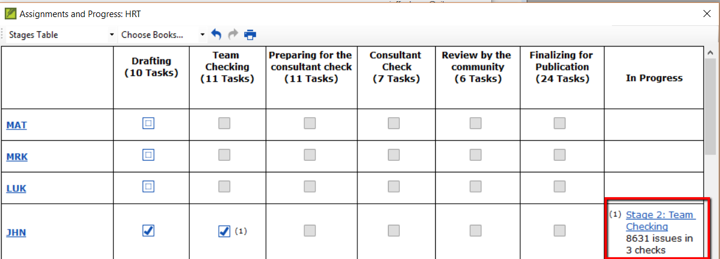

* Check the box for the stages of each book as appropriate.

The stage will be marked as complete unless errors have been found. The errors must be corrected before the stage can be marked as completed.

Paratext 8 will likely find errors for most older projects since new checks have been added.

# Setting up a project for success

Things to consider:

* + 1. It is a dynamic process
* When a project is brand new there aren’t a log of settings that can be fixed in concrete.
* As the project matures some of the inventories begin to make sense.
  + 1. Who is working on the project?
* Setup the Users, Roles and Permissions
* Would it be helpful to have a “Simplified Menu”?
  + 1. Do you need to customize the settings?
* custom.sty
* change settings of the stylesheet
* names of markers (in other languages)
* colour to help identify features?
* custom.vrs
* identify verses that are different from default versification
  + 1. What orthography will be used?
* Put the orthography in the language settings.
* (Keep in mind that what you put in the language settings could be going to the “Speech and Language Data Repository”
* How will the characters be keyed?
* Keyman
* AutoCorrect.txt
  + 1. What Quotation system will be used?
* Set up the quotation rules (Dynamic)
* Think about your rules
* Test what you have
* Adjust the rules
* Make corrections to the rules / or text as necessary
  + 1. When you have some text data
* Begin setting up the inventories
* Let’s start at the very beginning (Characters)
* Look for options in the inventories!
* Is the item valid all the time? Or just in certain situations?
* Scripture Reference Settings
* What book names are you using?
* What is the format for a reference?
* Where will you put the origin of notes?

# 

# Convert project

* 1. Introduction

If you have ever needed to rename your project, reduce the size of your project, change user names, change the encoding or struggled with composed/decomposed diacritics, then the convert project tool will help you solve these problems.

* + 1. Where are we?

You must be the administrator of the project to do these conversions.

* + 1. Why is it important?

Although, it is possible to make some changes to existing projects through the project and setting dialogs, several major changes require that a new project is created. Using the convert project dialog allows the new project to keep the project history.

* + 1. What are we going to do?

We will work through the six changes that can be made to your project.

* Changing the short name of the project
* Removing deleted files from the project history
* Clean up Paratext Live history
* Convert encoding to 65001 – Unicode (UTF8)
* Normalising – composed or decomposed
* Replacing old User names

Summary

This module shows how to:

## To convert a project

* From the Tools menu, choose Advanced, then Convert Project

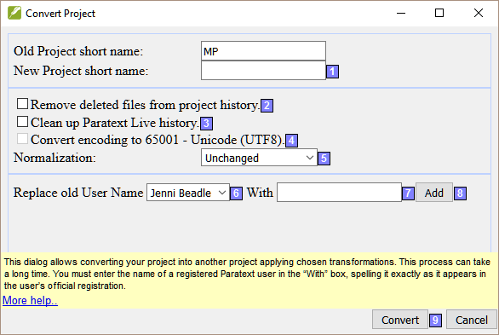

## Changing the short name of the project

* Confirm that the old name of the project is correct. (If not, close the dialogue and click in the correct project window, and access the dialog again.)
* Enter the new short name for the project in [1].

## Removing deleted files from the project history

[2] Select this if you have deleted files (such as large illustration files) that you no longer want to be part of project history and no longer want in the project repository.

## Clean up Paratext Live history

[3] Select this if you have edited the project with Paratext Live and want to replace names in the project history.

## Convert encoding to 65001 – Unicode (UTF8)

[4] Select this to convert a standard project encoding to Unicode.   
C:\Users\User\AppData\Local\ParatextHelp\HelpSystemHtml\warning.gifNOTE: This will not work to change the encoding if your project has a "hacked font".

## Normalising – composed or decomposed

[5] Select **Composed (NFC)** or one of the options in the drop-down list if the data in your project was created using a mix of composed and decomposed characters. (See the Guide for more details).

## Replacing old User names

* [6] Select the name of the user you want to replace from the drop-down list.
* [7] Enter the name of a registered Paratext user in this box.
* [8] Add, a summary of the replacement appears, with a "Remove" button.
* (Click Remove if you either made a mistake in typing the name in the "With" field OR decide not to make the replacement.)

## Convert the project

* [9] Click OK to convert the project.

See the note in the guide regarding shared projects.

# 

# Cross-references

* 1. Introduction

Most languages do not have access to concordances and other Bible study materials in their own languages. Adding cross references to your New Testament can greatly help your reader understand the text by helping your reader find passages on similar themes.

* + 1. Where are we?

Before you can insert cross references from a model text your administrator must have created all the books (and chapters and verses) in your project. They can be empty but they must be present.

* + 1. Why is it important?

Reading the New Testament is not like reading a novel. Having access to cross references allows your reader to find similar passages on the themes. But adding cross references one by one is too tedious. The insert cross reference feature allows you to insert all the cross references at once and also converts the book names and punctuation to match your scripture reference settings. Extracting cross-references from a model text allows you to easily insert the same cross-references.

* + 1. What are we going to do?

We are going to do three things: export the cross reference from a model text; then make sure all the settings for book names and scripture references have been entered for your project; and finally insert the cross references.

If you don’t have a model text with the desired cross-reference you can create your own list and import it.

Summary

This module shows how to

## Extract the references from the model text

* Open the model text.
* From the Insert menu, choose Cross references then Extract cross references
* Type a *filename*
* Cliquez sur OK.

Note : Resource texts may not allow you to extract cross references.

## Check your scripture reference settings

* From the Project menu, select Scripture Reference Settings.
* Verify that the following have been correctly defined for your project (edit them if necessary):
* The punctuation on the Reference Format tab.
* The book abbreviations on the Book Names tab.
* Click OK.

## Check your Language Settings

* From the Project menu, select Language Settings …
* Click the Other Characters tab.
* In the Verse segment characters box, enter at least six different characters separated by spaces.
* Click OK.

## Insert Cross references

* From the Tools menu, point to Cross References, and then select Insert Cross References.
* Click Browse....
* Find the .xrf file of extracted cross references.
* Select the file, and click Open.
* If desired, select one or more of the options:

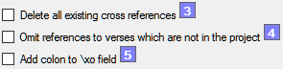  
(see the guide for more info)

* Click OK

If the Copyright box displays a copyright notice or required statement of acknowledgments, copy the text, and then paste it wherever you keep this kind of information for the project.

## Make your own xrf file

* Create a new text file
* Copy the first few lines from an existing cross reference xrf file.

Copyright = …  
Model=GNT92  
Versification=English  
VerseSegmentCount=6

* Add a list of references where the first is the verse to put in the cross reference and then second is the cross reference.

MAT.1:23 {ISA.7:14}

MAT.26:64 {DAN.7:13; PSA.110:1}

* Save the file in the cross reference folder.

Insert the cross references – ParaTExt will fail if there are any errors.