A PACVS signature in v-safe free text: a pre-registered study whose primary analysis was not feasible, with exploratory results
Matthew Halma¹
¹ Open Source Medicine, Tallinn, Estonia. ORCID: 0000-0003-2487-0636. Corresponding author: Matthew Halma, Director, Open Source Medicine, Pärnu mnt. 139c, 11317 Tallinn, Estonia; mhalma@opensourcemed.info.
Running title: PACVS signature in v-safe free text. Article type: Original Research Article. Draft of 2026-11-12.

Abstract
Introduction. Post-acute COVID-19 vaccination syndrome (PACVS) is a chronic multi-system condition that pharmacovigilance systems code one symptom at a time. CDC's v-safe collected free-text answers at 3, 6 and 12 months after a dose; one prior analysis used its structured answers [22], none its free text.
Objective. To test, under a pre-registered protocol, whether long-term v-safe free text shows a coherent, persistent and under-captured multi-domain symptom pattern.
Methods. Four questions were registered (osf.io/gnfpd) before any long-term text was read: clustering of nine candidate symptom domains, early onset and persistence, under-capture and dispersed coding in VAERS, and burden. Text was classified by a frozen keyword lexicon plus a language model and validated against CDC's MedDRA coding, with a confirmatory gate of precision and recall of at least 0.85.
Results. Of 7,819,251 entries, 1,595,121 were long-term. Only fatigue passed the gate, so the primary analysis could not be run; all results are the registered nine-domain sensitivity analysis. Of 8.62 million person-doses with a long-term survey, 87,229 (1.01%) met the case definition. Domain pairs co-occurred 1.25 times as often as chance (p = 0.001) in every dose and manufacturer stratum and in 1.06 million VAERS reports; nulls matched on how much each person wrote, or fixing each person-dose's own domain count, left a core in which cognitive symptoms co-occurred with sleep 2.3 to 2.7 times and with fatigue 2.1 to 2.3 times more than chance. The registered onset test was uninformative (28% early against a schedule-dependent 71% expected). Symptoms recurred at a later survey in 47 to 60% of cases, depending on how cases qualified, against 1.5 to 10.5% of comparison groups. Cases reached VAERS about as often as named acute diagnoses (rate ratio 0.94, 95% CI 0.90 to 0.98), with less dispersed coding.
Conclusion. 1.01% of person-doses with a long-term v-safe survey describe a multi-domain pattern whose cognitive, fatigue, sleep and dysautonomia core clusters beyond chance after adjustment for verbosity; when the symptoms began could not be established. The classifier did not meet its pre-registered accuracy standard, so the findings are hypothesis-generating.

Key Points
- Of 8.6 million person-doses with a long-term v-safe survey, 1.01% described a multi-domain symptom pattern meeting a pre-registered PACVS-like definition; the registered onset test could not establish when the symptoms began.
- Cognitive symptoms, fatigue, sleep disturbance and dysautonomia co-occurred 1.4 to 2.7 times more often than chance under every null tried, including one that fixes each person's own number of symptoms; VAERS captured these cases at nearly the same rate as named acute events.
- The text classifier failed its pre-registered accuracy gate for eight of nine domains, so the findings are hypothesis-generating and argue for a validated classifier before any confirmatory claim.

Introduction
Post-acute COVID-19 vaccination syndrome (PACVS) is a complex multi-system condition following COVID-19 vaccination, with symptoms similar to long COVID: fatigue, cognitive difficulty ("brain fog") and post-exertional malaise among them. Assigning causality to vaccination has been difficult, especially for a complex multi-system disorder [1, 2]. That leaves patients without the coherent clinical entity on which compensation, treatment and research depend [3].
Prevalence estimates range from 0.003% to 0.9% of COVID-19 vaccine recipients [2]. The higher figure comes from an occupational survey of workers; the lower relies on verified reports, which understate the rate. Case series have described a coherent presentation [4–15], but their patients came forward attributing symptoms to vaccination. Screening and pharmacovigilance do not identify PACVS, because there is no disease entity to code to: a system can flag fatigue or brain fog one symptom at a time, but not a constellation.
A syndrome that spans several organ systems and begins weeks to months after vaccination is hard for routine safety surveillance to see. Spontaneous reports are coded one symptom at a time to MedDRA Preferred Terms, so a multi-system pattern is split across many terms. Their denominators are also unknown, so changes in reporting can reflect awareness of the system or the salience of the vaccination campaign rather than the rate of events [16]. Active surveillance designs usually count events inside a fixed risk window after the dose, so later problems fall outside it.
v-safe, CDC's smartphone check-in system, followed about 10 million COVID-19 vaccine recipients in the United States for up to a year, soliciting their condition at fixed time points, and has been used to examine preliminary signals from VAERS [17]. A followed cohort with solicited reports gives the denominator that stimulated reporting lacks. v-safe asked open questions at 3, 6 and 12 months after a dose. Released under FOIA, these answers are the largest body of long-term, participant-written text on post-vaccination health. Levi and Lu [22] analysed v-safe's structured check-in answers: among 9,904,924 enrollees aged 16 or older, 185,285 (1.87%) reported worse health lasting at least three months that they attributed to vaccination (2.24% of women), while 1.92% reported prolonged worse health without attributing it. Their phenotype rests on the participant's attribution and the structured health answers. The present study differs in using the free text to define a symptom-based phenotype that does not depend on attribution, in testing whether symptom domains cluster against a null model, and in examining onset and recorded VAERS filing. The two analyses were independent; the preprint was read on 12 November 2026, after this study was registered and after its registered results had been computed.
We asked four pre-registered questions:
- Coherence (Q1). Do nine candidate PACVS symptom domains co-occur within people more than their individual frequencies predict?
- Natural history (Q2). Do cases' symptoms begin within six weeks of a dose, and do they persist more than in people who had a severe first week and recovered?
- Detection (Q3). Are cases less likely than people with named acute diagnoses to reach VAERS, and are their VAERS reports coded to a wider spread of terms?
- Burden (Q4). How often do cases report health impact, medical care and call-centre contact? (Descriptive.)

Methods

Data sources
Source | Content | Use
v-safe free text (FOIA 24-01322, original and updated releases, under-3 file) [19] | 7,819,251 entries after de-duplication | Classification
v-safe registrants, vaccinations, health check-ins [19] | 145.0 million check-ins; dose dates, manufacturer, sex (no age field was present in the linked release) | Dose anchor, survey type, health answers
CDC MedDRA coding of the free text (November 2024 release) [19, 21] | Preferred Terms per entry; 99.9% of entries coded | Reference standard
v-safe call centre (FOIA 23-00925, 23-00926) [19] | Cases, care, VAERS-filed dispositions | Q3, Q4
OpenVSafe person pages [18] | Best-matching VAERS report per VAERS-filed person, score out of 11 | Q3
VAERS public data (dated 2026-06-03) [20] | Reports, MedDRA terms, symptom text | Q3, Q1 replication

Each entry was linked to its registrant, the check-in it answered, the most recent preceding dose, CDC's MedDRA codes and call-centre outcomes within 90 days. Entries redacted under FOIA exemption (b)[6] were excluded. OpenVSafe match data were read from its public per-registrant pages [18] on 2026-11-10 and 2026-11-11 for the 44,954 people whom the call-centre data marked as VAERS-filed, at one request per second, within the access the site's robots.txt allows for those pages; no bulk file exists, and no permission beyond the site's published access rules was sought. Only the VAERS ID, match score, confidence and runner-up score were kept.

Pre-registration
The protocol was registered on OSF (osf.io/gnfpd) on 2026-11-11, before any 3-, 6- or 12-month text was classified or read. Code enforced this: long-term text could not be classified until the registration link was set. The taxonomy (v1.0) was frozen on 2026-11-10. The closest prior work, Levi and Lu's analysis of v-safe's structured answers [22], was identified on 12 November 2026, after registration and after the registered analyses had been run; it did not change the registered plan, and no amendment was filed for it. Two amendments were filed before the results they govern were computed:
- Amendment 1 replaced the planned two-coder gold set, for which no coders were available, with CDC's MedDRA coding as the reference standard.
- Amendment 2 replaced the registered language model (GLM-5.3) with DeepSeek V4.1 Flash, because the first model's quota cost made the full run infeasible.

Classification
Layer 1 is a keyword lexicon for 21 themes, including the nine PACVS domains: fatigue and post-exertional malaise, cognitive, dysautonomia, sensory-neuropathic, sleep, pain, gastrointestinal, menstrual and cardiorespiratory. It also tags three exclusion themes (named acute diagnosis, unrelated cause, upper-respiratory infection) and flags entries about the time before vaccination. It was run on all entries.
Layer 3 is a language model (deepseek/deepseek-v4.1-flash, reasoning off, prompt v0.1) given the same closed theme list. It labelled every unique long-term text to which layer 1 gave no theme: 649,516 entries, 386,862 unique texts. Requests went through a zero-data-retention route; texts containing a detectable e-mail address or phone number were not sent. The final classifier is the union of the two layers.

Validation and the confirmatory gate
An entry was positive for a domain in the reference if CDC coded it to at least one Preferred Term listed for that domain in the frozen map. All long-term entries with a CDC code were evaluated, excluding redacted and pre-vaccine entries. We computed precision and recall with 95% Wilson intervals. A domain was confirmatory if both were at least 0.85 for the final classifier. As registered, if any domain failed, Q1 to Q3 were to be run on passing domains (primary) and on all nine (sensitivity).

Case definition and comparison groups
The unit is a person-dose. A case meets three criteria:
- At a 3-, 6- or 12-month survey S, the person reported health worse than before vaccination, or a health impact (unable to do normal activities, missed work or school, or needed care).
- Free text at S names at least two PACVS domains, or free text across at least two long-term surveys names at least two between them.
- Free text at S names no exclusion theme.
Three comparison groups were defined, mutually exclusive, with priority case, then (b), (c), (a):
- (a) No symptoms: no long-term survey worse or with impact, and no PACVS text.
- (b) Acute event: free text at any survey of that dose names an acute diagnosis.
- (c) Severe week 1, recovered: an impact or at least two domains in week 1, then no long-term survey worse or with impact.

Statistical analysis
Q1. We built a person-dose by domain matrix for person-doses with long-term text. The statistic is the sum, over the 36 domain pairs, of the people having both. The null permutes each domain column independently 1,000 times (seed 20261110), keeping each domain's frequency. The one-sided p-value is (1 + number of null values at least the observed) / 1,001. Per-pair p-values were Holm-adjusted. The test was repeated within each dose and manufacturer with at least 1,000 person-doses, and on VAERS COVID-19 report text classified by layer 1.
Q2. Onset is the first survey type (week 1, six weeks, 3, 6 or 12 months) whose text names any of the case's long-term domains. Each case's null probability of early onset is the share of their completed check-ins for that dose that were in week 1 or the six-week period. The number of early-onset cases was compared with this Poisson-binomial null by an exact one-sided test. Persistence compares cases with group (c) on the share naming a PACVS domain at a later long-term survey, among those who completed one. We used a risk difference with a Newcombe interval and a one-sided z-test.
Q3. Analysis was at the person level: a case if any dose was a case, otherwise group (b) if any dose was. A person reached VAERS if a call-centre contact within 90 days of an entry recorded a VAERS filing, or OpenVSafe [18], a project of OpenVAERS that matches v-safe records to VAERS reports on timing, dose and shared symptoms, matched them to a report. We call this measure recorded VAERS filing. It is not VAERS capture in general: a report filed without call-centre contact and not matched by OpenVSafe is not counted. Matches needed a score of at least 8 of 11, and reports matched to more than one person were dropped (main set: 25,913 people). A sensitivity set used high-confidence matches only (23,925 people). Capture was compared as a rate ratio with a log-scale Wald interval. Dispersion compared the Shannon entropy of matched reports' MedDRA terms between groups, using a 1,000-fold permutation of group labels.
Q4 and attrition. Q4 gives rates per 1,000 for health impact, care and call-centre cases by group. Case prevalence was bounded by assuming every person-dose without a long-term survey was well (lower bound) or a case (upper bound).
Disclosure. Only aggregates were exported. Any cell with fewer than 10 people was suppressed, and nothing was reported below the national level. No free text was quoted.

Decisions where the registration was silent
- Survey types 'day 0' to 'day 7' count as week 1 and 'week 2' to 'week 6' as six weeks; impact is any health-impact answer other than 'N/A' or blank; entries flagged as pre-vaccine by either layer were dropped.
- The registered layer 2 (embedding classifier) was not built; the final classifier is layers 1 and 3. Layer 3 labelled long-term text only, so week-1 and six-week text was classified by layer 1 alone.
- Persistence uses each case's first worse-or-impact long-term survey, and group (c)'s first long-term survey, as the reference point; Q3 is run per person, because VAERS outcomes attach to people.
- Q1's permutation was re-implemented after registration for speed (each domain's positive rows drawn directly), which gives the same null distribution.
- The model-sensitivity check used 2,000 long-term residue entries (seed 1), the pilot's sample size, because the registration fixed none.

Model-sensitivity check
As registered, a second model, claude-opus-5-5 through the Anthropic API, labelled a fixed sample of long-term text: 2,000 long-term residue entries drawn with seed 1 (the pilot's sample size, since the registration fixed none), 1,687 unique texts. A theme is model-sensitive if its entry count differs by more than 20% between the two models on the texts both labelled.

Analyses not in the pre-registration
These were specified after the registered results were seen, each for the reason given, and are reported as exploratory. They do not replace any registered result.
- Text-matched co-occurrence null. Reason: the registered null ignores how much each person-dose wrote. Each domain's positives are placed at random within strata of long-term characters (deciles) and of entries (1, 2, 3, 4 or more) crossed with deciles; expected pair counts are the within-stratum products summed.
- Curveball null. Reason: the text-matched null still lets a person-dose's own domain count vary. Curveball trades keep every person-dose's domain count and every domain's frequency (30 burn-in rounds, 3 between samples, 1,000 samples, seed 20261110), unstratified and within entries (1, 2, 3 or more) and text-length tertiles. The total pair count is then fixed by construction, so only the 36 pairs are tested, with upper- and lower-tail p-values.
- Exclusion criterion variants. Reason: the exclusion tags had low precision. Criterion 3 and group (b) from keyword tags only, and criterion 3 dropped; group sizes, Q2 and Q3 for each.
- Persistence by qualification route and against group (d). Reason: the across-surveys route is partly circular and group (c) has no long-term impact by definition. Cases that met criterion 2 at a single survey are separated; group (d) is long-term responders worse or impacted at a long-term survey who named fewer than two domains there, excluding cases and acute events.
- Onset from structured week-1 answers. Reason: free text under-records early symptoms, check-boxes do not. Week-1 symptoms and severity for fatigue (fatigue field or 'Fatigue or tiredness'), pain (headache, joint pains, muscle or body aches) and gastrointestinal (nausea, diarrhoea, vomiting, abdominal pain), among cases with the domain and in group (a).
- Symmetric classifier. Reason: layer 3 had labelled long-term text only. It was also run on cases' early residue (38,647 entries) and the onset test repeated, with a second null uniform over completed survey types.
- Validation audit. Reason: CDC coding is not ground truth. 306 long-term entries where layer 3 and CDC disagree on a domain (17 per domain per side), seed 20261112, drawn for blind coding by the author.
- Dispersion with small-sample corrections. Reason: entropy rises with code count. Miller-Madow correction, rarefaction to equal code counts, two-sided permutation test.
- Redacted entries included in the Q1 rows, to bound the (b)[6] redactions; and the case count without criterion 3.
- Levi and Lu's cohorts rebuilt from the structured answers (their rules; no age field exists, so the adult check-in file stands in for 16 or older), as a linkage check, and cross-tabulated with the text-defined case at person level with Cohen's kappa.

Results

Corpus
The twelve updated FOIA releases and the under-3 file hold 7,819,275 rows, 7,819,251 after de-duplication; the release description gives 7,554,929 entries, and the difference is unexplained. Of the 7,819,251 entries, 1,595,121 came from long-term surveys, written by 1,207,426 people: 565,626 at 3 months, 586,468 at 6 months and 443,027 at 12 months. A further 5,791,000 came from week-1 and six-week surveys, and 433,130 could not be matched to a survey. The 144,972,101 check-ins are the 144,856,043 rows of the adult file and 116,294 of the under-3 file in our download, de-duplicated by response ID; Levi and Lu report 151,581,805 adult rows, so the file versions differ. Layer 3 labelled all 386,862 unique long-term residue texts with no failed requests after retry. The provider's per-request charges logged by the run total US$0.022 for that run and US$0.0005 for the later runs; the main run's row in the run table was lost when its process dropped a connection, so its token count is not logged [[HUMAN: confirm against the NanoGPT usage page]].

Classifier validation: one domain passed
Only fatigue passed the gate (precision 0.961, recall 0.859). Layer 3 raised recall in every domain but lowered precision. Dysautonomia, which passed on keywords alone (0.978 / 0.872), failed on precision once layer 3 was added (0.774). Eight domains are therefore exploratory, and the registered primary analysis, which needs at least two passing domains, could not be run. Every result below is the registered nine-domain sensitivity analysis.
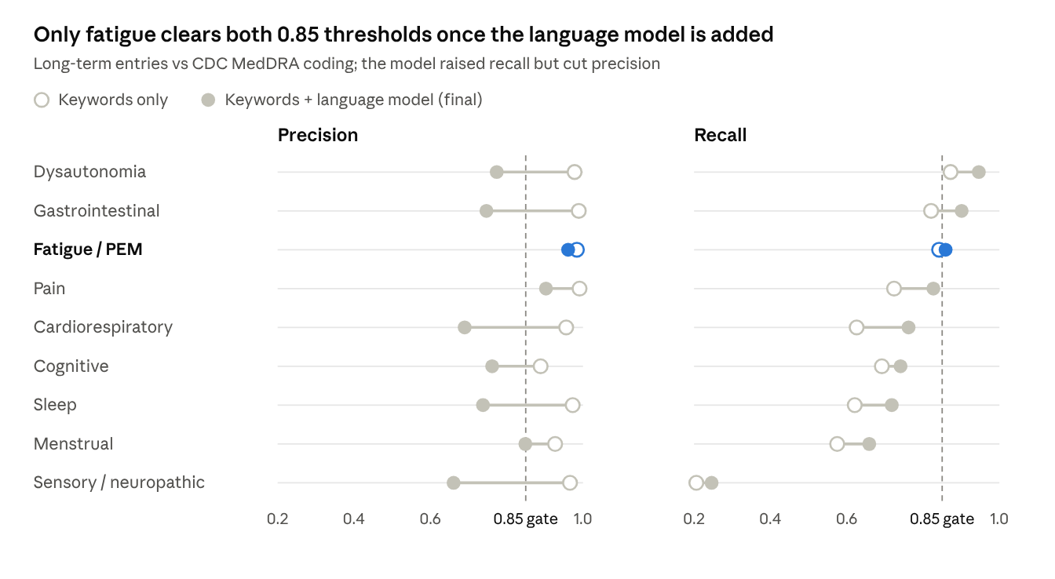
Figure 1. validate_meddra_lexicon and validate_meddra_final aggregates · 9 PACVS domains, long-term entries
A domain passes only if both its final (filled) dots sit right of the dashed line.
The exclusion themes also had low precision against the reference: unrelated cause 0.144, acute diagnosis 0.311. A post-hoc look at the CDC terms on these entries suggests most of the shortfall comes from gaps in the frozen map rather than from wrong tags. The commonest terms were COVID-19, a positive SARS-CoV-2 test, nasopharyngitis, cerebrovascular accident and thrombosis, none of which are in the map. Two real errors were seen: entries mentioning a negative COVID-19 test were tagged as an unrelated cause, and chronic conditions were tagged as acute diagnoses.

Case and comparison groups
Group | Person-doses | People | Share of person-doses with a long-term survey
Case | 87,229 | 86,323 | 1.01%
(a) No symptoms | 5,877,624 | 4,760,357 | 68.2%
(b) Acute event | 104,736 | 102,616 | 1.08% (93,028 with a long-term survey)
(c) Severe week 1, recovered | 1,602,523 | 1,518,229 | 18.6%
Other | 2,267,821 | 2,036,216 | 11.2% (963,254 with a long-term survey)

Of 17.46 million person-doses with any check-in, 49.4% completed a long-term survey. Response was higher after a week-1 health impact (60.1%) than without one (42.4%). The five groups cover 9,939,933 person-doses; the other 7.52 million completed no long-term survey and had neither an acute-diagnosis entry nor a severe week 1, so belong to no group. Case prevalence among responders was 1.01%, with bounds of 0.50% (all non-responders well) to 51.1% (all non-responders cases).

Characteristics of the groups
Cases were more often women and more often second-dose person-doses than the no-symptoms group (Table 1). Manufacturer shares were similar across groups. Age was not present in the linked release.
Table 1. Share of person-doses in each group, %.
 | Case | (a) No symptoms | (b) Acute event | (c) Severe week 1, recovered
Female | 77.5 | 58.1 | 68.9 | 72.8
Male | 21.3 | 41.1 | 30.3 | 26.2
Other or unknown sex | 1.2 | 0.8 | 0.8 | 1.0
Pfizer-BioNTech | 48.4 | 53.2 | 48.3 | 39.5
Moderna | 45.9 | 43.4 | 47.3 | 55.8
Janssen | 5.7 | 3.3 | 4.3 | 4.7
Dose 1 | 14.3 | 13.7 | 18.3 | 9.6
Dose 2 | 69.7 | 60.6 | 60.6 | 79.5
Dose 3 | 14.2 | 20.2 | 16.3 | 9.6
Dose 4 or later | 1.8 | 5.6 | 4.8 | 1.4

Q1: the domains cluster
Among 1,267,509 person-doses with long-term text, domain pairs co-occurred 235,184 times against 188,776 expected under the null (ratio 1.25, p = 0.001). The test rejected in all seven strata with at least 1,000 person-doses: doses 1 to 4 (ratios 1.21 to 1.39) and Pfizer-BioNTech, Moderna and Janssen (1.22 to 1.26). This meets the registered criterion for reproducibility, though at these sample sizes any real dependence reaches p = 0.001, so the ratios carry the information. The null keeps each domain's frequency but not each person's amount of text: a person-dose with more entries or longer entries has more chances to name several domains, and this alone produces some excess co-occurrence.
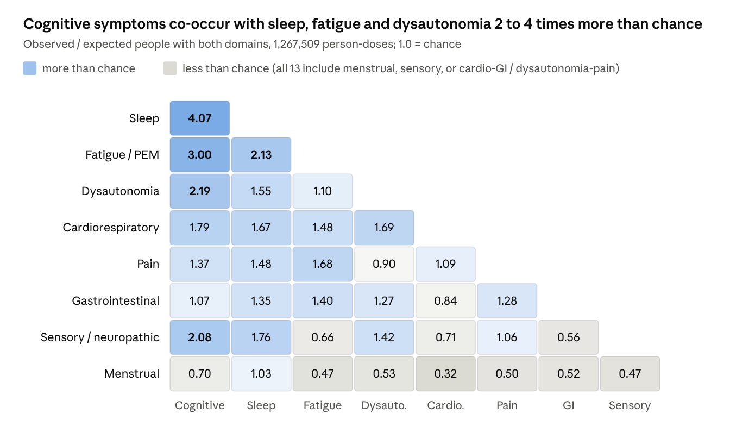
Figure 2. analysis_sens9_q1_pairs aggregate · 36 domain pairs, final classifier
Twenty-three of the 36 pairs exceeded the null after Holm adjustment (adjusted p = 0.036). The strongest ties were cognitive symptoms with sleep (4.1 times expected), fatigue (3.0) and dysautonomia (2.2). The other 13 pairs were at or below chance:
- all eight pairs involving menstrual symptoms;
- sensory symptoms with fatigue, gastrointestinal or cardiorespiratory symptoms;
- cardiorespiratory with gastrointestinal symptoms;
- dysautonomia with pain.
Replication in VAERS. We applied the keyword classifier to the symptom text of 1,057,077 VAERS reports for COVID-19 vaccines (2020 to 2026), one row per report. Pairs co-occurred 486,503 times against 262,471 expected (ratio 1.85, p = 0.001). Thirty-one of 36 pairs exceeded the null after Holm adjustment. As in v-safe, the strongest tie was cognitive symptoms with sleep (4.2 times expected), followed by cognitive symptoms with dysautonomia (2.9) and fatigue (2.8). Menstrual symptoms again did not cluster with fatigue, pain or sensory symptoms. VAERS reports mostly describe acute reactions, in which several symptoms often appear together, so this replication shows the same structure but not its timing.

Q2: onset test uninformative, strong persistence
Onset. Of 87,217 cases with an onset survey, 24,316 (27.9%) first described their case domains in week 1 or by six weeks. 62,192 (71.3%) were expected under the null, so H0 is not rejected (p = 1.0). 72% first described them at 3 months or later; 3 months was the commonest first survey (34%).
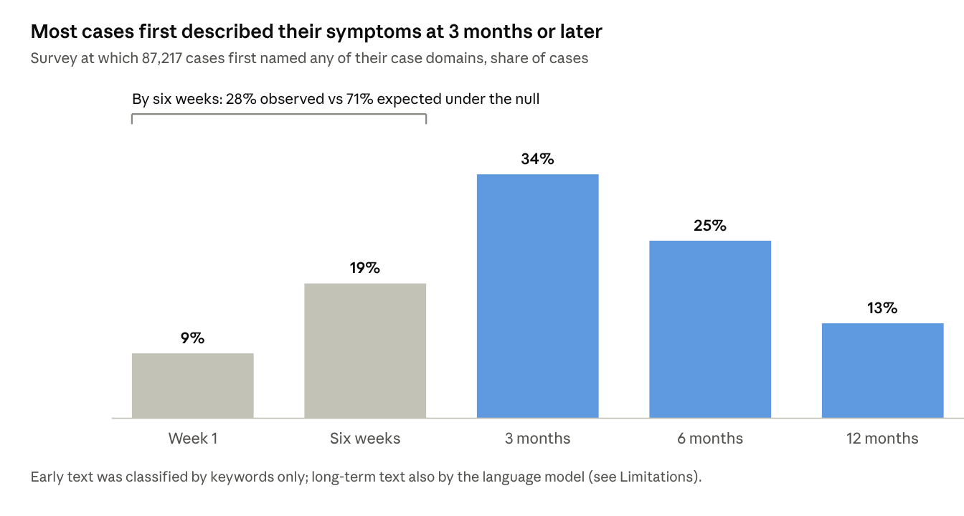
Figure 3. analysis_sens9_q2_onset and onset_distribution aggregates · 87,217 cases
Persistence. Among those who completed a later long-term survey, 60.3% of cases (30,907 of 51,221) named a PACVS domain again, against 1.5% of group (c) (17,416 of 1,169,538). The risk difference was 58.9 percentage points (95% CI 58.4 to 59.3, p < 0.001).

Q3: recorded VAERS filing slightly lower for cases, coding not more dispersed
Match set | Cases with a recorded VAERS filing | Group (b) with a recorded VAERS filing | Rate ratio (95% CI) | PT entropy, cases vs (b) | Dispersion p
Main | 3,937 / 86,323 (4.56%) | 4,944 / 101,690 (4.86%) | 0.94 (0.90 to 0.98) | 8.31 vs 8.59 | 1.0
High confidence | 3,925 / 86,323 (4.55%) | 4,921 / 101,690 (4.84%) | 0.94 (0.90 to 0.98) | 8.31 vs 8.61 | 1.0

Cases reached VAERS about 6% less often than people with named acute diagnoses; the upper limit is below 1, so H0 is rejected, but the two rates are close (4.6% and 4.9%). Group (b) here has 101,690 people rather than 102,616 because 926 people who were a case at one dose and an acute event at another count as cases. Dispersion was tested on matched reports of 2,122 cases and 2,642 group (b) people. Cases' reports were coded to a narrower, not wider, spread of terms, so H0 is not rejected. The difference survives the small-sample corrections added after the results were seen (Table 8): with the Miller-Madow correction the entropies are 8.38 and 8.67 bits, rarefied to equal code counts 8.31 and 8.59, and a two-sided permutation test gives p = 0.001.

Q4: burden (descriptive)
Group | Health impact at a long-term survey, per 1,000 | Care at a long-term survey, per 1,000 | Call-centre case, per 1,000
Case | 952.7 | 462.6 | 587.2
(b) Acute event | 680.7 | 518.1 | 771.4
(a) No symptoms | 0 | 0 | 19.5
(c) Severe week 1, recovered | 0 | 0 | 54.5

Zero rates in groups (a) and (c) follow from their definitions.

Model sensitivity (registered check)
On the fixed sample of 2,000 long-term residue entries (1,687 unique texts, all labelled by both models, no failures or refusals), four of nine PACVS domains were model-sensitive by the registered 20% rule: fatigue, menstrual, cardiorespiratory and cognitive symptoms (Table 2). Sleep had too few entries to report. Dysautonomia, gastrointestinal, pain and sensory-neuropathic symptoms were stable. Among the other themes, unrelated cause, persistence and care sought were flagged; Claude Opus applied each more often than DeepSeek. The sample is residue text, where the keyword layer found nothing, so the counts per domain are small and the shift statistic is noisy below about 50 entries. The direction for fatigue is nonetheless clear: on such text DeepSeek labelled it less than half as often as Claude. An earlier pilot on 2,000 random early entries had found every PACVS domain within 13% between the two models; the disagreement is specific to the harder long-term residue.
Table 2. Entries labelled with each theme by the two models on the fixed long-term residue sample.
Theme | DeepSeek V4.1 Flash | Claude Opus 5.5 | Shift | Model-sensitive
Fatigue / PEM | 20 | 46 | 0.57 | yes
Menstrual | 18 | 10 | 0.44 | yes
Cardiorespiratory | 68 | 41 | 0.40 | yes
Cognitive | 13 | 10 | 0.23 | yes
Sensory / neuropathic | 57 | 50 | 0.12 | no
Pain | 205 | 224 | 0.09 | no
Dysautonomia | 52 | 54 | 0.04 | no
Gastrointestinal | 105 | 107 | 0.02 | no
Sleep | <10 | <10 | suppressed
Unrelated cause (exclusion) | 429 | 621 | 0.31 | yes
Acute diagnosis (exclusion) | 131 | 112 | 0.15 | no
Upper respiratory (exclusion) | 232 | 229 | 0.01 | no
Persistence | 52 | 102 | 0.49 | yes
Care sought | 404 | 553 | 0.27 | yes
Pre-existing worsened | 49 | 61 | 0.20 | no

Analyses not in the pre-registration
Text-matched null for Q1. Mean domains per person-dose rose from 0.26 in the lowest decile of long-term characters to 1.07 in the highest. Matching the null on amount of text cut the ratio of observed to expected pairs from 1.25 to 1.06 (character deciles) and 1.04 (entries crossed with deciles), still at p = 0.001 at this sample size (Table 3).
Table 3. Q1 under the registered null and two text-matched nulls.
Null | Strata | Observed pairs | Expected pairs | Ratio | Pairs above null (Holm)
Registered (domain frequency only) | 1 | 235,184 | 188,776 | 1.25 | 23 of 36
Matched on character deciles | 10 | 235,184 | 221,060 | 1.06 | 19 of 36
Matched on entries × character deciles | 39 | 235,184 | 226,337 | 1.04 | 16 of 36

The specific structure survived (Figure 5): under the strictest matching, cognitive symptoms co-occurred with sleep 2.5 times, with fatigue 2.3 and with dysautonomia 1.6 times more than expected, fatigue with sleep 1.6 and with pain 1.4, and cardiorespiratory with dysautonomia 1.3; pairs that had been modestly above chance moved close to it, and the 13 pairs below chance stayed below.
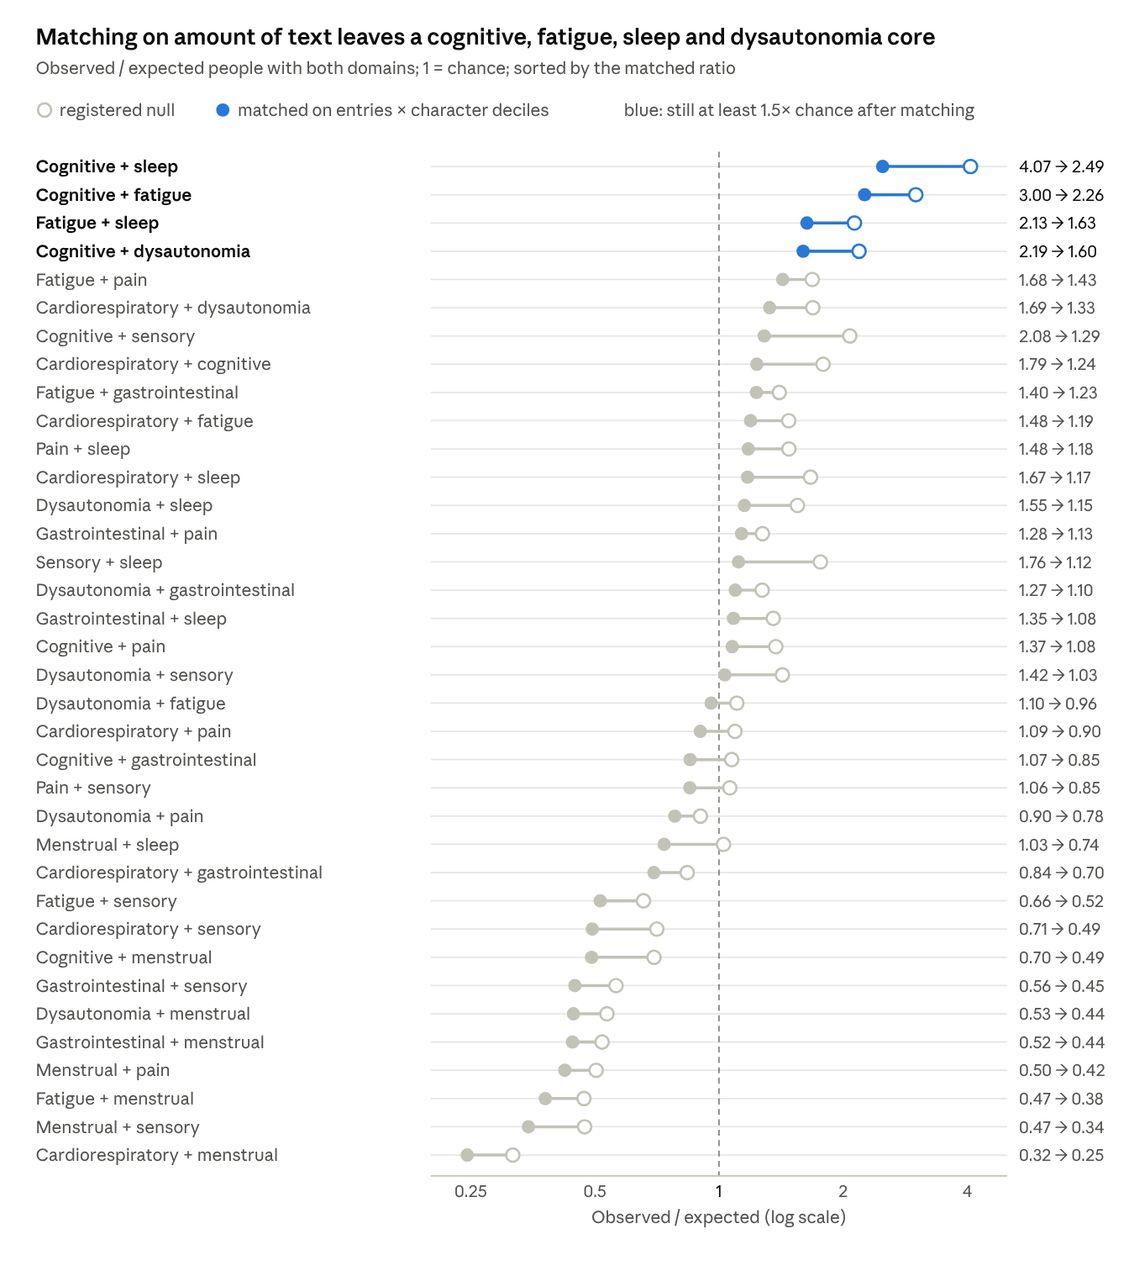
Figure 5. analysis_sens9_q1_pairs and analysis_expl_q1_textmatched_pairs aggregates · 36 domain pairs
Curveball null. With every person-dose's domain count and every domain's frequency fixed, the total pair count is invariant (235,184 in every sample), so only the 36 pairs can be tested (Table 11). The same core stood out under all three stratifications: cognitive with sleep 2.3 to 2.7 times expected, with fatigue 2.1 to 2.3 and with dysautonomia 1.4 to 1.5; fatigue with sleep 1.5 to 1.6 and with pain 1.4 to 1.5. Thirteen to fifteen pairs lay above the null after Holm adjustment and seventeen to nineteen below it, every menstrual pair among the latter.
Table 11. Q1 domain pairs under the curveball null (both margins fixed), observed / expected.
Pair | Unstratified | Within entries 1 / 2 / 3+ | Within text-length tertiles
Cognitive + sleep | 2.70 | 2.44 | 2.30
Cognitive + fatigue | 2.27 | 2.29 | 2.06
Fatigue + sleep | 1.60 | 1.62 | 1.47
Cognitive + dysautonomia | 1.55 | 1.42 | 1.53
Fatigue + pain | 1.45 | 1.48 | 1.39
Cognitive + sensory | 1.43 | 1.23 | 1.25
Cardiorespiratory + dysautonomia | 1.22 | 1.16 or less | 1.29
Pairs above null after Holm | 15 | 13 | 15
Pairs below null after Holm | 18 | 19 | 17
Fatigue + menstrual | 0.36 | 0.38 | 0.35
Cardiorespiratory + menstrual | 0.22 | 0.23 | 0.22

1,000 samples after 30 burn-in rounds, 3 rounds between samples, seed 20261110; the full 36-pair table is in the supplement.
Exclusion criterion variants. Criterion 3 removed about a third of would-be cases (135,252 without it against 87,229). Keyword-only exclusions changed the case count little (89,198) but shrank group (b) from 104,736 to 64,629, because most acute-diagnosis tags on the residue came from the language model and often named chronic conditions. Q1 is unaffected and Q2 held (early onset 27.7% and 23.3%; persistence 60.4% and 52.3% against 1.5%). Recorded VAERS filing fell to rate ratios of 0.82 (95% CI 0.79 to 0.86) and 0.78 (0.75 to 0.81), because the keyword-tagged group (b) filed more often (5.6%) (Table 4). Dispersion was never higher for cases. Including redacted entries among the Q1 rows (1,269,337 person-doses) left the ratio at 1.247 (p = 0.001).
Table 4. Case definition under three readings of the exclusion criterion.
Reading | Case person-doses | Group (b) person-doses | Early onset | Persistence, cases vs (c) | VAERS rate ratio (95% CI), main set
Registered: any layer | 87,229 | 104,736 | 27.9% | 60.3% vs 1.5% | 0.94 (0.90 to 0.98)
Keyword tags only | 89,198 | 64,629 | 27.7% | 60.4% vs 1.5% | 0.82 (0.79 to 0.86)
No criterion 3 | 135,252 | 103,009 | 23.3% | 52.3% vs 1.5% | 0.78 (0.75 to 0.81)

Onset re-examined. Applying the language model to cases' early residue (32,212 entries) raised the early share from 27.9% to 32.7%, still below the check-in null (71.3%) and a null spread evenly over completed survey types (42.2%; p = 1.0 for both). Structured week-1 answers tell a different story about a different thing: 80.9% of the 68,386 cases with a week-1 check-in and a fatigue, pain or gastrointestinal case domain had ticked a symptom in that domain, against 24.2% whose week-1 text named it; but 35 to 40% of the no-symptoms group and 89 to 92% of the severe-then-recovered group had ticked the same boxes. The check-boxes record the common acute reaction, not the start of a persistent syndrome (Table 5).
Table 5. Onset of cases' domains under four readings.
Measure | Early (week 1 or six weeks) | Comparison
Registered: first text mention, layer 1 on early text | 24,316 of 87,217 (27.9%) | check-in null 71.3%; survey-type null 42.2%
Symmetric: language model also on cases' early residue | 28,490 of 87,217 (32.7%) | same nulls; p = 1.0
Week-1 text names a fatigue, pain or gastrointestinal case domain | 19,833 of 81,826 (24.2%)
Week-1 checkbox in the same domain | 55,342 of 68,386 with a week-1 check-in (80.9%) | no-symptoms group 35 to 40%; severe-then-recovered 89 to 92%

By-group checkbox rates use all cases and a 1-in-20 sample of other person-doses.
Persistence by qualification route and against group (d). 69,816 case person-doses (80.0%) met criterion 2 at a single survey and 17,413 only across surveys. Persistence was 47.1% for same-survey cases against 60.3% for all, both against 1.5% in group (c); group (d), worse or impacted but naming fewer than two domains, had 10.5%. The risk difference is 58.9 points for the registered comparison and 36.6 (95% CI 36.1 to 37.1) for same-survey cases against group (d) (Table 7).
Table 7. Persistence of a PACVS domain at a later long-term survey, by case route and comparison group.
Comparison | Cases | Comparison group | Risk difference, points (95% CI)
Registered: all cases vs group (c) | 30,907 / 51,221 (60.3%) | 17,416 / 1,169,538 (1.5%) | 58.9 (58.4 to 59.3)
Same-survey cases vs group (c) | 17,177 / 36,478 (47.1%) | 17,416 / 1,169,538 (1.5%) | 45.6 (45.1 to 46.1)
All cases vs group (d) | 30,907 / 51,221 (60.3%) | 32,391 / 308,869 (10.5%) | 49.9 (49.4 to 50.3)
Same-survey cases vs group (d) | 17,177 / 36,478 (47.1%) | 32,391 / 308,869 (10.5%) | 36.6 (36.1 to 37.1)

Validation audit. Layer 3 and CDC coding disagreed on a PACVS domain for 223,652 entry-domain pairs where only CDC was positive and 111,523 where only layer 3 was; a seeded sample of 306 (17 per domain per side) was drawn for blind coding by the author. [[HUMAN: pending coding]]
Dispersion with small-sample corrections. Group (b) contributed more codes (19,063) than cases (18,072). Neither the Miller-Madow correction nor rarefaction to 18,072 codes changed the direction, and the two-sided permutation test rejects equality (Table 8).
Table 8. Shannon entropy (bits) of MedDRA Preferred Terms on matched VAERS reports, main match set.
Measure | Cases (2,122 people, 18,072 codes) | Group (b) (2,642 people, 19,063 codes)
Raw | 8.31 | 8.59
Miller-Madow corrected | 8.38 | 8.67
Rarefied to 18,072 codes (mean of 200 draws) | 8.31 | 8.59
Difference, raw | -0.28
p, one-sided (cases more dispersed) | 1.0
p, two-sided | 0.001

The high-confidence match set gave the same picture (raw 8.31 vs 8.61; two-sided p = 0.001).
Week-1 structured answers, cases against group (a). Cases whose case domains included fatigue had ticked week-1 fatigue in 78.9% (64.4% moderate or severe) against 35.5% (14.6%) of group (a); pain 80.2% (63.1%) against 40.0% (16.0%); gastrointestinal symptoms 47.8% (29.3%) against 10.2% (2.7%); 53 to 57% reported a week-1 health impact, which group (a) has none of by construction (Table 9). Cases had a heavier week 1 than people who stayed well, but so did group (c), whose persistence was 1.5%: the structured answers separate cases from the well, not from the recovered.
Table 9. Week-1 check-box answers, cases with the domain against group (a) (1-in-20 sample), % of person-doses.
Domain | Group | Person-doses | Any week-1 symptom in the domain | Moderate or severe | Week-1 health impact
Fatigue | cases with fatigue | 37,326 | 78.9 | 64.4 | 56.6
Fatigue | group (a) | 219,910 | 35.5 | 14.6 | 0
Pain | cases with pain | 51,151 | 80.2 | 63.1 | 55.5
Pain | group (a) | 219,910 | 40.0 | 16.0 | 0
Gastrointestinal | cases with gastrointestinal symptoms | 24,325 | 47.8 | 29.3 | 53.3
Gastrointestinal | group (a) | 219,910 | 10.2 | 2.7 | 0

Reproduction of Levi and Lu's cohorts. Rebuilt from the structured answers alone, their dose-1 and dose-2 Prolonged-AE counts agree within 0.5% (32,732 against 32,838; 101,064 against 100,564), which supports the linkage (Table 10). The shortfalls of 3.6% in enrollees, 9.7% in Prolonged-AE and 11.6% in Prolonged-NoAttr sit almost entirely in the dose-3-or-more sub-cohorts (35% fewer in each), consistent with our check-in file holding 6.7 million fewer rows than theirs; the released files carry no age field, so their 16-or-older restriction could not be applied, which would raise our counts. The joins were not adjusted. Among 6,754,831 people in both denominators, 29,593 were both a text-defined case and in Prolonged-AE, 56,730 text-defined only and 137,742 Prolonged-AE only: 34.3% of text-defined cases attributed worse health to vaccination on a check-box, and 17.7% of Prolonged-AE met the text definition (Cohen's kappa 0.22). The two definitions select overlapping but largely different people.
Table 10. Levi and Lu's cohorts rebuilt from structured answers.
Group | This study | Levi and Lu | Difference | %
Enrollees (adult file; theirs: aged 16 or older) | 9,552,127 | 9,904,924 | -352,797 | -3.6
Prolonged-AE | 167,335 | 185,285 | -17,950 | -9.7
Prolonged-AE, dose 1 | 32,732 | 32,838 | -106 | -0.3
Prolonged-AE, dose 2 | 101,064 | 100,564 | +500 | +0.5
Prolonged-AE, dose 3 or more | 33,539 | 51,883 | -18,344 | -35.4
Prolonged-NoAttr | 167,930 | 189,982 | -22,052 | -11.6
Prolonged-NoAttr, dose 1 | 20,389 | 18,710 | +1,679 | +9.0
Prolonged-NoAttr, dose 2 | 89,862 | 81,462 | +8,400 | +10.3
Prolonged-NoAttr, dose 3 or more | 57,679 | 89,810 | -32,131 | -35.8
Control | 9,216,862 | 9,529,657 | -312,795 | -3.3
Women in Prolonged-AE | 124,376 | 137,430 | -13,054 | -9.5
Women (denominator) | 5,941,118 | 6,141,800 | -200,682 | -3.3

Symptom frequencies among cases, compared with published case series
Among the 87,229 case person-doses, pain was the most often named domain (70.2%), then fatigue (51.5%), gastrointestinal symptoms (33.1%) and dysautonomia (25.1%); cognitive (8.5%), menstrual (5.3%) and sleep (4.0%) symptoms were named least. Cases named a median of 2 domains (mean 2.29). Table 6 sets these beside six published PACVS series [4–6, 10, 12, 13], using each paper's own symptom label.
Table 6. Share of patients with each symptom domain: this study and published PACVS case series, %.
Domain | This study, v-safe cases, free text (n = 87,229 person-doses) | Mundorf 2024, online checklist (n = 191) [5] | Krumholz 2023, online checklist (n = 241) [6] | Dinser 2026, CCC questionnaire (n = 26) [4] | Gerhard 2023, neurology clinic (n = 50) [12] | Tokumasu 2023, clinic records (n = 121) [10]
Fatigue / PEM | 51.5 | exhaustion 84.8; PEM 70.7 | excessive fatigue 69; exercise intolerance 71 | new exhaustion 76.9; deterioration with exertion 96.2 | fatigue 46 | general fatigue 24.8
Cognitive | 8.5 | brain fog 76.4 | brain fog 63 | concentration impairment 88.5 | cognitive impairment 36 | not reported
Dysautonomia | 25.1 | dizziness 80.1; perceptible heartbeat 72.8 | palpitations 60; dizziness 50 | positional dizziness 65.4; POTS 50.0 | vertigo 16 | dizziness 4.1
Sensory / neuropathic | 14.9 | paresthesia 79.6; numbness 62.8 | numbness 63; neuropathy 63 | perceptual and sensory disorders 46.2 | paraesthesia 56 | sensory impairment 28.1
Sleep | 4.0 | unrestful sleep 80.6; insomnia 36.1 | insomnia 61 | sleep disturbances 57.7 | not reported | not reported
Pain | 70.2 | muscle pain 80.6; headache 63.4 | myalgia 55; headache 53 | headache 65.4; muscle pain 61.5 | headache 30; myalgia 22 | headache 17.4
Gastrointestinal | 33.1 | nausea 52.4; diarrhoea 40.3 | abdominal pain 33; nausea or vomiting 32 | intestinal dysfunction 65.4 | not reported | nausea or vomiting 5.8
Menstrual | 5.3 | abnormal cycle 42.9 | irregular cycles 20 | not reported | not reported | not reported
Cardiorespiratory | 16.3 | exertional dyspnoea 59.7; angina 46.4 | shortness of breath 37; chest pain 26 to 28 | dyspnoea 38.5 | not reported | chest discomfort 3.3

Percentages are of each series' whole sample; menstrual items in this study and in [5, 6] use denominators that include men. Finsterer and Scorza [13] describe three patients and are not tabulated. Samples differ in how symptoms were elicited: fixed checklists of 38 to 96 items [4–6], clinician-recorded complaints [10, 12], or, here, unprompted free text at 3 to 12 months.
The rank order overlaps but the levels do not: checklist series report most domains in 60 to 90% of patients, clinician-recorded series in 4 to 56%, and v-safe free text sits between for fatigue, pain and gastrointestinal symptoms and well below both for cognitive and sleep symptoms. The 8.5% naming cognitive symptoms, against 36 to 88% elsewhere, reflects the classifier's recall for that domain (0.74), the symptoms people find easiest to name unprompted, and a question that asked about health after a dose rather than about a syndrome.

Discussion
The pre-registered confirmatory analysis could not be run, because only one of nine domains met the accuracy gate. In the registered sensitivity analysis, three of five hypotheses were supported:
- symptoms cluster (Q1);
- they persist (Q2);
- cases reach VAERS less often than people with named acute diagnoses (Q3).
Two were not supported, and both results ran in the opposite direction: early onset (Q2) and dispersed VAERS coding (Q3). The supported effects differ greatly in size. Clustering and persistence are large; under-capture is a 6% difference between two rates near 5%.
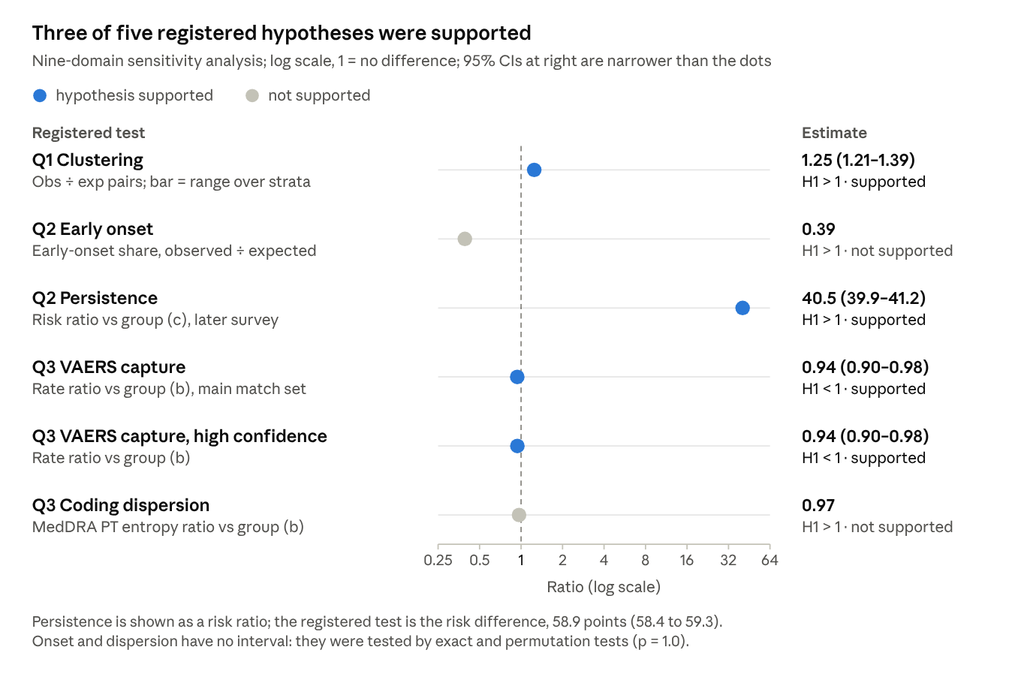
Figure 4. analysis_sens9 Q1–Q3 aggregates · registered tests, nine-domain sensitivity analysis
Clustering. The excess co-occurrence centres on cognitive symptoms, fatigue, sleep and dysautonomia. That is the core described for PACVS and for long COVID. It held in every dose and manufacturer stratum. Pain and gastrointestinal symptoms, the commonest domains, contributed large absolute counts but smaller excesses. Menstrual and sensory symptoms did not join the cluster. The text-matched null (Table 3, Figure 5) settled most of it: matching on amount of text removed most of the aggregate excess, from 1.25 to 1.04, but the cognitive, fatigue, sleep and dysautonomia core remained at 1.6 to 2.5 times chance, and 16 pairs stayed above the null. A curveball null that fixes each person-dose's domain count as well (Table 11) gives the same core at 1.4 to 2.7 times, with 13 to 15 pairs above it; under that null the aggregate ratio is 1 by construction. The syndrome-like finding is that core, not the aggregate ratio.
Onset. The registered hypothesis assumed that a vaccine-related syndrome would be described first in the weeks after the dose. Instead, 72% of cases first described their case domains at 3 months or later. This has two readings, and our data cannot yet separate them:
- Late-onset or late-recognised effects. If real, they would be missed by any design that counts only events in a fixed window after the dose, often 1 to 42 days.
- Background illness. Late onset is also what intercurrent illness, including COVID-19 infection, would produce. It weakens the case for attribution to the dose.
Three features of the data bias our onset measure towards late description:
- Early surveys collected symptoms mainly through checkboxes, while long-term surveys were open-ended.
- Early text was classified by keywords only, which had lower recall.
- Daily week-1 check-ins inflate the expected early share to 71%.
Both re-examinations were run (Table 5). Classifying early and late text alike raised the early share from 27.9% to 32.7%, still below even a null spread evenly over survey types. Structured week-1 answers show that most cases had ticked fatigue or pain in week 1, but so had most people who were severe and recovered and a third of those who stayed well: the checkboxes record reactogenicity, which cannot be told apart from the start of a persistent syndrome. The registered test therefore records when symptoms were first written down, not when they began. It is uninformative about onset, and the structured data cannot settle it either.
Persistence. Persistence in 60% of cases, against 1.5% of group (c), is large. Part of the gap is built into the definitions: group (c) by construction reported no worse health or impact at long-term surveys. Cases, in turn, were selected for naming at least two domains at a long-term survey, which makes naming one at a later survey more likely. Two checks added after the results were seen narrow the gap without closing it (Table 7): restricting to cases that met criterion 2 at a single survey lowers persistence to 47.1%, and a comparison group that was worse or impacted but named fewer than two domains has 10.5% persistence, so the strictest difference is 36.6 points rather than 58.9. The comparison shows that the pattern is not a slow resolution of a severe first week and recurs more often than other long-term complaints, and little more. It does not show how persistence compares with the general population, and the risk ratio in Figure 4 should not be read as an effect size.
Detection. Cases were about 6% less likely than people with named acute diagnoses to reach VAERS, a small but clear difference. Their VAERS reports were, contrary to our hypothesis, coded to a narrower spread of terms, a difference that held under the Miller-Madow correction, rarefaction and a two-sided test. VAERS coding does not appear to scatter this pattern. One possible reason is that the few cases who reach VAERS are those with a more recognisable presentation. On these data, the detection problem, if there is one, lies in the 95% of cases who never reach VAERS at all, which this comparison cannot see, rather than in a lower filing rate than acute events or in coding. Under the two alternative readings of the exclusion criterion (Table 4) the rate ratio fell to 0.82 and 0.78, because the language model's acute-diagnosis tags had diluted group (b) with chronic conditions; the registered figure is the most conservative of the three.
Model sensitivity. The two language models agreed on early text but not on the long-term residue, the text the keywords had missed. Fatigue, the only domain to pass the gate, was labelled less than half as often there by DeepSeek as by Claude Opus. The final classifier's fatigue recall of 0.86, and so its passing the gate, depends on which model labelled the residue. Cardiorespiratory, cognitive and menstrual symptoms were also model-sensitive, and the unrelated-cause exclusion was applied 45% more often by Claude, so the case count itself would differ between models.
Relation to earlier work. Case series of PACVS describe fatigue, cognitive impairment, post-exertional malaise, dysautonomia and neuropathic symptoms as the core presentation [4–6, 10, 12], and a shared clinical and immunological profile with post-acute COVID-19 has been reported [4]. The cluster found here, centred on cognitive symptoms, fatigue, sleep and dysautonomia, matches that core. Sensory-neuropathic symptoms, prominent in some series [8, 9, 12], did not join it, which may reflect the classifier's low recall for that domain (0.25). Published prevalence estimates run from 0.003% to 0.9% [2]; the 1.01% of person-doses with a long-term survey here sits at the top of that range, before any adjustment for attrition or classifier error, and is a share of responses rather than of recipients. Levi and Lu's analysis of v-safe's structured answers found 1.87% of participants reporting worse health lasting at least three months that they attributed to vaccination [22]; our 1.01% applies a stricter definition, at least two symptom domains in free text and no named alternative cause, to long-term responders. Rebuilding their cohorts from the structured answers reproduced their dose-1 and dose-2 counts within 0.5% (Table 10), and the two definitions overlap only partly: a third of text-defined cases attributed worse health to vaccination on a check-box, and a sixth of their cohort met the text definition (kappa 0.22). The text-defined phenotype is therefore not a relabelling of self-attribution. The predominance of women among cases (77.5%) matches case series [5, 6], but v-safe registrants were also mostly women, and the no-symptoms group was 58% women.

Limitations
- The classifier failed its gate. Eight of nine domains fell short of 0.85 precision or recall, so every analysis rests on exploratory labels. Low recall undercounts cases; low precision in some domains overcounts them.
- The co-occurrence null ignores amount of text. Each permutation keeps a domain's frequency but gives every person-dose the same chance of each domain, whatever they wrote. More or longer entries give more chances to name several domains. An exploratory text-matched null removed most of the aggregate excess and left a specific core; the registered ratio of 1.25 should not be quoted without it.
- The reference is coding, not truth. CDC coded entries for adverse-event reporting, often to the most prominent symptom. The frozen map was built from the lexicon's own terms and misses relevant Preferred Terms, as the exclusion themes showed. Measured precision is likely too low for some domains, but we did not alter the map after registration.
- Unequal classification over time. Layer 3 labelled only long-term text, which favours finding domains at long-term surveys. This affects onset (Q2) most. On the registered model-sensitivity sample, four PACVS domains, including fatigue, were model-sensitive, so the one gate pass is specific to the model used.
- Self-described text, not diagnosis. A case describes a pattern in their own words. No clinical confirmation was available, and no age field was present in the linked release.
- Attrition. Only 49% of person-doses with a check-in completed a long-term survey, so the prevalence bounds are wide. People with a week-1 health impact were more likely to respond (60.1% against 42.4%), which may inflate the observed 1.01%.
- Exclusions are imperfect. Negative COVID-19 tests and chronic conditions were sometimes tagged as exclusions. This removes some true cases and blurs group (b).
- Comparison groups are partly defined by the outcome. Group (c)'s low persistence and cases' high persistence are both partly built into their definitions.
- VAERS linkage. VAERS capture relies on call-centre dispositions and on OpenVSafe's probabilistic matches [18], which we did not validate independently. Matched reports exist only for people the call centre recorded as filing. Q3 was run at person level, while the groups are defined per dose.
- Implementation choices after registration. These are listed in Methods; all were made without seeing results.

Conclusions
About 1% of long-term v-safe responses describe a multi-domain symptom pattern. Its domains cluster beyond chance; once the null is matched on how much people wrote, the clustering is confined to a core of cognitive symptoms, fatigue, sleep and dysautonomia. It persists across surveys and reaches VAERS slightly less often than named acute events. It was mostly first described months after vaccination, which leaves open whether it reflects late vaccine effects or background illness. Because the classifier did not meet its pre-registered accuracy standard, these findings are hypothesis-generating. They justify a validated classifier and a structured-answer analysis of onset.
Acknowledgements. The author thanks OpenVAERS for publishing OpenVSafe's v-safe-to-VAERS matches and ICAN for hosting the FOIA releases.

Declarations
Funding. No funding was received for this study.
Conflicts of Interest. MH is Director of the Open Source Medicine Foundation and has previously received funding from the Independent Medical Alliance. He has published on PACVS and vaccine-injury recognition [3, 16]. He has no role with, and has received no payment from, OpenVAERS, ICAN or any litigation body, and the language-model services used were paid for at list price.
Ethics Approval. This secondary analysis used de-identified records released publicly under the US Freedom of Information Act and public VAERS data, and published only aggregate data with at least 10 people per cell. It did not involve contact with participants and did not require ethics review.
Consent to Participate. Not applicable; the study used de-identified public records.
Consent for Publication. Not applicable.
Availability of Data and Material. The v-safe, call-centre and MedDRA files are public FOIA releases hosted by ICAN [19]; VAERS data are public [20]; OpenVSafe's match pages are public [18]. The pre-registration and its two amendments are at osf.io/gnfpd. Only aggregates with at least 10 people per cell are released; no participant-level data or free text are shared.
Code Availability. Analysis code, the frozen taxonomy (v1.0) and the classifier prompts are at github.com/MattH55/vsafe-freetext, tag v1.0.1-submission, archived on Zenodo [[Zenodo DOI, added once minted]].
Authors' Contributions. Matthew Halma: conceptualisation, methodology, software, validation, formal analysis, investigation, data curation, writing (original draft, review and editing), visualisation, project administration.
AI tools. A large language model (DeepSeek V4.1 Flash) served as the layer-3 classifier and a second (Claude Opus 5.5) as the model-sensitivity comparator, as described in Methods. AI assistants (Anthropic Claude) assisted with code and with drafting and editing this manuscript under the author's direction; the author reviewed all content and takes full responsibility for it. No AI tool is an author.
Data protection. Free text was stored and classified locally. For layer 3 it was sent, in batches of 20 entries with no registrant code, date or other field attached, to NanoGPT's API routed to DeepSeek V4.1 Flash with the provider's zero-data-retention and no-data-collection options set; the 2,000-entry comparison sample was sent to the Anthropic API (claude-opus-5-5) under that provider's standard API terms at the time of use. Entries containing a detectable e-mail address or phone number were not sent. The retention terms as read at the time of use are recorded in the repository (docs/data-use.md). No free text is quoted.
Before submission, replace the bracketed items above and on the title page: funding, conflicts of interest, ethics statement, repository URL, affiliation, ORCID and corresponding address.

References
1. Bellavite P, Donzelli A, Isidoro C. The WHO Algorithm for Causality Assessment of Adverse Effects Following Immunization with Genetic-Based Anti-COVID-19 Vaccines: Pitfalls and Suggestions for Improvement. J Clin Med. 2024;13:7291. doi:10.3390/jcm13237291
2. Platschek B, Boege F. The Post-Acute COVID-19-Vaccination Syndrome in the Light of Pharmacovigilance. Vaccines. 2024;12:1378. doi:10.3390/vaccines12121378
3. Halma M, Varon J. Restoring trust in vaccination: listening to patients and acknowledging Post-Acute COVID Vaccine Syndrome. Front Med. 2025;12. doi:10.3389/fmed.2025.1688170
4. Dinser J, Anft M, Wiemers L, Skrzypczyk S, Kohut E, Kurek J, et al. Shared Clinical and Immunological Features of Post-Acute COVID-19 and Post-Acute COVID-19 Vaccination Syndromes. medRxiv. 2026. doi:10.64898/2026.09.18.26363380
5. Mundorf AK, Semmler A, Heidecke H, Schott M, Steffen F, Bittner S, et al. Clinical and Diagnostic Features of Post-Acute COVID-19 Vaccination Syndrome (PACVS). Vaccines. 2024;12:790. doi:10.3390/vaccines12070790
6. Krumholz HM, Wu Y, Sawano M, Shah R, Zhou T, Arun AS, et al. Post-Vaccination Syndrome: A Descriptive Analysis of Reported Symptoms and Patient Experiences After Covid-19 Immunization. medRxiv. 2023. doi:10.1101/2023.11.09.23298266
7. Wang W, Yellamsetty A, Edmonds RM, Barcavage SR, Bao S. COVID-19 vaccination-related tinnitus is associated with pre-vaccination metabolic disorders. Front Pharmacol. 2024;15:1374320. doi:10.3389/fphar.2024.1374320
8. Rouleau I, Issa Kana KDN, Zafack JG, Viger YB, De Serres G. New-onset anesthesia/paresthesia following the administration of COVID-19 vaccines in Quebec, Canada. Vaccine. 2025;57:127217. doi:10.1016/j.vaccine.2025.127217
9. Safavi F, Gustafson L, Walitt B, Lehky T, Dehbashi S, Wiebold A, et al. Neuropathic symptoms with SARS-CoV-2 vaccination. medRxiv. 2022. doi:10.1101/2022.05.16.22274439
10. Tokumasu K, Fujita-Yamashita M, Sunada N, Sakurada Y, Yamamoto K, Nakano Y, et al. Characteristics of Persistent Symptoms Manifested after SARS-CoV-2 Vaccination: An Observational Retrospective Study in a Specialized Clinic for Vaccination-Related Adverse Events. Vaccines. 2023;11:1661. doi:10.3390/vaccines11111661
11. Shrestha Y, Venkataraman R. The prevalence of inverse health consequences of COVID-19 vaccines: A post-vaccination study. Vacunas. 2022;23:S67–76. doi:10.1016/j.vacun.2022.03.002
12. Gerhard A, Raeder V, Pernice HF, Boesl F, Schroeder M, Richter J, et al. Neurological symptoms after COVID-19 vaccination: a report on the clinical presentation of the first 50 patients. J Neurol. 2023;270:4673–7. doi:10.1007/s00415-023-11895-9
13. Finterer J, Scorza FA. A retrospective analysis of clinically confirmed long post-COVID vaccination syndrome. J Clin Transl Res. 2022;8:506–8. PMID 36452006
14. Grieshaber V, Strumann C, Holzwarth S, Toepfner N, von Meißner WCG, Konstantopoulos N, et al. The Long-Term Tolerability of BNT162b2 in Children and Adolescents (the CoVacU18 Study). Dtsch Arztebl Int. 2025;122:257–63. doi:10.3238/arztebl.m2025.0032
15. Riad A, Pokorná A, Attia S, Klugarová J, Koščík M, Klugar M. Prevalence of COVID-19 Vaccine Side Effects among Healthcare Workers in the Czech Republic. J Clin Med. 2021;10:1428. doi:10.3390/jcm10071428
16. Halma M, Varon J. DARE-SAFE: Denominator-Adjusted Rate Estimates of Substance Adverse Events Frequency Evaluation in Pharmaceuticals and Vaccines. Pharmacoepidemiology. 2025;4:7. doi:10.3390/pharma4020007
17. Zauche LH, Miller ER, Kim SS, Jazwa A, Shay DK. Monitoring Vaccine Safety: United States Vaccine Safety Surveillance Systems. J Pediatr Health Care. 2026;40:174–86. doi:10.1016/j.pedhc.2025.07.016
18. OpenVAERS. OpenVSafe: v-safe participant records matched to VAERS reports [Internet]. openvsafe.org. Person pages read 2026-11-10 to 2026-11-11; only the VAERS ID, match score (0 to 11), confidence and runner-up score of each match were retained.
19. Informed Consent Action Network. v-safe data [Internet]. icandecide.org/v-safe-data/. Free-text responses released by CDC under FOIA 24-01322 (twelve interim and final releases and an under-3 file, 2024), registrant, vaccination and health check-in files, call-centre records (FOIA 23-00925 and 23-00926) and CDC's MedDRA coding of the free text (November 2024). Downloaded 2026-11-08 to 2026-11-10.
20. US Department of Health and Human Services. Vaccine Adverse Event Reporting System (VAERS) data [Internet]. vaers.hhs.gov/data.html. All-years CSV files dated 2026-06-03.
21. MedDRA Maintenance and Support Services Organization. Medical Dictionary for Regulatory Activities (MedDRA) [Internet]. meddra.org.
22. Levi R, Lu N. Reporting on prolonged adverse health impact among V-SAFE enrollees. Research Square [Preprint]. Posted 25 Aug 2026. doi:10.21203/rs.3.rs-10768889/v1

Supplementary table S1: Q1 by stratum
Stratum | Person-doses | Observed pairs | Expected pairs (null mean) | Ratio | p
All | 1,267,509 | 235,184 | 188,775.6 | 1.246 | 0.001
Dose 1 | 147,659 | 30,825 | 25,068.7 | 1.230 | 0.001
Dose 2 | 827,368 | 156,367 | 129,573.6 | 1.207 | 0.001
Dose 3 | 247,784 | 42,053 | 30,259.4 | 1.390 | 0.001
Dose 4 | 44,660 | 5,934 | 4,383.7 | 1.354 | 0.001
Janssen | 55,754 | 12,621 | 10,320.7 | 1.223 | 0.001
Moderna | 574,355 | 105,796 | 85,728.5 | 1.234 | 0.001
Pfizer-BioNTech | 637,049 | 116,722 | 92,787.0 | 1.258 | 0.001

p = 0.001 is the smallest value possible with 1,000 permutations. Strata with fewer than 1,000 person-doses were not tested, as registered.

