Matthew Horotn

EE380 Projects Lab

Project 2 Report

**Problem Description**

Create a program to find missing variables for varying filters and display the filters' characteristics for phase and magnitude on a bode plot.

**Design**

Tools/Software

Implemented entirely in Microsoft Visual Studio 2017 (C#).

UI

There's drop down selection for RC/RL/RLC and lowpass, highpass, bandpass, and bandstop filters. From there the variables used for all or part of each of these are available to input data. A button to calculate the missing variables and a button to reset all values on the page are located at the bottom. This is entirely a flat design with no hierarchical structure.

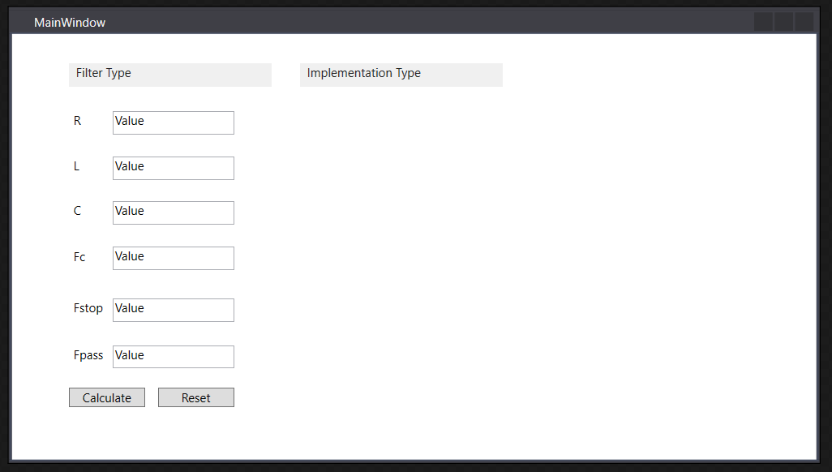

Code

MenuItems are selected for filter type (high,low,bandpass/stop) and Implementation Type (RL,RC,RLC).

Labels and Textboxes are used to input variables for the selected configuration.

All variable values and MenuItem values are reinitialized with the reset button.

Calculation of missing values (fc, fstop, fpass, c, l, r) are done with nested switch statements tied to the Calculate button. The values are casted to Double, used in the equation, and casted back to string. Graphs don’t work yet.

Global variables

selectedFilterType

selectedImplementationType

numArgs

used to determine (crudely) if enough information has been provided to calculate missing values

Please see Attached Code in appendix A

**Theoretical Results**

**Simulation Results**

**Experimental Design**

**Measurement Results**

**Conclusion**

This was a fun project, I should’ve allocated more than 1 day to it though because I was unable to meet all requirements for testing. In total I’d say 4 hours were spent designing and implementing the system.