|  |
| --- |
| Bearsoft GAMES |
| Assignment One-COMP2068 |
| **The Island!** |
| Version #6.0  All work Copyright © 2015 by Bearsoft Games.  All rights reserved. |
| **Matthew Lane** |
|  |



|  |
| --- |
| Jan 28th 2015 |

**Table of Contents**

1. Title Page
2. Table of contents (Here)
3. Version History
4. Game Design

**Version History**

1. – First slide added to project, ready to begin the Island.
2. – Added second and third slides to project. (Lateral options)
3. – Added several more slides and some death options.
4. – Added more slides, more death options. Added a suicide option. Ready to begin the success line.\
5. – Fixed spelling and grammar errors. Added final slides and positive outcome. Finished core of game!
6. - Fixed some tag issues and added more comment lines.
7. – Fixed CSS, added new fonts, background image, removed border.

**Game Design**

1. **Game Overview**

In the island, you play as an unnamed and mostly unwilling character, who wakes up on a beach with amnesia. The goal of the game is to safely traverse the island and escape. There are many pitfalls, and many more ways to die than to succeed. Even when you think your getting somewhere, death is just around the corner.

1. **Game Play Mechanics**

*The game operates on a text-based html platform. You are presented with a situation, and given several options about what you wish to do. Making the correct choice will allow you to continue to progress through the game, while the wrong choice will end in a dead end, or death.*

1. **Controls**

*The island only uses a mouse, which is needed to select which option you would like to undertake. There is no need for a keyboard, or joystick, as this is a text based game.*

1. **Interface Sketch**

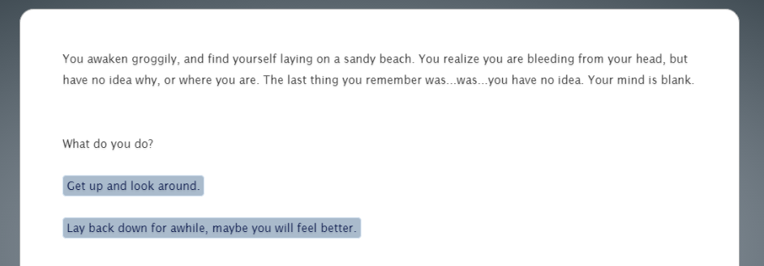

1. **Game World**

*The island, surprisingly, takes place on an island. The island has a cave, sharp rocks, the ocean, and a jungle. There are many dangers on the island, and to make it out safely, you will need to be very careful.*

1. **Game Progression**

In the island, the game progresses as you make choices at each stage. Each choice leads to several more choices, some options are dead ends, others are death. There is one path to success to find, which is via the cave.

1. **Story Index**

The following is a description of the choices at each node in the story, and their result (success path or death).

**INTRO**

*The into to the game explains you have woken up on a beach, you have received a blow to the head and remember nothing. You are dizzy and in poor shape. From here, you have two options. Get up immediately and go exploring, or wait awhile and see if you feel any better.*

*Get up – Success path.*

*Lay back down – Death.*

**The Beach**

*From the beach, there are three options. You can move toward the cave, which is the success path. There are also sharp rocks to explore, or you can continue down the beach.*

*The Cave – Success path.*

*Sharp rocks – Dead end, or death.*

*Further down the beach – Dead end, or death.*

**Sharp rocks**

*From the rocks, your character notices something in the water. Attempting to get it has one of three options. Attempting to get a stick to reach it, or just attempting to get to the object in the water.*

*Get the object in the water – Dead End.*

*Get the stick – Death.*

*Return to the beach. – Success path.*

**Further down the beach**

*If you choose to walk further down the beach, you will become hot and dehydrated, there are four options. There is a jungle to explore, an ocean to swim in, or you can continue to walk to walk down the beach.*

*Continue down the beach – Death.*

*Swim – Either dead end, or suicide.*

*Jungle – Death.*

*Return to the beach – Success.*

**The cave**

*The cave appears to be the least inviting option, but it is in-fact the only success path. The cave is dark, and sounds dangerous, and it is. From the cave entrance there are 2 options.*

*Enter the cave – Success.*

*Return to the beach – Potential success.*

**Inside the cave**

From inside the cave, there are two options. You can continue through the cave, or make a turn.

Continuing – Success.

Turn – Death.

**Continuing**

This is the end of the story. The user sees a boat, and gets a lift off the island. If you have made it this far, congratulations! You have completed, The Island!