User Facing Documentation

By: Matthew Lum and Alex Bodian

Welcome to Gun Activity Map Explorer Online:

This Documentation hopes to assist you in understand and getting the most out of our beloved project so that you too may draw your own conclusions and arm yourself with knowledge.

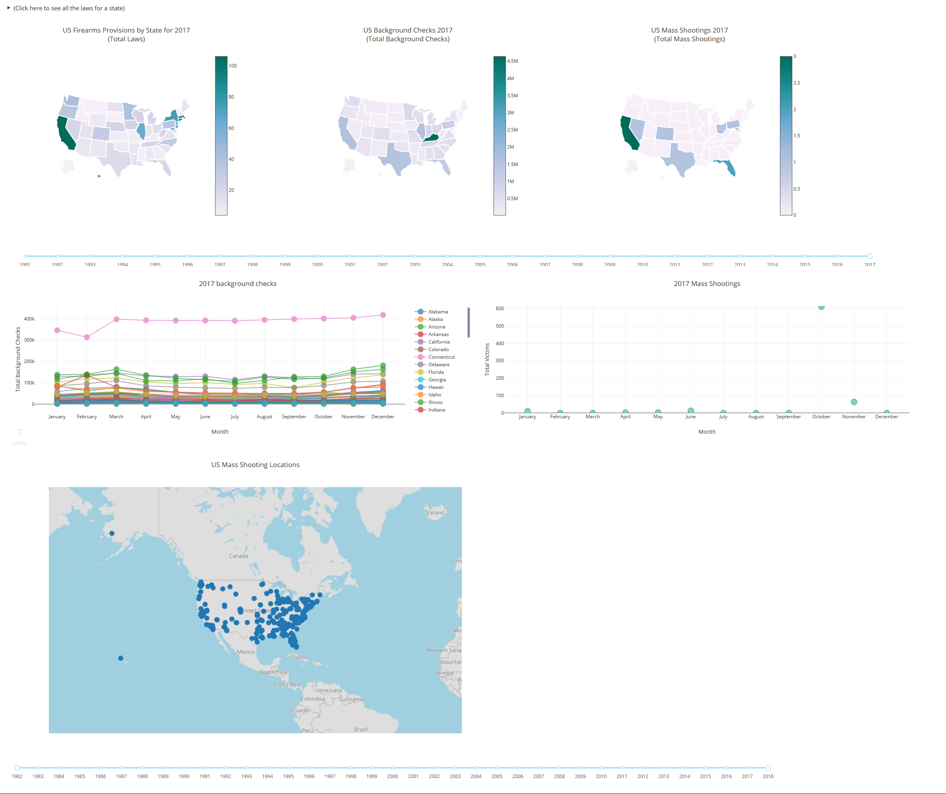

**Choropleths:(Section 1/3)**

The provided choropleths highlight the density of specific data in states. The darker a state the more of a certain item exists in that state for the year. The maps are listed (from left to right) as Amount of Firearms Provisions by State, Background Checks by State, Mass Shootings by State.

You can adjust the year displayed by clicking on the desired year from the timeline seen at the bottom of the following figure. (note some years may not have had any data record from them)

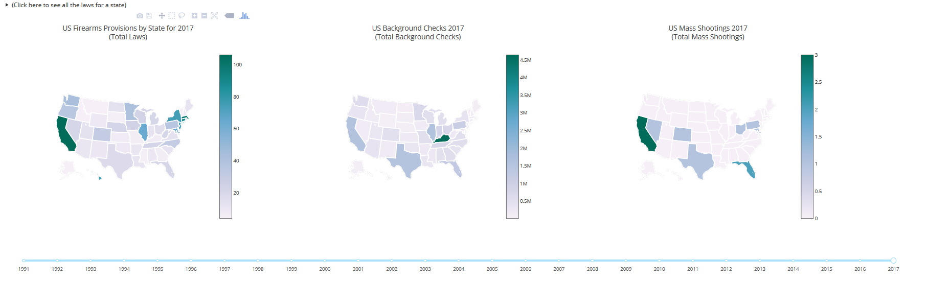

To access the laws for a specific state first open the Provisions tab by clicking on the the arrow in the top left hand corner.

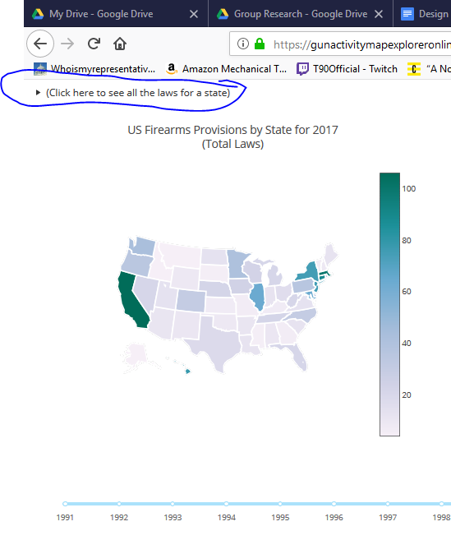

From there simply hover over any state in the US FireArms Provisions by State for 2017 (Total Laws) map to see it’s laws.

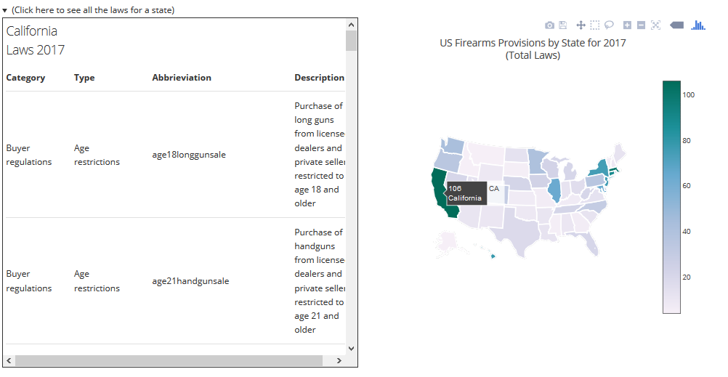

**Scatter Plots:(Section 2/3)**

In this section you can see the number of background checks per State, by month for any year. To the right of that is the Mass Shootings by month for any year.

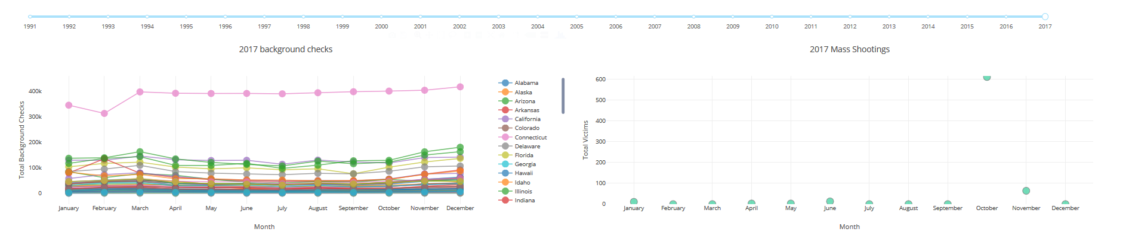

Once again the year can be adjusted via clicking the timeline above.

You may also select and deselect certain states to narrow your scope.

Double clicking allows displaying a single state only graph or for displaying all 50 states again.

**Mass Shooting Locations:(Section 3/3)**

Finally there is the Mass Shooting Locations map which displays all of the Mass Shootings that have occured in the us for our provided databases.

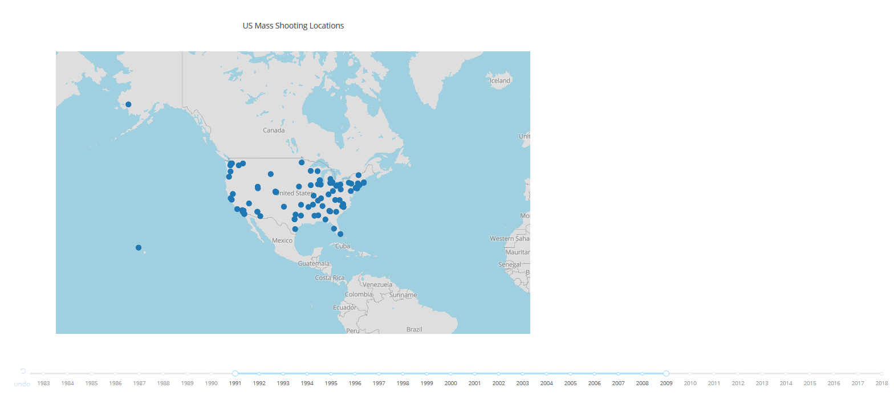

You have scroll wheel in to zoom into the exact coordinates of a location.

You can also adjust the range slider on the timeline at the bottom of webpage.

**In Conclusion:**

We hope that the Gun Activity Map Explorer Online was naturally intuitive and that for the areas it is not that this documentation has assisted you to get the fullest from your experience.