**CSE3310**

**SuperChat**

**McLeod, Rahimzadeh, Myers**

**Software Requirements Specification**

**Document**

**Version: 1.4** **Date: 02/17/2017**

# 1. Introduction

## 1.1 Purpose

This document shall provide a complete description of the SuperChat user chat interface. The contents of this document define the features, requirements, interfaces, and limitations of SuperChat. This information is provided for all investors, customers, members of the board, interested parties, and developers actively pursuing the realization of this software.

## 1.2 Scope

This software system will serve as a peer-to-peer chat interface for all individuals who use the product. The system will allow for chatrooms in which peers can communicate and share ideas easily and effectively. This system will serve as a high speed and redundant solution for individuals disillusioned with current chat offerings.

Specifically, SuperChat will manage user profiles characterized by a nick, and further defined by unique identification numbers. These profiles shall communicate to each other using peer-to-peer OpenSplice DDS connections within well-defined ‘chatrooms’, all presented in a clean NCurses graphical user interface.

**2. Requirements**

|  |  |  |  |
| --- | --- | --- | --- |
| UID | Requirement | Source | Notes |
| SC001 | Superchat shall maintain a graphical user interface implemented by the ncurses graphical library. | SuperChat System Description Para 1 |  |
| SC002 | Superchat shall have users defined by a UUID , an 8 character ‘nick’, and other information contained within a text field of length 140 characters. | SuperChat System Description  Para 10-11 | Users will be standardized |
| SC003 | Superchat users shall be able to define a new chatroom. | SuperChat System Description  Para 3 | Chatrooms will be standardized |
| SC004 | Superchat users shall be able to send and receive messages within a chatroom. | SuperChat System Description  Para 3 |  |
| SC005 | Superchat users shall be able to add available users to a chatroom. | SuperChat System Description  Para 3 |  |
| SC006 | Superchat shall maintain a list of available users. | SuperChat System Description  Para 4 |  |
| SC007 | Messages in Superchat shall be no longer than 144 characters. | SuperChat System Description  Para 2 |  |
| SC008 | Each instance of chatroom shall be in a separate window. | SuperChat System Description  Para 3 |  |
| SC009 | Messages in Superchat shall be defined by a string terminated by carriage return. | SuperChat System Description  Para 2 |  |
| SC010 | Chatrooms shall display the past messages sent between its associated users. | SuperChat System Description  Para 3 |  |
| SC011 | Chatrooms shall maintain a text entry field which Users shall use to send messages. | SuperChat System Description  Para 3 |  |
| SC012 | Superchat shall maintain a public chatroom in which all available users shall be a member by default. | SuperChat System Description  Para 7 |  |
| SC013 | Superchat shall run on Linux Operating Systems. | SuperChat System Description  Para 1 |  |
| SC014 | Superchat shall communicate via a decentralized, peer-to-peer architecture using Opensplice. | SuperChat System Description  Para 14 |  |
| SC015 | There shall be a text field containing a list of all Users, those who are online shall also display an associated Chatroom. | SuperChat System Description  Para 4 |  |
| SC016 | A User shall only be connected to a single chatroom at any given time. | Engineering Decision |  |
| SC017 | A User shall be able to accept or reject invitations to new chatrooms. | Engineering Decision |  |
| SC018 | Users who disconnect from SuperChat shall remain visible, but be designated offline. | SuperChat System Description  Para 4 |  |
| SC019 | The limit to the number of Users shall be defined by system limitations. | SuperChat System Description  Para 5 |  |
| SC020 | There shall be no more than ten chatrooms available to SuperChat Users at any given time. | SuperChat System Description  Para 8 |  |
| SC021 | If there are no Users in a chatroom for ten minutes it’s name is blanked out, indicating the room is available. | SuperChat System Description  Para 9 |  |
| SC022 | When first executing SuperChat, a user shall be asked to define his ‘nick’, which is limited to 8 characters. | SuperChat System Description  Para 10 |  |
| SC023 | A users ‘nick’ shall be alterable throughout the life of the program. | SuperChat System Description  Para 10 |  |
| SC024 | Users shall be able to view the profile information of other Users on the system. | SuperChat System Description  Para 11 |  |
| SC025 | Superchat maintain an IDL identical to those of other program versions. | SuperChat System Description  Para 14 |  |
| SC026 | Superchat shall maintain interoperability between versions identical to its own and those that are not. | SuperChat System Description  Para 15 |  |
| SC027 | Superchat shall define Users and Chatrooms in a way that is comensorate with other versions of the program | SuperChat System Description  Para 15 |  |
| SC028 | Superchat shall not leak memory or overload available processors. | SuperChat System Description  Para 16 |  |
| SC029 | Superchat users shall be updated of the status of other users ever 500 ms. | SuperChat System Description  Para 17 |  |
| SC030 | Superchat Users shall be limited to sending messages once every second. | SuperChat System Description  Para 16 |  |
| SC031 | Superchat Users shall be able to create chatrooms, change chatrooms, add available users, and exit the program using the function keys. | SuperChat System Description  Para 6 |  |

**3. Modeling**

**3.1 Use Case Diagrams**

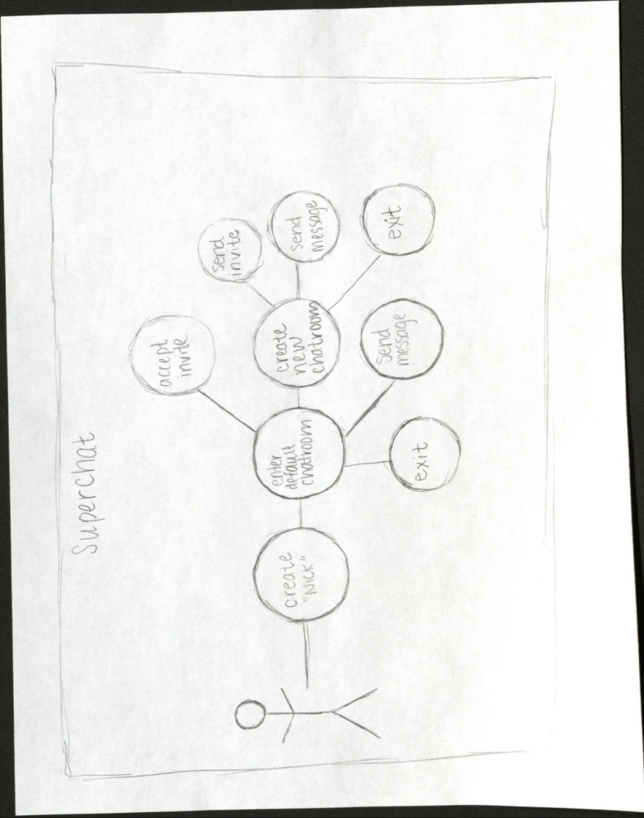

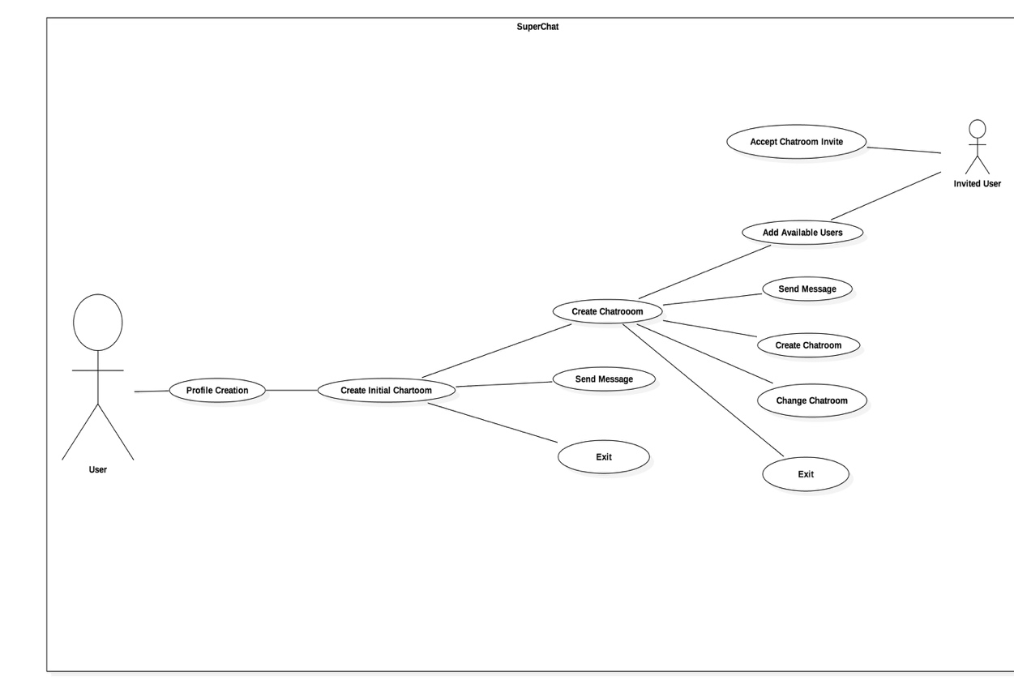

**3.2 State Diagram**

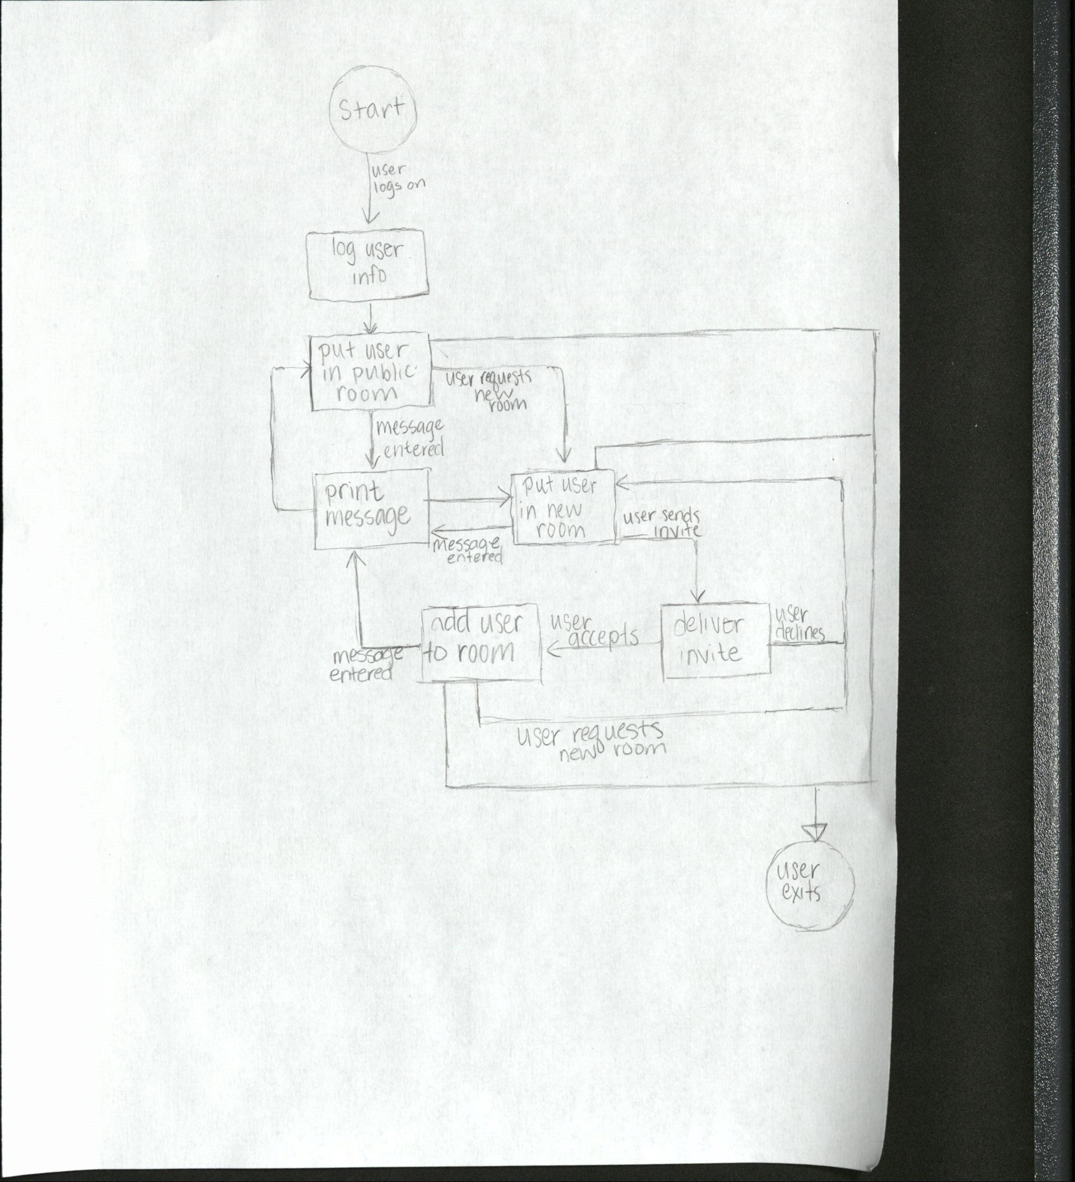

**3.3 Class Diagram**

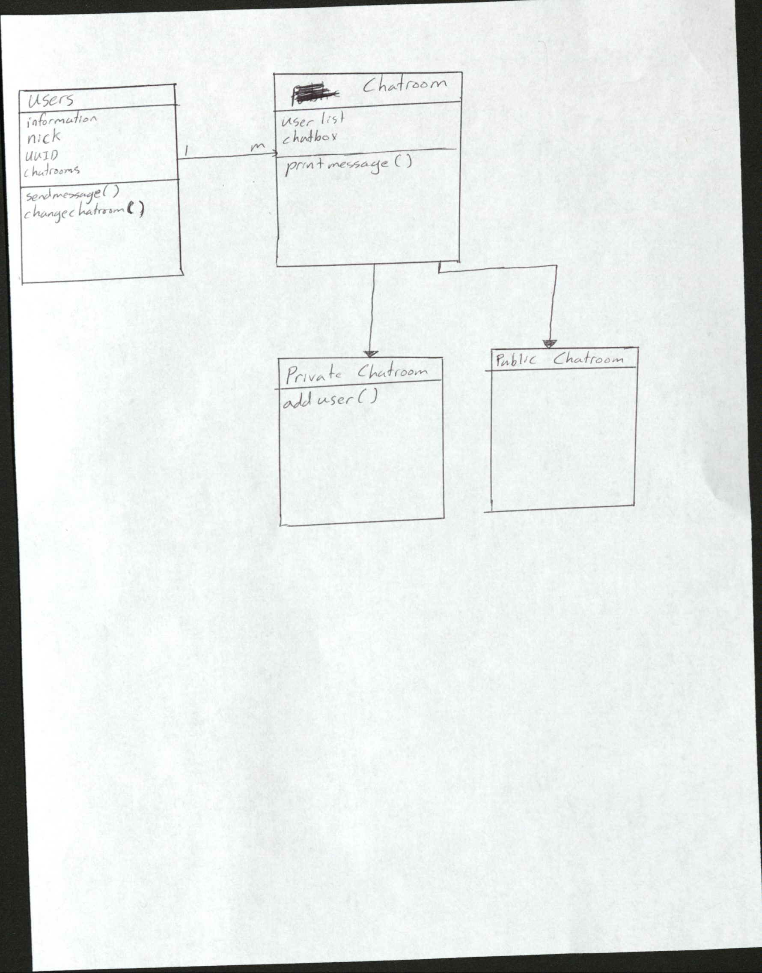

**3.4 User Interface**

