Efficient Data Synchronisation Utility
Design document · Matthew Mikhail · bandwidth-constrained client to collection server
1. Architecture
A single unprivileged agent runs on the client machine. It has three moving parts and one piece of durable state.
- Watcher. Subscribes to filesystem events on the monitored directories. Its job is latency, not correctness.
- Reconciler. Walks the same directories on a timer using stat() only. This is the mechanism trusted for correctness, and it runs first on start-up.
- Transfer worker. Hashes candidate files and moves them over a resumable, chunked HTTP protocol.
- Local manifest. A SQLite database holding, per path, what the agent last saw on disk and what the server has confirmed. The gap between those two columns is the work queue.
The server is a content-addressed blob store plus a path index, and verifies every file before publishing it. Responsibilities stay separate: the watcher supplies hints, the reconciler establishes truth, the worker moves bytes, the manifest is the only durable client state, and the server is the sole authority on what it has received.
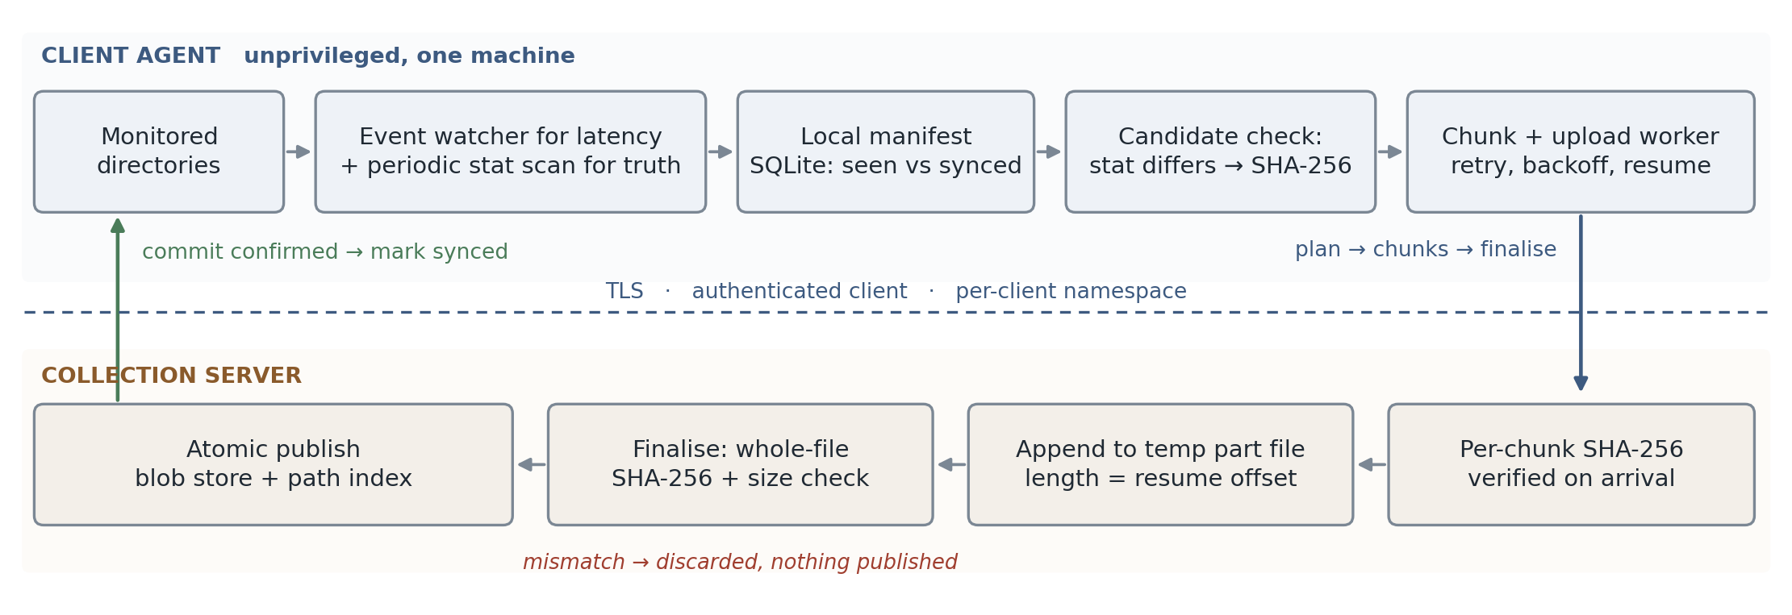
2. Change detection
Cost per pass matters more than cleverness, so the check is layered and only spends CPU when the cheap layer says something moved. One, stat() gives size, mtime and inode; against the manifest row that rules out almost every file for one syscall. Two, if any differ, the agent computes a SHA-256 over the file, and that digest becomes the version identity for the rest of the pipeline. Three, if the server already holds that digest, nothing is sent and the manifest row is updated so the next pass is cheap again.
Hashing everything every pass would be correct and simple, but on a large tree it is a full read of the dataset per interval, a poor trade when stat() answers the same question for almost every file. Metadata alone is not sufficient either: mtime can move backwards after a restore or an archive extraction, and its granularity is limited. Hashing on a metadata change buys close to the accuracy of hashing at close to the cost of stat(). On POSIX, st_ctime is a useful extra signal because user space cannot set it, though it has no portable Windows equivalent.
Filesystem events are a latency optimisation, not the source of truth, because the platform APIs document their own gaps. inotify drops events when its queue overflows and reports IN_Q_OVERFLOW, and it is not recursive. ReadDirectoryChangesW discards its entire buffer on overflow and tells the caller to enumerate the directory instead. Neither sees anything that happened while the agent was not running. The reconciliation scan is the backstop that makes all of those recoverable, which is why a missed event, a crash or a power failure costs latency rather than correctness.
Renames and deletes. A rename appears as a new path plus a manifest row whose path no longer exists. Because the server addresses content by hash, the new path resolves to a blob it already holds, so a rename costs one small request and zero file bytes. Deletions are reported as tombstones rather than executed, so a buggy or compromised client cannot instruct the collection server to erase history.
3. Bandwidth efficiency
Four mechanisms, in order of how much they save:
- Only files whose metadata changed are considered at all.
- A batched pre-flight request sends {path, size, sha256} for a set of candidates. The server answers skip (it has this version at this path), link (it has the content under some other name) or upload with the offset it already holds. Renames, copies, reverts and re-installs collapse to metadata.
- Uploads are split into fixed 1 MiB chunks and resume from the server's offset, so a dropped connection costs the chunk in flight rather than the file.
- Chunks are compressed for transport only when compression actually helps. Integrity hashes are computed over the uncompressed bytes, so compression never participates in the correctness argument.
Fixed-size chunks were chosen over content-defined chunking deliberately. CDC pays off when transferring deltas against a previous version of the same file, which needs a per-file chunk index on the server and rolling hashes on the client: a materially larger system, for a benefit that only appears with large files receiving small in-place edits. If telemetry showed that pattern, the first optimisation would be a chunk hash list in the pre-flight request so the server can name the chunks it holds. That is a small change on top of what is here, which is precisely why chunks are fixed-size and content-addressed now.
4. Reliability
Client state is one SQLite database in WAL mode with synchronous=FULL. SQLite commits are atomic across process crash and power loss, so the manifest is never half-written. One invariant makes recovery simple: a file is marked synced only after the server has answered that it committed it. Every failure therefore costs repeated work, never skipped work.
- Application restart. The agent re-scans, finds rows where the on-disk digest differs from the confirmed one, and continues.
- Network interruption. The client asks the server for its offset and resumes there. It does not cache that offset: a second copy of the number is a second thing that can be wrong.
- Partial transfer. Partial data lives in a temporary area on the server, is never visible under a real path, and is garbage collected after a TTL.
- Power failure. The manifest is at either the old commit point or the new one. The server's partial file is the length it last reported or shorter, and since the client re-reads the offset, a shorter file resumes from further back.
Retries use exponential backoff with full jitter, bounded attempts, and honour Retry-After. Jitter matters because a recovering link brings every agent back at once. Retries are safe because every endpoint is idempotent: chunk upload is a PUT, which RFC 9110 defines as idempotent; re-sending a chunk the server already holds returns the current offset without appending; finalising an already-committed upload returns the same success. After a bounded number of failures a file is quarantined and surfaced to an operator rather than retried forever.
5. Integrity and security
Integrity. The client computes a SHA-256 of the whole file before it reads a byte for transfer, and declares it up front. Each chunk carries its own SHA-256 in an RFC 9530 Content-Digest header, so in-flight corruption costs one chunk rather than a file. At finalise, the server independently hashes everything it received and compares that against the client's declared digest and size. Only if both match does it publish, by moving the verified blob into place with an atomic rename and then committing the path index row. A partial or corrupted file has no route to publication: it has no name in the store until it has been verified.
The mid-transfer modification race. The client re-checks size, mtime and inode before finalising, which catches the common case cheaply, but that check is an optimisation, not the guarantee. The guarantee is the server's own hash: a torn read of old and new bytes cannot match the digest the client declared before it started, so the server rejects it and the client picks the file up next pass as a new version. The prototype includes a test that edits a file mid-upload and restores its mtime to defeat the metadata check, precisely to show the server still refuses it.
Honest limitations. This detects torn reads, it does not prevent them. Without OS-level snapshots (VSS, LVM, ZFS) there is no atomic read of a file on a running system, so a continuously written file may never converge; a quiescence window and quarantine bound that rather than eliminate it. Separately, SHA-256 proves the server holds what the client read; it says nothing about a compromised client, which controls both the bytes and the digest. That is an endpoint trust problem and no transfer protocol solves it.
Security controls, kept proportionate.
- TLS with certificate validation and no downgrade path. SHA-256 and TLS 1.3 are consistent with the ASD ISM's Guidelines for Cryptography.
- Clients are authenticated (mTLS, or a short-lived token from a device credential in the OS keystore rather than a config file) and authorised to write only within their own namespace.
- Client-supplied paths are validated and rejected, not sanitised, and never used to build a filesystem path on the server. Content lands under blobs/<server-computed-digest>, so path traversal has no filesystem write primitive to reach.
- The upload session id is derived from (client, path, content digest), so it cannot be repointed at another path to relabel content.
- Limits on file size, chunk size, batch size, per-client quota and request rate, enforced where the bytes arrive rather than against a declared size. Deduplication is scoped per client, because a digest a client has never sent should not become a capability for content another client holds.
- The agent runs unprivileged with read-only access to the monitored directories, does not follow symlinks out of them, and skips device, socket and FIFO nodes. Logs record paths and digests, not content.
6. Transfer protocol and end-to-end workflow
POST /v1/sync/plan [{path, size, sha256}, ...]
-> per file: skip | linked | upload {upload_id, chunk_size, offset}
PUT /v1/uploads/{id}/at/{n} chunk bytes + Content-Digest: sha-256=:...:
-> 200 {offset} | 409 {offset} | 422 chunk digest mismatch
GET /v1/uploads/{id} -> {offset, chunk_size}
POST /v1/uploads/{id}/finalise {path, sha256, size}
-> 200 committed | 409 incomplete {offset} | 409 digest_mismatch
Chunks are addressed by the byte offset they start at rather than by index: an index must be read against a chunk size both sides agree on, while an offset means one thing and is the same number the server reports for resume.
- A watcher event or reconciliation scan marks a path as a candidate: stat() differs from the manifest row, and the file has been metadata-stable for the quiescence window.
- The client records (size, mtime, inode), computes SHA-256 = H, and sends a batched plan request.
- The server answers skip, linked, or upload with an upload id, chunk size and the offset it already holds.
- The client PUTs chunks from that offset, each carrying its own digest. The server verifies each chunk, appends only at its current offset, and returns the new one. An interruption means re-reading the offset and continuing, not restarting.
- The client re-stat()s the file. If it moved, this version is abandoned and re-queued.
- The client posts finalise with H and the size. The server hashes what it received, checks both, publishes the blob atomically and commits the path index row.
- The client writes the confirmed digest into the manifest. That commit is what makes the sync successful.
7. Design trade-offs
- Whole-file rather than delta transfer. A one-byte change in a 1 GB file costs 1 GB. Accepted for v1: delta machinery is significant, and a chunk hash list is a small upgrade if the workload needs it.
- Two local reads for a new file, one to hash and one to send. Streaming first means discovering afterwards that the server already had the content, and a wasted upload on a constrained link costs far more than a local read.
- Fixed chunk size trades per-request overhead against work lost when a connection drops, and is server-advertised so it is tunable per link without redeploying agents.
- No client-side offset cache, and SQLite rather than a database service. The server is the single authority on what it has received, and per-machine state is one file with atomic commits and no daemon.
- HTTP over a custom protocol. Proxies, TLS termination, auth and observability already exist for it, and the resumable pattern here is the one the IETF resumable-upload draft formalises.
Standards claims rest on NIST FIPS 180-4; RFC 9110 §9.2.2 and §10.2.3; RFC 9530; inotify(7); Microsoft ReadDirectoryChangesW; SQLite Atomic Commit; POSIX rename(). Chunk size, backoff parameters and the quiescence window are engineering recommendations, not requirements.

