Question 1A

Unity vs. Amazon Lumberyard

* Unity is easier to learn
* Free asset store
* Broader genres which can be created
* Free game publishing

Question 1B

C# vs Java

* C# can access code written in other languages
* Object-oriented
* More features
* Better performance

Question 2A



Question 2B

Question 3

If content is not compressed, it will take longer to load, leading to lower customer satisfaction. With more people not waiting for the website to load, the search ranking will also be affected, therefore your product showing further down the search. A good way to reduce file size is by using tools like imageOptim, JPEGmini or tinyPNG. By passing images through these tools, they will take less space, reducing problems of storage and physical space needed to store the needed hard drives where the images themselves are saved (Mesina, 2016)

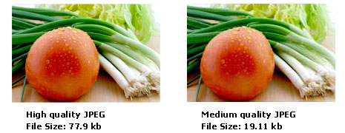

# References

Mesina, G. (2016, August 08). *Why you should care about media optimization.* Retrieved from enginedigital: https://www.enginedigital.com/perspectives/2016/08/why-you-should-care-about-media-optimization/