**INTERLINKS Integrating Digital Tools in Healthcare Education: An Analysis of Faculty Experiences and Strategies at Al-Farabi Kazakh National University**

Table of Contents

1. Introduction

* Background
* Objectives of the Study
* Methodology

2. Demographic Information

* Overview of Respondents
* Demographic Distribution

3. Digital Integration and Infrastructure

* Digital Pedagogy Integration
* E-learning Resource Management
* Learning Spaces and Equipment
* Digital Learning Environment
* Areas for Improvement and Strengths

4. Digital Technology in Teaching and Learning

* Enhancement of Communication and Assessment
* Use of Digital Technologies for Creative Assessments
* Enhancement of Student Interaction and Learning
* Educational Experience with Digital Tools
* Online Communication Effectiveness

5. Digital Preparedness and Support

* Global Digital Era Preparedness
* Staff Support in Digital Transition
* Financial Support for Digital Education
* Support for Personal Device Use and Online Services

6. Innovation and Development in Digital Education

* Advancing Research in Digital Health and E-learning
* Innovation in Digital Technologies
* Development of New Digital Tools
* Collaboration in Digital Education

7. Digital Strategy and Suitability

* Suitability of Digital Solutions for the Local Context
* Participatory Decision-Making in Digital Services
* Support for Paperless Practices
* Online Environment for Collaboration

8. Assessment, Performance Tracking, and Faculty/Staff Engagement

* Effectiveness of Assessment and Feedback Systems
* Support for Performance Tracking
* Engagement in Faculty-Staff Digital Use

9. Digital Ethics and Safety

* Awareness of Safe Personal Data Storage
* Awareness of Digital Copyright Norms
* Equality and Inclusivity Standards
* Safe Online Behaviour
* Digital Health and Well-being Protection

10. Specialized Analysis of Survey Two

* Overview and Objectives
* Detailed Response Analysis
* Implications and Recommendations

11. Appendices

* Survey Questions Comparison
* Detailed Questionnaire Results
* Thematic Analysis Charts

12. References

**Executive Summary**

This report examines the integration of digital technologies in teaching at Al-Farabi Kazakh National University, focusing on the faculties of Medicine and Public Health. The study, rooted in comprehensive faculty surveys and collaborative projects with the University of Nottingham, aims to develop a sustainable digital education strategy tailored to Kazakhstan's unique needs, preparing students for a technologically advanced healthcare environment.

The research methodology merged two distinct surveys, gathering data from 133 faculty members across various departments. These surveys, comprising both quantitative and qualitative questions, provided a holistic view of digital technology integration within the institution. Findings reveal a generally positive perception of digital integration and infrastructure, with an average score of 3.76 out of 5. Faculty members reported strong digital pedagogy integration, with 72.9% agreement, and effective e-learning resource management. Nevertheless, learning space design and equipment reliability emerged as areas requiring attention and improvement.

The results concerning digital technology in teaching and learning proved highly encouraging. Faculty members expressed high overall satisfaction, yielding an average score of 4.12 out of 5. They noted that new technologies significantly enhance communication and assessment in practical training, while also highlighting the strong use of digital technologies for creative assessments. Online communication between faculty and students received particularly high marks, and faculty demonstrated strong motivation to incorporate digital technologies into their teaching practices.

Evaluation of digital preparedness and support within the institution yielded mixed results. While the survey revealed a positive view of student preparation for the digital era and robust support for digital tool usage, financial backing for digital education initiatives lagged behind. This aspect received one of the lower scores, indicating a clear opportunity for strategic investment and development.

Innovation and development in digital education showed promising progress, achieving an average score of 3.96 out of 5. Faculty members acknowledged significant advancements in digital health and e-learning research. The findings suggest that enhancing collaborative efforts and tool development could further accelerate innovation in this domain.

The digital strategy's suitability for the local context garnered positive feedback, scoring an average of 4.00 out of 5. Notably, the online collaboration environment received high praise. The survey did, however, uncover a need for greater faculty involvement in decision-making processes related to digital services.

Assessment, performance tracking, and faculty-staff engagement yielded largely positive results. Digital technologies play an effective role in faculty-staff engagement, and there's strong support for leveraging student data in performance tracking. The study identified student assessment systems as an area with potential for enhancement, as it scored slightly lower than other aspects in this category.

The exploration of digital ethics and safety awareness among faculty members revealed varying levels of understanding across different digital standards and practices. While knowledge of safe personal data storage norms proved relatively strong, awareness of equality and inclusivity standards in the digital space requires bolstering.

Despite the overall positive findings, faculty members face several challenges in incorporating digital resources. These obstacles include technical issues such as poor internet connectivity, financial constraints related to paid subscriptions, insufficient training or skills, time limitations for learning new tools and creating digital content and varying levels of student adaptation to digital tools.

Drawing from these insights, the report recommends a multi-faceted approach to enhance digital education at the university. Key suggestions include upgrading digital infrastructure across campus, offering training and ongoing support for faculty and students, securing access to essential digital resources, crafting guidelines for seamless integration of digital tools into various course types, and allocating dedicated budget for digital education initiatives.

In conclusion, this digital strategy seeks to capitalize on existing positive attitudes and practices while addressing identified challenges. By implementing these recommendations, the university stands to significantly improve teaching efficacy and student engagement in an evolving educational landscape. Ultimately, this approach aims to enhance the quality and accessibility of healthcare education at Al-Farabi Kazakh National University, positioning it at the forefront of digital innovation in medical education within the region.

# 1. Introduction

## The rapid integration of digital technologies into educational systems has transformed traditional pedagogical approaches, particularly in the context of higher education. This report explores the use of digital tools and resources in teaching at Al-Farabi Kazakh National University, with a focus on the faculties of Medicine and Public Health. The findings presented are based on an analysis of faculty surveys, thematic analyses, and collaborative projects between the University of Nottingham and Kazakh institutions. The research highlights both the successes and challenges faced by educators in adopting digital pedagogies. It also emphasizes the importance of continuous support, training, and infrastructure improvements to fully leverage digital tools in enhancing educational outcomes. The results of this study can inform future strategies for integrating technology into the curriculum, ultimately aiming to improve both teaching efficacy and student engagement in a rapidly evolving educational landscape.

## 1.1 Background

## The Al-Farabi Kazakh National University, in collaboration with the University of Nottingham, has embarked on a transformative journey to enhance digital healthcare education. This partnership, fuelled by previous successful projects and grants from organizations like the British Council and Erasmus+, seeks to integrate advanced digital technologies and pedagogical strategies into Kazakhstan's educational framework. Leveraging the expertise from both institutions, the initiative aims to develop a sustainable, innovative digital strategy that addresses the unique needs of the region. This background sets the foundation for our report, which explores how such collaborations can significantly elevate the quality of education and tailor digital solutions to local contexts, thereby preparing students for a technologically advanced healthcare environment.

## 1.2 Objectives of the Study

## The primary objective of this project is to develop a digital education strategy that enhances the quality and accessibility of healthcare education at Al-Farabi Kazakh National University. Specifically, the project aims to:

## 1. Integrate Advanced Digital Tools: Utilize cutting-edge technologies like virtual reality and interactive platforms to create immersive and engaging learning experiences.

## 2. Enhance Faculty Digital Literacy: Provide robust training programs to ensure that faculty are well-equipped to employ digital tools effectively in their teaching practices.

## 3. Foster Collaborative Learning: Promote the use of digital platforms that facilitate collaboration among students and between students and faculty, enhancing the educational process.

## 4. Improve Educational Resources: Curate and develop high-quality digital content that is tailored to the needs of healthcare education.

## 5. Support Continuous Learning: Establish frameworks for ongoing professional development and digital skill enhancement for both students and faculty.

## These objectives are designed to foster an environment that not only adapts to the current technological advances but also anticipates future educational needs.

## 1.3 Methodology

This study involved the administration of two distinct surveys (See Appendix), which were later merged for analysis. This approach allowed the research team to gather extensive data on the use and perception of digital technologies in education across various faculty members. The methodology is detailed as follows:

1. **Survey Design**: Two separate surveys were initially designed to capture a broad spectrum of information. The first survey focused on general aspects of digital pedagogy, infrastructure, and faculty preparedness, while the second survey concentrated on specific experiences, challenges, and best practices in the use of digital tools within different departments. Both surveys included a combination of closed and open-ended questions to gather quantitative and qualitative data.
2. **Participant Selection**: The surveys were distributed to faculty members across various departments within the university. The objective was to ensure representation from different disciplines, levels of experience, and digital proficiency. This diverse participation provided an overview of digital technology integration within the institution.
3. **Data Collection**: The surveys were administered electronically to facilitate broad participation. Faculty members received invitations via email, and multiple reminders were sent to encourage response. A total of 133 faculty members completed the surveys, providing a robust dataset for subsequent analysis.
4. **Merging of Survey Data**: Upon completion, the data from both surveys were merged into a single dataset for analysis. This merging process involved aligning similar questions from both surveys, identified by their question labels (e.g., Q1, Q2, Q21), and consolidating responses where appropriate. This unified dataset allowed for a holistic analysis of the digital education landscape across the university.
5. **Data Analysis**:
   * **Quantitative Analysis**: The merged dataset was analysed using descriptive statistics to summarize the responses. Measures such as means, medians, and modes were calculated to identify trends and patterns in the faculty's experiences and perceptions of digital education.
   * **Qualitative Analysis**: Open-ended responses from both surveys were subjected to thematic analysis. This approach identified recurring themes and narratives, providing deeper insights into the specific challenges and successes encountered by faculty members in their use of digital technologies.
6. **Technical Assessment**: In parallel with the survey analysis, a technical assessment was conducted to evaluate the digital tools and infrastructure at the university. This assessment focused on the adequacy, reliability, and usability of the digital resources used in educational activities.

# 2. Demographic Information

The survey received responses from 133 faculty members, with a majority from the Department of Clinical Disciplines (38.53%) and the Department of Fundamental Medicine (29.36%). Most respondents have been with the faculty for 1-3 years (52.29%), and the majority are female (83.49%). Job titles varied, with most being Senior Lecturers (38.53%) or Lecturers (27.52%).

Below is the table summarizing these demographic results:

| **Demographic** | **Details** |
| --- | --- |
| **Department** | Clinical Disciplines: 38.53%, Fundamental Medicine: 29.36%, Other: 32.11% |
| **Tenure at Faculty** | 1-3 years: 52.29%, <1 year: 26.61%, 4-9 years: 17.43%, 10+ years: 3.67% |
| **Gender** | Female: 83.49%, Male: 16.51% |
| **Job Title** | Senior Lecturer: 38.53%, Lecturer: 27.52%, Associate Professor: 25.69%, Other: 8.26% |

**3. Theme 1- Digital Integration and Infrastructure**

|  |  |  |  |  |
| --- | --- | --- | --- | --- |
| **Question** | **Strongly Agree/Agree (%)** | **Neutral (%)** | **Disagree/Strongly Disagree (%)** | **Mean Score** |
| your faculty effectively integrates digital pedagogy in courses for quality education | 72.9% | 5.3% | 3.8% | 4.20 |
| your faculty manages e-learning resources effectively | 63.9% | 13.5% | 4.5% | 4.01 |
| learning spaces are well-designed for digital use | 32.3% | 34.6% | 15.0% | 3.27 |
| digital classroom equipment is reliable and user-friendly | 45.9% | 22.6% | 13.5% | 3.47 |
| digital media facilities are accessible for work | 48.1% | 21.8% | 12.0% | 3.59 |
| teaching software meets industry standards and is current | 58.6% | 15.0% | 8.3% | 3.75 |
| the digital learning environment is reliable | 60.2% | 17.3% | 4.5% | 3.88 |
| the digital learning environment is well-designed | 57.1% | 21.1% | 3.8% | 3.84 |
| the digital learning environment is easy to navigate | 59.4% | 18.8% | 3.8% | 3.87 |

The data reveals insights into the faculty’s use of digital technology, with an average perception score of 3.76 out of 5 where 5 is ‘Strongly agree’, suggesting a generally favourable view towards digital integration and infrastructure, though indicating potential areas for enhancement. A significant 59.4% of respondents acknowledge effective digital pedagogy integration within courses, highlighting a solid foundation with room for further advancement in using digital tools optimally for education. The management of e-learning resources scores higher at 4.01, reflecting a positive reception, yet suggesting possible improvements in resource allocation and usage.

Responses related to learning spaces and equipment demonstrate mixed satisfaction levels: design for digital use scored 3.27, equipment reliability 3.47, accessibility of digital media facilities 3.59, and software meeting industry standards 3.75.

The digital learning environment scores well, with reliability at 3.88, design at 3.84, and ease of navigation at 3.87, indicating that the platform's structure and user interface are strong points. This environment could serve as a benchmark for other areas needing uplift.

Areas for Improvement:

- Further integrate digital pedagogy through targeted faculty training and better resource distribution.

- Upgrade the reliability and user-friendliness of digital classroom equipment.

- Regular updates to teaching software to align with industry standards are crucial.

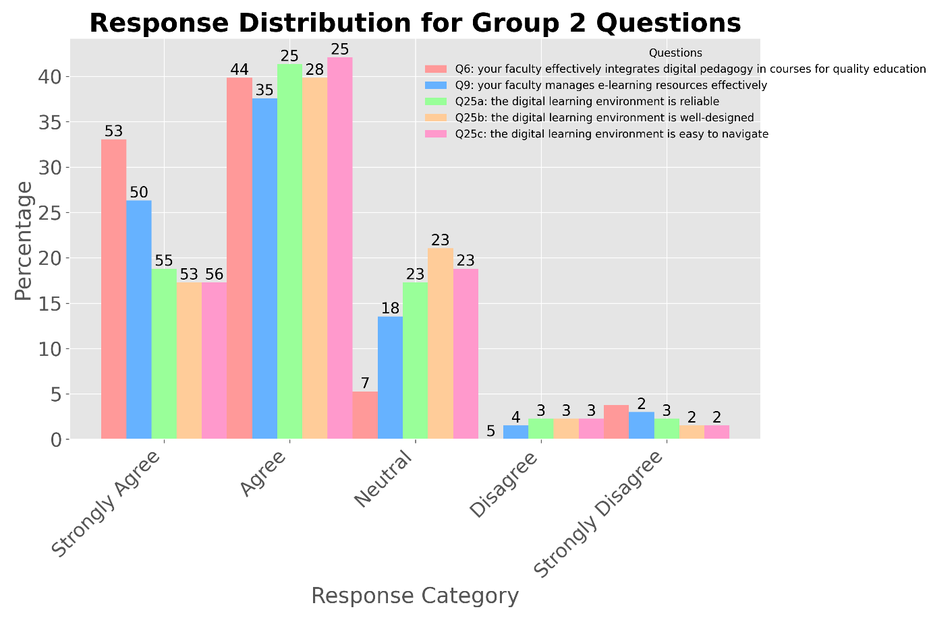

Figure 1: Response Distribution for Questions Related to Digital Pedagogy and Learning Environment

Figure 2: Response Distribution for Questions Related to Learning Spaces and Digital Equipment

**Theme 2- Digital Technology in Teaching and Learning**

|  |  |  |  |  |
| --- | --- | --- | --- | --- |
| **Question** | **Strongly Agree/ Agree (%) or Fully Motivated/ Motivated (%)** | **Neutral** | **Disagree/ Strongly Disagree (%) or Not Motivated /Completely Unmotivated (%)** | **Mean Score** |
| new technologies enhance communication and assessment in practical training | 72.2% | 6.8% | 3.0% | 4.17 |
| digital technologies are used for creative student assessments and feedback | 68.4% | 10.5% | 3.0% | 4.15 |
| digital technologies enhance student interaction and learning locally and internationally | 63.2% | 16.5% | 2.3% | 4.06 |
| your faculty provides an excellent educational experience using digital tools | 58.6% | 18.8% | 4.5% | 3.94 |
| your faculty provides impactful digital educational resources | 62.4% | 15.0% | 4.5% | 3.97 |
| online communication between faculty and students is effective | 75.2% | 5.3% | 1.5% | 4.29 |
| you use digital tools platforms confidently in the classroom | 65.4% | 14.3% | 2.3% | 4.07 |
| Motivated to use digital technologies | 71.4% | 6.8% | 3.8% | 4.28 |

Data from the questions within theme 2 presents an overall positive view of digital technology in education, with a mean score of 4.12 out of 5, suggesting favourable perceptions of its role in teaching and learning. A notable 71.4% of respondents believe that new technologies significantly enhance communication and assessment in practical training, highlighting the recognized potential of technology in these critical educational aspects.

Creative student assessments and feedback are positively viewed, with a mean score of 4.15, indicating an innovative approach to evaluation. Digital technologies are seen as instrumental in enhancing student interaction and learning across local and international contexts, scoring 4.06, which underscores the potential for a global learning environment.

The educational experience facilitated by digital tools receives a positive response (mean score: 3.94), showing successful technological integration. However, the provision of impactful digital educational resources, with a score of 3.97, suggests there is room for improvement.

Online communication between faculty and students rates highly at 4.29, though there is scope for further enhancement. Faculty confidence in using digital tools in the classroom is strong (mean score: 4.07), critical for effective technology integration. Additionally, motivation levels are high, with a 4.28 mean score, where 71.4% of respondents are fully motivated or motivated, reflecting a robust enthusiasm for adopting technology in education.

**Theme 3- Digital Preparedness and Support**

|  |  |  |  |  |
| --- | --- | --- | --- | --- |
| **Question** | **Strongly Agree/Agree (%)** | **Neutral (%)** | **Disagree/Strongly Disagree (%)** | **Mean Score** |
| your faculty prepares students for a global digital era | 63.2% | 16.5% | 2.3% | 4.04 |
| your faculty prepares staff to support students in a digital era | 60.9% | 16.5% | 4.5% | 3.98 |
| your faculty offers financial support for digital education | 48.1% | 23.3% | 10.5% | 3.63 |
| your faculty offers support for creating and using digital technologies in education and healthcare | 59.4% | 16.5% | 6.0% | 3.86 |
| students are supported in using their own digital devices | 63.2% | 16.5% | 2.3% | 3.96 |
| students can access online services worldwide | 66.2% | 12.0% | 3.8% | 4.07 |
| you support others in using digital tools for teaching learning | 72.9% | 6.8% | 2.3% | 4.18 |
| you are offered opportunities to learn necessary digital skills | 66.9% | 12.0% | 3.0% | 4.06 |
| you can assess your digital skills for career planning | 58.6% | 18.0% | 5.3% | 3.86 |
| you have time to explore new digital tools and methods | 65.4% | 11.3% | 5.3% | 3.92 |

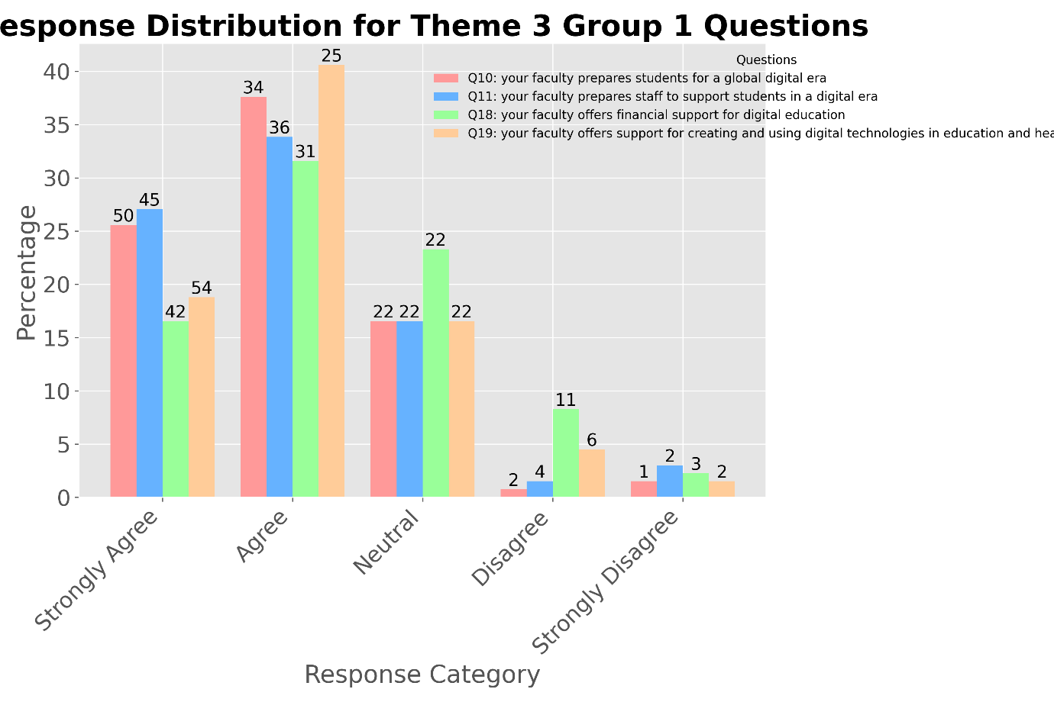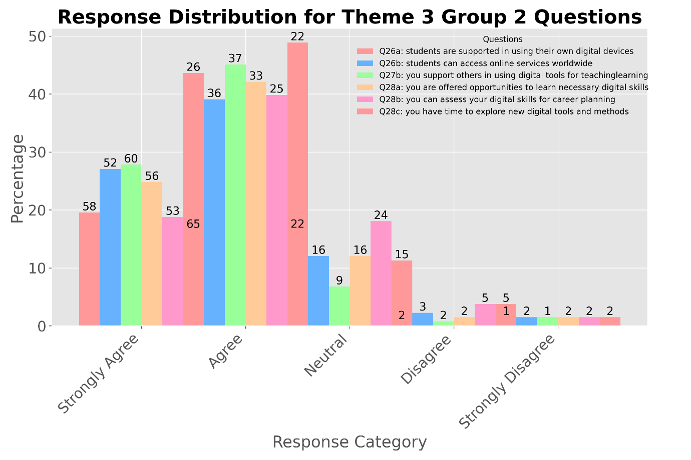

The theme 3 results indicate a generally positive perception of digital technology integration within the faculty. A majority of respondents, 63.2%, agree that the faculty prepares students well for a global digital era, reflected by a mean score of 4.04. Similarly, 60.9% feel supported in helping students in a digital context, scoring 3.98. Financial support for digital education receives lower approval at 48.1%, with a mean score of 3.63, suggesting potential areas for enhancement. Notably, 72.9% of faculty members feel confident in supporting others with digital tools, earning the highest mean score of 4.18. Accessibility to online services worldwide is also strong, with 66.2% agreement and a score of 4.07. Opportunities for learning digital skills are positively viewed by 66.9% of respondents, aligning with a supportive score of 4.06. The findings highlight strengths in digital tool support and learning opportunities, though improvements in financial backing and broader resource support could further enhance outcomes.

**Theme 4 Innovation and Development in Digital Education**

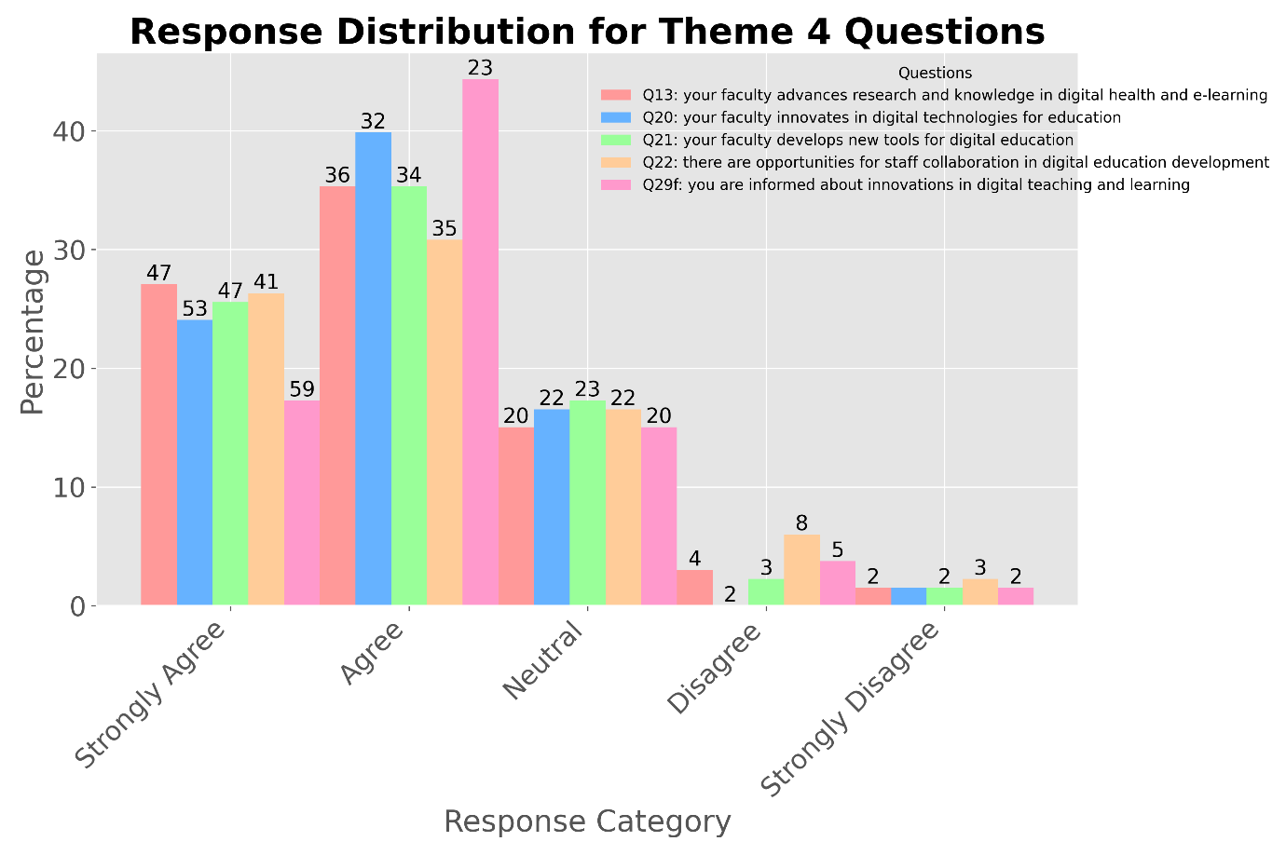

|  |  |  |  |  |
| --- | --- | --- | --- | --- |
| Question | Strongly Agree/Agree (%) | Neutral (%) | Disagree/Strongly Disagree (%) | Mean Score |
| your faculty advances research and knowledge in digital health and e-learning | 62.4% | 15.0% | 4.5% | 4.02 |
| your faculty innovates in digital technologies for education | 63.9% | 16.5% | 1.5% | 4.04 |
| your faculty develops new tools for digital education | 60.9% | 17.3% | 3.8% | 3.99 |
| there are opportunities for staff collaboration in digital education development | 57.1% | 16.5% | 8.3% | 3.89 |
| you are informed about innovations in digital teaching and learning | 61.7% | 15.0% | 5.3% | 3.88 |

Theme 4 results reveal a moderate level of innovation within the faculty regarding digital education, with an overall theme mean score of 3.96. Specifically, 62.4% of respondents acknowledge that the faculty advances research and knowledge in digital health and e-learning, receiving a mean score of 4.02. Furthermore, 63.9% agree that there is innovation in digital technologies for education, indicated by a 4.04 mean score. Development of new digital tools is positively viewed by 60.9% of faculty, scoring 3.99. However, opportunities for staff collaboration in digital education development have a slightly lower reception at 57.1% agreement and a 3.89 mean score. Also, 61.7% of respondents are informed about innovations in digital teaching and learning, with a mean score of 3.88. These results suggest that while there is appreciable innovation, enhancing collaborative efforts and further development of new digital tools could improve overall digital education efficacy.

**Theme 5- Digital Strategy and Suitability**

|  |  |  |  |  |
| --- | --- | --- | --- | --- |
| Question | Strongly Agree/Agree (%) | Neutral (%) | Disagree/Strongly Disagree (%) | Mean Score |
| your faculty provides digital solutions suitable for Central Asia post-Soviet | 64.7% | 12.8% | 4.5% | 4.00 |
| you can participate in decisions on digital services | 59.4% | 17.3% | 5.3% | 3.88 |
| your faculty supports paperless practices | 58.6% | 17.3% | 6.0% | 3.98 |
| there is a good online environment for collaboration | 67.7% | 12.0% | 2.3% | 4.14 |

Theme 5 data offers insights into the faculty's digital strategy, particularly its adaptability to the local context, scoring an overall mean of 4.00 out of 5. This score reflects a moderately positive view of how the digital strategy aligns with the needs of the Central Asia/post-Soviet region. While the digital solutions are generally well-received, there is an opportunity to better tailor these tools to enhance their relevance and effectiveness locally. Decision-making participation scored 3.88, suggesting room for greater inclusivity in the digital planning processes. The faculty's support for paperless practices achieved a score of 3.98, indicating a shift towards sustainability, although further efforts could push these practices more broadly. Online collaboration environments rated highly at 4.14, showcasing a strong base for digital cooperation.

Strengths to Leverage:

1. The positive reception of tailored digital solutions provides a base for further refinement.

2. The robust online collaboration setup can be expanded for wider educational and operational use.

3. Current support for paperless practices indicates readiness for further digital advancements.

**Theme 6- Assessment, Performance Tracking, and Faculty-Staff Engagement**

|  |  |  |  |  |
| --- | --- | --- | --- | --- |
| **Question** | **Strongly Agree/Agree (%)** | **Neutral (%)** | **Disagree/Strongly Disagree (%)** | **Mean Score** |
| student assessment and feedback systems are effective | 62.4% | 15.0% | 4.5% | 3.91 |
| faculty supports using student data for performance tracking | 67.7% | 10.5% | 3.8% | 4.05 |
| digital technologies are effectively used in faculty-staff engagement | 69.9% | 8.3% | 3.8% | 4.13 |

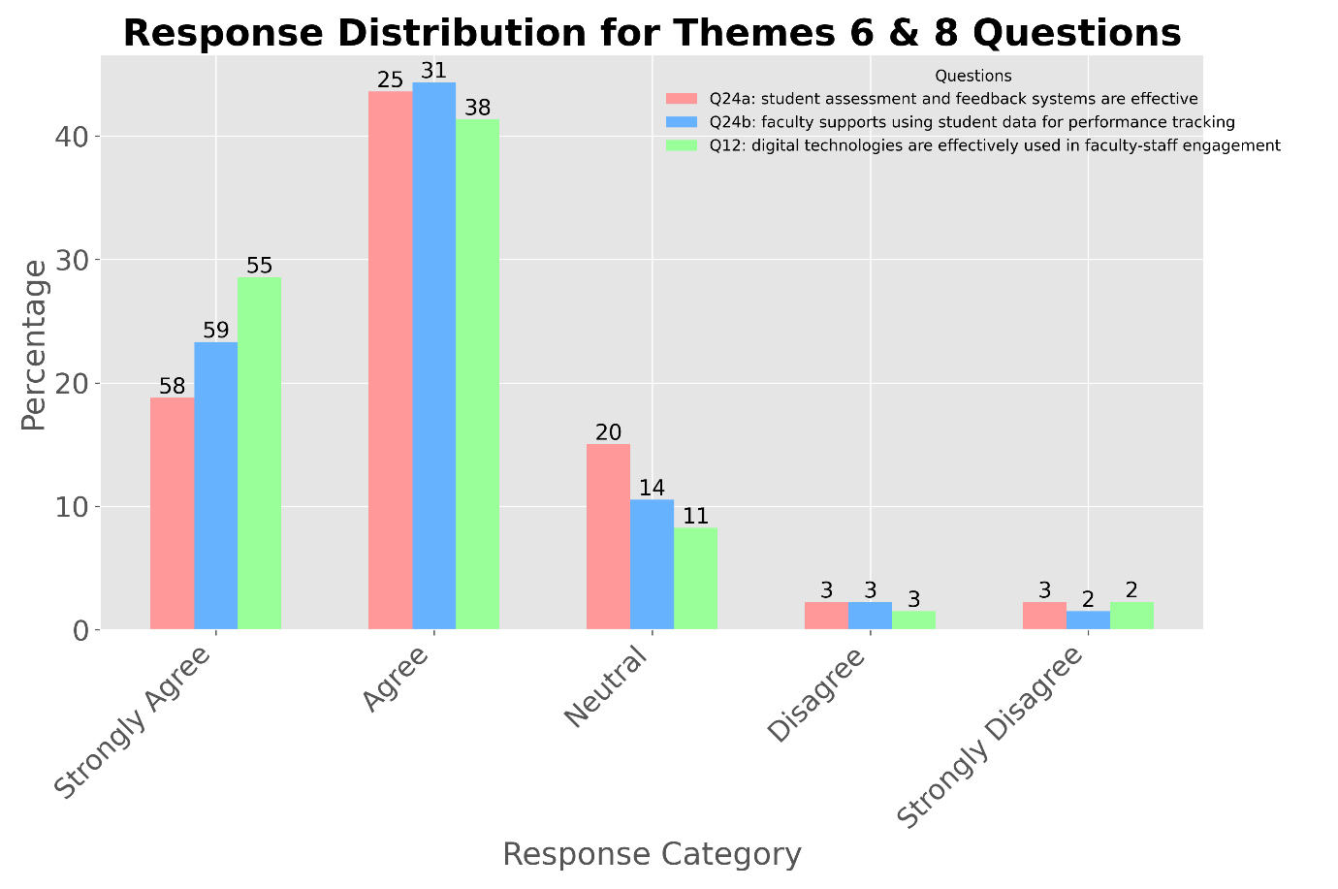

Feedback for theme 6 questions on the faculty’s digital practices shows varying levels of satisfaction across different areas. For student assessment and feedback systems, 62.4% of respondents feel these are effective, leading to a mean score of 3.91, suggesting there is potential for enhancement. The use of student data for performance tracking is more positively viewed, with 67.7% approval and a mean score of 4.05, indicating a strong support for data-driven approaches. Additionally, digital technologies in faculty-staff engagement receive the highest approval at 69.9%, with a mean score of 4.13, highlighting effective use of digital tools in fostering communication and collaboration. This area stands out as a strong point in the faculty’s adoption of technology.

**Theme 7- Digital Ethics and Safety**

|  |  |  |  |  |
| --- | --- | --- | --- | --- |
| **Question** | **Strongly Agree/Agree (%)** | **Neutral (%)** | **Disagree/Strongly Disagree (%)** | **Mean Score** |
| you know the norms for safe personal data storage | 61.7% | 15.0% | 5.3% | 3.89 |
| you are informed about digital copyright norms | 49.6% | 21.8% | 10.5% | 3.66 |
| you are informed about equality and inclusivity standards | 47.4% | 23.3% | 11.3% | 3.62 |
| you are informed about safe online behavior | 57.1% | 18.8% | 6.0% | 3.84 |
| you are aware of digital health and well-being protection | 57.1% | 16.5% | 8.3% | 3.79 |

Theme 7 results highlight varying familiarity levels with digital standards and practices among faculty members. Regarding the norms for safe personal data storage, 61.7% of respondents indicate they are well-informed, with a mean score of 3.89, suggesting a solid understanding but noting there's room for more comprehensive training.

Awareness of digital copyright norms appears to be less understood, with only 49.6% feeling adequately informed, resulting in a mean score of 3.66. This indicates a significant gap in knowledge that could impact compliance and ethical use of digital content.

For equality and inclusivity standards, only 47.4% of respondents feel well-informed, and the mean score of 3.62 reflects a need for improved education on these critical issues to ensure fairness and equity in digital interactions.

Knowledge about safe online behaviour is reported by 57.1% of the faculty, with a mean score of 3.84, indicating a reasonably good awareness but also highlighting the need for ongoing education in cybersecurity practices.

Similarly, 57.1% report being aware of digital health and well-being protection, with a mean score of 3.79, suggesting that while there is a decent level of understanding, more could be done to enhance awareness and practices related to digital well-being.

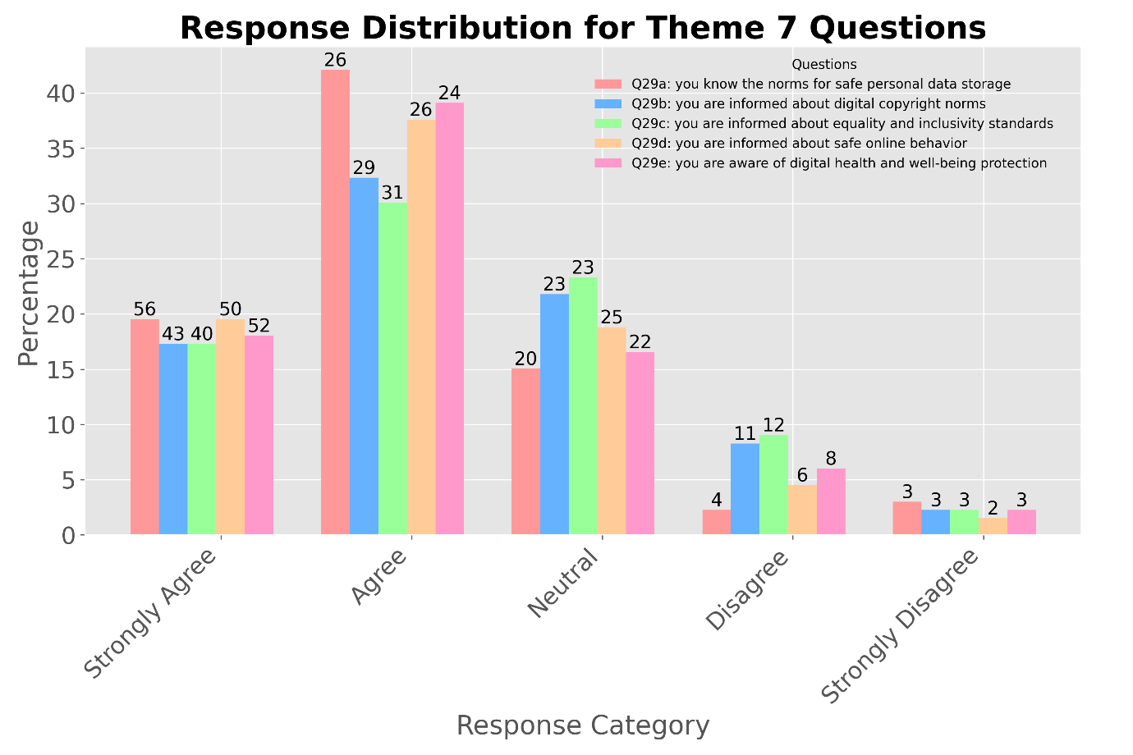

**Specific Analysis of Survey Two**

This section provides a specialized analysis of Survey Two, which was initially combined with Survey One to deliver descriptive statistics and thematic insights aligned with the study's objectives. The decision to segregate Survey Two for further scrutiny was driven by its rich open-ended questions that offer deeper qualitative insights, warranting a distinct examination. The analysis presented below explores these detailed responses separately, highlighting unique perspectives and nuanced feedback from the second survey participants.

* 1. **Overall Perception:**

Respondents generally view the use of technology in teaching positively, with descriptions ranging from "modern" and "high" to "actively used" and "inevitable." Many mention the increased adoption of digital tools, especially since the COVID-19 pandemic.

* There's a wide variety of tools being used, indicating a diverse digital ecosystem.
* Many educators are using a mix of general educational tools and specialized medical resources.
* The adoption of technology appears to be driven both by institutional initiatives and individual instructor preferences.
  1. **Popular Digital Tools and Resources:**

1. Learning Management Systems (LMS): Moodle, Google Classroom
2. Video conferencing: Zoom, Microsoft Teams
3. Interactive tools: Kahoot, Quizlet, Jamboard
4. Medical resources: Amboss, Lecturio, Complete Anatomy
5. General tools: Google Suite, PowerPoint, Excel

* 1. **Thematic Analysis of Challenges in Incorporating Digital Resources:**

This related to Q8: "Can you describe any challenges you have faced in incorporating digital resources or digital tools into your modules and strategies to overcome these?"

Analysis of Thematic Findings:

1. Technical Issues (33.3%): The most commonly reported challenge, with respondents citing problems such as poor internet connectivity and inadequate hardware. This highlights the need for improved infrastructure to support digital teaching.
2. Financial Constraints (23.8%-green bar): Many respondents mentioned the cost of digital resources, particularly paid subscriptions, as a significant barrier. This suggests a need for institutional support in acquiring necessary digital tools.
3. Lack of Training/Skills (13.3%): Some educators felt they lacked the necessary knowledge or skills to effectively use digital tools, indicating a need for more comprehensive training programs.
4. Time Constraints (11.1%): Respondents noted that learning new tools and creating digital content is time-consuming, suggesting a need for allocated time or resources for digital content development.
5. Student Adaptation (11.1%): Challenges related to students' varying levels of digital literacy were mentioned, particularly for older students. This indicates a need for student support in digital skills development.
6. Administrative Hurdles (5.6%): A small number of respondents mentioned bureaucratic processes or restrictions as challenges, suggesting some institutional barriers to digital tool adoption.
7. No Challenges Reported (16.7%): Interestingly, some respondents reported no significant challenges, which could indicate varying levels of digital readiness among faculty.

1. **Desired Percentage of Digital Curriculum**

Most respondents (67%) prefer a balanced approach, with 26-75% of the curriculum delivered digitally. Key reasons include:

* Flexibility for students, especially those balancing work and family commitments
* Enhanced learning through diverse resources and self-paced study
* Preparation for the digital healthcare landscape

However, many emphasize the importance of maintaining hands-on, practical training for clinical skills, suggesting a blended learning approach.

1. **Views on Technology in Teaching:**
   1. Sentiment Distribution:
   * Positive views dominate, with 12 out of 18 respondents (67%) expressing favourable opinions.
   * Neutral views are held by 4 respondents (22%).
   * Only 2 respondents (11%) expressed negative views.

* 1. Thematic Analysis of Views on Technology in Teaching

A thematic analysis was conducted on the responses to questions regarding views on technology in teaching. This analysis revealed five primary themes, each supported by quotes from the survey data. The themes provide insight into the educators' perceptions, experiences, and attitudes towards technology use in their teaching practices.

* Widespread Use and Positive Reception

This theme emerged as the most prominent, with most respondents indicating that technology is extensively and positively used in their teaching.

One respondent stated, "Various technologies are widely used in teaching. This applies both to various technologies in learning process, and to apply modern computer technologies that help teachers to teach and assess students' knowledge and skills."

This sentiment was echoed by many, suggesting a general acceptance and appreciation of technology in the educational setting.

* Modern and Innovative Approaches

Many educators viewed the use of technology to keep up with modern educational trends and implement innovative teaching methods.

A particularly comprehensive response highlighted this: *"Using technology in medical education has a variety of educational goals, including facilitating basic knowledge acquisition, improving decision making, increasing perceptual variation, improving skill coordination, practicing for rare or critical events, learning team training, and improving psychomotor skills*."

This quote demonstrates the multifaceted ways in which technology is perceived to enhance and modernize the teaching process.

* Supportive of Learning Process

Respondents frequently mentioned how technology enhances and supports the learning experience.

One educator succinctly put it: "*Thanks to technology, teachers can customize learning for students. Simple technologies Power Points, games, internet homework assignments etc. are very suitable tools*."

This theme underscores the perceived value of technology in creating more engaging, personalized, and effective learning experiences.

* Challenges in Implementation

Despite the overall positive reception, some respondents noted difficulties in effectively implementing technology.

A particularly illustrative quote stated: "*Google Meet is not good for us when working with international students with different levels of internet connection. University do not provide subscription for med sources mentioned above - this is most challenging for teachers and students*!"

This theme highlights the practical obstacles that educators face, particularly regarding infrastructure and access to resources.

* Continuous Improvement and Adaptation

Some responses indicated an awareness of the need for ongoing refinement and adaptation in technology use.

One brief but telling response noted: "*At the intermediate level as I know*."

This theme suggests that while technology use is widespread, there's recognition that its implementation is an ongoing process requiring continuous assessment and improvement.

These findings have several implications:

1. The positive reception suggests a favourable environment for further technology integration in teaching.
2. The emphasis on modern and innovative approaches indicates an openness to new teaching methods, which could be leveraged in future digital education initiatives.
3. The recognition of technology as supportive of learning underscores the importance of aligning technology use with pedagogical goals and student outcomes.
4. The mention of challenges highlights the need for robust support systems, training programs, and resources to ensure effective technology integration.
5. The theme of continuous improvement suggests an opportunity for ongoing assessment and refinement of technology use in teaching.

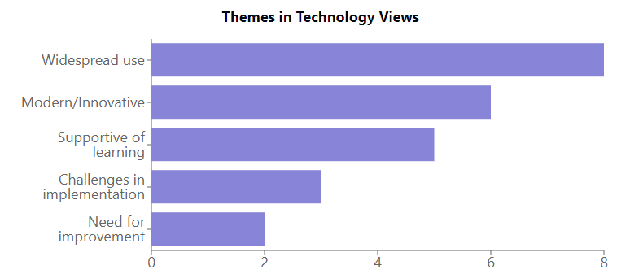

1. **Thematic Analysis of Technology Experience (Q7)**

Key themes emerging from the analysis:

1. Adaptation and Evolution
   * Many respondents described a journey of adapting to new technologies, especially in response to the COVID-19 pandemic.
   * Example: "since 2020, the use of technology has become inevitable. it was impossible to teach without mastering the video hosting platforms..."
2. Tool Diversity and Experimentation
   * Educators are using a wide variety of tools, indicating a willingness to experiment and find what works best for their teaching needs.
   * Example: "I use 3D Complete Anatomy by Elsevier - for my anatomy classes, Zoom for meetings, <https://www.freeconferencecall.com/> for videolectures..."
3. Blended Learning Approaches
   * Many responses indicate a mix of digital and traditional teaching methods, suggesting a preference for blended learning.
   * Example: "I widely use in my practice presentations with audio settings, various methods of videoconferencing - zoom, MS Teams, etc."
4. Emphasis on Student Engagement
   * Several responses highlight the use of interactive tools to increase student engagement.
   * Example: "After studying the topic, students are invited to take an online test in Google forms with a detailed description of what and how to do."
5. Continuous Learning and Improvement
   * Educators express a sense of ongoing learning and improvement in their use of digital tools.
   * Example: "I completed training in working in Moodle, which gave me the opportunity to use a wide range of different elements in Moodle to diversify tasks and increase students' interest in the learning process."

This thematic analysis reveals that educators are on a journey of technological adaptation, actively experimenting with various tools to enhance their teaching while focusing on student engagement and their own continuous improvement.

These additional analyses provide a more nuanced understanding of the educators' experiences, challenges, and attitudes towards technology use in teaching. They complement the quantitative data by offering deeper insights into the lived experiences and perceptions of the respondents.

1. **Perceived Student Interest in Digital Learning**

The survey asked educators' perceptions of their students' interest in digital learning, providing valuable insights into the demand for digital education from the student perspective. The responses revealed a mixed but generally positive view of student interest in digital learning methods.

A significant portion of educators reported high student interest in digital learning. One respondent noted, "*Yes, students go so that classes include digital platforms, as it is convenient, it does not take time to go somewhere, etc., students always ask for assignments on any platforms*." This sentiment was echoed by several others, highlighting the perceived convenience and flexibility that digital learning offers to students.

However, the responses also indicated a nuanced view of student preferences. Some educators observed that while students appreciate digital resources, they still value face-to-face interactions, especially in medical education. As one respondent put it, *"I think that my students (interns) understand that classes should be held offline in full contact with the patient, alas, without this, it's impossible! But they like it when I give them certain links to case databases, or videos of interesting patient exams that I can't show them at the moment*!"

Interestingly, several educators noted that student interest in digital learning varies depending on the subject matter and the type of learning activity. For instance, one respondent observed, "*All non-medical disciplines they want to be remote. But it is better to carry out medical offline. According to a student survey."*

The methods educators used to gauge student interest varied, including direct feedback, observations of engagement with digital tools, formal surveys, and performance comparisons between digital and traditional assignments.

1. **Importance of Digital Skills (Q13) and Suggestions for University Improvement (Q15)**

There is unanimous agreement among respondents that developing digital skills is crucial for students. Key reasons include:

* Preparation for the increasingly digital healthcare industry
* Enhancement of research and information-gathering abilities
* Improvement in communication and collaboration skills
* Increased competitiveness in the global job market

The thematic analysis for the responses to Question 13: "To improve the quality of digital teaching and learning what does your university need to do?" breaks down suggestions how to achieve the requirements:

1. **Recommendations for Improving Digital Teaching and Learning**

Based on the survey responses, key recommendations include:

1. Enhanced Infrastructure:
   * Improve internet connectivity across campus
   * Provide modern computers and large screens in classrooms
   * Ensure access to necessary hardware (laptops, tablets) for both faculty and students
2. Training and Support:
   * Organize regular workshops on using digital tools effectively
   * Provide ongoing technical support for both faculty and students
   * Facilitate peer-to-peer learning and best practice sharing among faculty
3. Resource Access:
   * Secure institutional subscriptions to key digital platforms and resources
   * Develop a curated repository of digital resources relevant to healthcare education
4. Curriculum Integration:
   * Develop guidelines for effectively integrating digital tools into various course types
   * Encourage the creation of digital content tailored to specific courses
5. Financial Support:
   * Allocate budget for acquiring necessary digital tools and resources
   * Consider providing stipends or incentives for faculty developing digital content

**Conclusion**

The INTERLINKS project, a collaboration between the University of Nottingham and Al-Farabi Kazakh National University, aimed to co-create a strategy for developing digital healthcare education in Kazakhstan. The project surveyed 133 faculty members to gain insights into the current state of digital integration in healthcare education.

The survey results indicate a generally positive reception of digital technologies in teaching and learning. Faculty members reported satisfaction with digital pedagogy integration and e-learning resource management, with an average score of 3.76 out of 5. Notably, there is high motivation among respondents to use digital technologies in teaching, scoring 4.28 out of 5.

While the overall perception is positive, the survey identified areas for potential improvement. Learning space design and equipment reliability received lower scores (3.27 and 3.47 out of 5, respectively), suggesting these as areas that may benefit from attention. Financial support for digital education initiatives also received a lower score (3.63 out of 5), indicating a possible area for review.

The survey revealed varied levels of awareness regarding digital ethics and safety practices among respondents. While knowledge of safe personal data storage norms was relatively strong, awareness of equality and inclusivity standards in the digital space scored lower.

Based on these findings, we suggest considering the following actions:

* Review the current state of learning spaces and digital equipment, considering potential upgrades where feasible.
* Assess the current allocation of financial resources for digital education initiatives.
* Consider developing targeted training programs to enhance digital skills among faculty, focusing on areas where the survey indicated lower confidence levels.
* Explore ways to improve awareness of digital ethics and safety practices, particularly regarding equality and inclusivity standards in digital spaces.
* Investigate the potential for expanding online collaboration tools, which received positive feedback in the survey.
* Consider conducting further, more detailed studies on specific aspects of digital education implementation to gather more comprehensive data.

**Appendix:**

|  | **Survey 1 Question** |  | **Survey 2 Question** |
| --- | --- | --- | --- |
| Q1 | Which department do you work in? | Q1 | In which faculty/school/department that you are currently working? |
| Q2 | What subjects do you teach? | Q2 | Which areas of the curriculum do you currently teach? |
| Q3 | How long have you worked at the faculty? | Q3 | How many years have you worked here? |
| Q4 | What is your gender? | Q4 | What gender do you identify as? |
| Q5 | What is your current job title? | Q5 | Please indicate your academic position. |
| Q6 | Agree that your faculty effectively integrates digital pedagogy in courses. | Q6 | Please describe your view of how technology is used in teaching in your university. |
| Q7 | Agree that new technologies enhance communication and assessment. | Q7 | Tech Experience. |
| Q8 | Agree that digital technologies are used for creative assessments. | Q8 | Can you describe any challenges you have faced in incorporating digital resources or digital tools? |
| Q9 | Agree that your faculty manages e-learning resources effectively. | Q9 | Please elaborate on any exemplar cases of incorporating digital resources or tools in the curriculum. |
| Q10 | Agree that your faculty prepares students for a global digital era. | Q10 | Can you give any examples of digital tools or apps that you find or would find useful for teaching? |
| Q11 | Agree that your faculty prepares staff to support students in a digital era. | Q11 | Where would you like to see more digital resources or digital tools in your modules or curricula? |
| Q12 | Agree that digital technologies are effectively used in faculty-staff engagement. | Q12 | Digital Percentage. |
| Q13 | Agree that your faculty advances research and knowledge in digital health and e-learning. | Q13 | Improve Quality. |
| Q14 | Agree that digital technologies enhance student interaction and learning locally and internationally. | Q14 | Develop Skills. |
| Q15 | Agree that your faculty provides an excellent educational experience using digital tools. | Q15 | Student Skills. |
| Q16 | Agree that your faculty provides digital solutions suitable for the Central Asia/post-Soviet context. | Q16 | Student Digital Wants. |
| Q17 | Agree that your faculty provides impactful digital educational resources. |  |  |
| Q18 | Agree that your faculty offers financial support for digital education. |  |  |
| Q19 | Agree that your faculty offers support for creating and using digital technologies in education. |  |  |
| Q20 | Agree that your faculty innovates in digital technologies for education. |  |  |
| Q21 | Agree that your faculty develops new tools for digital education. |  |  |
| Q22 | Agree that there are opportunities for staff collaboration in digital education development. |  |  |
| Q23a | Agree that learning spaces are well-designed for digital use. |  |  |
| Q23b | Agree that digital classroom equipment is reliable and user-friendly. |  |  |
| Q23c | Agree that digital media facilities are accessible for work. |  |  |
| Q23d | Agree that teaching software meets industry standards and is current. |  |  |
| Q24a | Agree that student assessment and feedback systems are effective. |  |  |
| Q24b | Agree that faculty supports using student data for performance tracking. |  |  |
| Q24c | Agree that you can participate in decisions on digital services. |  |  |
| Q25a | Agree that the digital learning environment is reliable. |  |  |
| Q25b | Agree that the digital learning environment is well-designed. |  |  |
| Q25c | Agree that the digital learning environment is easy to navigate. |  |  |
| Q26a | Agree that students are supported in using their own digital devices. |  |  |
| Q26b | Agree that students can access online services worldwide. |  |  |
| Q26c | Agree that online communication between faculty and students is effective. |  |  |
| Q26d | Agree that your faculty supports paperless practices. |  |  |
| Q26e | Agree that there is a good online environment for collaboration. |  |  |
| Q27a | Agree that you use digital tools/platforms confidently in the classroom. |  |  |
| Q27b | Agree that you support others in using digital tools for teaching/learning. |  |  |
| Q28a | Agree that you are offered opportunities to learn necessary digital skills. |  |  |
| Q28b | Agree that you can assess your digital skills for career planning. |  |  |
| Q28c | Agree that you have time to explore new digital tools and methods. |  |  |
| Q29a | Agree that you know the norms for safe personal data storage. |  |  |
| Q29b | Agree that you are informed about digital copyright norms. |  |  |
| Q29c | Agree that you are informed about equality and inclusivity standards. |  |  |
| Q29d | Agree that you are informed about safe online behaviour. |  |  |
| Q29e | Agree that you are aware of digital health and well-being protection. |  |  |
| Q29f | Agree that you are informed about innovations in digital teaching and learning. |  |  |
| Q30 | How motivated are you to use digital technologies in teaching/learning? |  |  |

