# 1 Executive Summary

Well, not quite *executive*- we don’t have the budget for Gold letters. We thought it may be a good idea for you to look where all the people in the world have used the resources. (click the link below, or right, its close) {World Map of RLO Usage}

↑This world map has 24942 IP addresses of those who allowed their IP to be captured. So in reality there are 4x more IPs than displayed. Please interact with this map by zooming in/out and hovering over locations (then come back here of course).

*(thanks to ipinfo.io who power organizations around the world with reliable IP data)*

## 1.1 The Dataset

This data set had 109151 participants from all over the world. That is about the same as the population of Cambridge, United Kingdom (125,257). Imagine that today everyone in Cambridge used these RLOs for healthcare education.

…and if they tell a group of their colleagues, who later tell other friends, relatives, tutors, that is.. well..lots more.

## 1.2 Number of Learning Object Users (2006-2022)

What happened in 2017? Did they get a free bar of chocolate with every use? How did the COVID-19 pandemic effect the uptake from 2022 to now? These are some questions which this graph can be the start towards the answers.

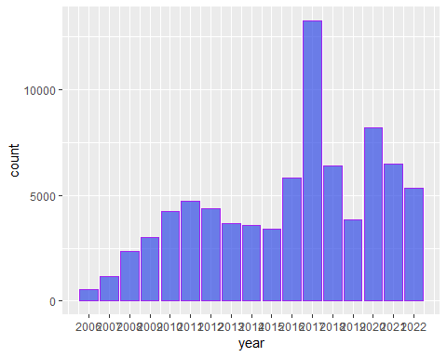

This dataset included results from a variety of individuals that we call Stakeholders. Stakeholders include:

-Tutors/teachers/lecturers,

-patients/service users/carers,

-and students in either further or higher education.

To keep it short, here is a summary table showing if Stakeholders found the RLO(s) they used to be *worth recommending to others*. We hope there are few NO responses, and many YES responses.

# A tibble: 16 × 3  
# Groups: Identity, Recommend [16]  
 Identity Recommend n  
 <chr> <chr> <int>  
 1 HE student No 36  
 2 HE student Yes 910  
 3 Healthcare professional No 67  
 4 Healthcare professional Yes 1539  
 5 Other No 25  
 6 Other Yes 899  
 7 Other <NA> 15  
 8 Patient/Service-user/Carer No 2  
 9 Patient/Service-user/Carer Yes 62  
10 Patient/Service-user/Carer <NA> 3  
11 Student No 176  
12 Student Yes 3712  
13 Student <NA> 39  
14 Tutor/Teacher/Lecturer No 5  
15 Tutor/Teacher/Lecturer Yes 387  
16 Tutor/Teacher/Lecturer <NA> 3

UP TO HERE

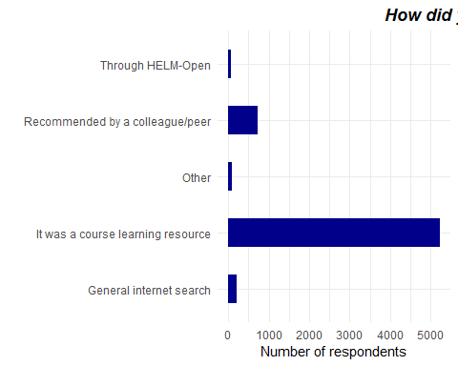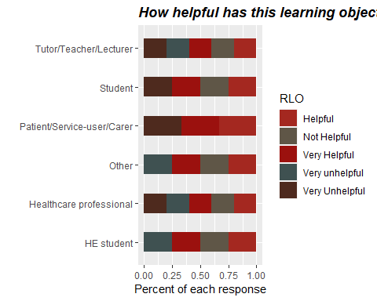

# A tibble: 24 × 3  
# Groups: Identity, dRLO [24]  
 Identity dRLO n  
 <chr> <chr> <int>  
 1 HE student It was a course learning resource 80  
 2 HE student Other 2  
 3 HE student Recommended by a colleague/peer 4  
 4 HE student Through HELM-Open 1  
 5 Healthcare professional General internet search 7  
 6 Healthcare professional It was a course learning resource 131  
 7 Healthcare professional Other 3  
 8 Healthcare professional Recommended by a colleague/peer 10  
 9 Other General internet search 8  
10 Other It was a course learning resource 50  
# … with 14 more rows

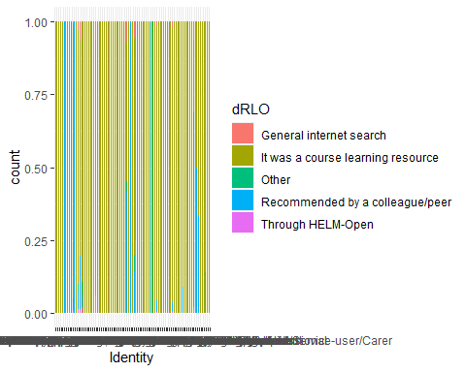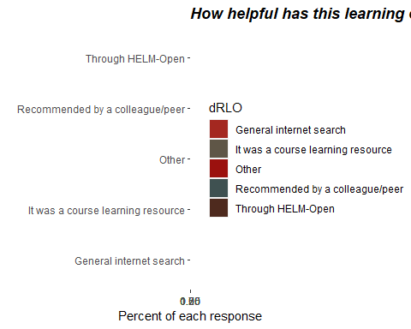

# A tibble: 24 × 3  
# Groups: Identity, dRLO [24]  
 Identity dRLO n  
 <chr> <chr> <int>  
 1 HE student It was a course learning resource 80  
 2 HE student Other 2  
 3 HE student Recommended by a colleague/peer 4  
 4 HE student Through HELM-Open 1  
 5 Healthcare professional General internet search 7  
 6 Healthcare professional It was a course learning resource 131  
 7 Healthcare professional Other 3  
 8 Healthcare professional Recommended by a colleague/peer 10  
 9 Other General internet search 8  
10 Other It was a course learning resource 50  
# … with 14 more rows

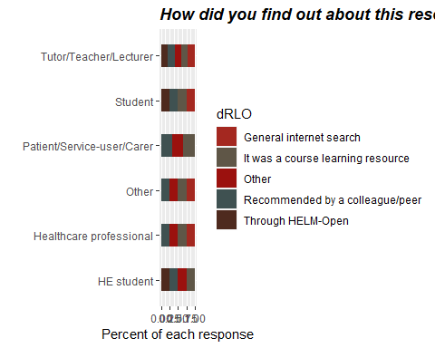

| Identity | RLO | n |
| --- | --- | --- |
| HE student | Helpful | 378 |
| HE student | Not Helpful | 13 |
| HE student | Very Helpful | 540 |
| HE student | Very unhelpful | 15 |
| Healthcare professional | Helpful | 566 |
| Healthcare professional | Not Helpful | 28 |
| Healthcare professional | Very Helpful | 979 |
| Healthcare professional | Very unhelpful | 13 |
| Healthcare professional | Very Unhelpful | 20 |
| Other | Helpful | 351 |
| Other | Not Helpful | 25 |
| Other | Very Helpful | 543 |
| Other | Very unhelpful | 4 |
| Patient/Service-user/Carer | Helpful | 20 |
| Patient/Service-user/Carer | Very Helpful | 44 |
| Patient/Service-user/Carer | Very Unhelpful | 3 |
| Student | Helpful | 1630 |
| Student | Not Helpful | 101 |
| Student | Very Helpful | 2153 |
| Student | Very Unhelpful | 8 |
| Tutor/Teacher/Lecturer | Helpful | 152 |
| Tutor/Teacher/Lecturer | Not Helpful | 2 |
| Tutor/Teacher/Lecturer | Very Helpful | 238 |
| Tutor/Teacher/Lecturer | Very unhelpful | 1 |
| Tutor/Teacher/Lecturer | Very Unhelpful | 1 |

### 1.2.1 index.Rmd: **metadata and layout options**

In index.Rmd, set your thesis’ basic metadata (e.g., title, author name)

Also set filepath(s) to your abstract, acknowledgements, abbreviations, and bibliography (one or more **.bib** files):

Finally, **index.Rmd** is also where you customise layout options. For example, in PDF output what should the heading for the bibliography section say? How should page numbers be positioned? Should line numbers be shown? In HTML output, what CSS files should be used for styling?

### 1.2.2 other **.Rmd** files in root folder: thesis chapters

* each chapter of your thesis should have its own **.Rmd** file in the root directory
* when you knit **index.Rmd**, these chapters are merged together in alphabetical order, based on their filenames

### 1.2.3 **front-and-back-matter/**

* this folder holds the front and back matter of your thesis
* it has **.Rmd** files for your abstract, acknowledgements, abbreviations, and a welcome note that is included in HTML output. Note how these files start with an underscore (e.g. **_abstract.Rmd**). This means they will not automatically be merged into the thesis – they are explicitly included in **index.Rmd**
* **98-appendices** and **99-references.Rmd** are automatically merged into thesis, however - therefore their file names start with a high number, so that they will be included by the very end (merging is done alphabetically)
* **99-references.Rmd** sole purpose is to set the heading for the references section in HTML and Word output

### 1.2.4 **_bookdown.yml**: build options

* Set output directory for your thesis files (**docs/** is the default, as it makes it easy to publish HTML output on GitHub pages)
* Should R Markdown automatically merge **.Rmd** files in alphabetical order? Alternatively, specify explicitly which files should be included.

### 1.2.5 **scripts-and-filters**

* **knit-function.R** has the functions that are used when you build the entire thesis by knitting **index.Rmd**
* **create_chunk_options.R** lets you include cute quotes at the start of a chapter in PDF output
* **colour_and_highlight.lua** lets you color text or apply background color to text

### 1.2.6 **templates**

* **template.tex** is the LaTeX template used to build the entire thesis to PDF in the OxThesis layout (relies on **ociamthesis.cls**)
* **brief-template.tex** is the LaTeX template used to build a single chapter to PDF in the OxThesis layout (relies on **ociamthesis.cls**)
* **beltcrest.pdf**: the oxford logo used on the front page of the PDF output

## 1.3 Building your entire thesis

* Build the entire thesis by opening **index.Rmd** and clicking the ‘knit’ button.
* The generated thesis files are saved in the **docs/** folder
* If you want to customise the build function, edit **scripts_and_filters/knit-functions.R**

#### 1.3.0.1 PDF output

knit: (function(input, ...) {  
 thesis_formats <- "pdf";  
 ...

When you build the entire thesis to PDF, Latex generates a whole bunch of auxillary files - these are automatically removed after the build process end by the custom knit function that is used when you knit **index.Rmd**.

To change how this removal is done, edit **scripts_and_filters/knit-functions.R**. The line file.remove(list.files(pattern = "*\\.(log|mtc\\d*|maf|aux|bcf|lof|lot|out|toc)$")) within if ("pdf" %in% output_format){ is the one that removes files after PDF output is generated.

#### 1.3.0.2 BS4 book output (HTML)

knit: (function(input, ...) {  
 thesis_formats <- "bs4";  
 ...

* NOTE: the [bs4 book output](https://pkgs.rstudio.com/bookdown/reference/bs4_book.html) requires the downlit and bslib R packages (install them with install.packages)
* Note also that to deploy a BS4 book on GitHub Pages, there must be a **.nojekyll** file in the **docs/** folder, otherwise GitHub does some voodoo that causes some filepaths not to work. This file is generated automatically by oxforddowns knitting function.

#### 1.3.0.3 Gitbook output (HTML)

knit: (function(input, ...) {  
 thesis_formats <- "gitbook";  
 ...

* Note that to deploy a gitbook on GitHub Pages, there must be a **.nojekyll** file in the **docs/** folder, otherwise GitHub does some voodoo that causes some filepaths not to work. This file is generated automatically by oxforddowns knitting function.

#### 1.3.0.4 Word output

knit: (function(input, ...) {  
 thesis_formats <- "word";  
 ...

* Note that the Word output has no templates behind it, and many things do not work (e.g. image rotation, highlighting corrections). **I encourage pull requests that optimise the Word output, e.g. by using tools from the** [**officer**](https://github.com/davidgohel/officer) **package.**

## 1.4 Building a single chapter

To knit an individual chapter without compiling the entire thesis you:

1. open the **.Rmd** file of a chapter
2. add a YAML header specifying the output format(s) (e.g. bookdown::word_document2 for a word document you might want to upload to Google Docs for feedback from collaborators)
3. click the knit button (the output file is then saved in the root folder)

As shown in the sample chapters’ YAML headers, to output a single chapter to PDF, use e.g.:

output:  
 bookdown::pdf_document2:  
 template: templates/brief_template.tex  
 citation_package: biblatex  
documentclass: book  
bibliography: references.bib

The file **templates/brief_template.tex** formats the chapter in the OxThesis style but without including the front matter (table of contents, abstract, etc).