Bibliometric Analysis: LLMs in Healthcare Simulation
Complete Figure Compendium - Core Dataset (3,000 papers)
Generated: March 2026

Graphical Abstract
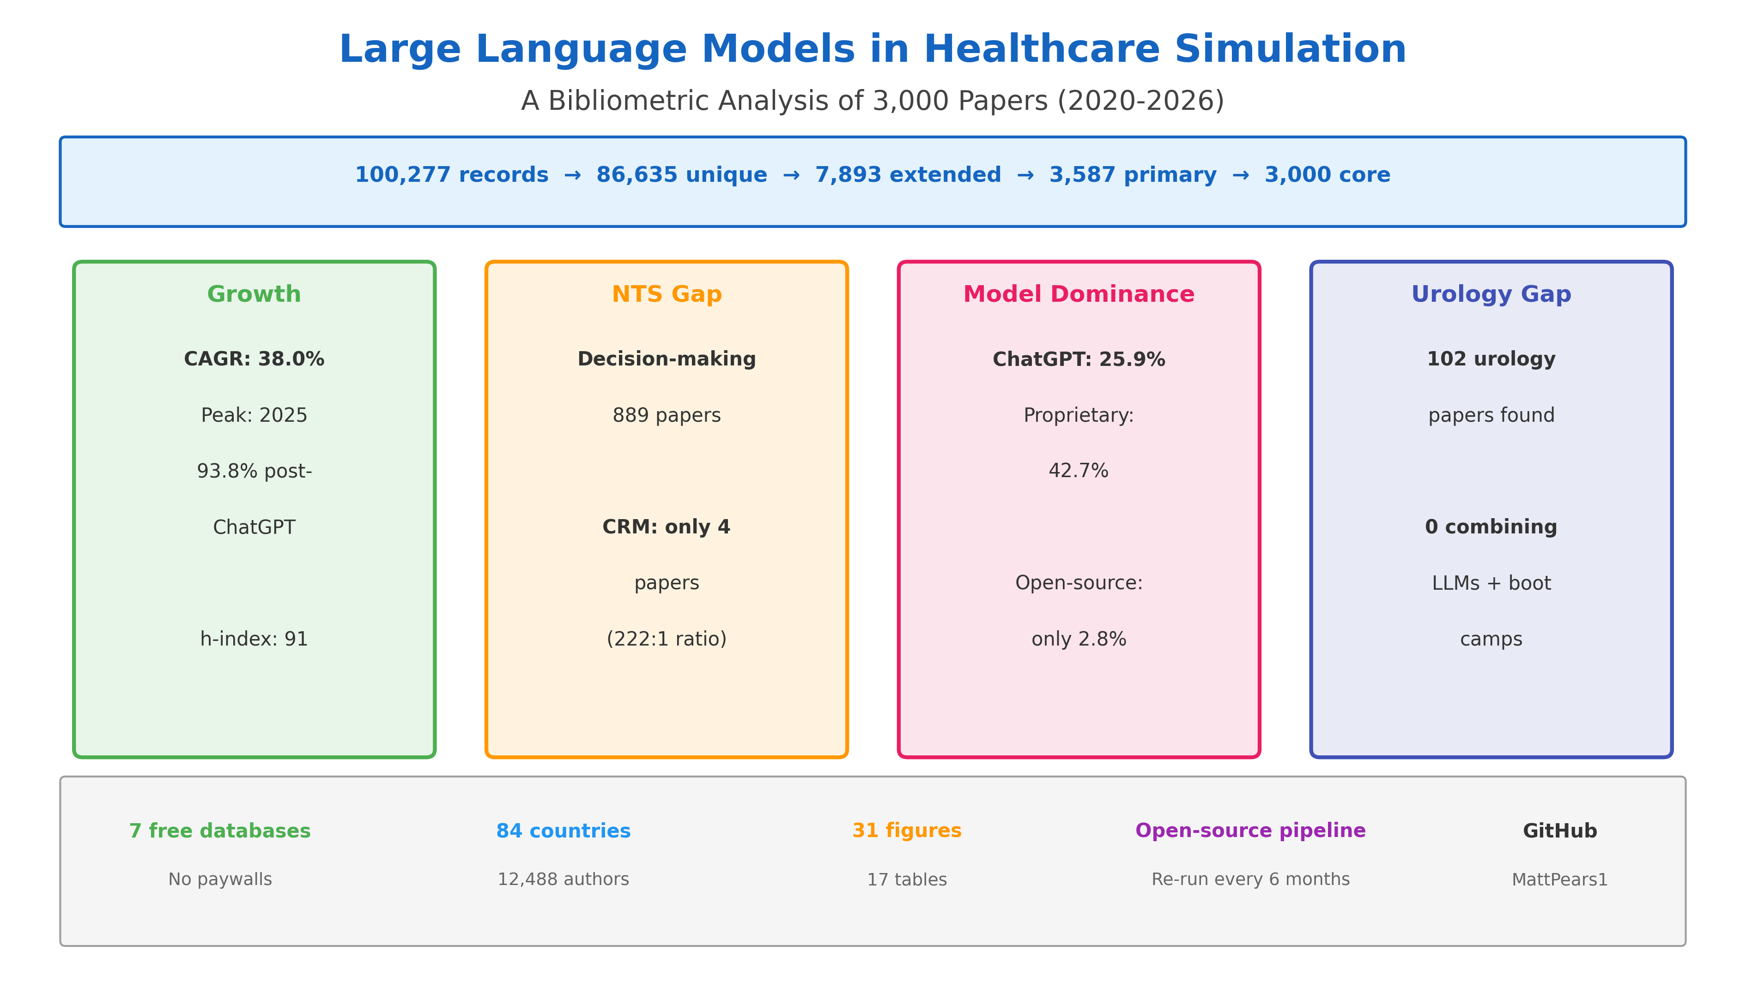
Summary infographic highlighting four key findings: 38.0% CAGR growth, the NTS gap (Decision-making 889 vs CRM 4), proprietary LLM dominance (42.7% vs 2.8% open-source), and the urology boot camp gap (0 papers).

Figure 1: PRISMA 2020 Flow Diagram
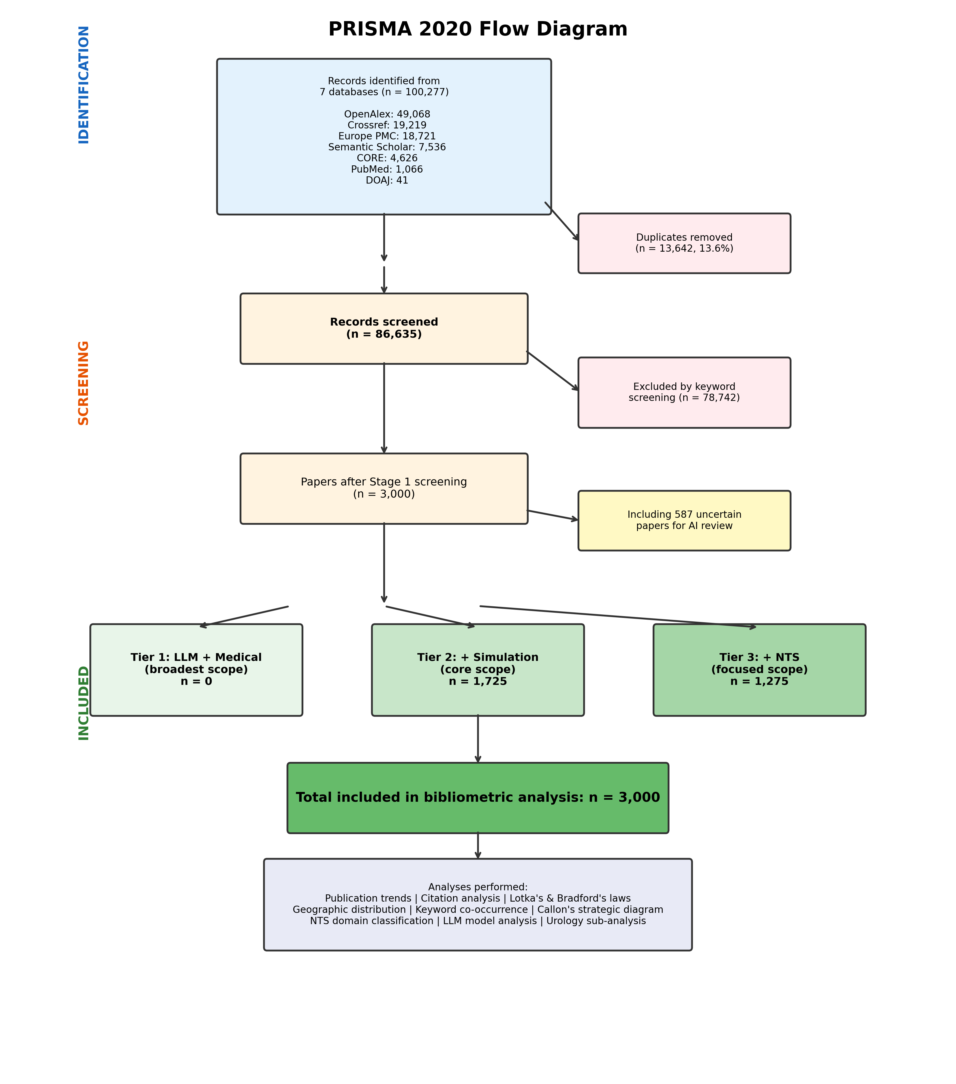
Three-level corpus selection: 100,277 raw records from 7 databases, deduplication to 86,635 unique, screening to extended (7,893), primary (3,587), and core (3,000) corpus.

Figure 2: Publication Trends by Year
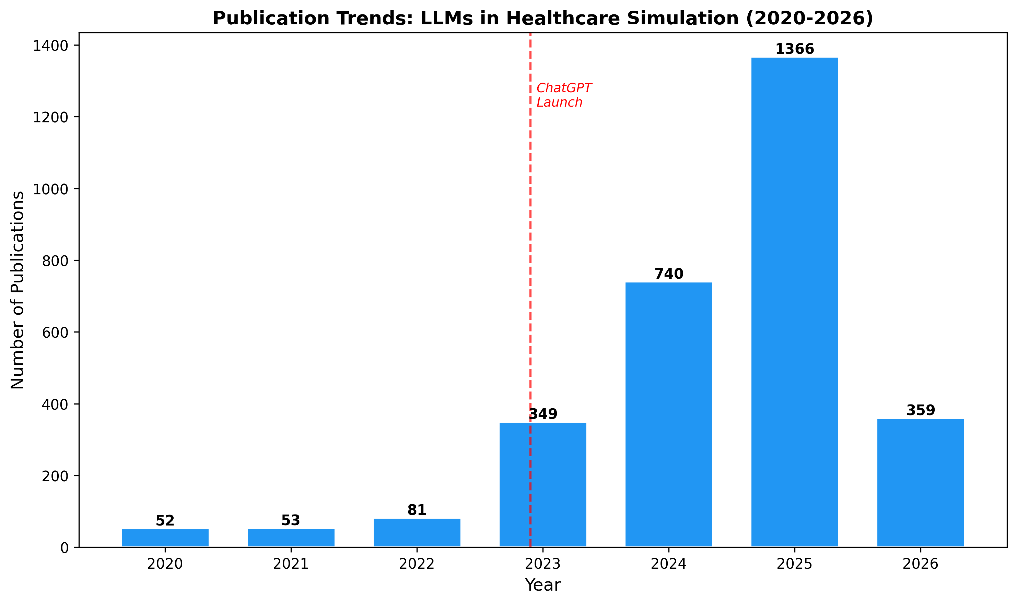
Annual counts showing ChatGPT inflection point. Pre-ChatGPT: 186 papers (6.2%), post-ChatGPT: 2,814 (93.8%), peak 2025 with 1,366 papers.

Figure 3: Cumulative Growth
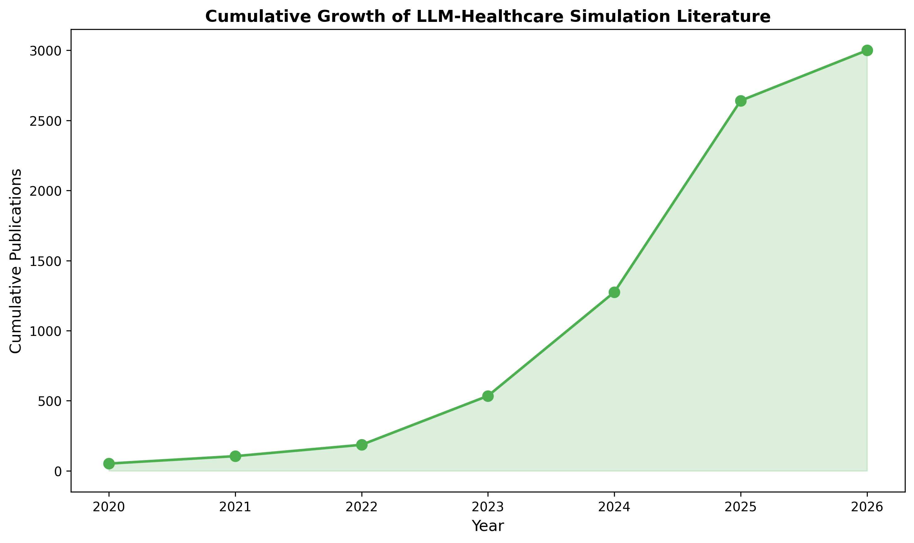
Cumulative growth curve with CAGR of 38.0%, showing exponential acceleration from 2023.

Figure 4: Citation Distribution
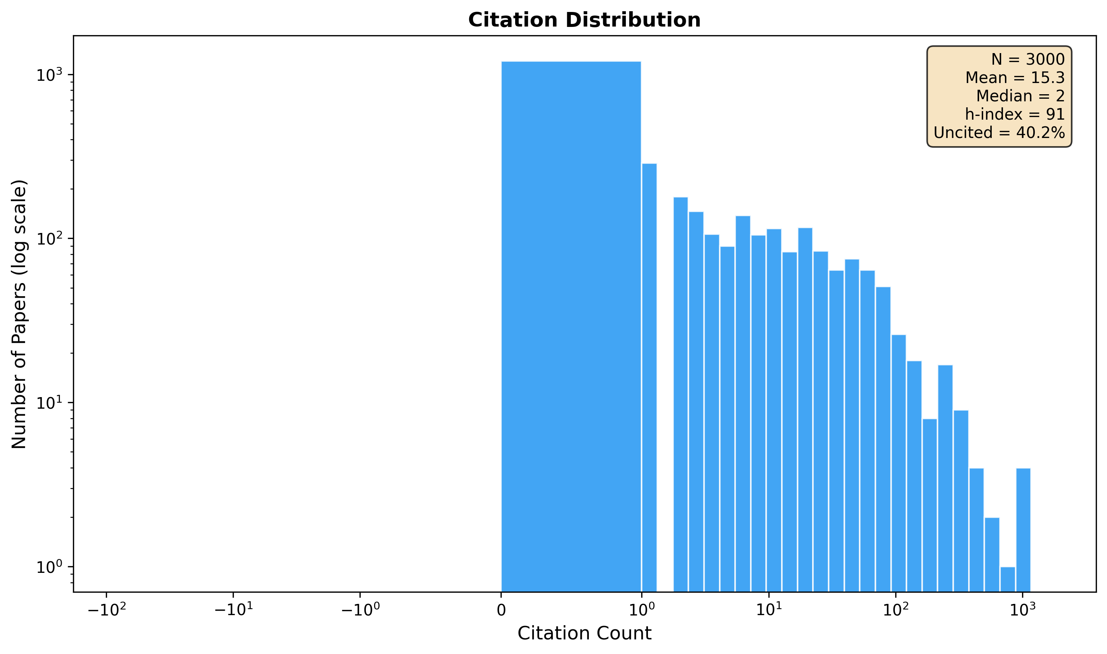
Log-scaled histogram. h-index 91, g-index 165, mean 15.30 citations, ~35% uncited due to publication recency.

Figure 5: Citations by Year
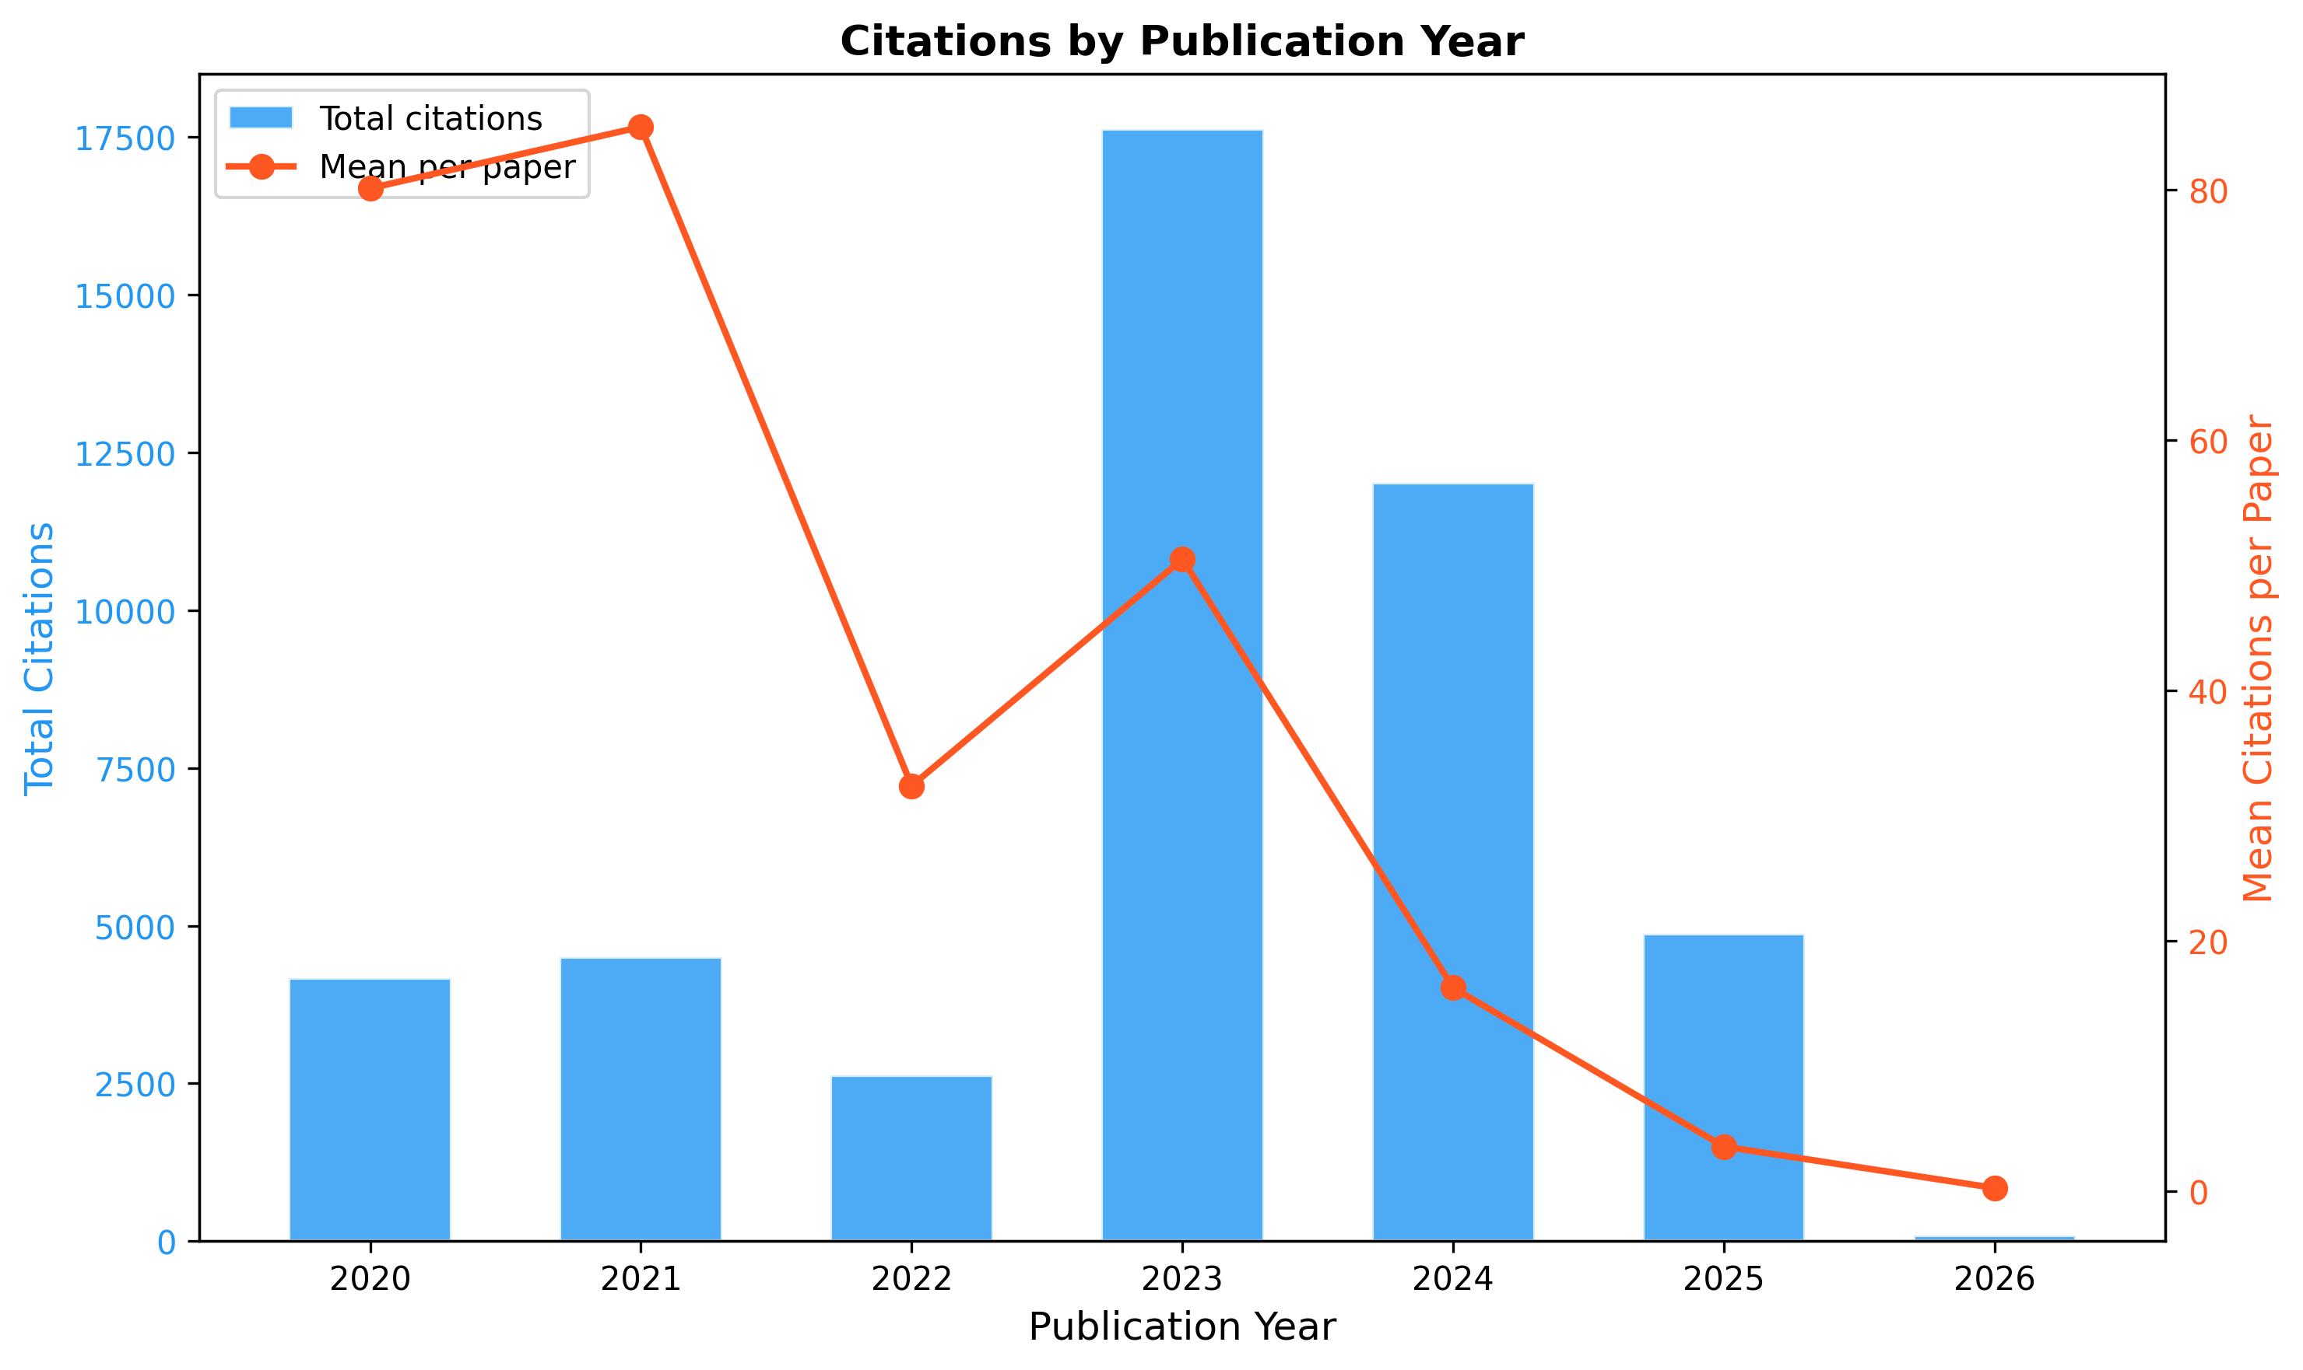
Mean and total citations by year showing citation maturation: earlier papers have higher means, 2025-2026 papers have insufficient citation windows.

Figure 6: Callon Strategic Diagram
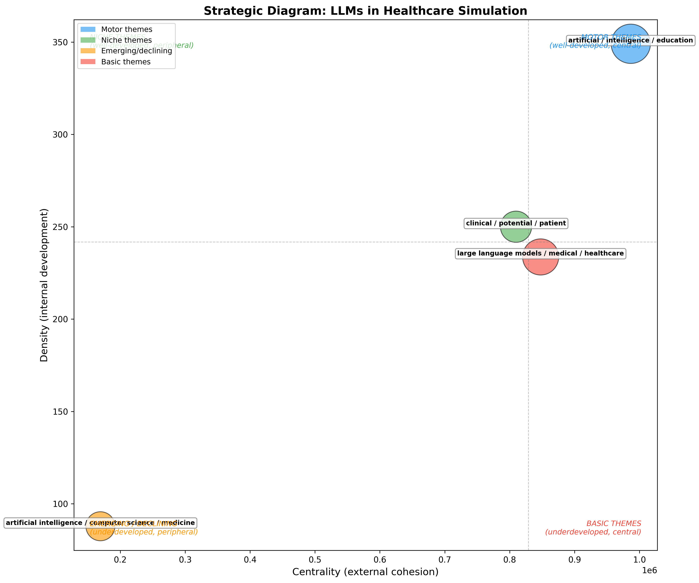
Five thematic clusters plotted by centrality and density. Three motor themes (upper-right) and two emerging themes (lower-left).

Figure 7: NTS Domain Frequencies
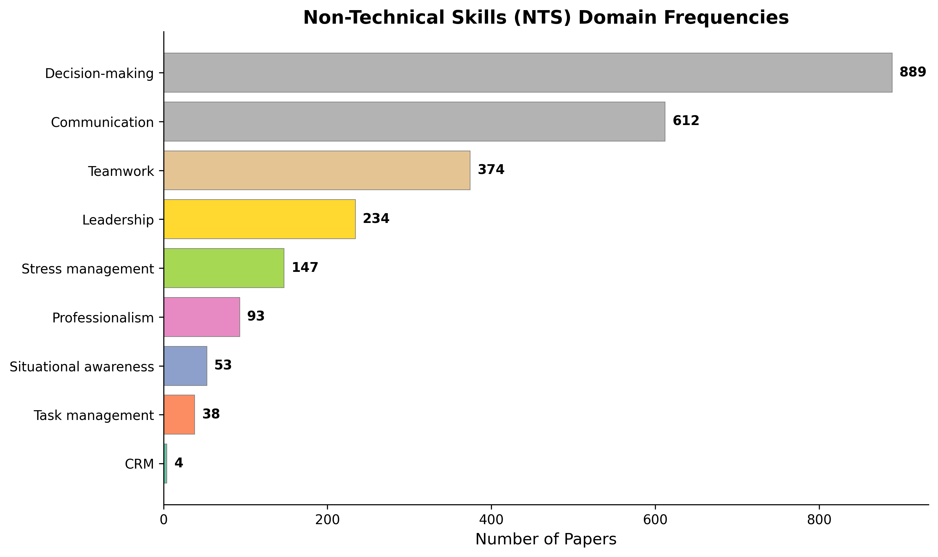
Nine NTS domains: Decision-making (889, 29.6%) and Communication (612, 20.4%) dominate. CRM (4, 0.1%) is critically under-researched.

Figure 8: NTS Temporal Heatmap
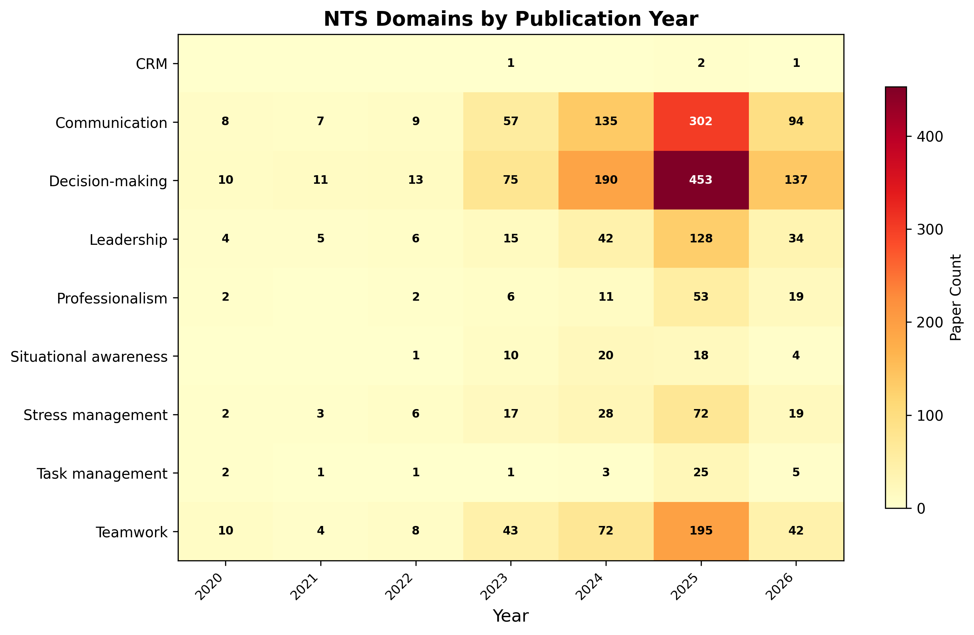
Year-by-domain heatmap showing Decision-making and Communication growth across all years, while CRM remains sparse throughout.

Figure 9: Simulation x NTS Cross-Tabulation
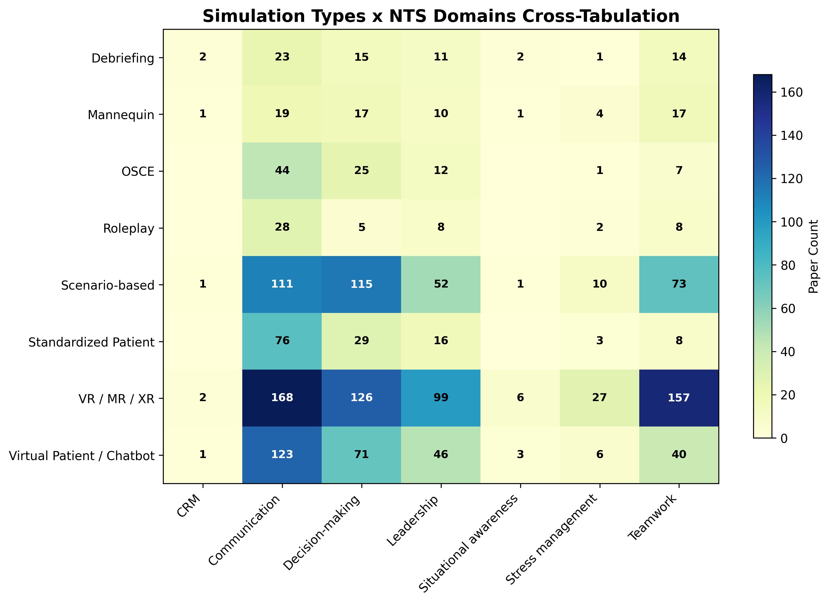
Heatmap of simulation modalities vs NTS domains. VR/MR/XR has broadest NTS coverage. Mannequin-based simulation has minimal CRM engagement.

Figure 10: Simulation Type Frequencies
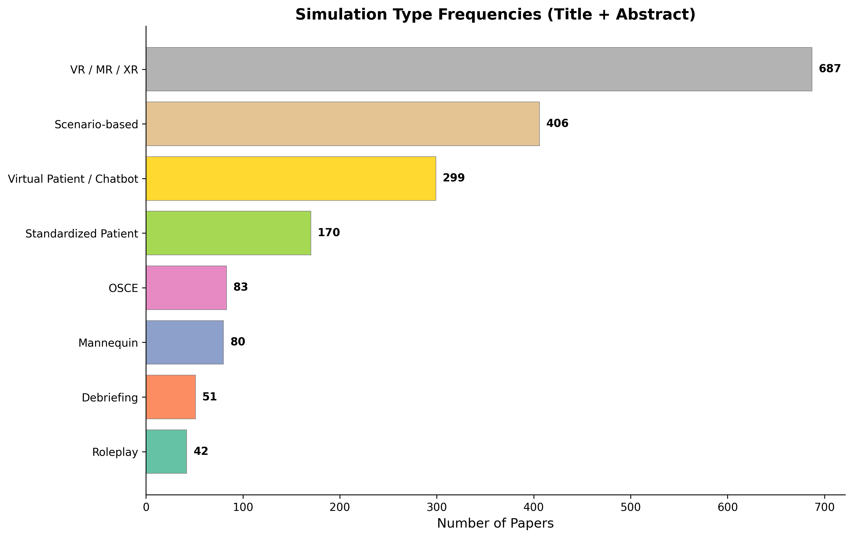
VR/MR/XR leads (687, 22.9%), Scenario-based (406, 13.5%), Virtual Patient/Chatbot (299, 10.0%). Mannequin (80, 2.7%) is underrepresented.

Figure 11: LLM Model Frequencies
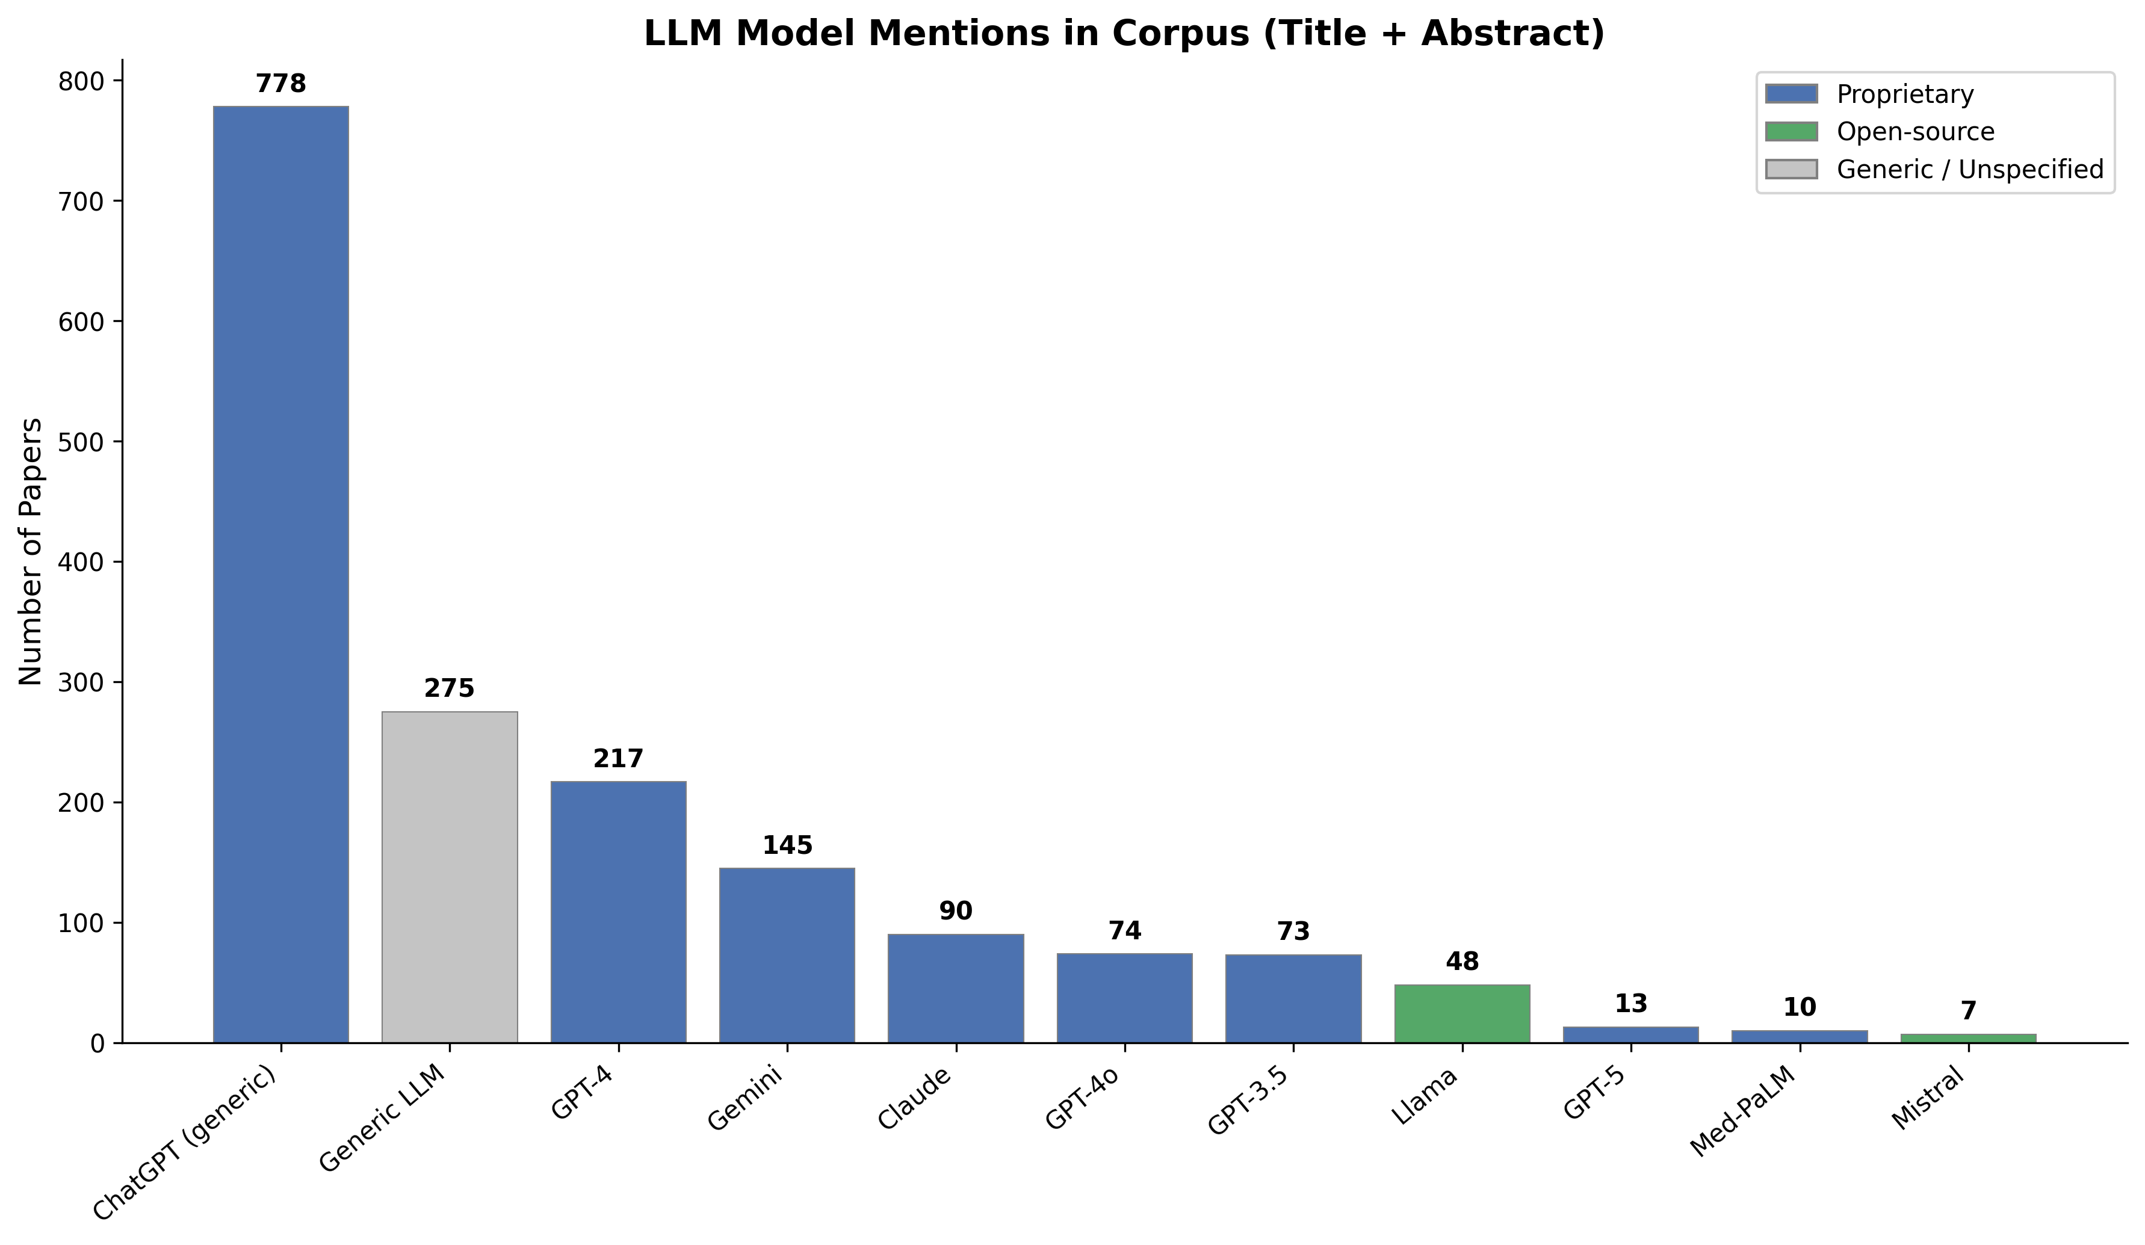
ChatGPT dominates (778, 25.9%), GPT-4 (217, 7.2%), Gemini (145, 4.8%). Open-source: Llama (48), Mistral (7).

Figure 12: Proprietary vs Open-Source
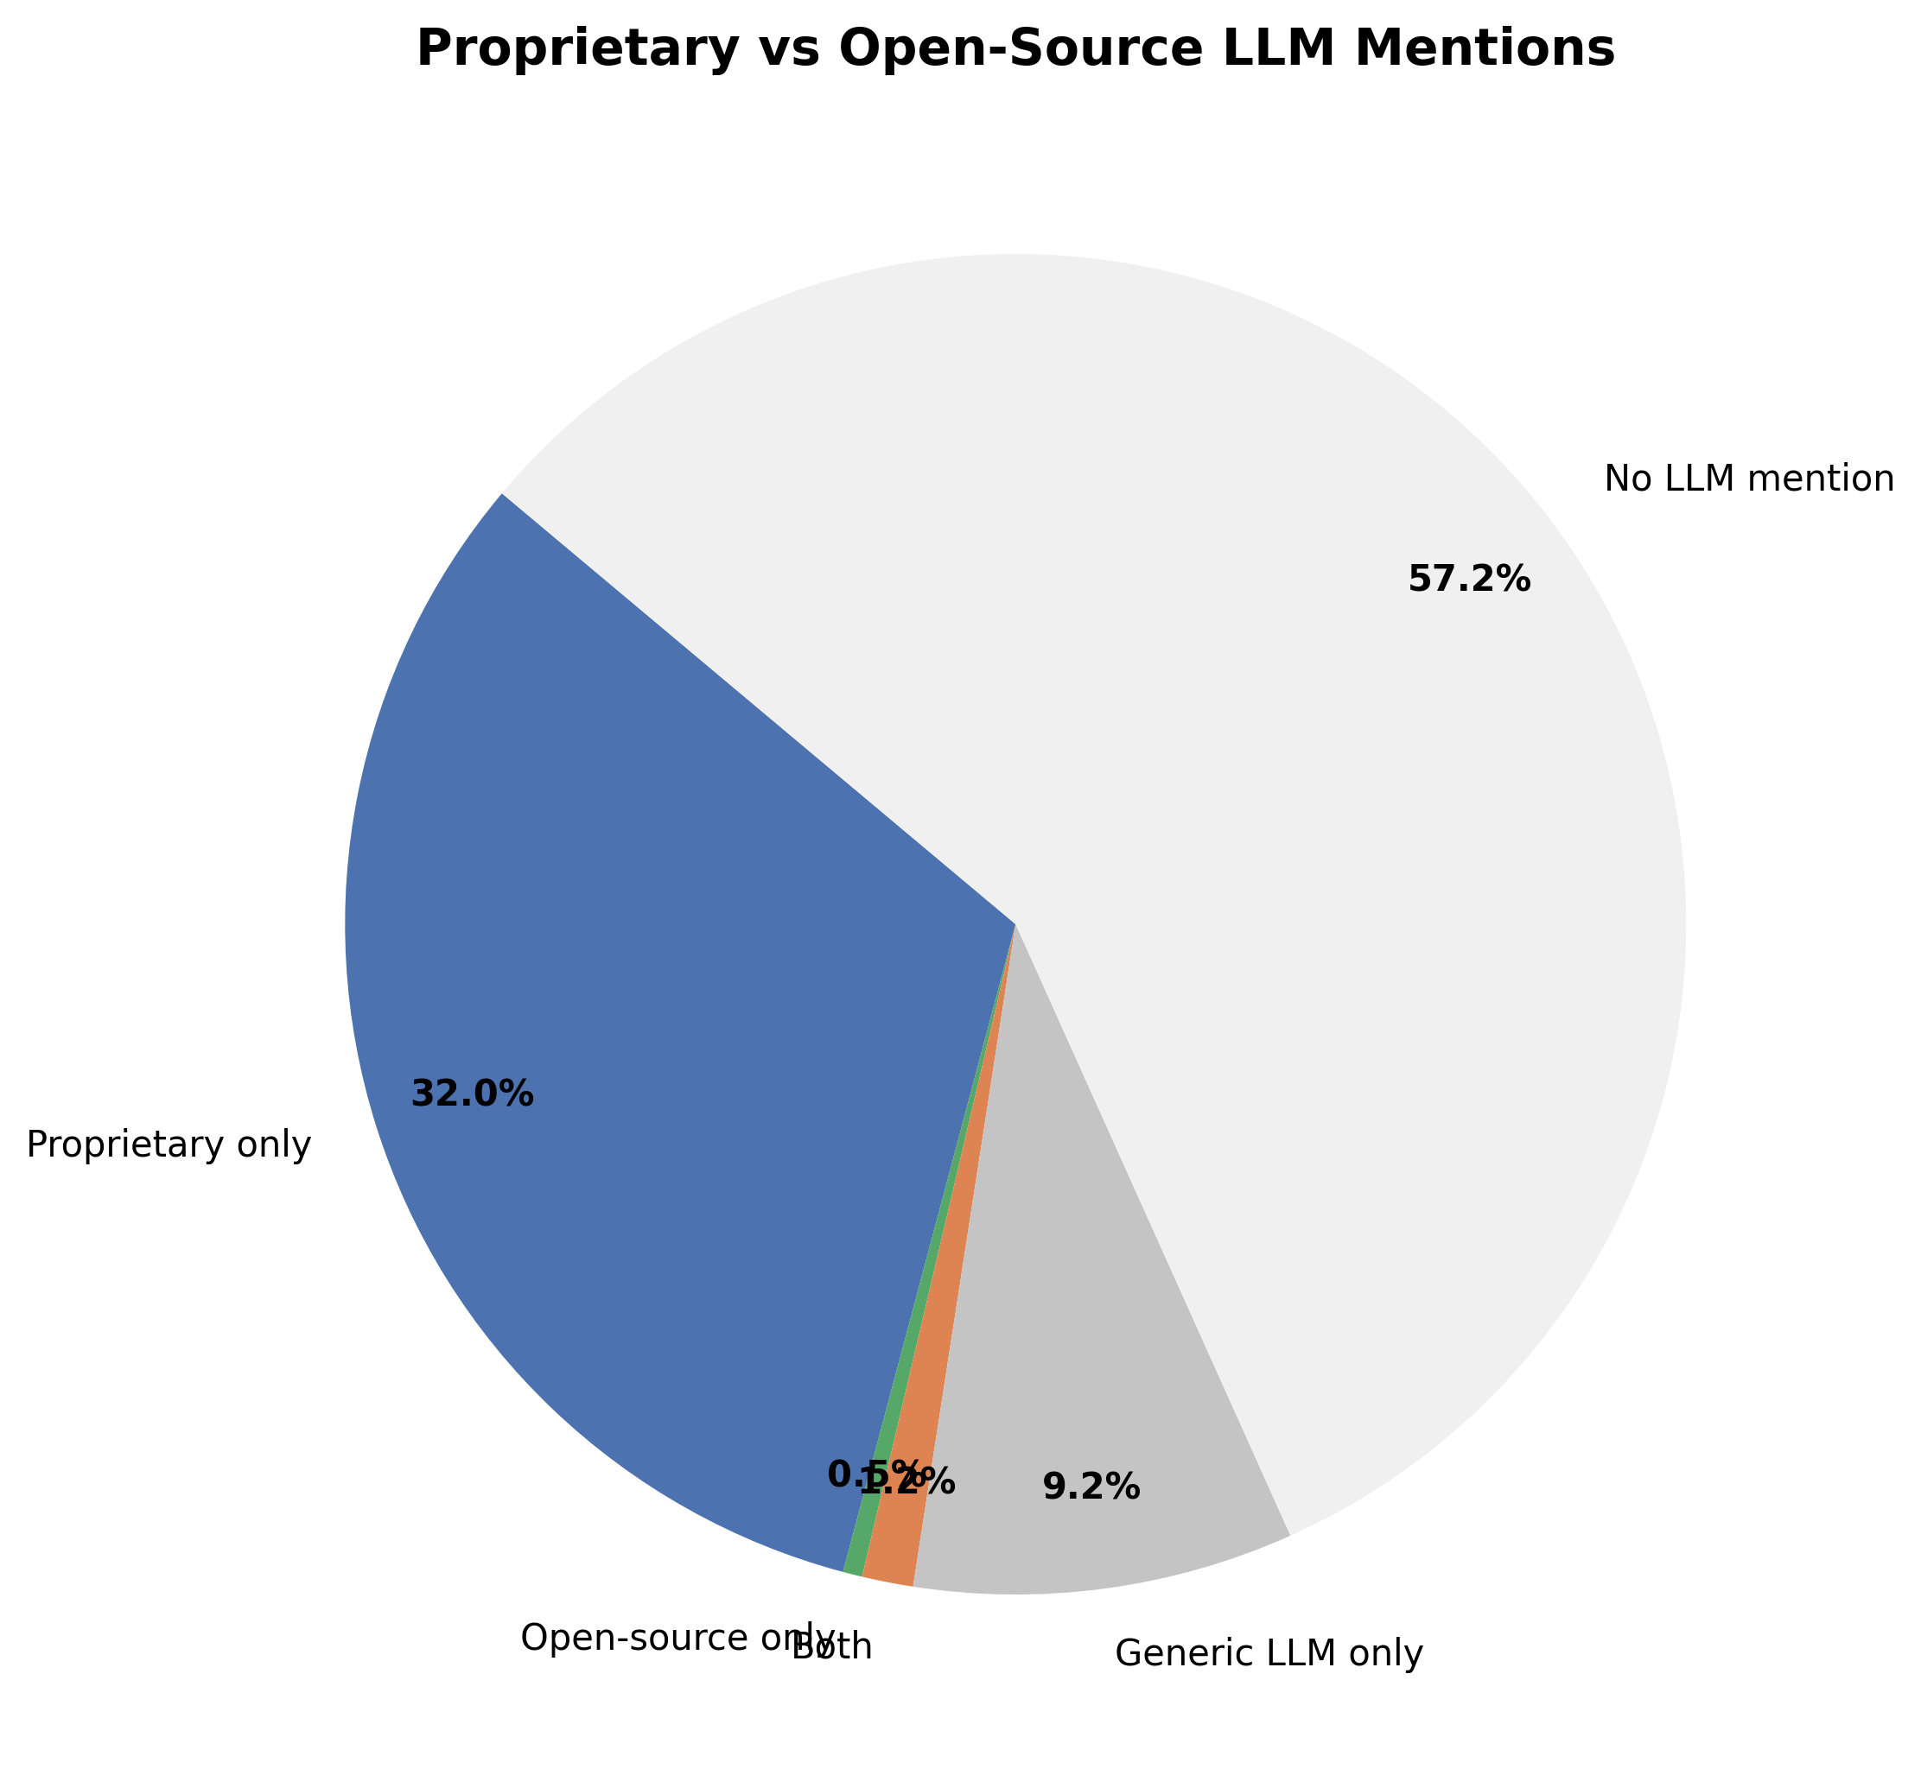
Proprietary models in 32.0% of papers vs 0.5% open-source. Raises reproducibility and institutional dependency concerns.

Figure 13: LLM Model Trends
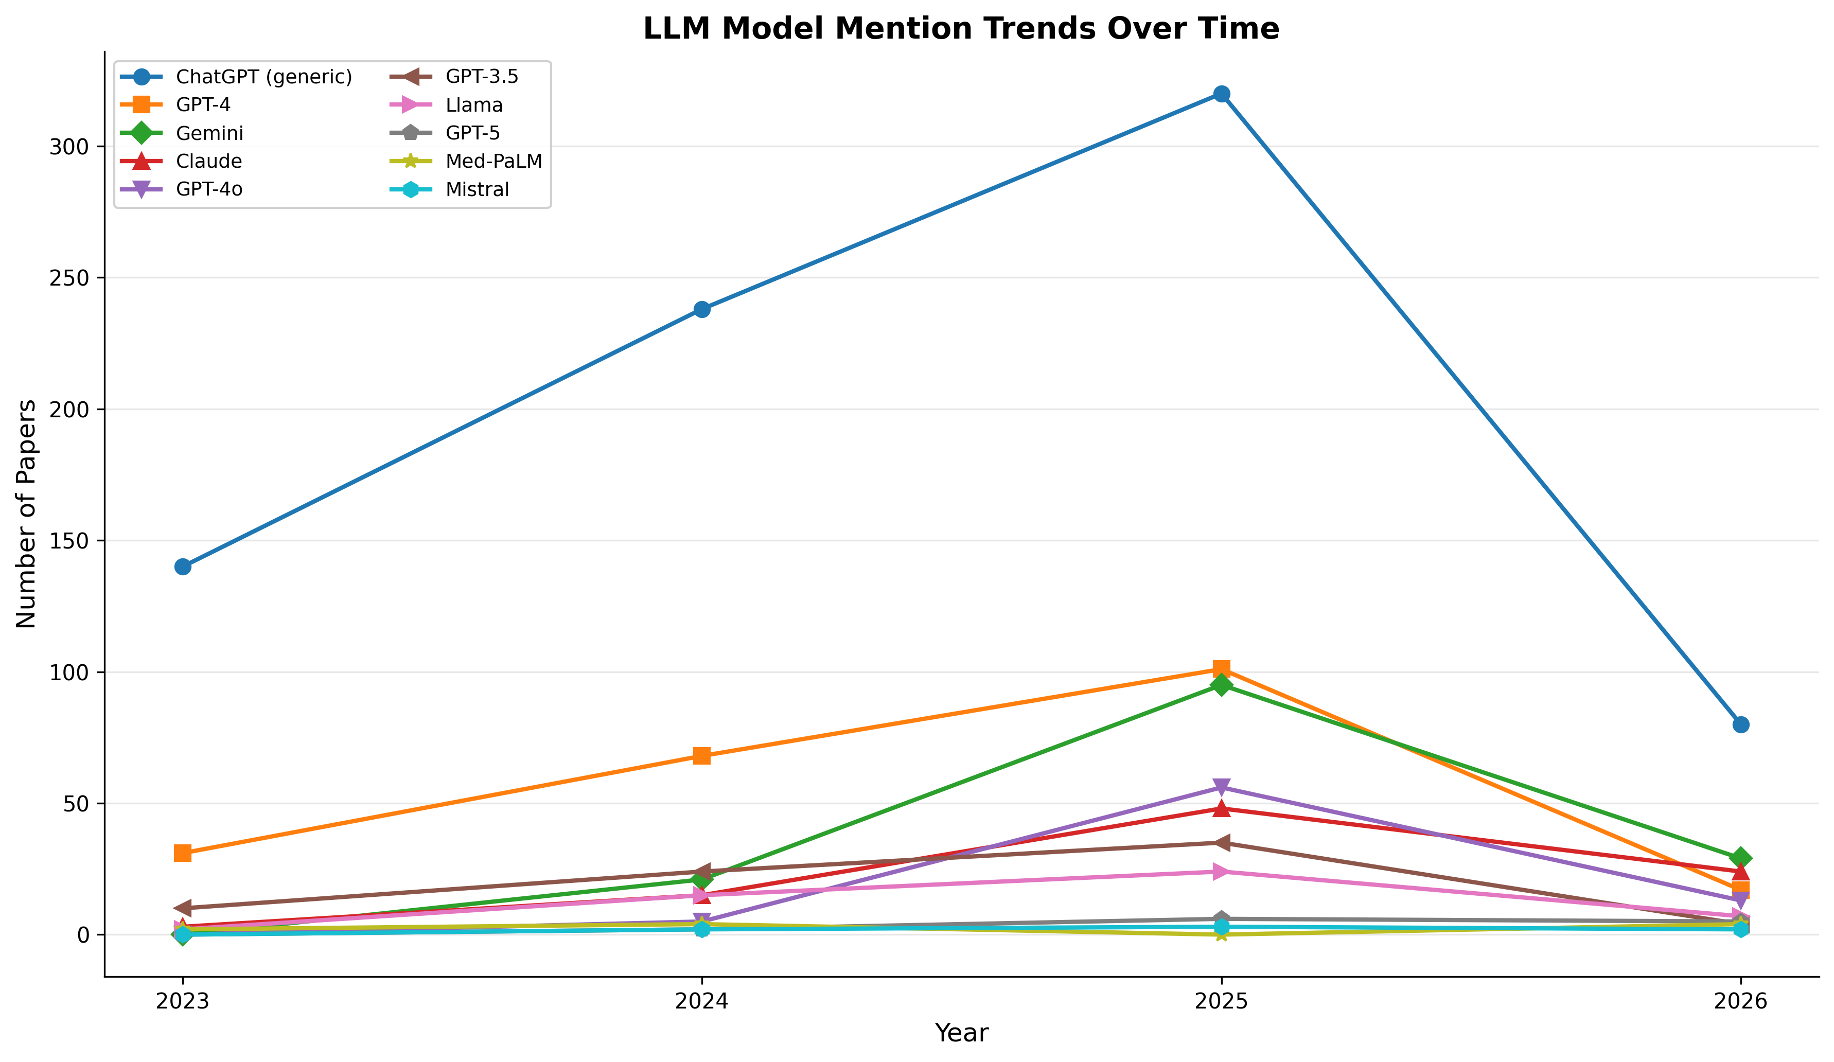
Temporal trends: ChatGPT sustained dominance, Gemini steepest growth, GPT-3.5 declining as newer models supersede it.

Figure 14: Top 20 Countries
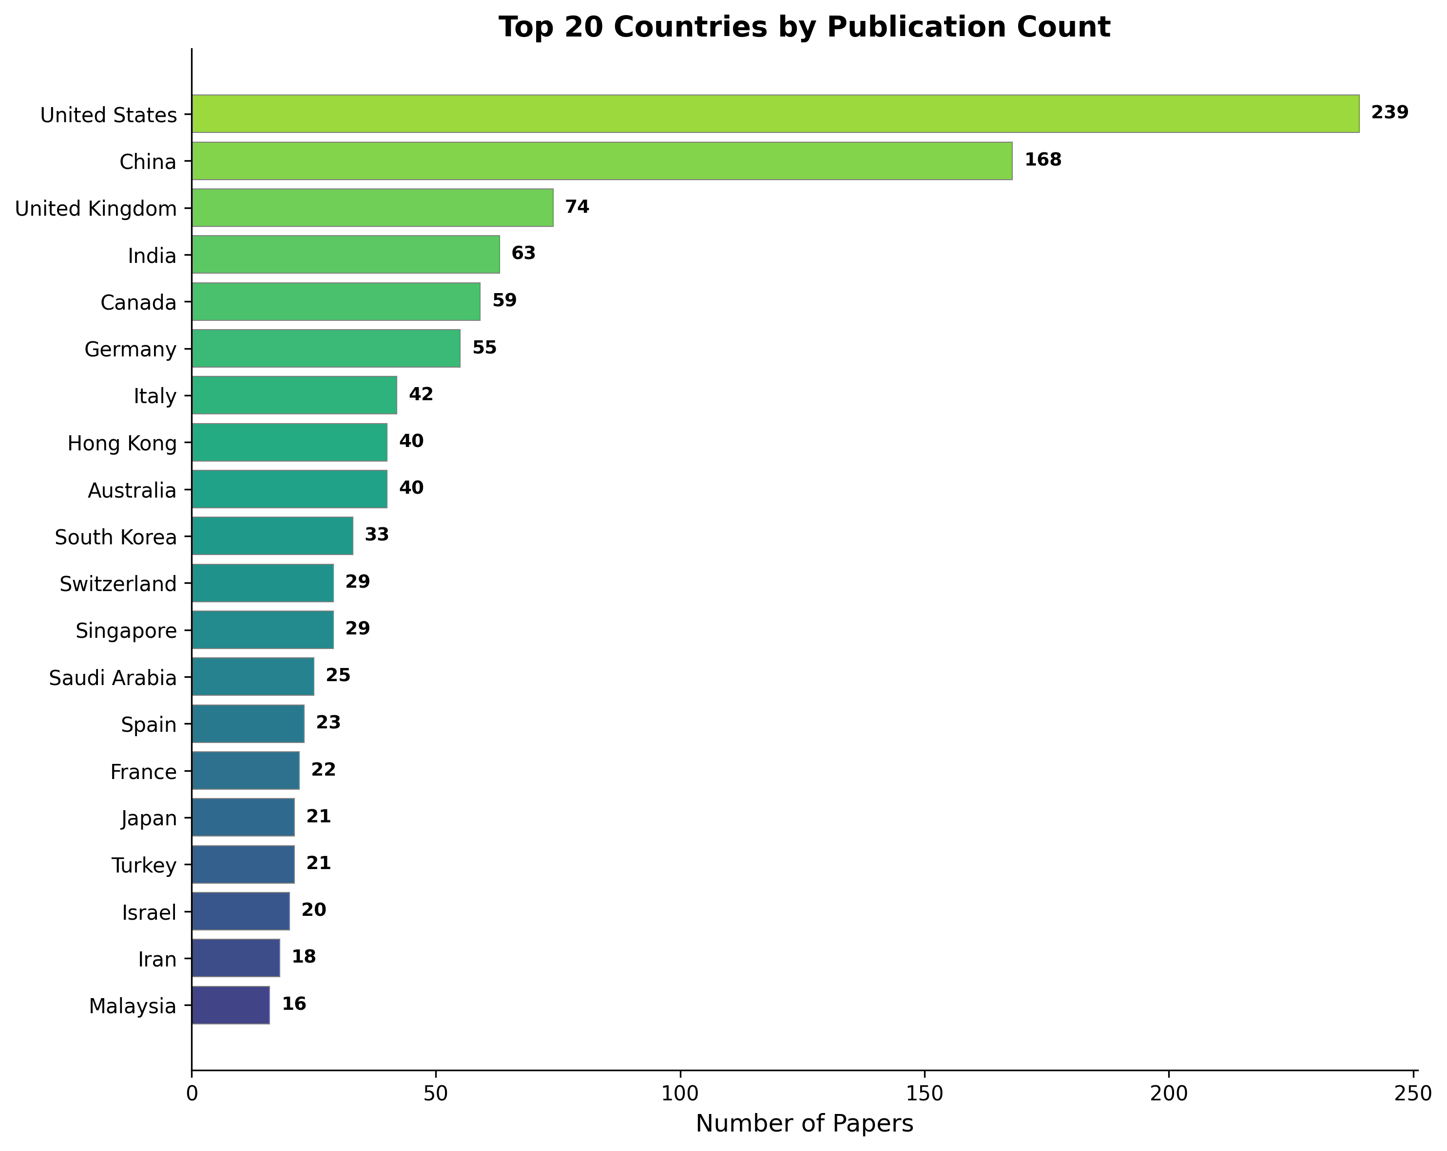
84 countries. USA (239), China (168), UK (74), India (63), Canada (59). High-income countries dominate.

Figure 15: Continental Distribution
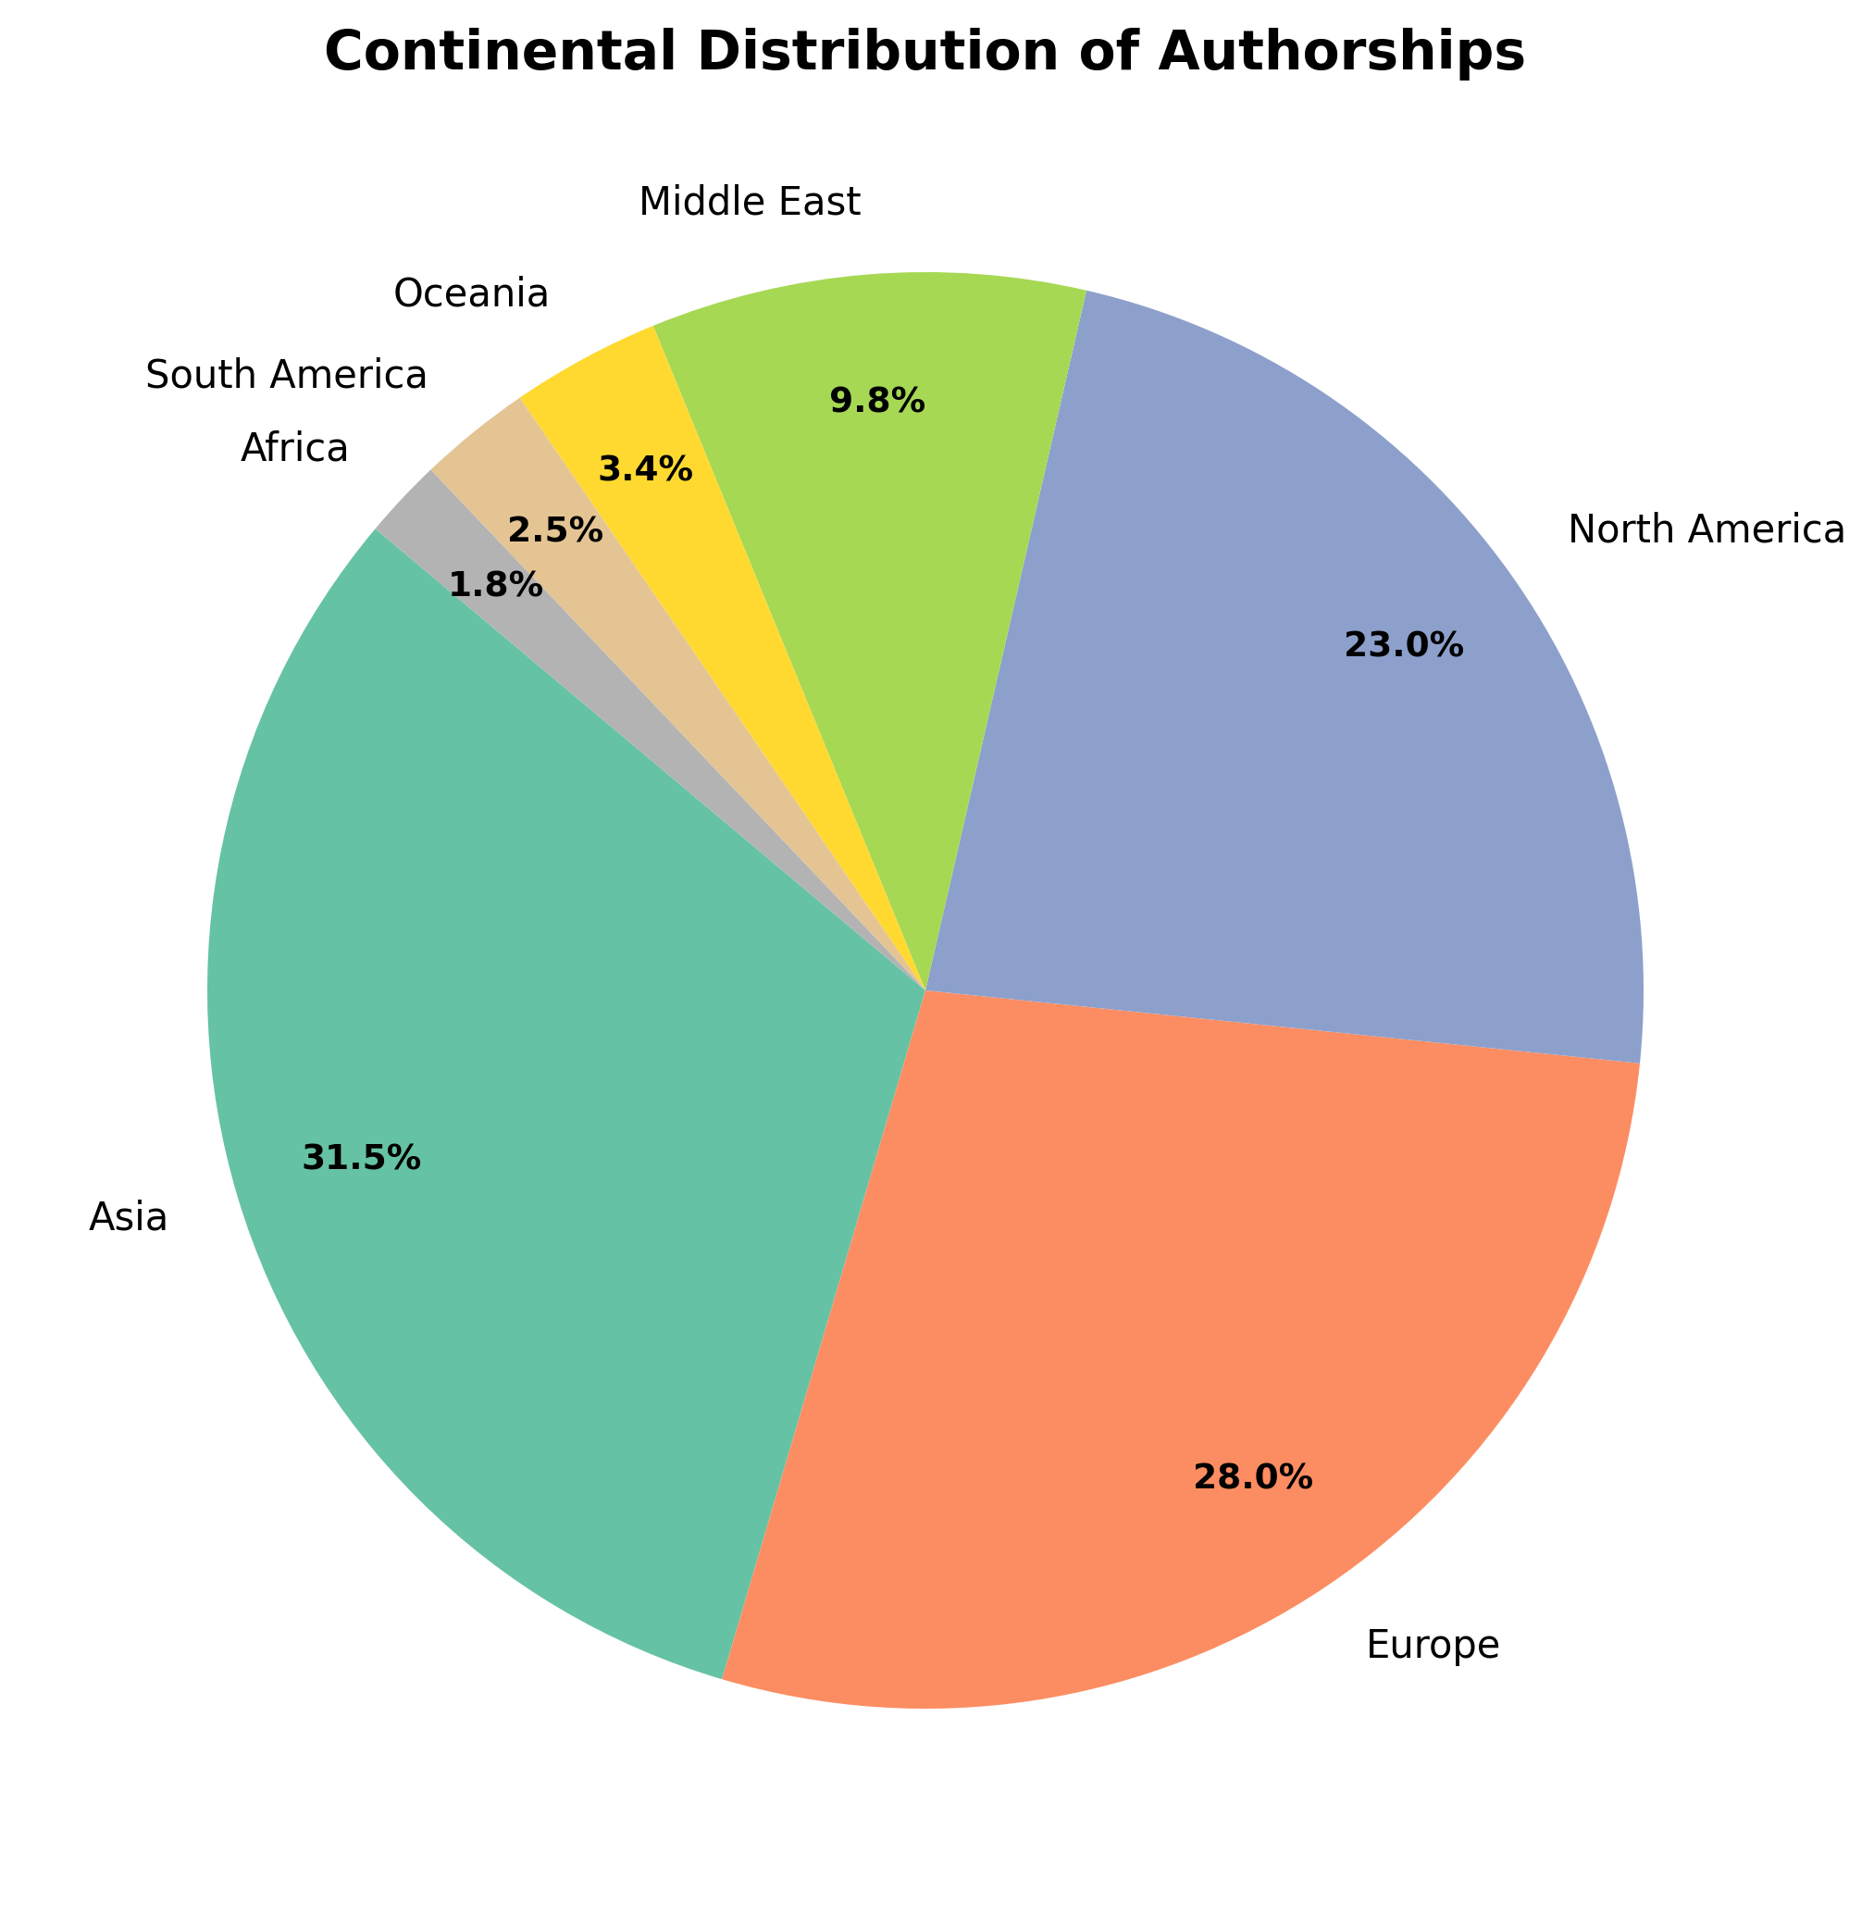
Concentration in Asia and North America/Europe. Limited Africa and South America representation raises equity concerns.

Figure 16: Top 20 Authors
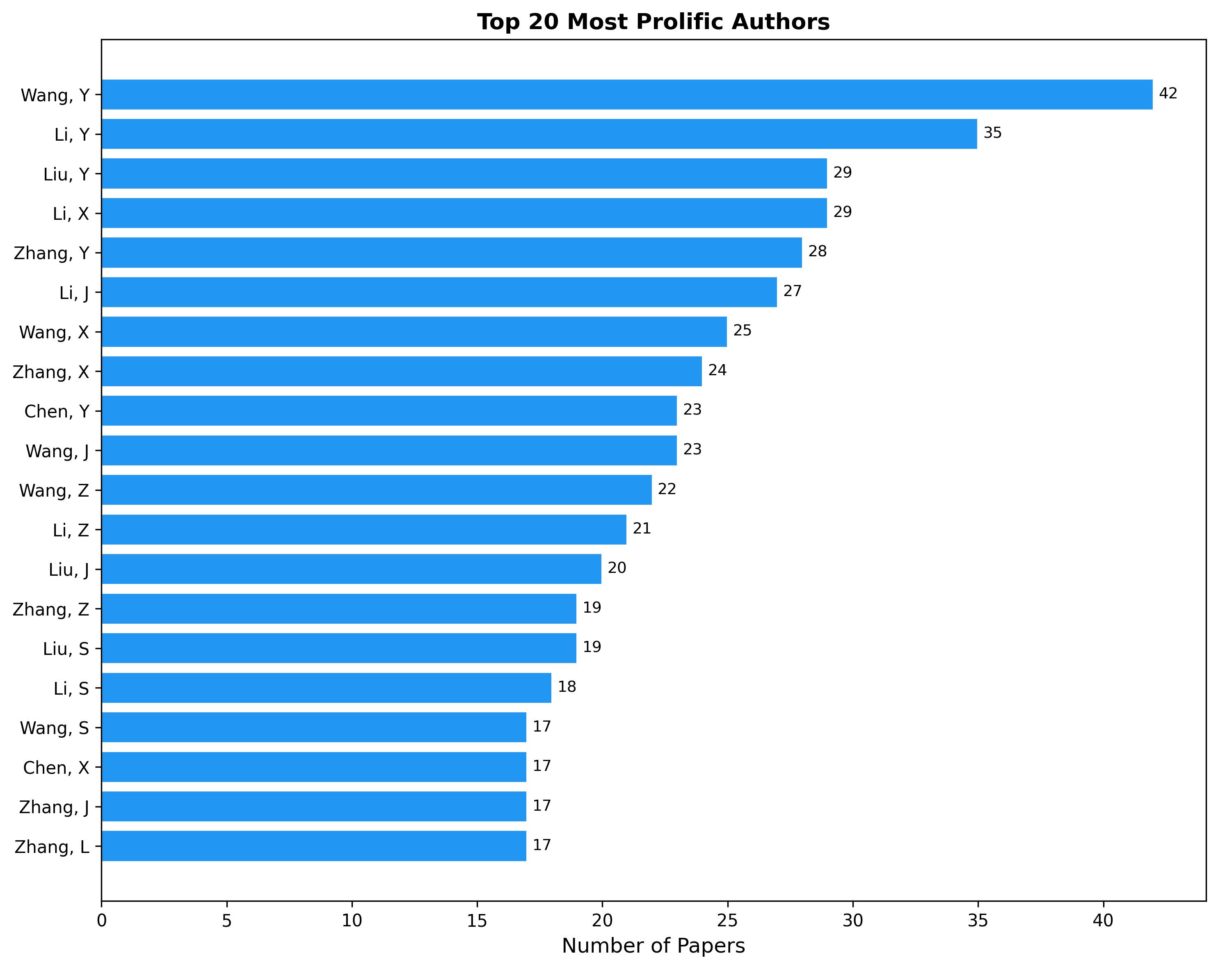
Most prolific authors. Chinese-affiliated name predominance may partly reflect disambiguation challenges.

Figure 17: Author Productivity
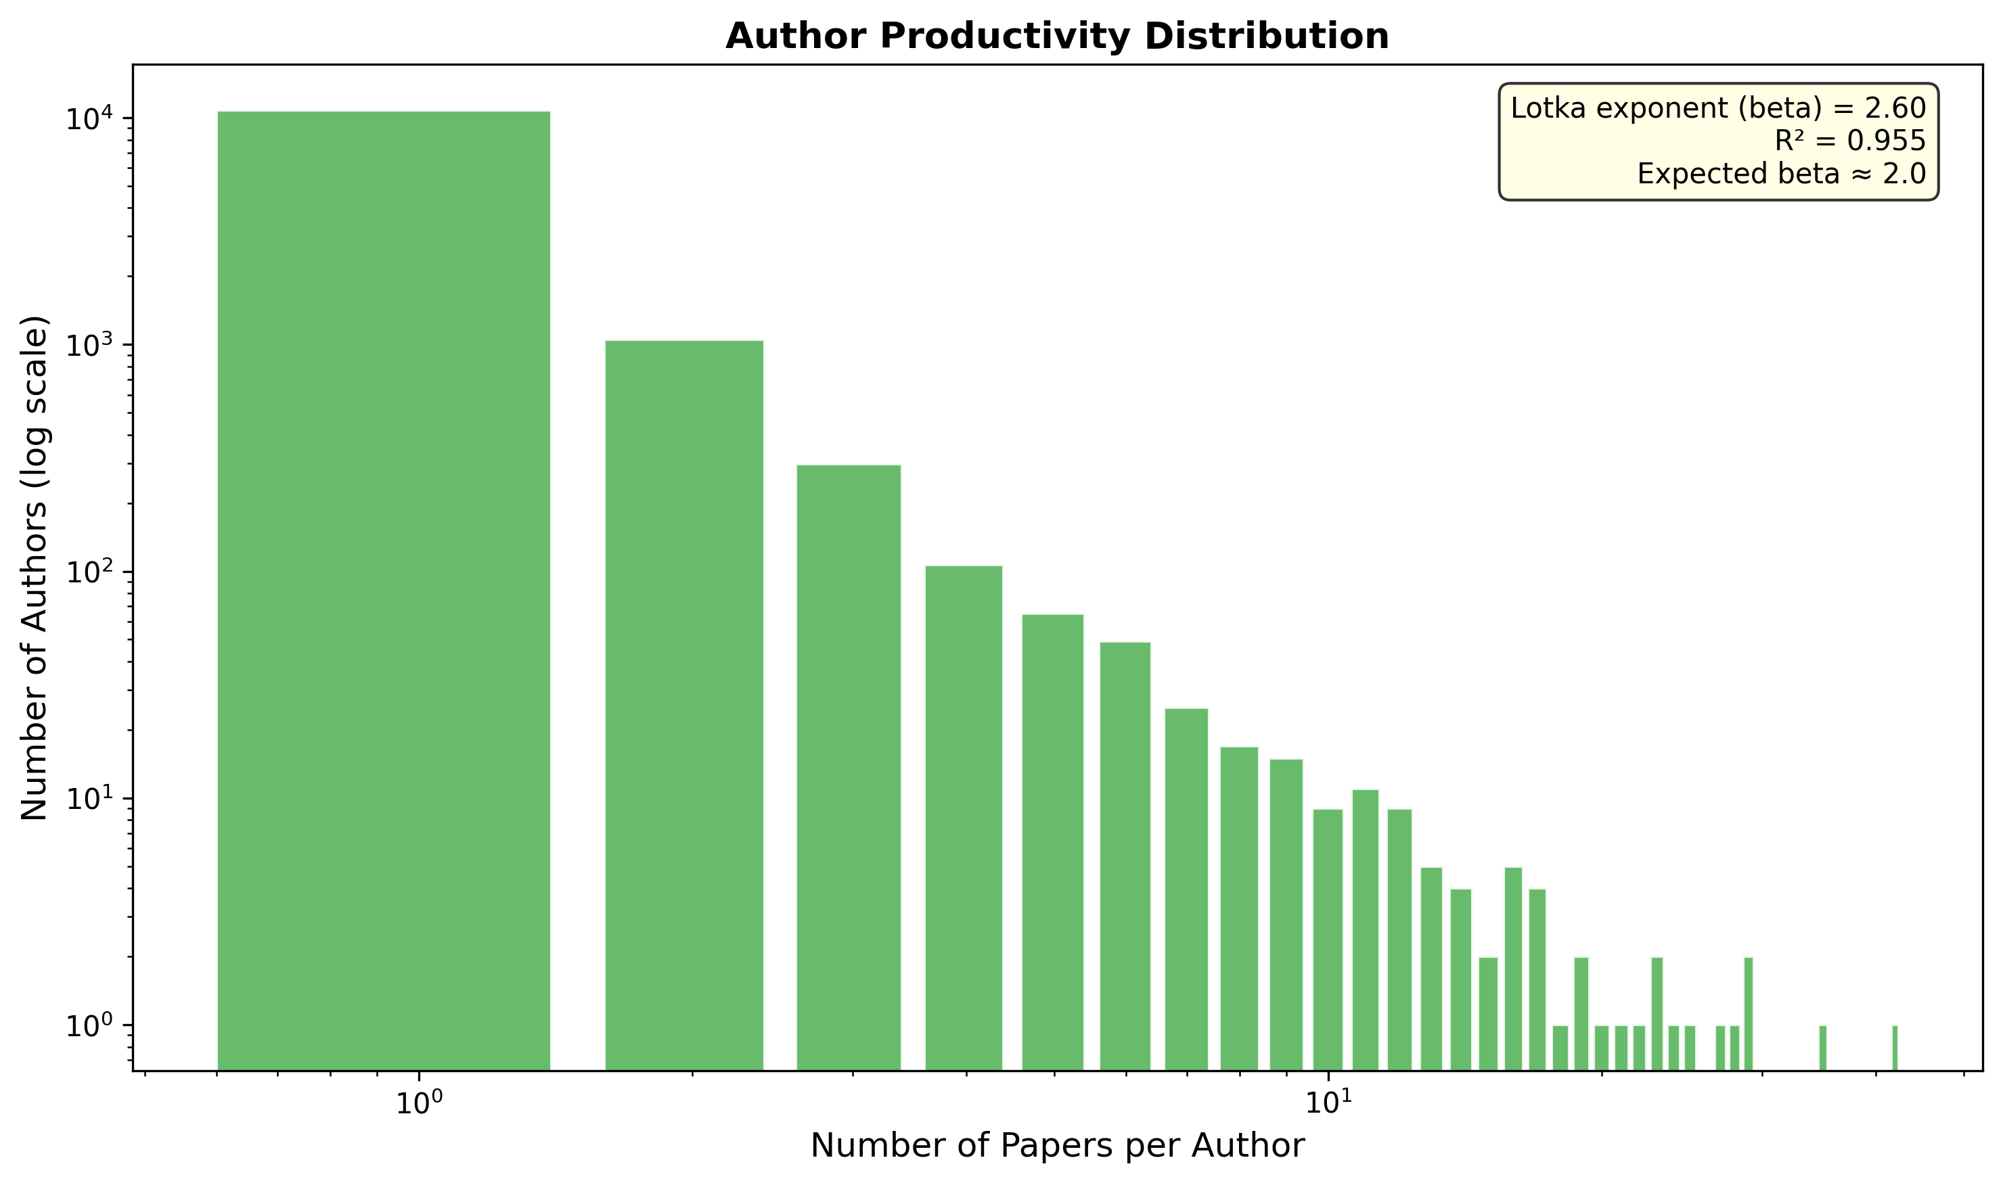
86.4% of 12,488 authors contributed one paper. Characteristic of a young field attracting diverse first-time contributors.

Figure 18: Lotka Law Test
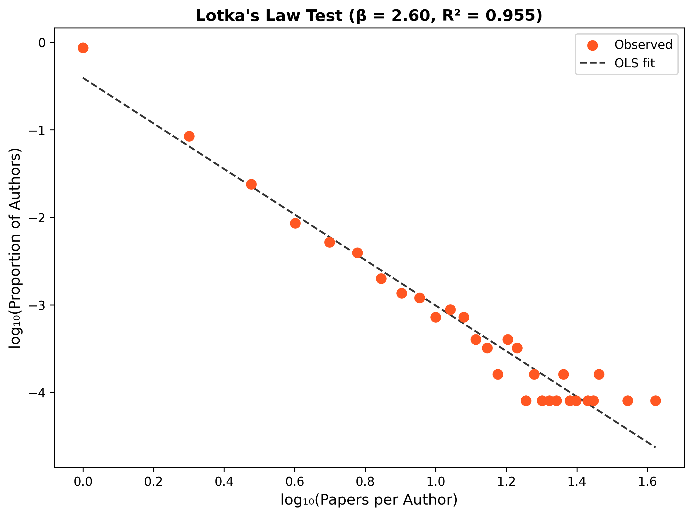
Log-log regression: beta=2.602, R-squared=0.955. Excellent fit confirming classical inverse-square author productivity.

Figure 19: Collaboration Index
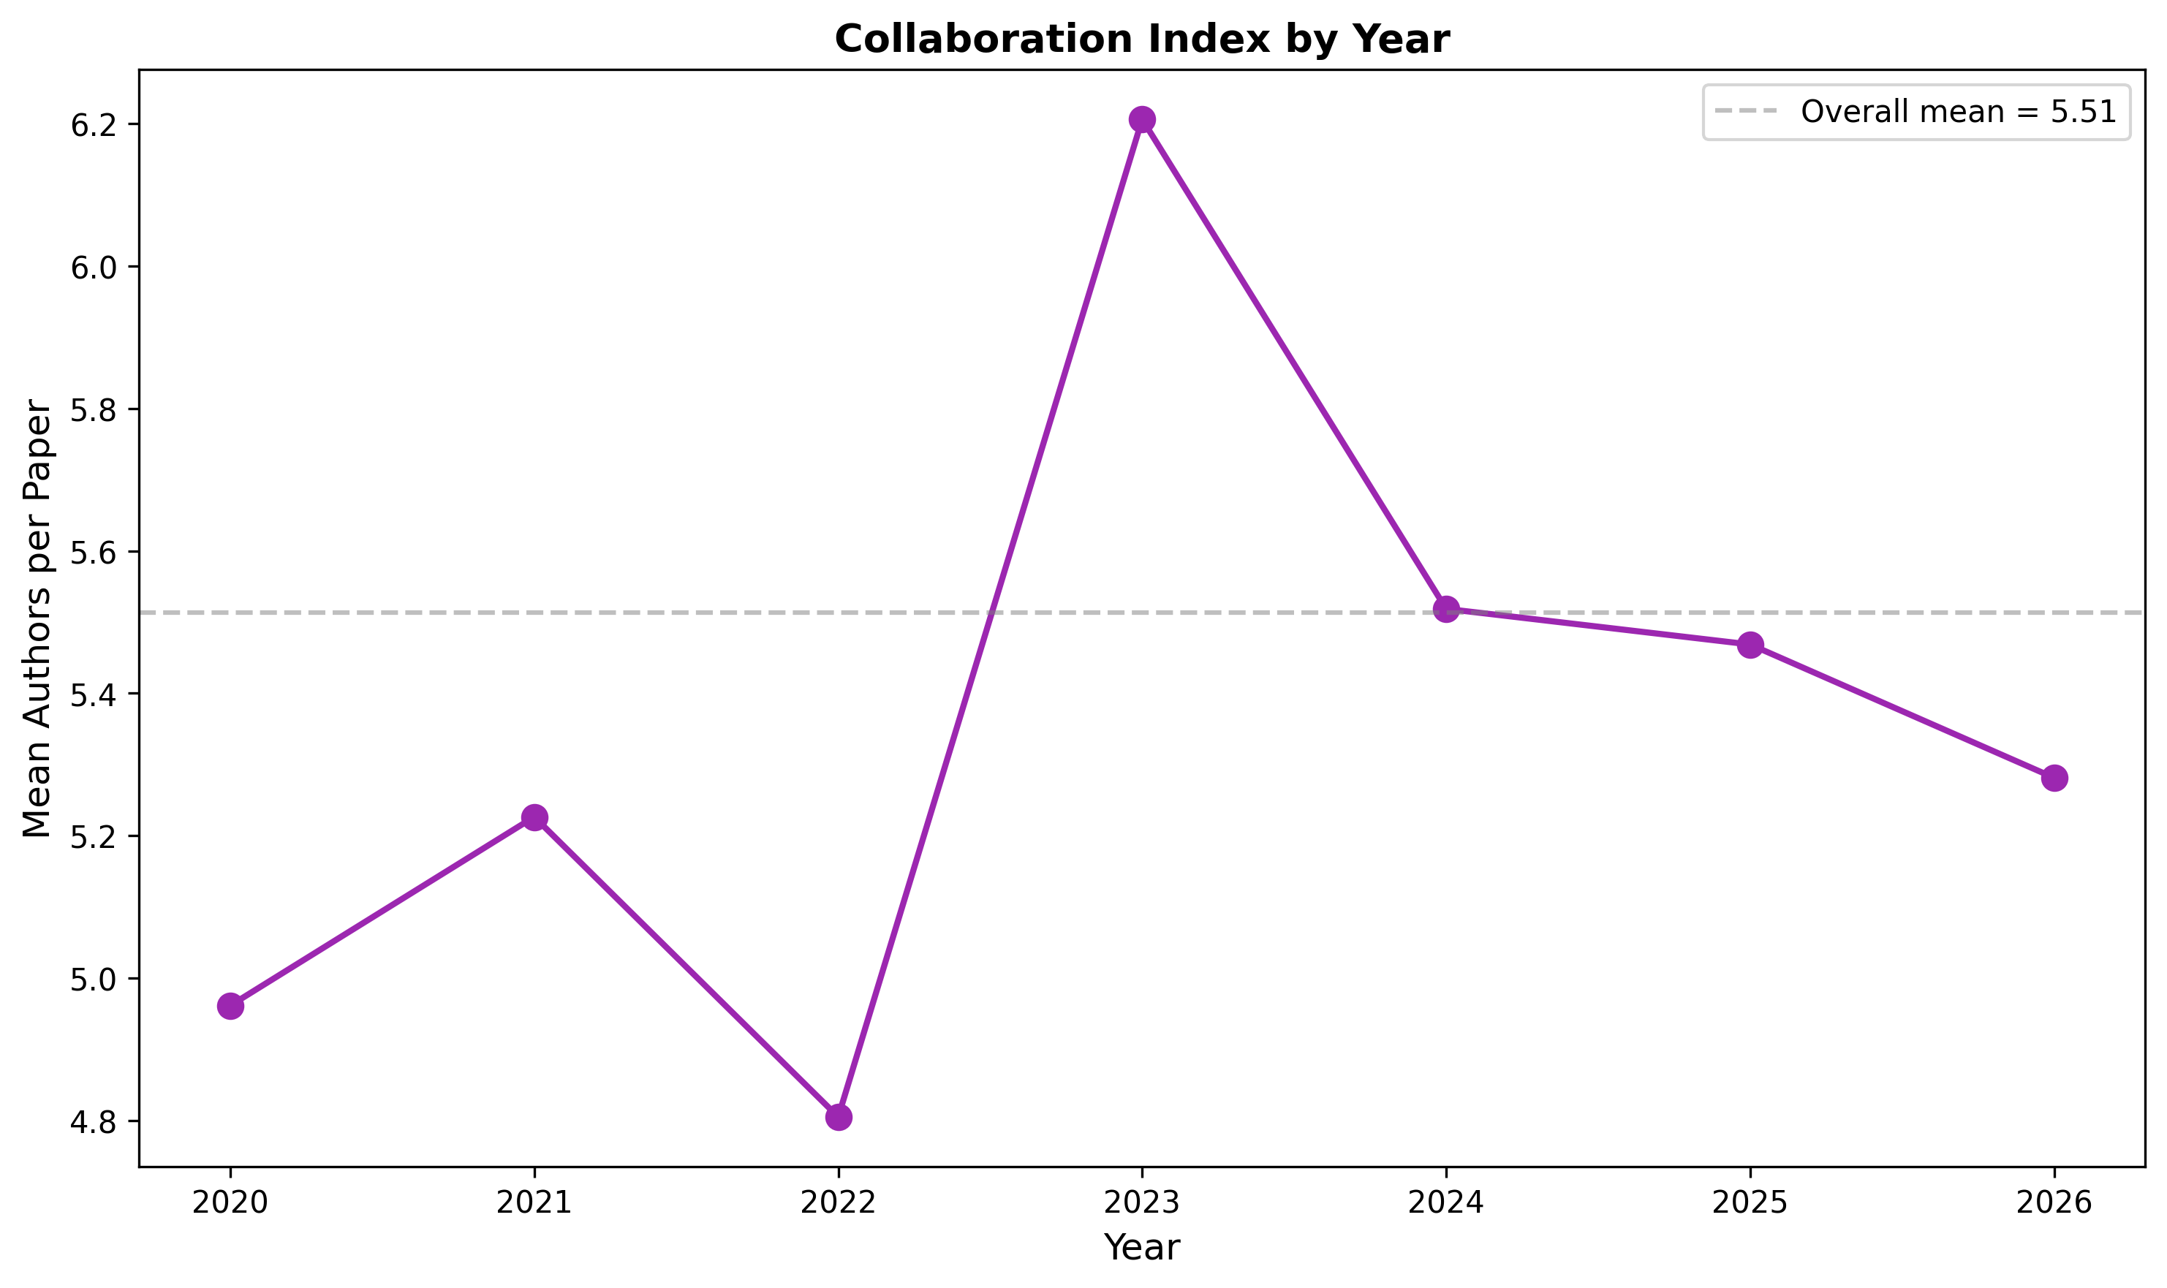
Mean 5.51 authors per paper, consistent with multidisciplinary biomedical research norms.

Figure 20: Top 20 Journals
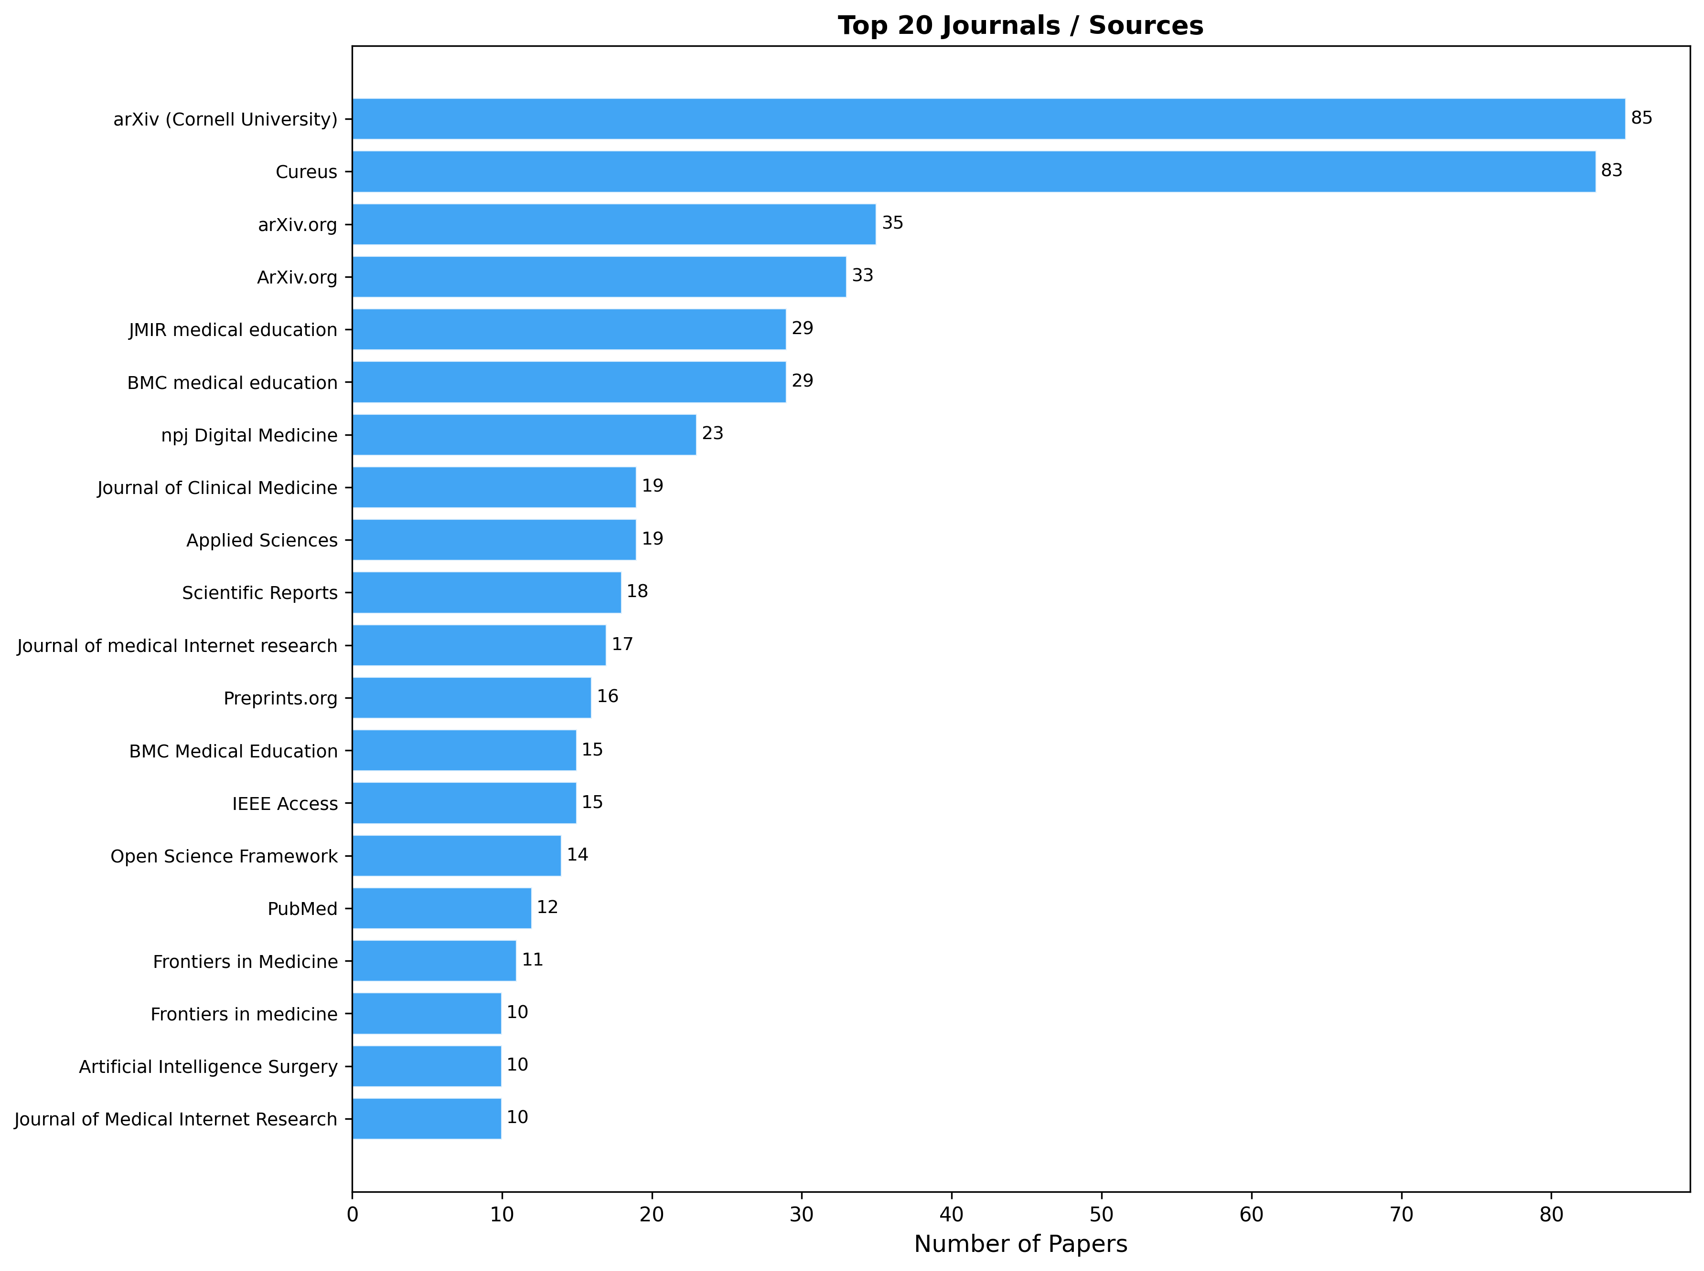
arXiv (85) and Cureus (83) lead, reflecting preprint and open-access culture in AI research.

Figure 21: Bradford Law Zones
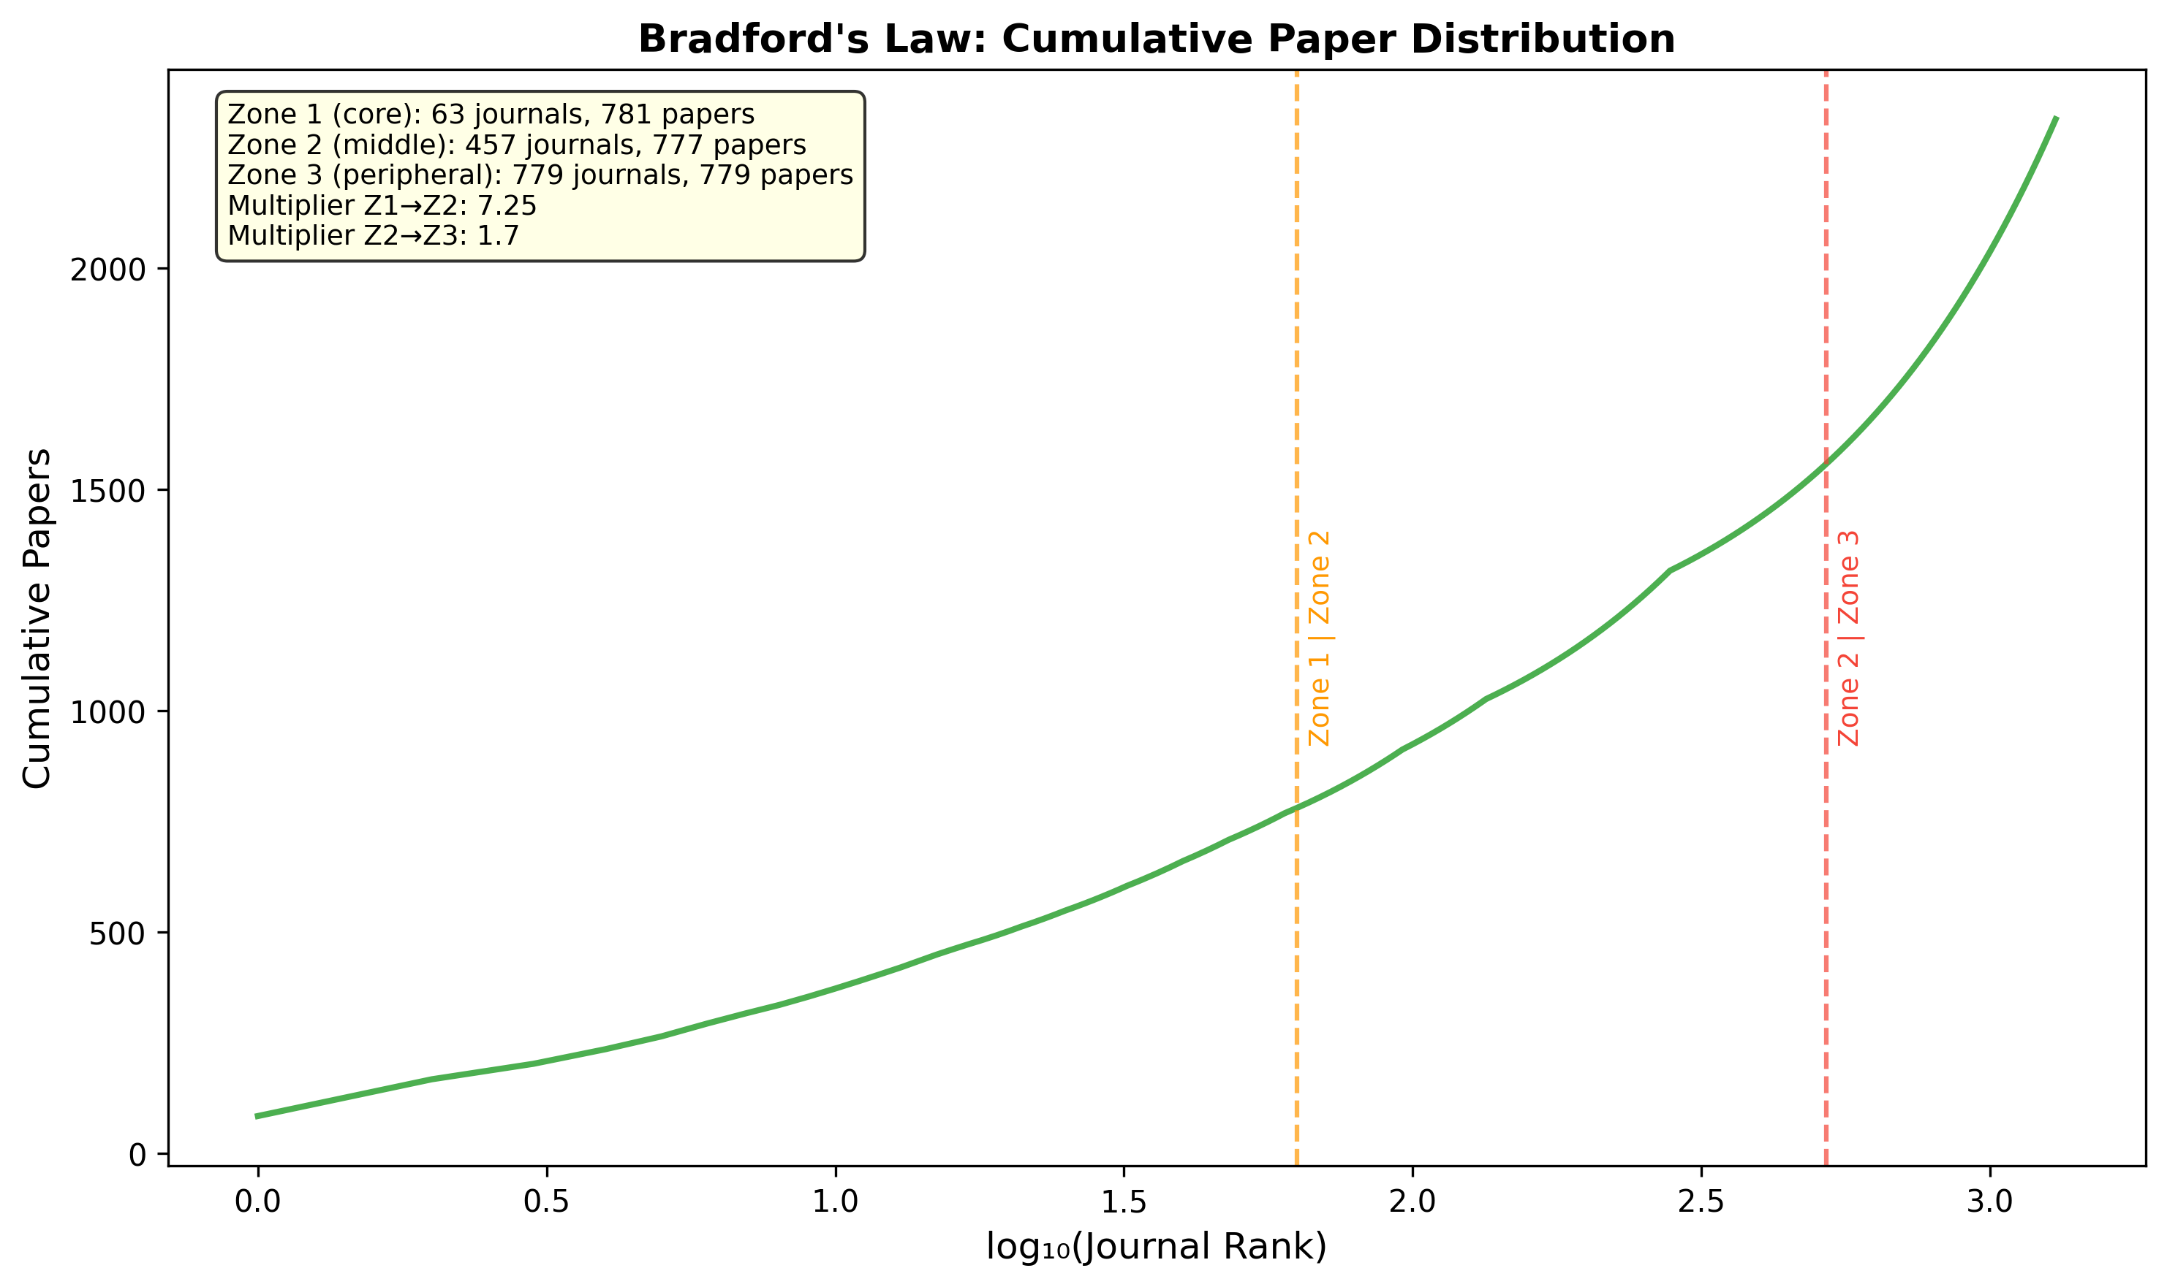
1,299 journals in three zones. Zone 1 (core): 63 journals. Multiplier 7.25 confirms expected scatter.

Figure 22: Publication Types
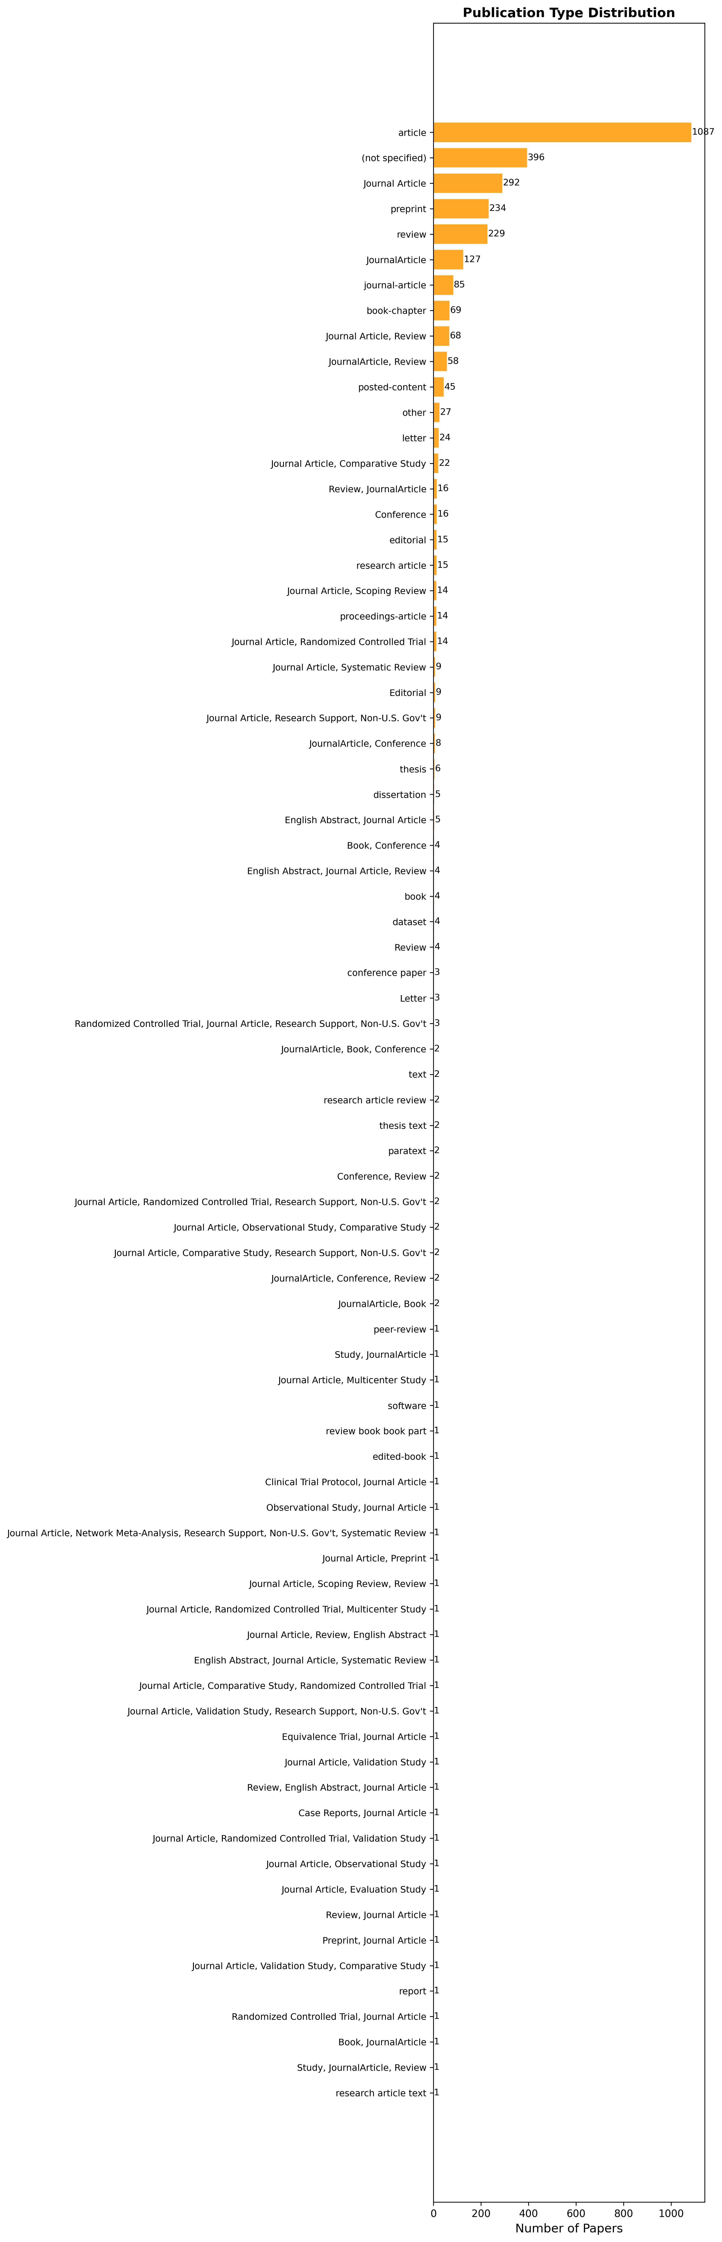
Articles (38.4%), reviews (8.6%), preprints (8.0%). Document type heterogeneity affects evidence quality.

Figure 23: Research Methods
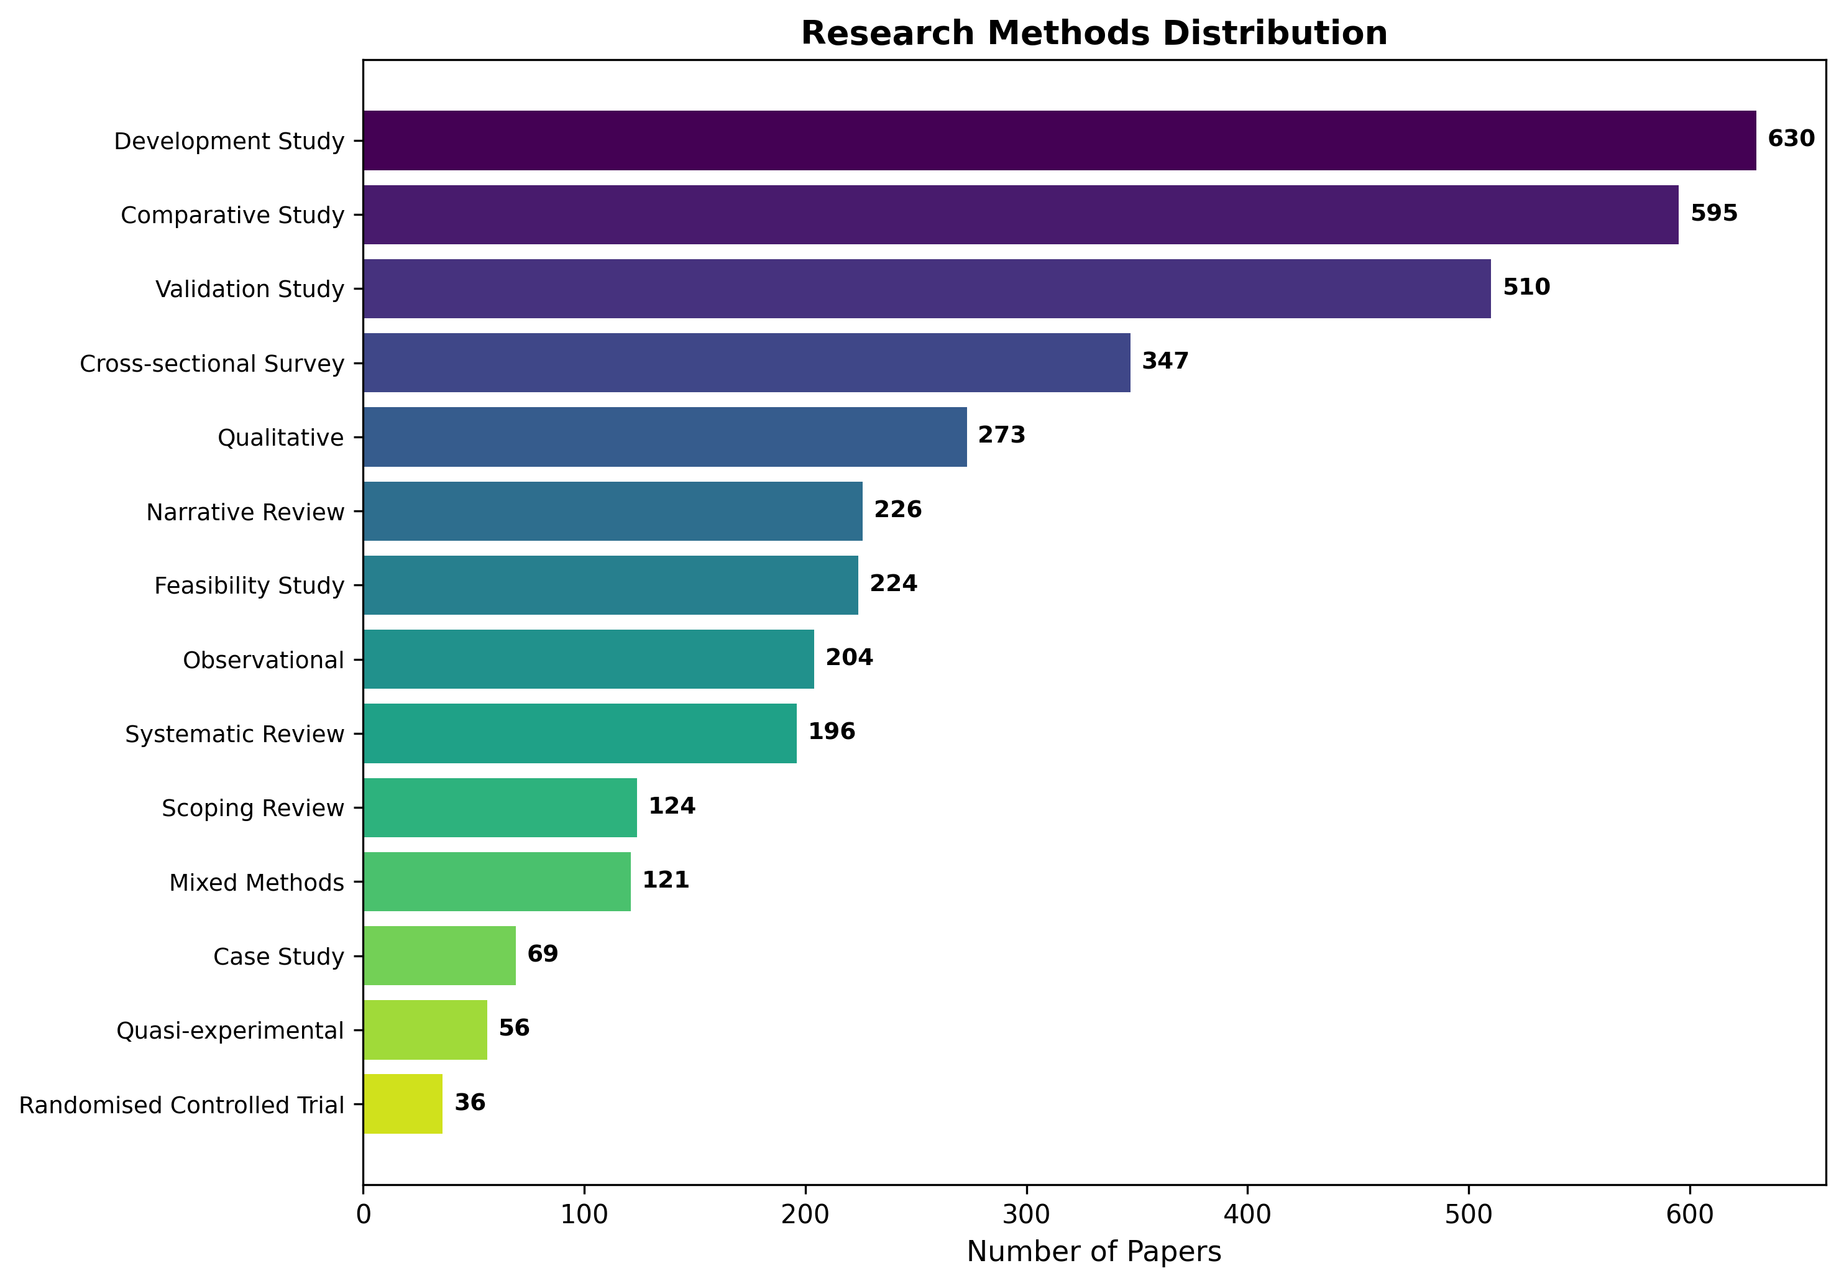
Development studies (630) and comparative studies (595) dominate. Only 36 RCTs (1.2%) identified.

Figure 24: Top 30 Keywords
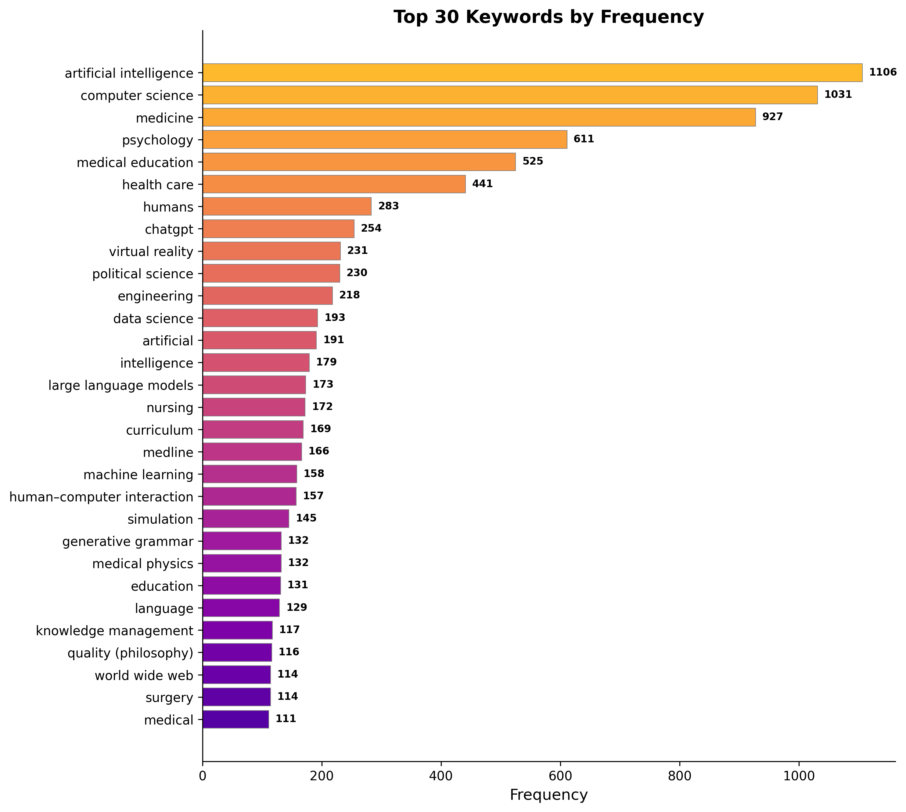
AI, computer science, medicine, medical education as dominant terms reflecting interdisciplinary nature.

Figure 25: Keyword Co-occurrence Network
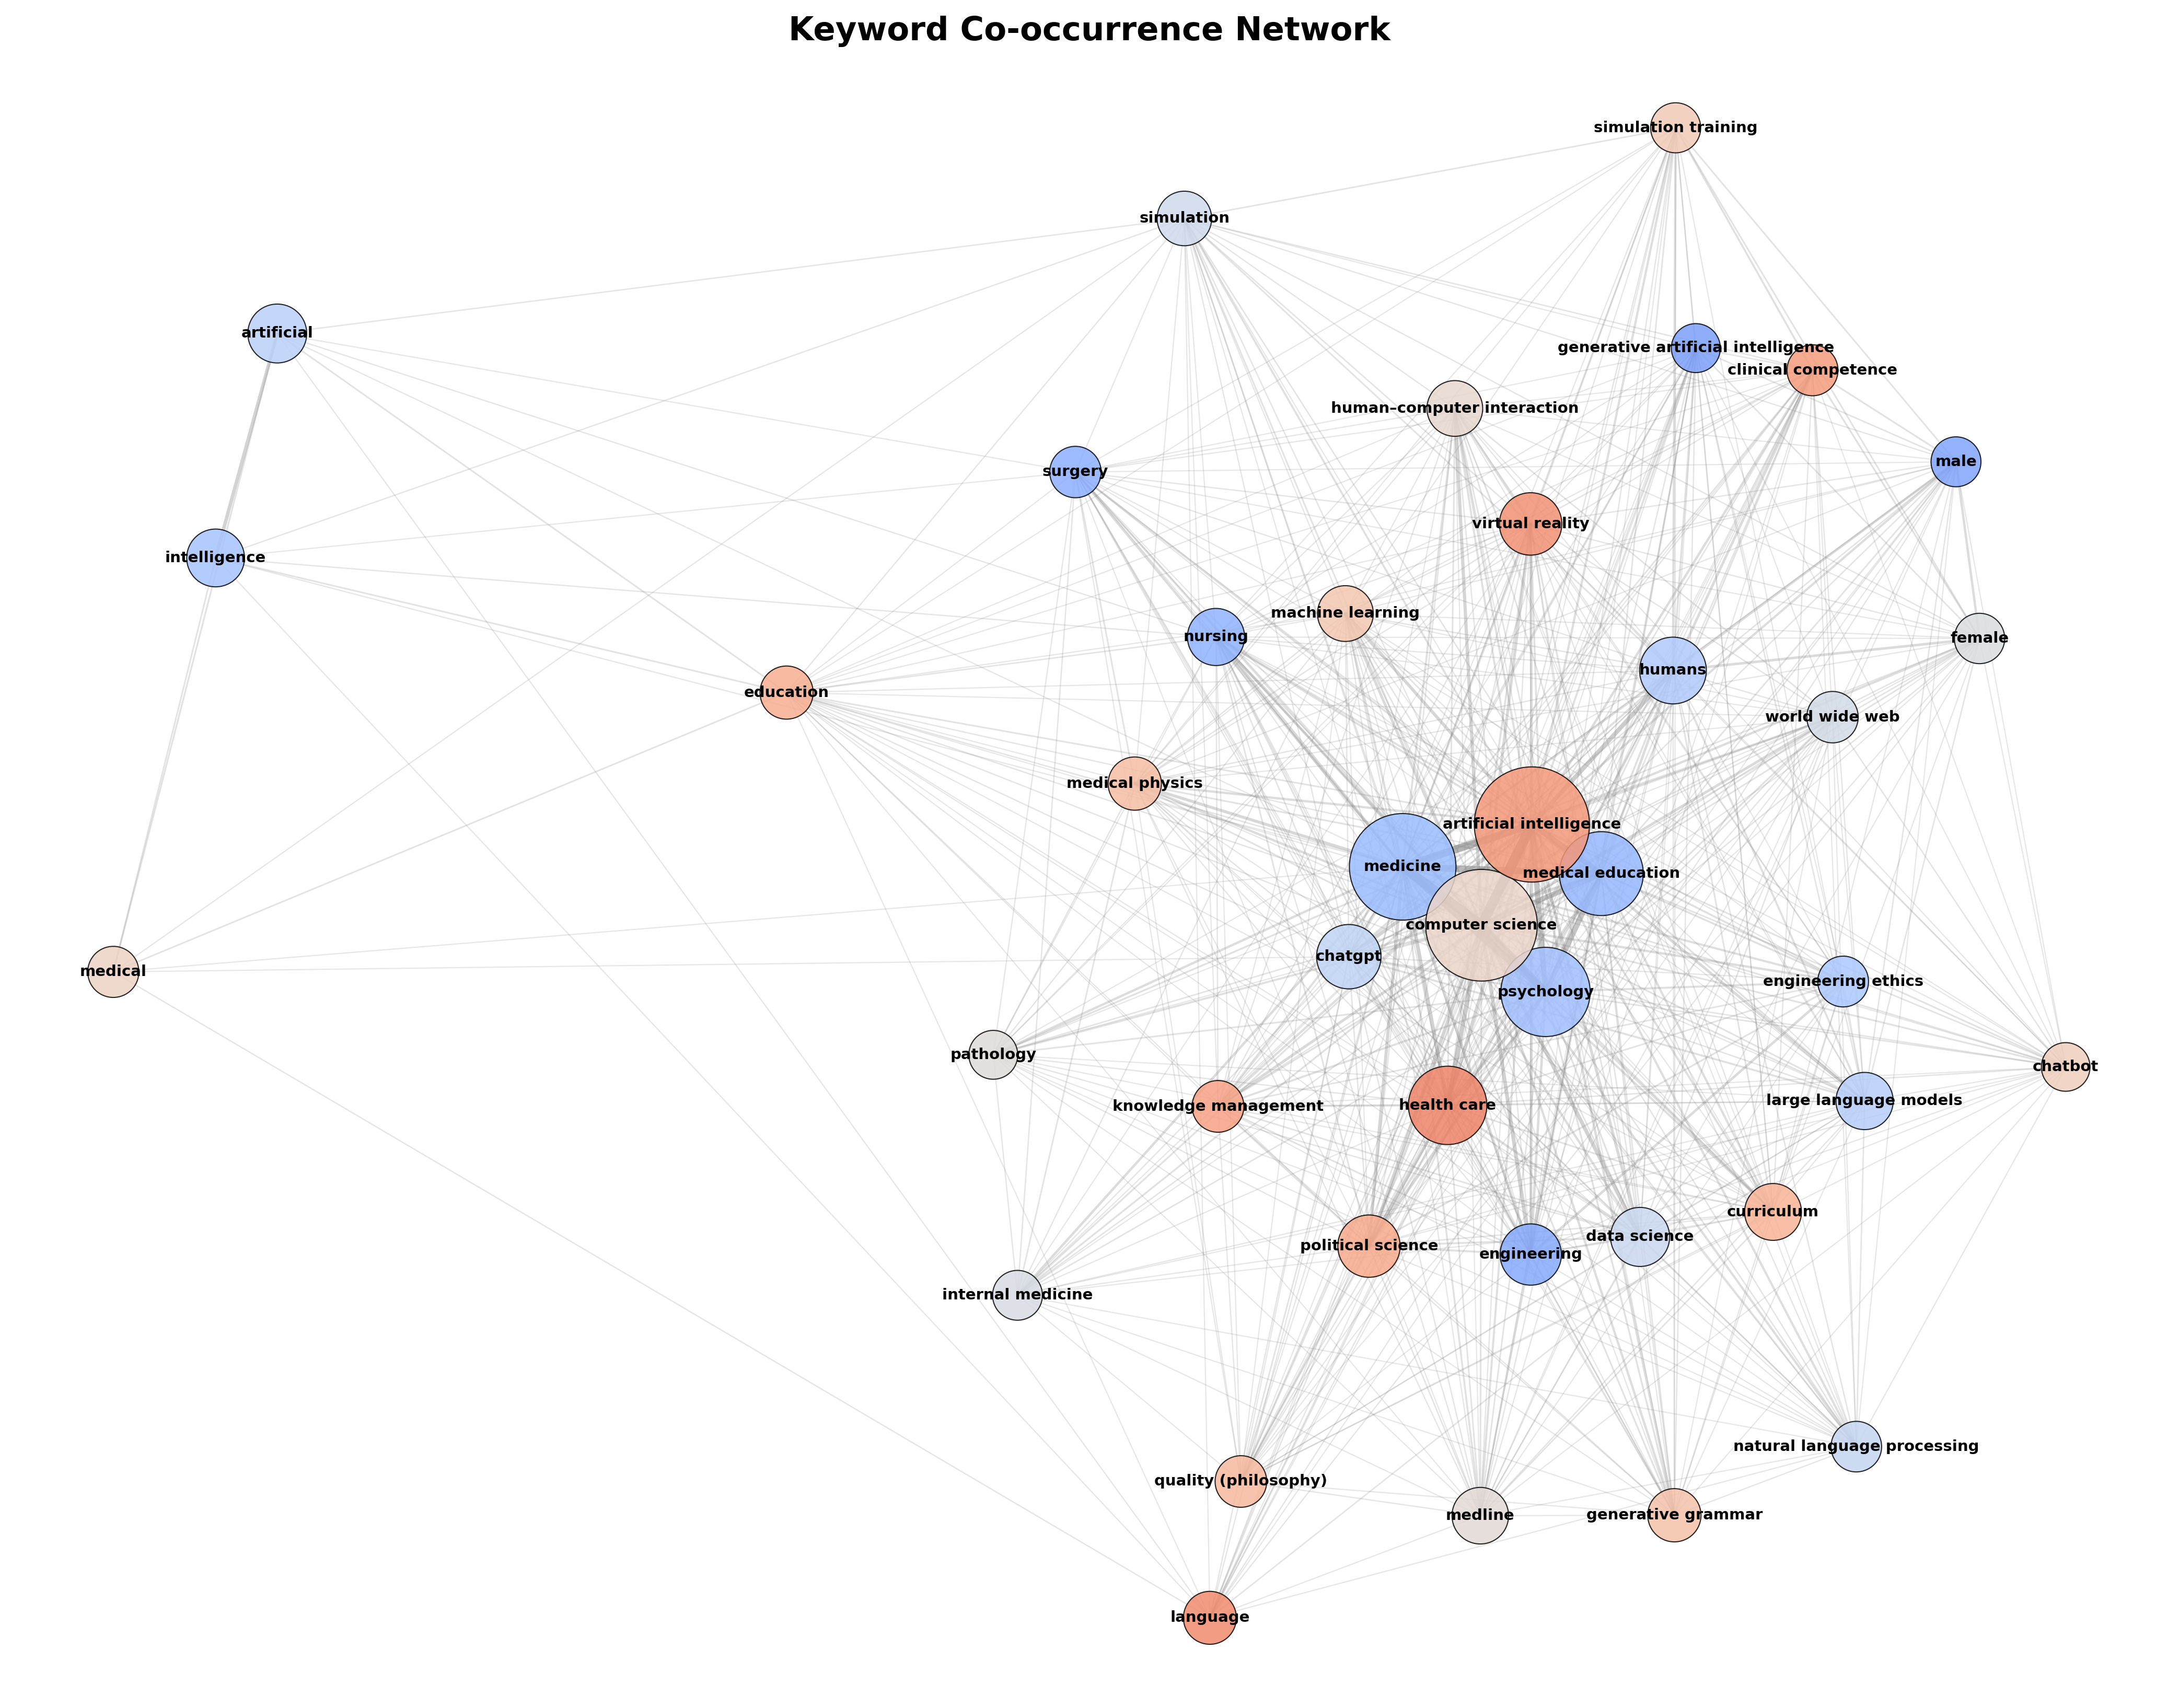
Network showing intellectual structure with clusters around AI methodology, clinical applications, and education.

Figure 26: Keyword Word Cloud
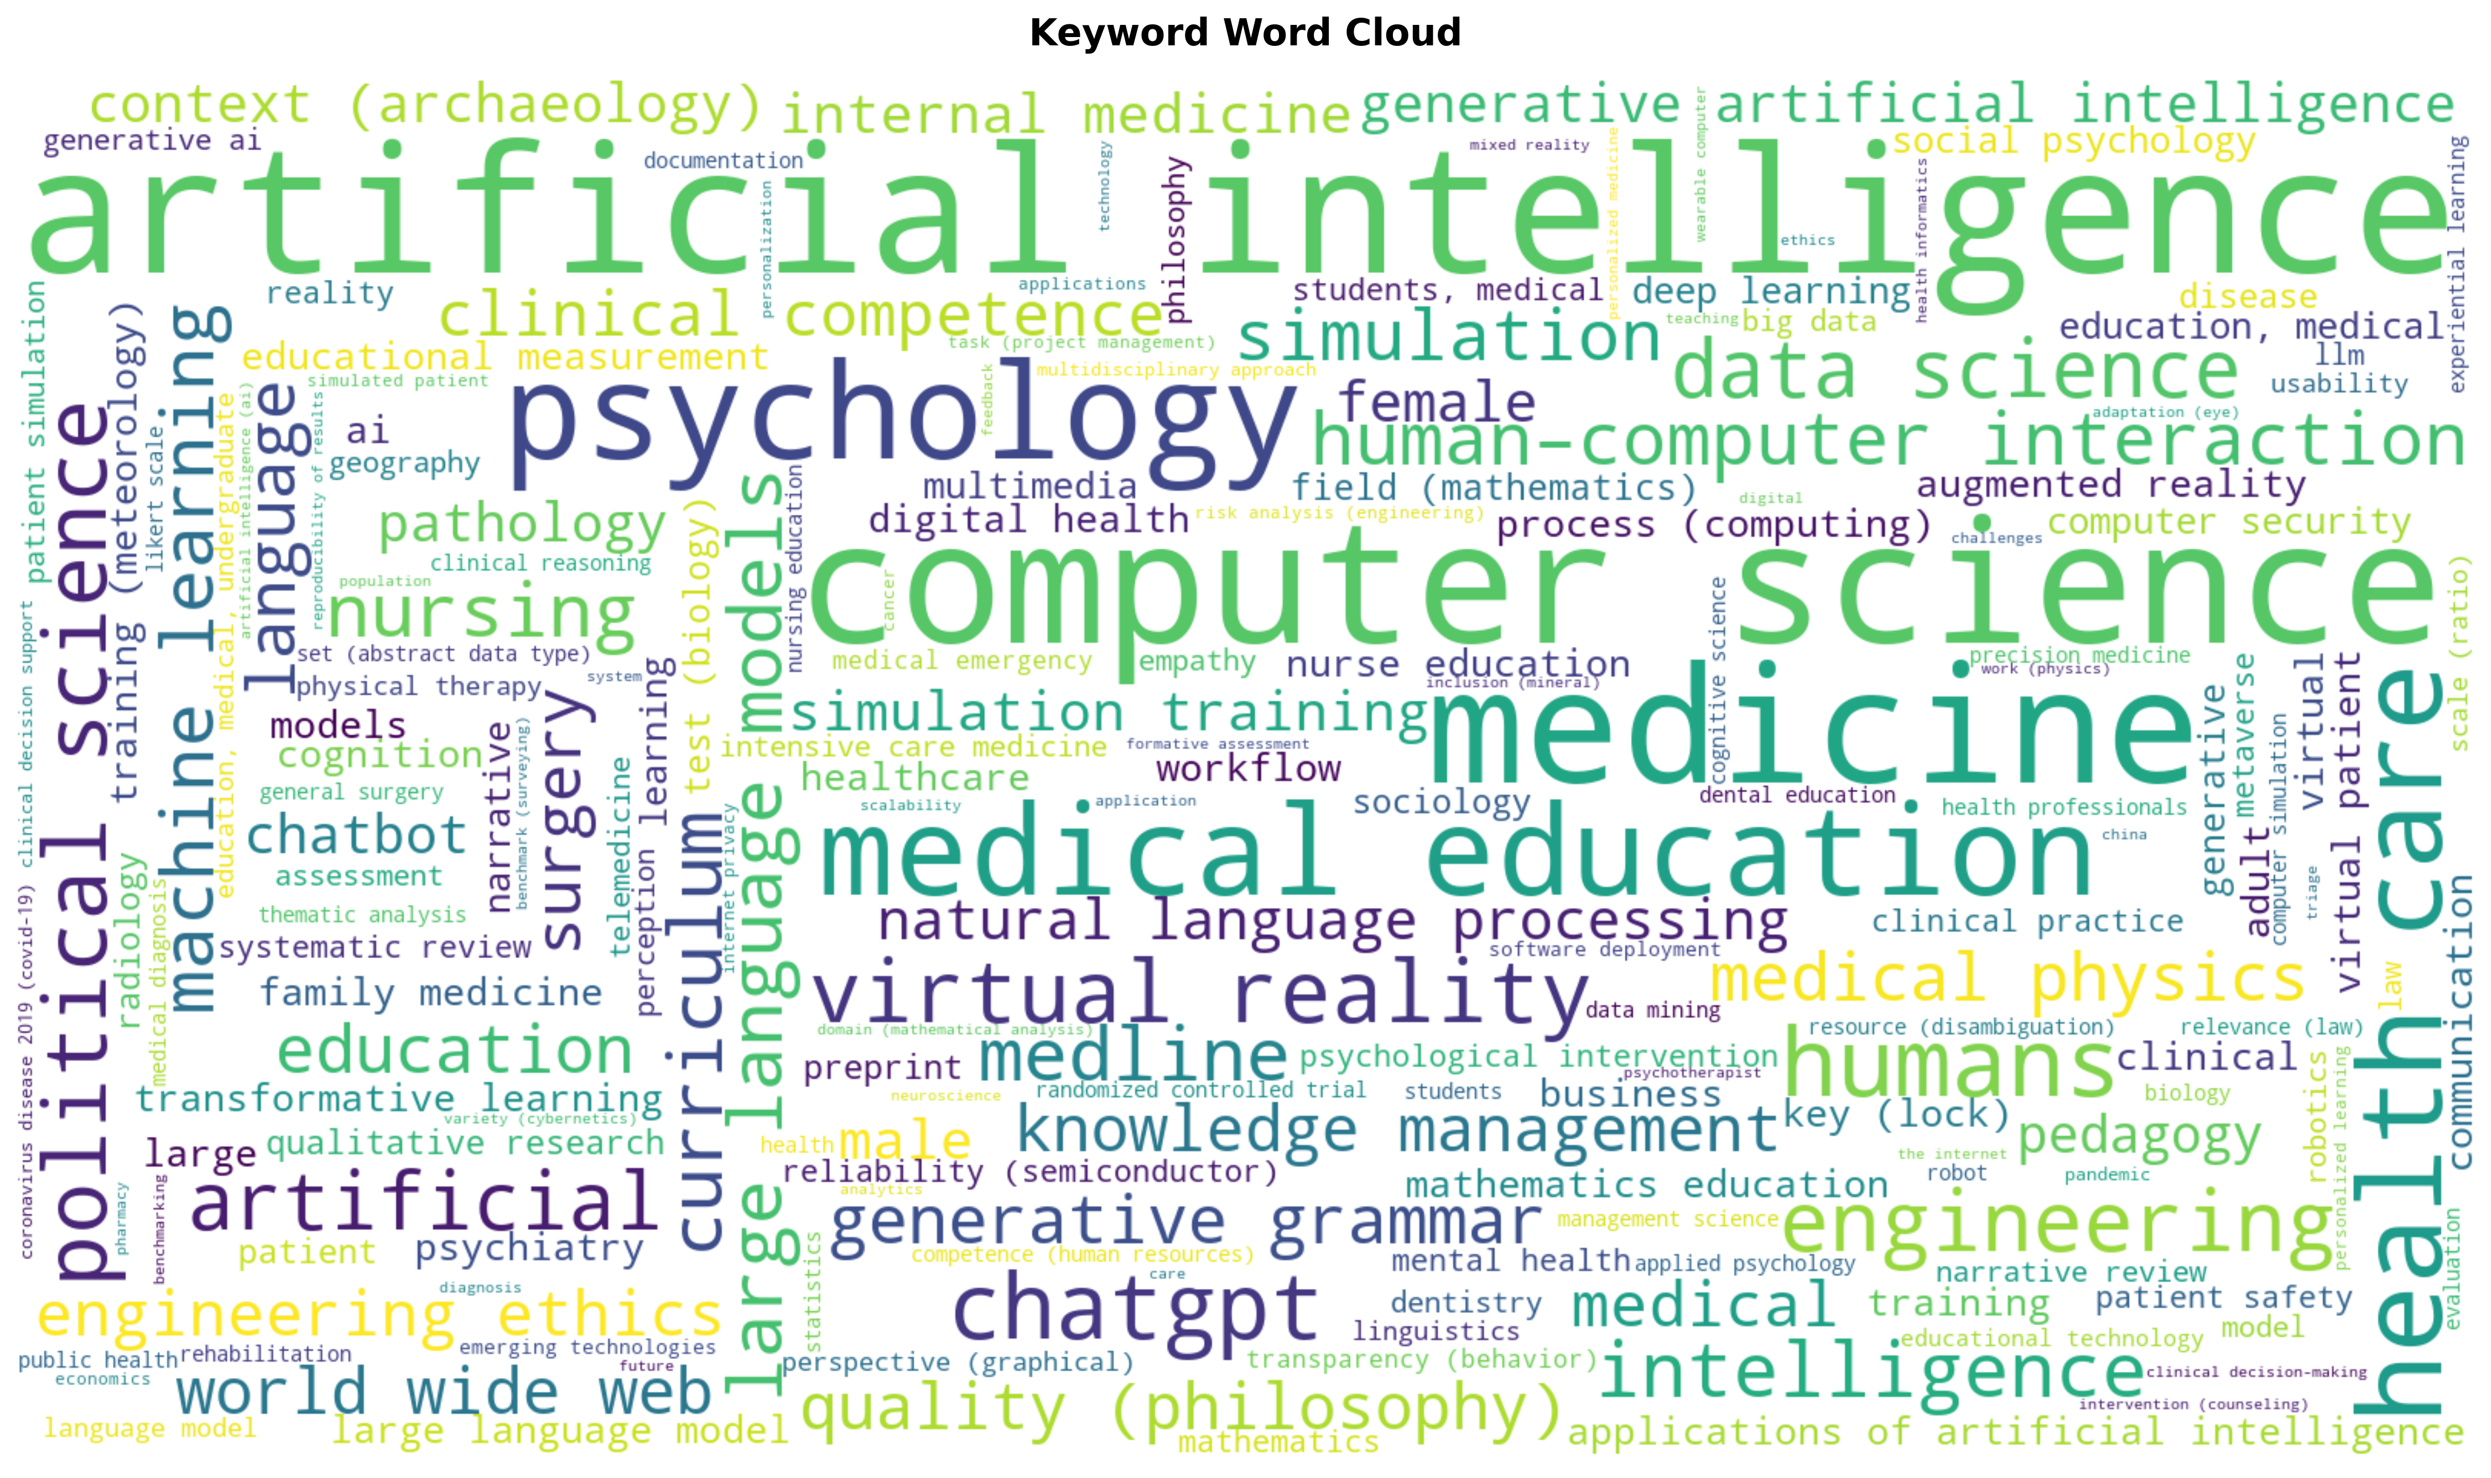
Visual keyword frequency representation confirming interdisciplinary character of the field.

Figure 27: Urology Sub-Analysis
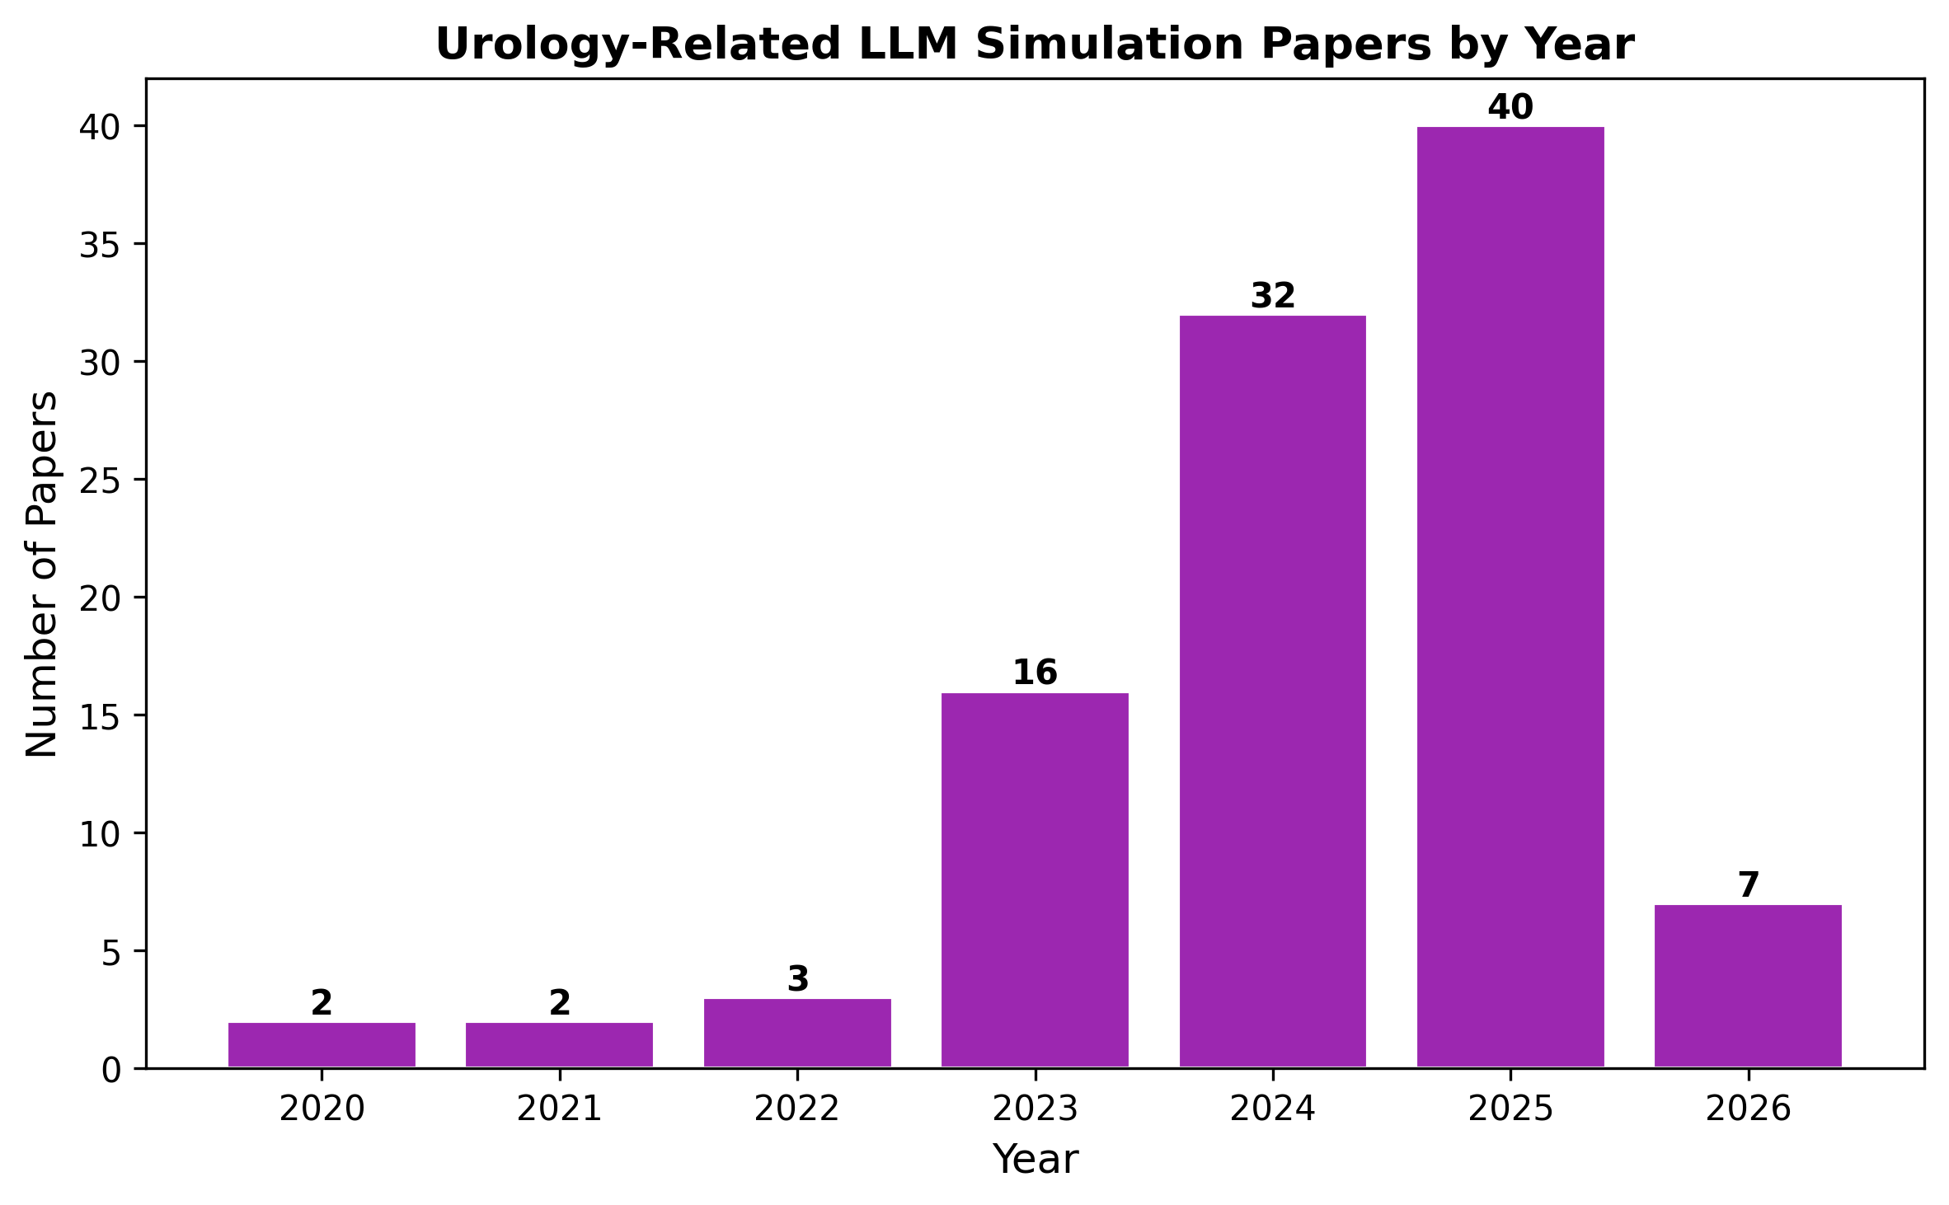
102 urology papers, growth from 2 (2020) to 40 (2025). Zero combine LLMs with simulation boot camps.

Figure 28: Source Database Distribution
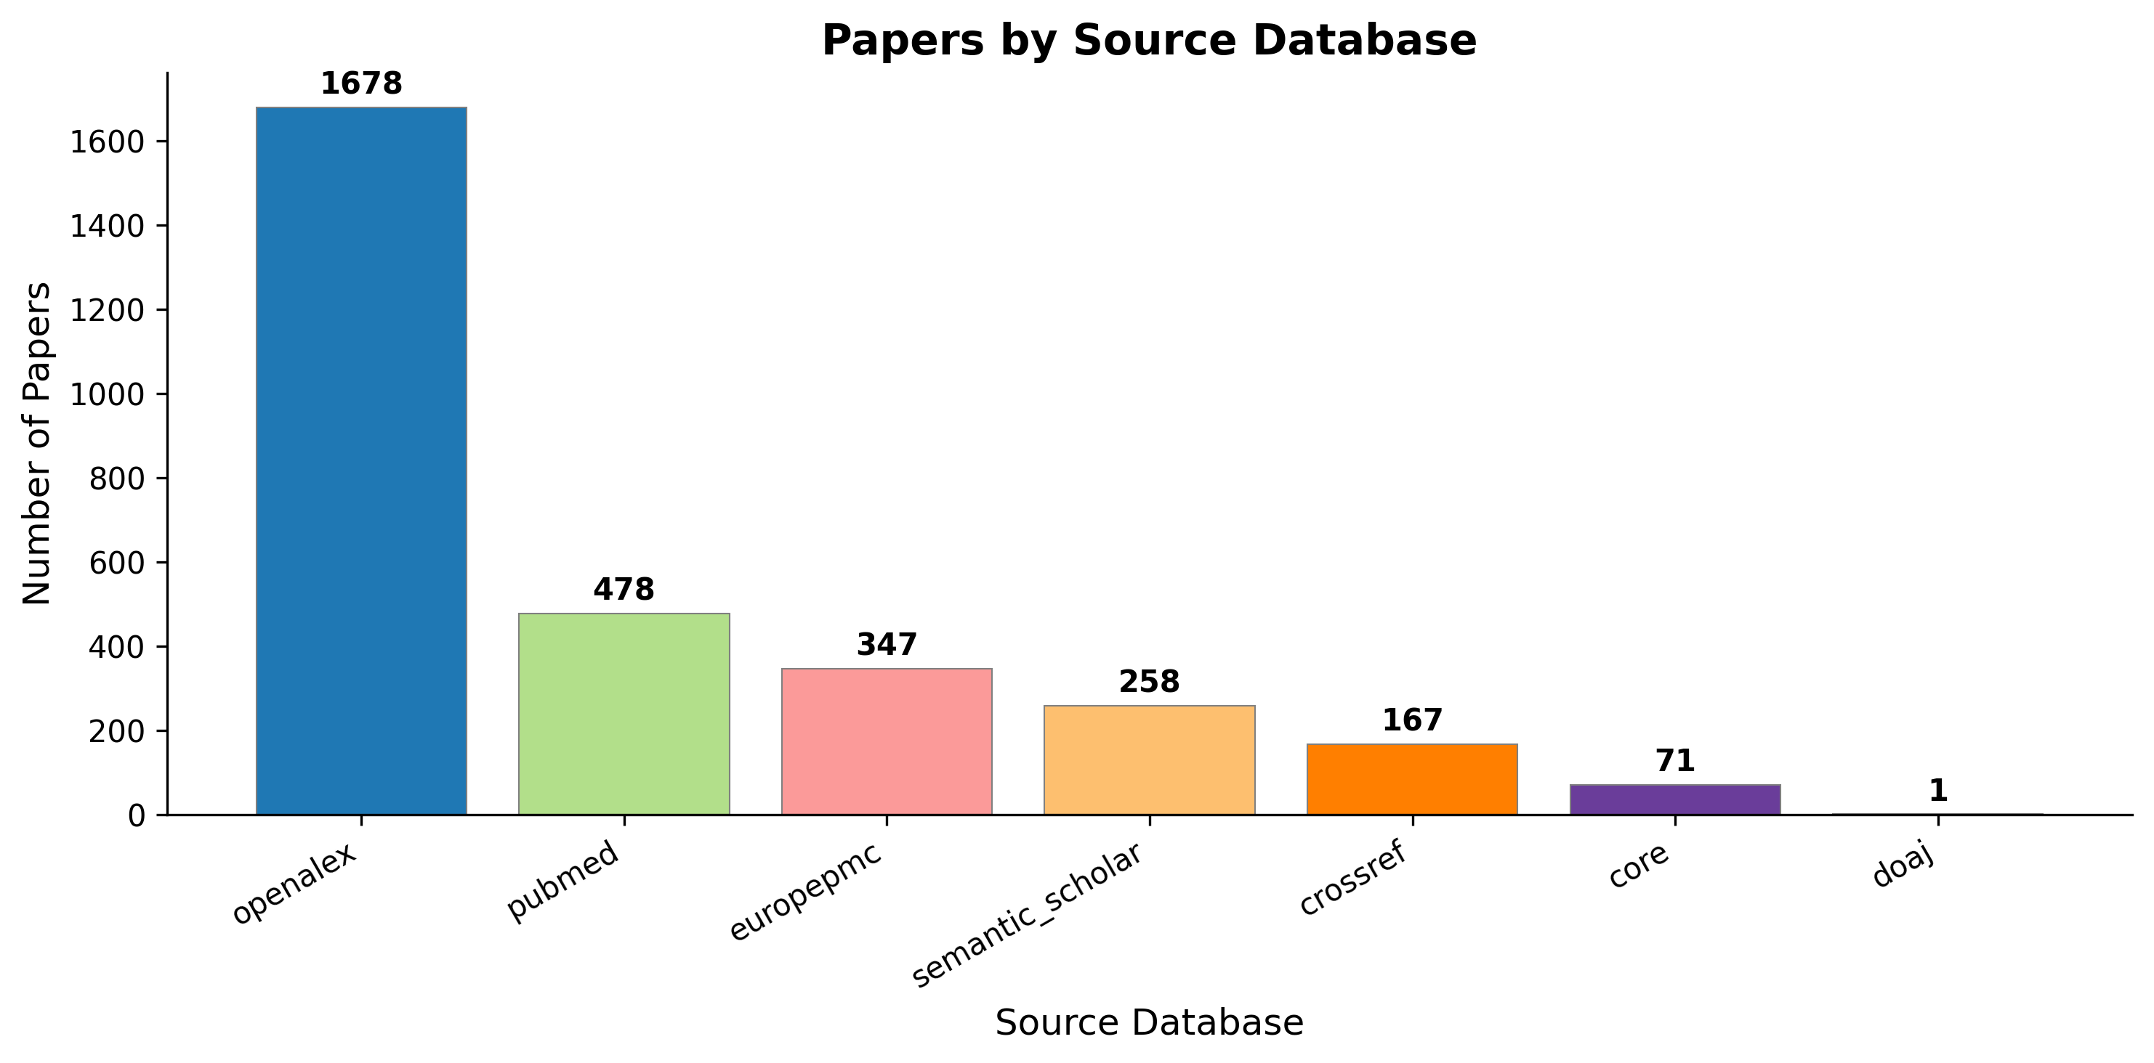
OpenAlex largest contributor, followed by Europe PMC and Crossref. Validates multi-source approach.

Figure 29: Tier Distribution
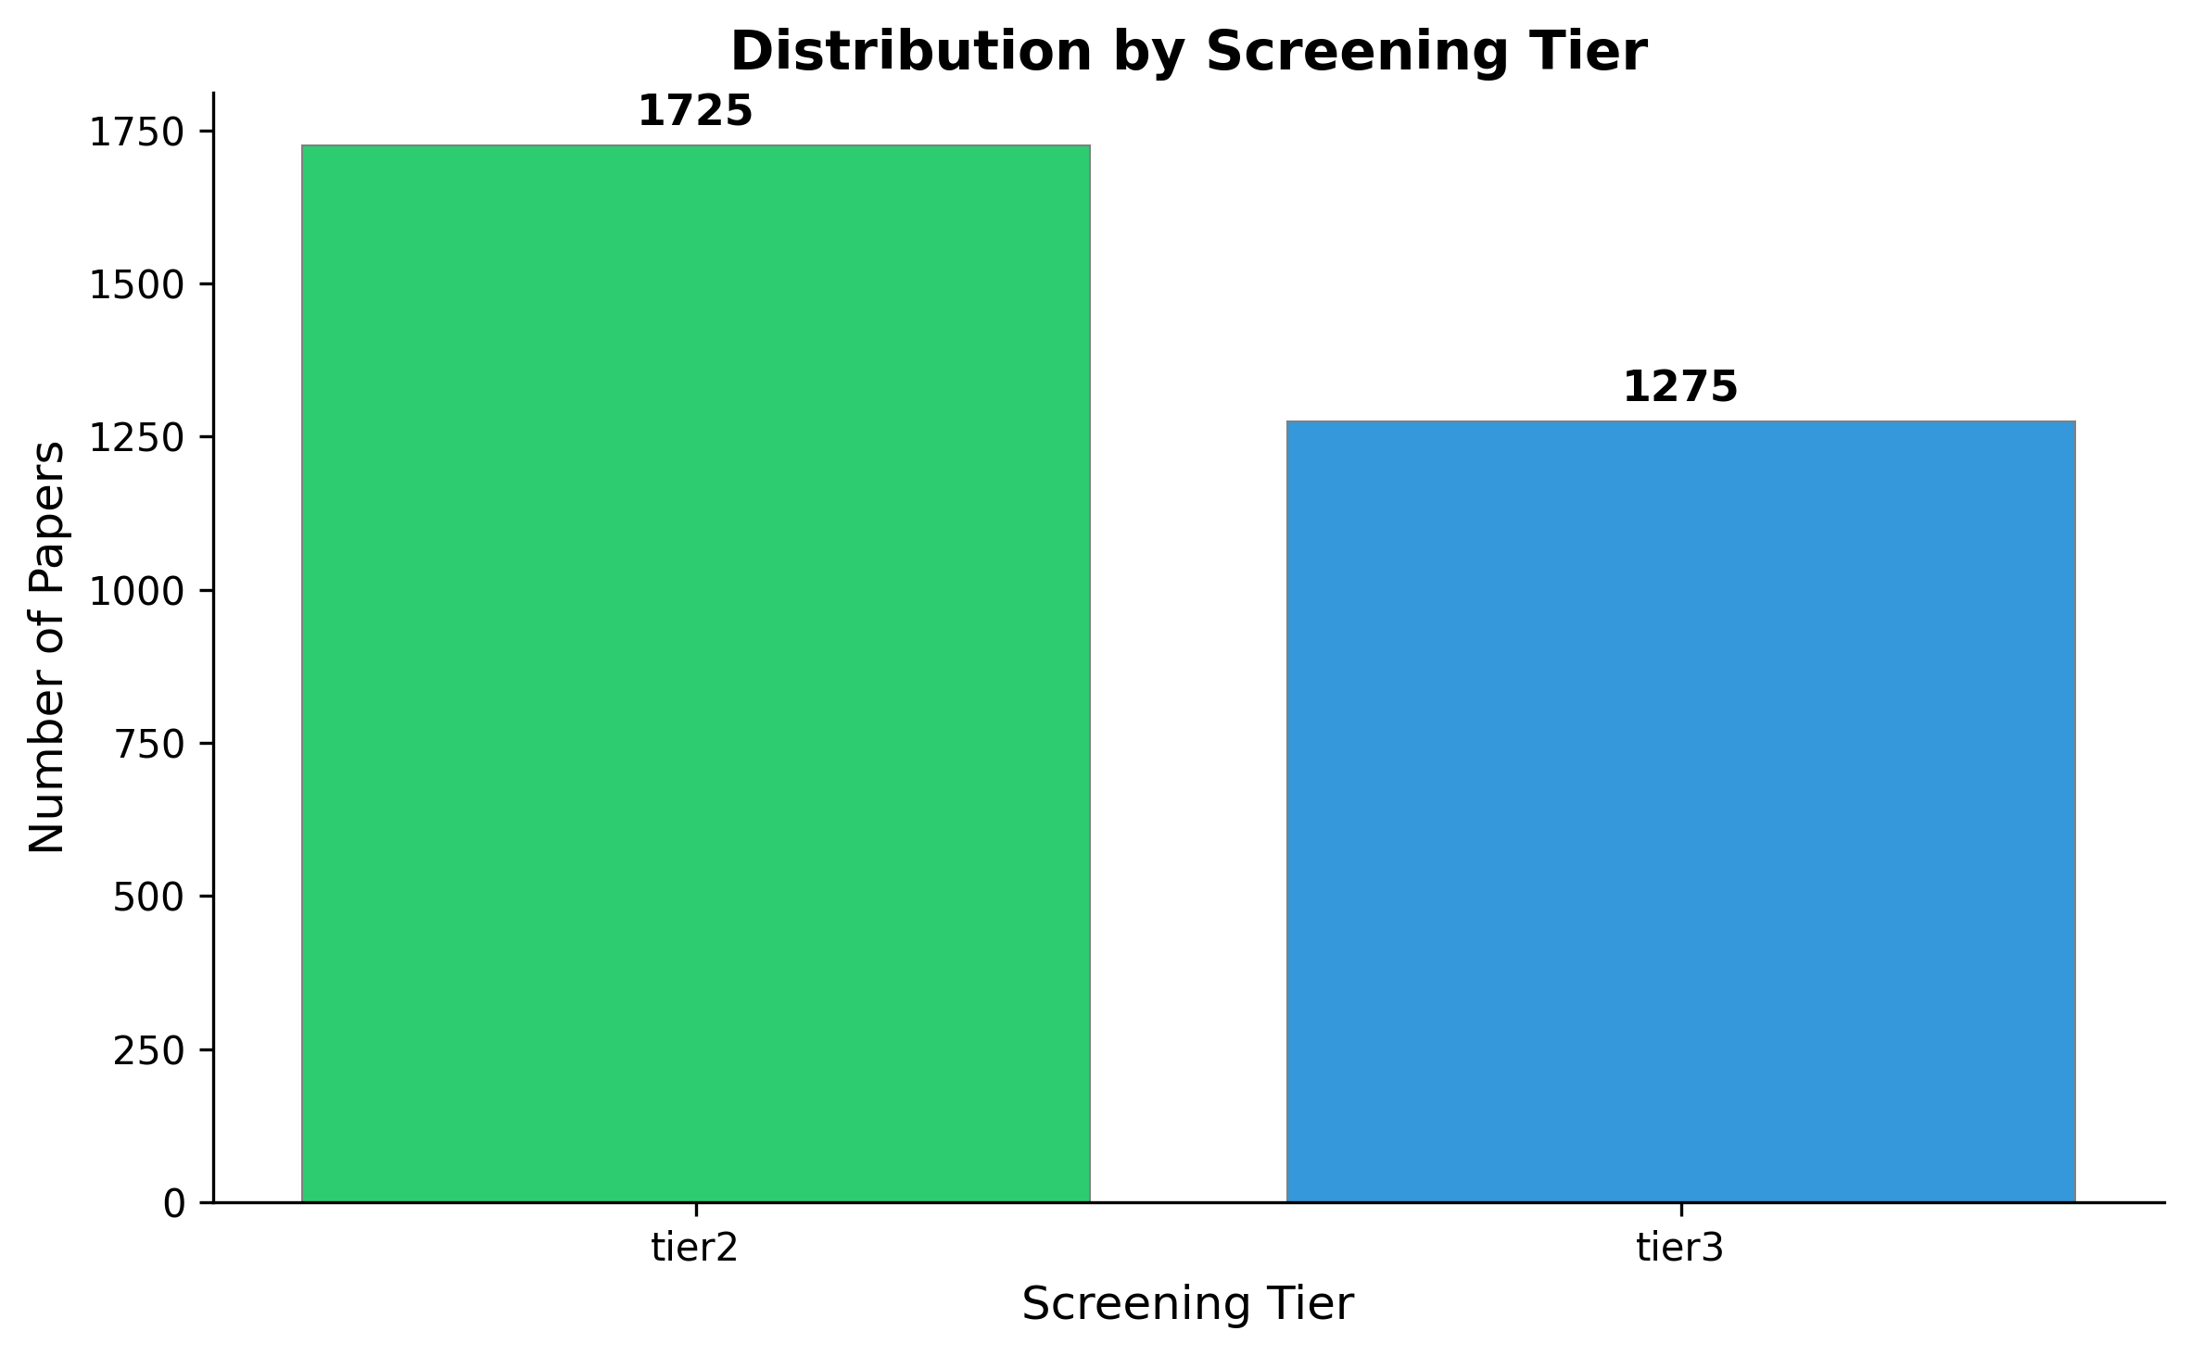
Tier 2 (LLM+healthcare simulation): 57.5%, Tier 3 (+NTS): 42.5% of core corpus.

Figure 30: Document Types
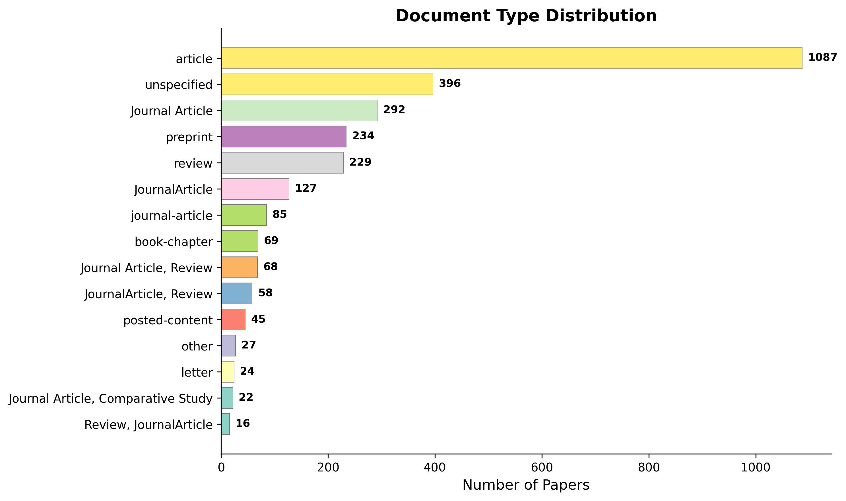
Peer-reviewed articles vs preprints, book chapters, and conference proceedings breakdown.

Figure 31: Metadata Completeness
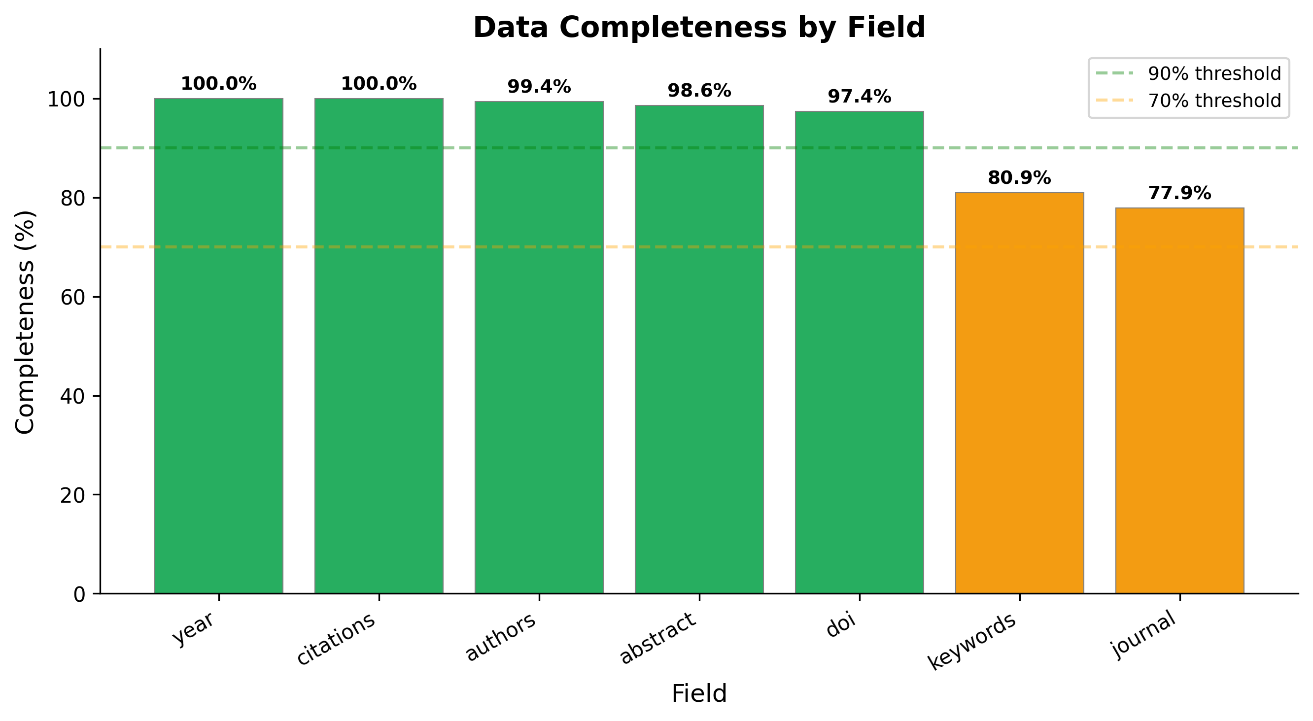
Citation (100%), year (100%), authors (99.6%) high completeness. Journal info (77.9%) is the main gap.

