**APPENDIX**

Matthew Perrott, Student number: 5067624

Copied from SPSS due to printer problems.

COMPUTE TotalGames=CFL + NBA + NFL + MLB + NHL.

EXECUTE.

* Chart Builder.

GGRAPH

/GRAPHDATASET NAME="graphdataset" VARIABLES=gender COUNT()[name="COUNT"] MISSING=LISTWISE REPORTMISSING=NO

/GRAPHSPEC SOURCE=INLINE.

BEGIN GPL

SOURCE: s=userSource(id("graphdataset"))

DATA: gender=col(source(s), name("gender"), unit.category())

DATA: COUNT=col(source(s), name("COUNT"))

COORD: polar.theta(startAngle(0))

GUIDE: axis(dim(1), null())

GUIDE: legend(aesthetic(aesthetic.color.interior), label("gender"))

GUIDE: text.title(label("Woman Versus Men"))

SCALE: linear(dim(1), dataMinimum(), dataMaximum())

ELEMENT: interval.stack(position(summary.percent(COUNT))), color.interior(gender))

END GPL.

**Graph**

[DataSet1]

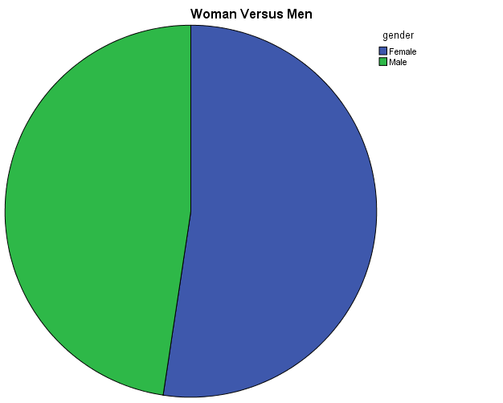

* Chart Builder.

GGRAPH

/GRAPHDATASET NAME="graphdataset" VARIABLES=Race COUNT()[name="COUNT"] MISSING=LISTWISE REPORTMISSING=NO

/GRAPHSPEC SOURCE=INLINE.

BEGIN GPL

SOURCE: s=userSource(id("graphdataset"))

DATA: Race=col(source(s), name("Race"), unit.category())

DATA: COUNT=col(source(s), name("COUNT"))

GUIDE: axis(dim(1), label("Race"))

GUIDE: axis(dim(2), label("Count"))

GUIDE: text.title(label("Different Ethnicities "))

SCALE: linear(dim(2), include(0))

ELEMENT: interval(position(Race*COUNT), shape.interior(shape.square))

END GPL.

**Graph**

[DataSet1]

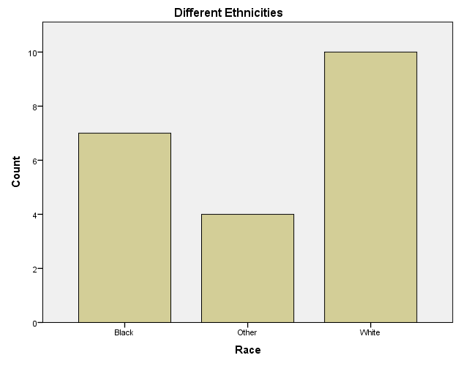

FREQUENCIES VARIABLES=MLB CFL

/STATISTICS=MINIMUM MAXIMUM MEAN MEDIAN MODE

/ORDER=ANALYSIS.

**Frequencies**

[DataSet1]

|  |  |  |  |
| --- | --- | --- | --- |
| **Statistics** | | | |
|  | | MLB | CFL |
| N | Valid | 21 | 21 |
| Missing | 0 | 0 |
| Mean | | 18.524 | 6.381 |
| Median | | 5.000 | 2.000 |
| Mode | | .0 | .0 |
| Minimum | | .0 | .0 |
| Maximum | | 100.0 | 50.0 |

**Frequency Table**

|  |  |  |  |  |  |
| --- | --- | --- | --- | --- | --- |
| **MLB** | | | | | |
|  | | Frequency | Percent | Valid Percent | Cumulative Percent |
| Valid | .0 | 4 | 19.0 | 19.0 | 19.0 |
| 1.0 | 1 | 4.8 | 4.8 | 23.8 |
| 2.0 | 3 | 14.3 | 14.3 | 38.1 |
| 3.0 | 1 | 4.8 | 4.8 | 42.9 |
| 5.0 | 3 | 14.3 | 14.3 | 57.1 |
| 10.0 | 1 | 4.8 | 4.8 | 61.9 |
| 12.0 | 2 | 9.5 | 9.5 | 71.4 |
| 40.0 | 2 | 9.5 | 9.5 | 81.0 |
| 50.0 | 3 | 14.3 | 14.3 | 95.2 |
| 100.0 | 1 | 4.8 | 4.8 | 100.0 |
| Total | 21 | 100.0 | 100.0 |  |

|  |  |  |  |  |  |
| --- | --- | --- | --- | --- | --- |
| **CFL** | | | | | |
|  | | Frequency | Percent | Valid Percent | Cumulative Percent |
| Valid | .0 | 7 | 33.3 | 33.3 | 33.3 |
| 1.0 | 1 | 4.8 | 4.8 | 38.1 |
| 2.0 | 3 | 14.3 | 14.3 | 52.4 |
| 3.0 | 1 | 4.8 | 4.8 | 57.1 |
| 5.0 | 3 | 14.3 | 14.3 | 71.4 |
| 10.0 | 2 | 9.5 | 9.5 | 81.0 |
| 12.0 | 2 | 9.5 | 9.5 | 90.5 |
| 15.0 | 1 | 4.8 | 4.8 | 95.2 |
| 50.0 | 1 | 4.8 | 4.8 | 100.0 |
| Total | 21 | 100.0 | 100.0 |  |

CROSSTABS

/TABLES=gender BY Race

/FORMAT=AVALUE TABLES

/CELLS=COUNT

/COUNT ROUND CELL.

**Crosstabs**

[DataSet1]

|  |  |  |  |  |  |  |
| --- | --- | --- | --- | --- | --- | --- |
| **Case Processing Summary** | | | | | | |
|  | Cases | | | | | |
| Valid | | Missing | | Total | |
| N | Percent | N | Percent | N | Percent |
| gender * Race | 21 | 100.0% | 0 | 0.0% | 21 | 100.0% |

|  |  |  |  |  |  |
| --- | --- | --- | --- | --- | --- |
| **gender * Race Crosstabulation** | | | | | |
| Count | | | | | |
|  | | Race | | | Total |
| Black | Other | White |
| gender | Female | 4 | 1 | 6 | 11 |
| Male | 3 | 3 | 4 | 10 |
| Total | | 7 | 4 | 10 | 21 |