For the term project, each person was to implement Prim’s and Kruskal’s algorithm on 30 different graphs ranging from 50 vertices to 1000. Prims and Kruskal's are two algorithms that are used to find the minimum spanning tree of a graph. In the medical industry where I work, kruskal's is commonly used to cluster records from patients in an attempt to find a common pattern to help spot and identify possible risks. Though the two algorithms generally solve the same problem, they both have different requirements and runtimes and are better suited towards different types of problems.
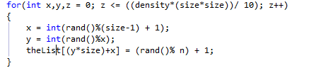
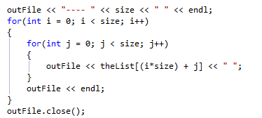
The graph generator I used was 95% written by me. At first I was having a hard time deciding how to make a sparse graph, but with a little help from the internet, I was able to come up with the following code that works surprisingly well. Though the original pseudo-code was only for sparse-mid, I was able t adapt it to my system to give me a for loop that allowed the user to enter density rating between 1 and 10 for the desired density level. After this for loop, my matrix is saved in a text file. Like many other generators out there I'm sure, the first line represents the dimensions of the matrix, and the rest of the data is the actual matrix. Very standard stuff. I used ofstream and simply outputted to the file as if I was outputting to the screen, which works surprisingly well.
For the experiment, I initially generated 30 graphs ranging from a size of (50x50) to (1000x1000). As will be shown later, I elected to produce larger graphs as well, extending all the way up to (10k x 10k). Of the graphs I produced, roughly a third were sparse, a third were dense, and the remaining were somewhere in the middle. The experiment is simple. Run each graph through the algorithms three (3) times and average the time taken for each size. The goal here is to determine how has the running time grew compared to the matrix size. The data for these are graphs produced by the very same program, and all runs were made on the UNT csp machines using the g++ compiler.
A quick note about the algorithms. The first algorithm used is Prim's. It's a greedy algorithm that by itself, and in this implementation has a runtime of O(V²). Kruskal's is also a greedy algorithm, though it possesses a theoretical runtime of O(E log V) where E is the number of edges in the graph and V is the number of vertices. Seeing this, it should be slower than Prim's, by a long shot but looking at pseudo-code, they should provide roughly the same output on sparse graphs.
The results definitely surprised, but make a lot of sense in hindsight. I generally found a trend amongst the two algorithms. Prims tended to be expodentially faster, but the MST it formed was always more costly than from Kruskal's. I believe that this has to do with the fact that kruskal does not require that you pick a weight that connects to already visited nodes. Without this requirement, it allows you to construct the most efficient MST possible. As side effect of this is the increased running time, and the possiblility of making two MST's that are not connected (though this is only likely to happen on an extremely sparse graph). It was an interesting tradeoff, and begs the question, "Would you rather have speed or accuracy? You can't have both". I learned a lot writing these algorithms, as they were not something I had a lot of coding knowledge about beforehand. Below are the graphs and results I received from my testing. I generated three different graphs for each size, and took the average of the three for my time. Because running times for Prim's was so low, I tested all the way up to matrix sizes of 10k. In my graphs, sparse represents sparse, dense a complete graph, and mid is somewhere in the middle. Thanks for reading!
