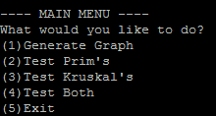
To make it easier for running, all the code for the generator and algorithms is contained from within the program. At run, the user is prompted with the following options. You can either use the number without parenthesis, or you can type out what you would like to do. For example, you would type “prim” if you wanted to run prim’s. The graphs were generated randomly and saved to text documents. To make it easier to generate, I ask for the size, range (1-n), and density level (1 – 10) from within the program and generate the matrix thereafter. After the matrix has been generated, the user inputs a filename to save the matrix under. After this, the program will write the file to the local directory inside a text file. After generating files, or if the user already has generated files, you can go straight to testing!
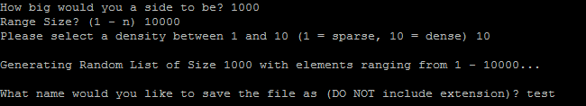
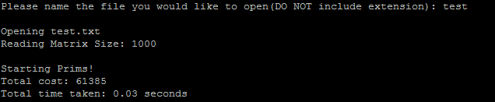
From the main menu, you can test just Prim’s, just Kruskal’s, or both! After selecting one of these menu options, you will be prompted to enter the file you would like to import from. After that, the program does the rest. For both algorithms, it will only display the “total cost” and “total time” on the prompt. Each algorithm will generate a text file after completion of the results, in case you want to go more into depth with what it was doing.
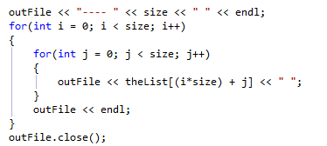
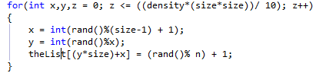
The code generator is really an over-glorified random number generator. You are able to specify a matrix size, a range and density. The following code takes that and puts it into dynamic array that is initialized after the size is given. (note, all the code was written in visual studio for the color coding, but run and debugged on the csp machines). The density part is used for how far the loop goes to. The higher the density, the more complete the resulting graph. After that, it opens up an ofstream with the file name given appended with “.txt”. As is common with most matrices stored in a text file, the first line always represents the size of the matrix, with the following lines being the actual data. I decided to separate all of my data by spaces, as it was the easiest to read if I decided to open the file independently of the program. After it finishes writing the matrix, the program goes back to the main menu.
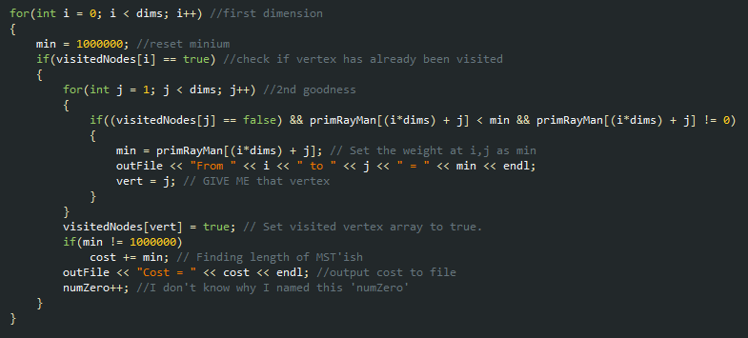
Prims is a very simple nested for loop. I didn't do anything out of the ordinary for it. The only thing that might be considered special is that for all of my loops, I use a one dimensional array to represent the matrix. I find it easier to sort through, easier to initialize, and generally more trouble free! As mentioned earlier, after this algorithm finishes running, a detailed report of all the nodes it visited and the changes in the cost are saved to a text file. All the program shows on screen is the cost, and the time.
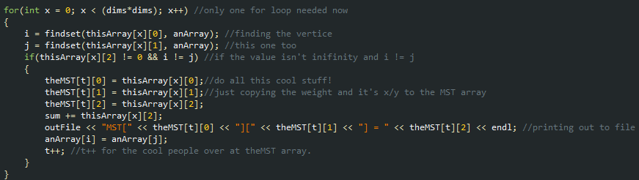
Kruskal's is my favored out of the two. Despite it taking longer, it always finds a better MST, atleast in my testing. Just as with Prims, I used a one dimensional array to represent a matrix. I copied the matrix into a second array that was suitable for sorting. After sorting with quicksort by weight, I ran it through this forloop. Just as with prims, the results are published in a text document after completion. All the screen shows is the total cost, and running time.
Last but not least, I'd like to take a look at my code for reading in matrices. Just like my writer, it uses ifstream. After reading the first line, it initializes an array of that value squared (another case of using a 1d array), and proceeds to read in the array using the getline method.
