Program 1 - Hello World
Due Date: September 28, 2010 11:59 PM
Convert the standard Hello World C program into MIPS Assembly language using syscall in place of standard I/O functions. Use MARS to test your code. Submit your commented code and data. Provide evidence of compilation and execution. And include a short report detailing your experiences, the code and its operations.

Shows text/data segments and bottom shows successful compiling.
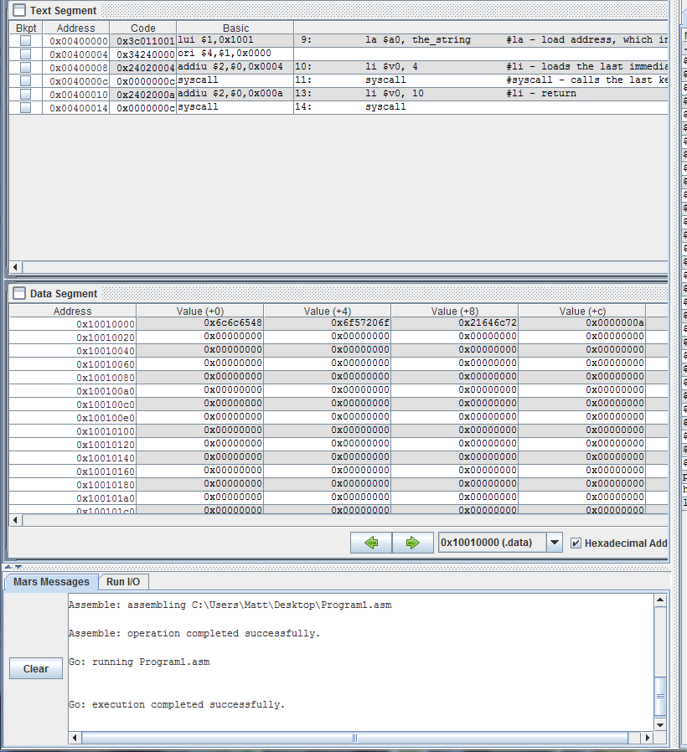

I/O showing program completion
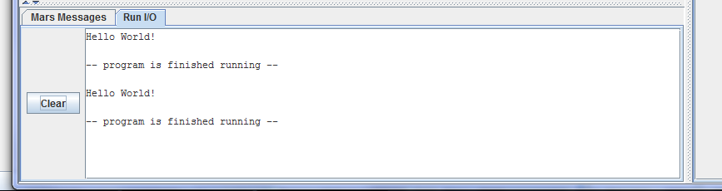

Report:

Writing this program was very interesting. I expected mips to be extremely difficult to comprehend, but once you get past the very basic (but often used) commands, it’s not that hard to pick up. What I felt was the hardest part about this program was what registers to call. It’s something that has been hard for me, and I think will continue to be a little difficult. But as far as the commands go, I thought it was easy.

Overall, this was a great learning exercise!

