**Background**

At the end of the onboarding process there is a search CTA, prompting users to look at potential wedding venues. In its current form, c. 45.3% of users respond to this CTA, which we would like to increase (more searches = more engagement = more enquiries). Two changes were suggested to the onboarding process to see if we could improve this metric.

**The Tests**

Variant 0 was the control (no changes). The two modifications were:

* **Variant 1**: The option of choosing “Undecided” on the location step of onboarding (leaving only data-entry or SKIP as options).
* **Variant 2:** Hid the text around the counts of venues in your location, leaving only “We found some perfect venues for you!”.

There aren’t many concerns around the tests which might have unduly influence the results (although its not clear why the # of users different for each Variant).

**Results**

We tested for an improvement in search CTA %. There was little evidence that variant 1 led to an improvement in search CTA %. However, variant 2 had strong evidence of an improvement (c. 94%). In the test, Variant 2 achieved c. 52.1% response rate to the CTA.

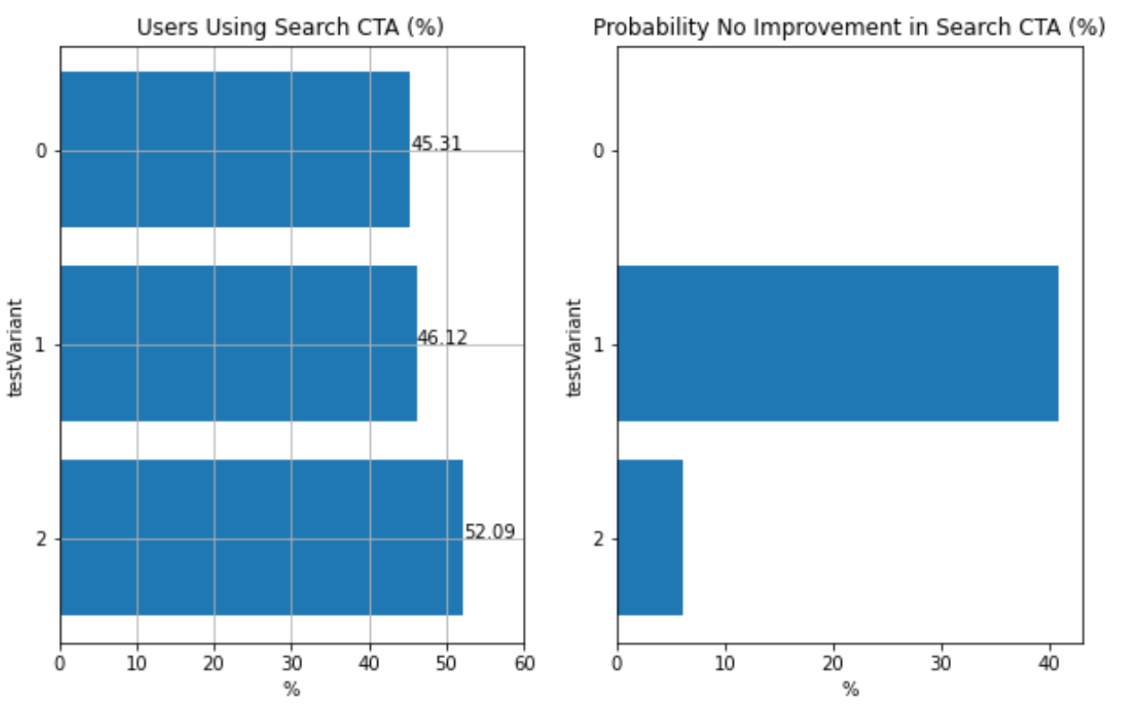

Logically, “we found some perfect venues for you” is a stronger CTA than simply stating the count of venues in a location. The test suggests this change should be implemented for all users.

**Further Tests**

* Instead of a text CTA, it might be interesting to have an embedded scroll window, where users can see images of ‘recommended venues’. The images would be the top results from the search page anyway. When the users clicked through it would take them to the search page. I think users are more likely to click on a lovely image of a country house venue than read text. Plus… you could eventually monetize this (venues pay to appear here).
* Within the framework of this test, I would like to explore the other metrics in the dataset which we would like to improve (e.g. number of searches, number of enquiries).