MAKR 140 Design Notebook – Pool Lap Counter

Iterative Design Made Easy with 3D Modeling – Project 2: Smoking Pipes
As a maker, something profound I learned as a student in architecture was to approach design and prototyping as an iterative process. Just like in evolution, changes are made and tested and slowly the design transforms and improves. This method meshes particularly nicely with digital fabrication since it’s relatively easy to produce an updated design and evaluate the changes made to it. I give myself room for my first iteration to fail because although it may not work the way I’d like, there are almost certainly a number of things about it that do work. Usually by the third or fourth iteration the design becomes quite solid and the light at the end of the tunnel grows brighter.
<https://makezine.com/2013/10/23/tutorial-laser-cutting-techniques-and-projects/>

For example, my laser-cut nametags are too small and lack a hole for running a connector (string, pin) through. I can change the design, scaling up the tag and adding a hole (or holes).

Ideas – add more holes to lighten the tags and make them interesting – while keeping them strong! Increase size for ease of handling and legibility. Make holes for attachment. Find thinner material for light weight. I like the way the permanent marker works with etched plastic – try variations on that...color, material.

26sep19

Strategy: use the tools, get to know them. Find ideas that way. I started a list of project ideas – can’t find it. Make a new one.

27sep19
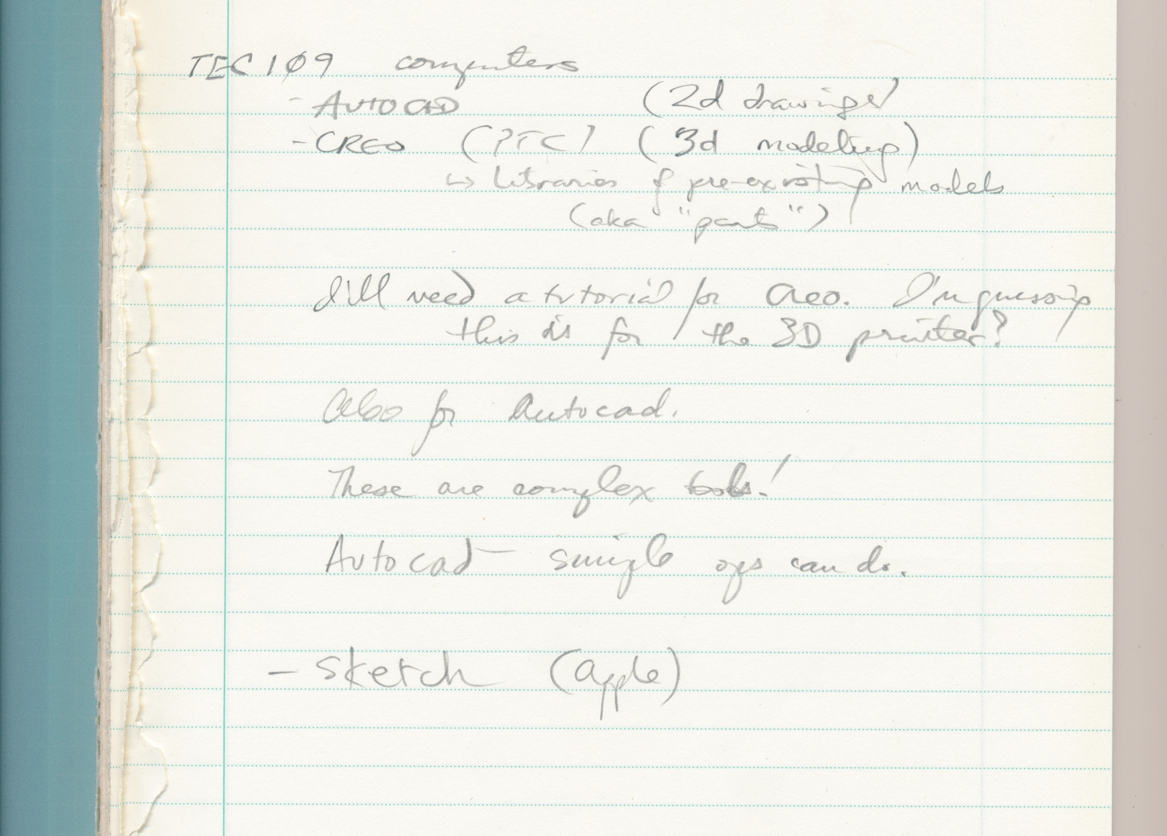
Visited TEC109 computer lab. AutoCAD, Creo (3d) and Apple Sketch all played with. Of course there is Google Sketch too. There’s a lot to be learned here, but maybe best to start with more ideas and actually making things. I did learn to use their scanner:

Not totally relevant but I went to mow the grass and the mower seized (it’d done so last time but freed up). Thanks to Will’s gift of good tools plus my good reorganization of the tools I have I tore the thing down and now have the motor (which is also hanging) to be blown out at HackerLab. Having tools and capabilities is in itself good and I’ve enjoyed simply using and contemplating them.
11/5/2019
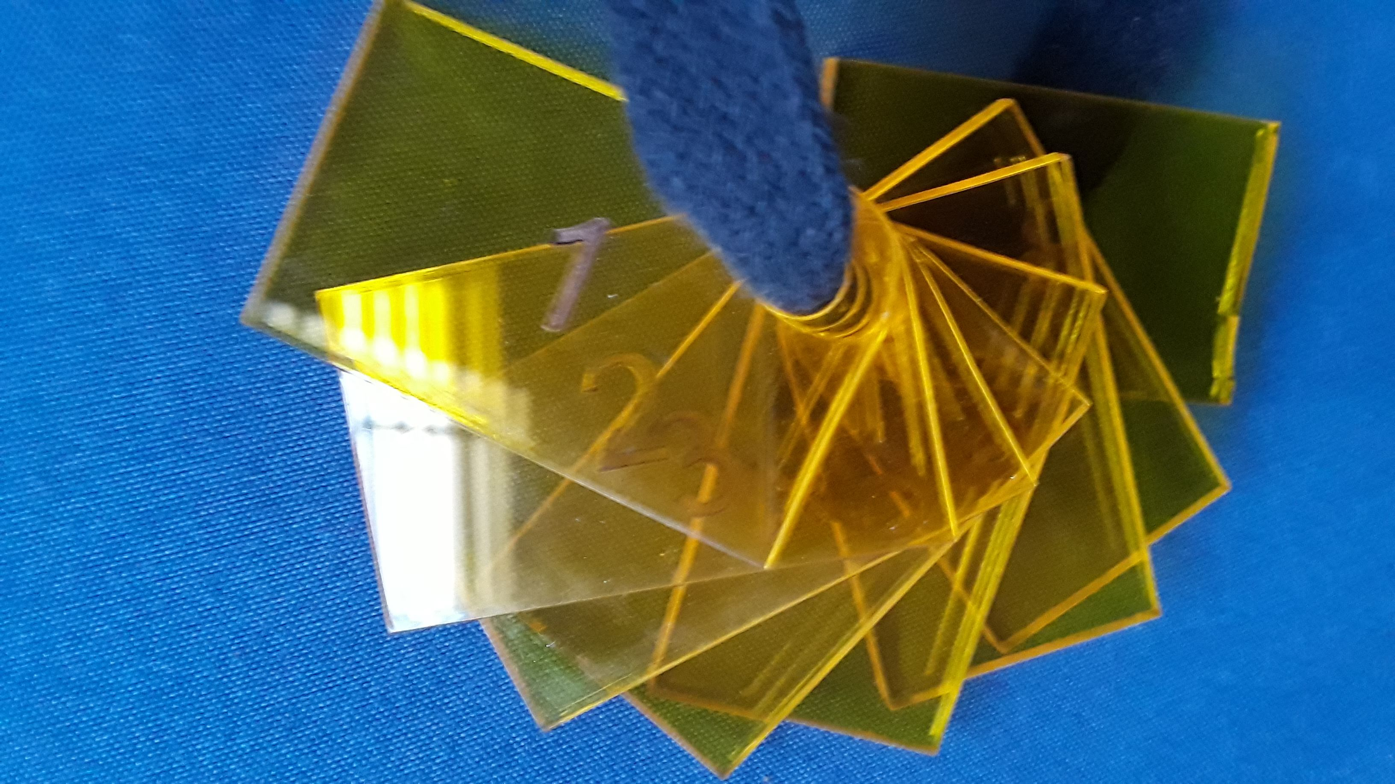
Made plastic numbered tags for lap counter. Thinking of other possibilities: maybe some flippable cards, one for one 50-yard lap (flip twice=100yards) and others to count in binary, in some fashion that would require but one flip per increment. I know binary well and could do it although it’s sort of silly.
For now, the floats on the lane separator ropes works fine as long as my neighbor isn’t using it.
Went to the CNC router class today. It’s a multi-session class. I will download the software, Autodesk Fusion 360, and play with it.

11/15/2019
Learned to use 3D printer.
11/16/2019
Here’s my rev 0 swimming lap counter prototype. It’s a plastic food container cut in half, a chopstick, and packaging tape, plus my tabs. Thanks to my loving spouse Laura for advice.
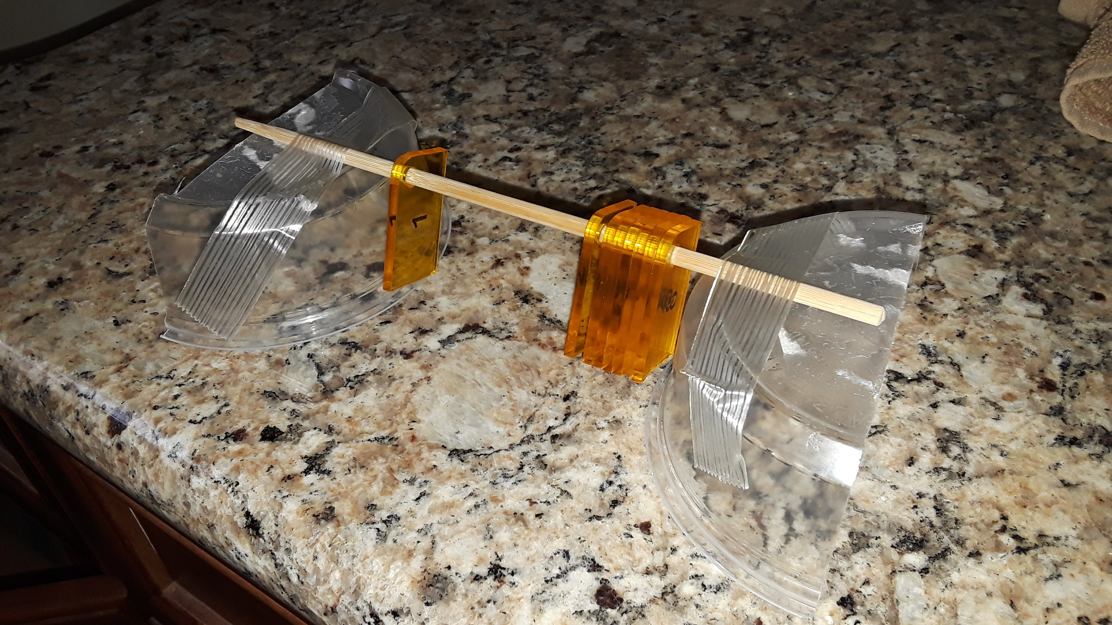
It is light and, with some difficulty, can be dis- and reassembled.
It’s cheap.
It will be difficult to use, I think. I will test it next week in the pool. Things to look for:
- Too lightweight?
- Tabs too small?
- Do numbers matter? I added them just for fun – the laser cutter etched them nicely. But I can count tabs easily.
- Make them different colors for increments.

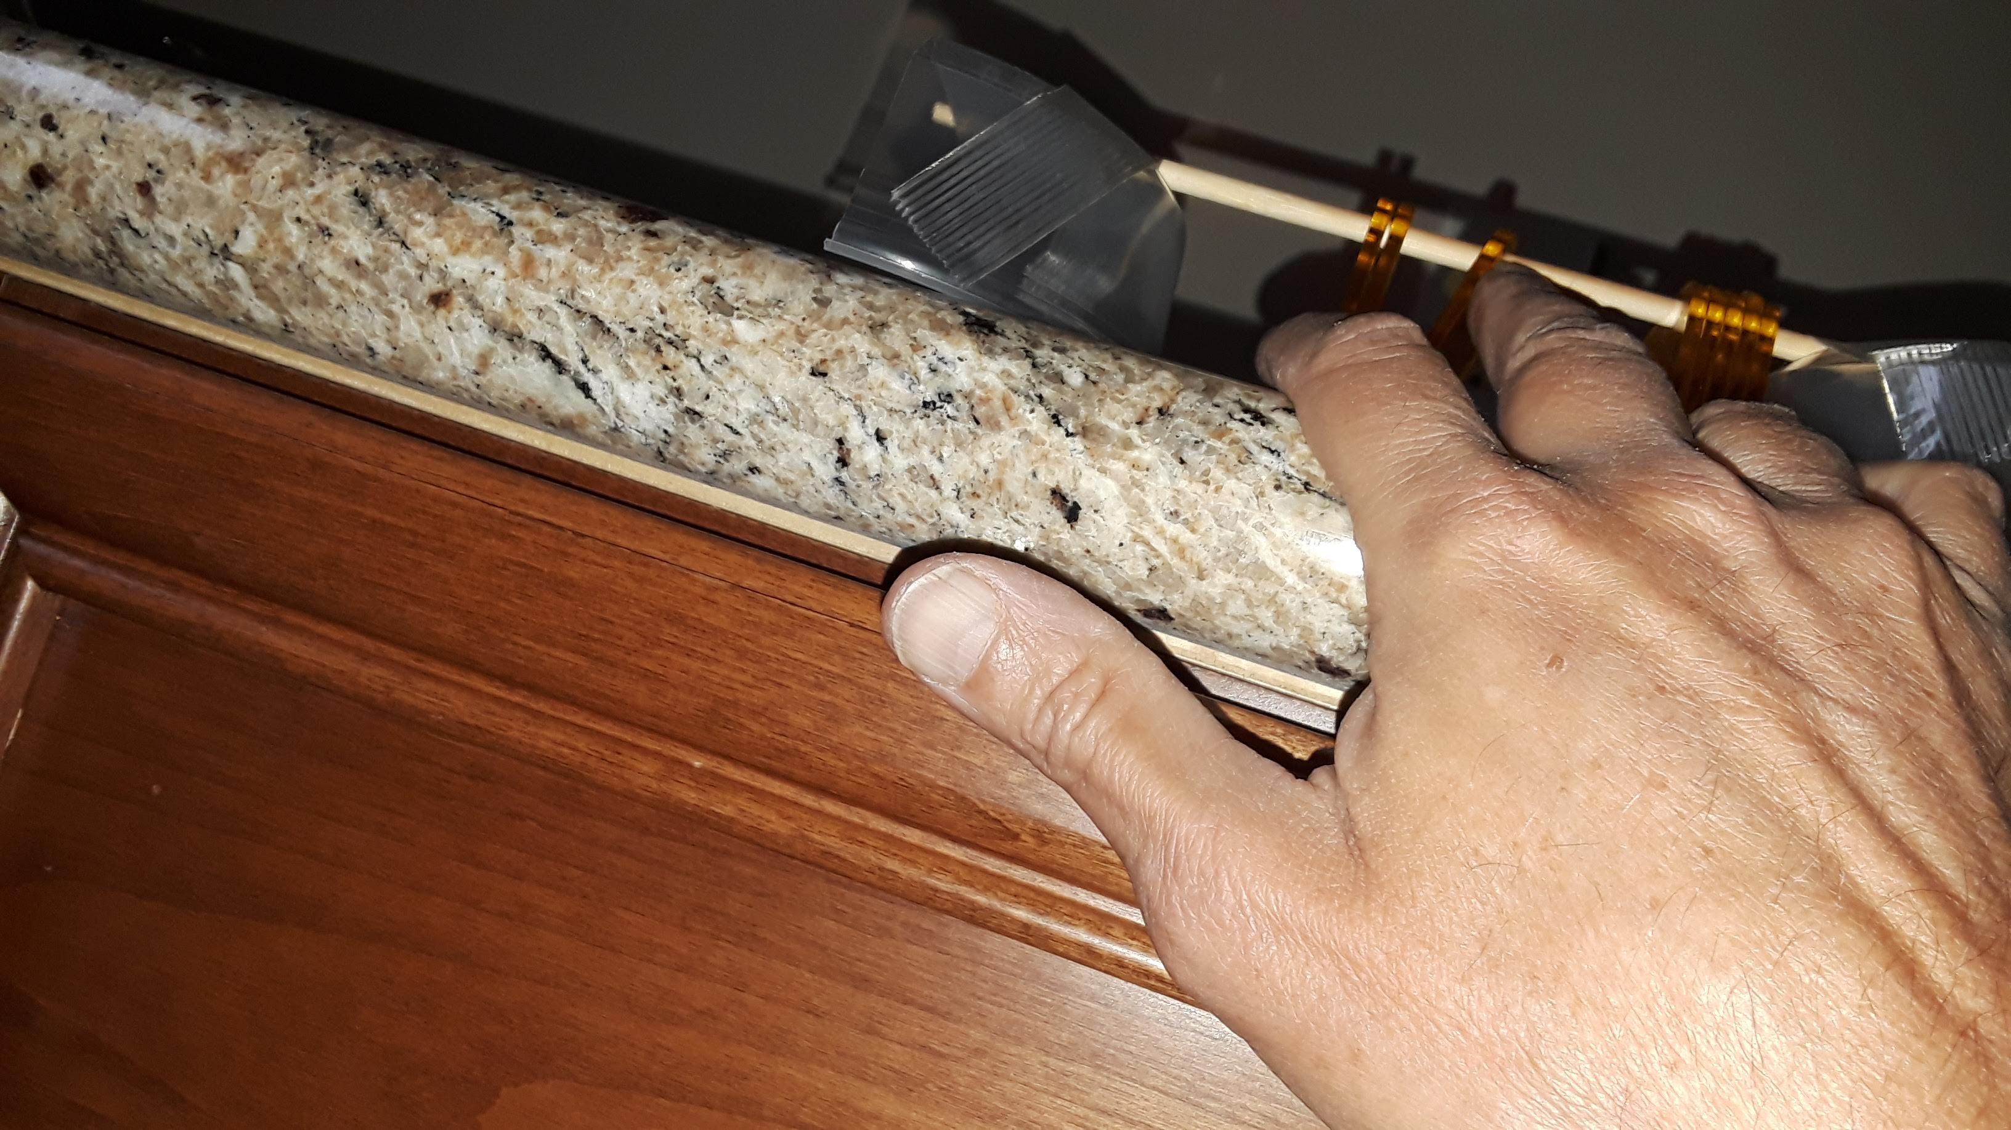
This is what it might be like to flip the counters from in the pool. It sits on the pool deck and I’d be below the deck in the water. Look how hard it is to reach, and how unstable it may be, and how small the tabs are, making it necessary to fiddle with them.

Instead, may want to make the tabs big. I can cut larger tabs and a larger food container and try this, but first let’s try it in the pool next week.

