Job and task cards
All workers and jobs here are made up.
Shop | Store | Garden
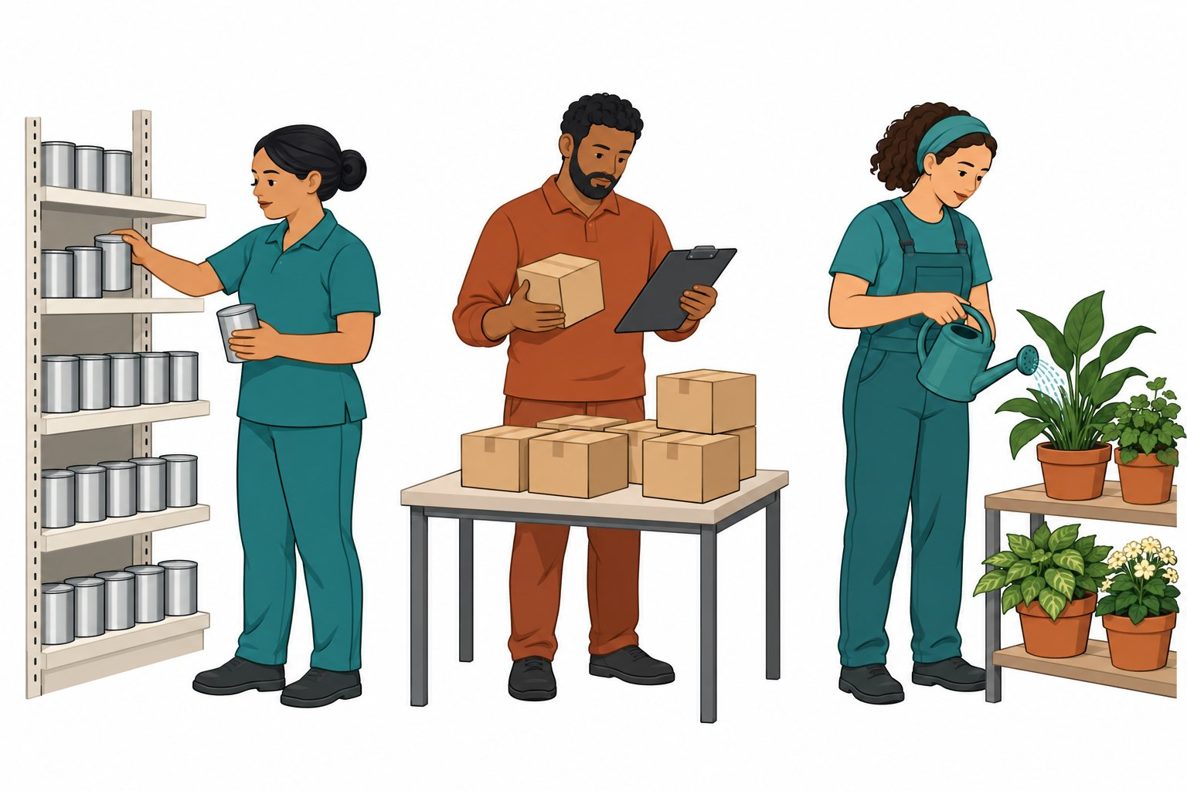
Shop: put tins on a shelf. Help shoppers find a tin.
Store: check boxes on a list. Put boxes in safe rows.
Garden: give water to pots. Pull weeds from plant beds.
These are the roles for this task. Jobs can share skills.

Cut and match
Read the cards or ask for help.
Card | Card
A  Put tins on the shelf. | B  Help a shopper find a tin.
C  Check boxes on a list. | D  Put boxes in a safe row.
E  Give water to pots. | F  Pull weeds from a bed.
Shop · Store · Garden

Choose a role
Pick two roles. Match a task to each.
Role | Task
________________ | ________________
________________ | ________________
Choose one role to look at. Say why.
I chose the ______ role.
The task is ______.
My reason is ______.
A job can use more than one skill.
Which skill could two roles share?
Help: Please read the words. Show the step. Give me time.

