Picture steps for a paper pack
This is a made-up job. Use paper cards only.
Cut out the two picture cards. Which comes first?
Card A | Card B
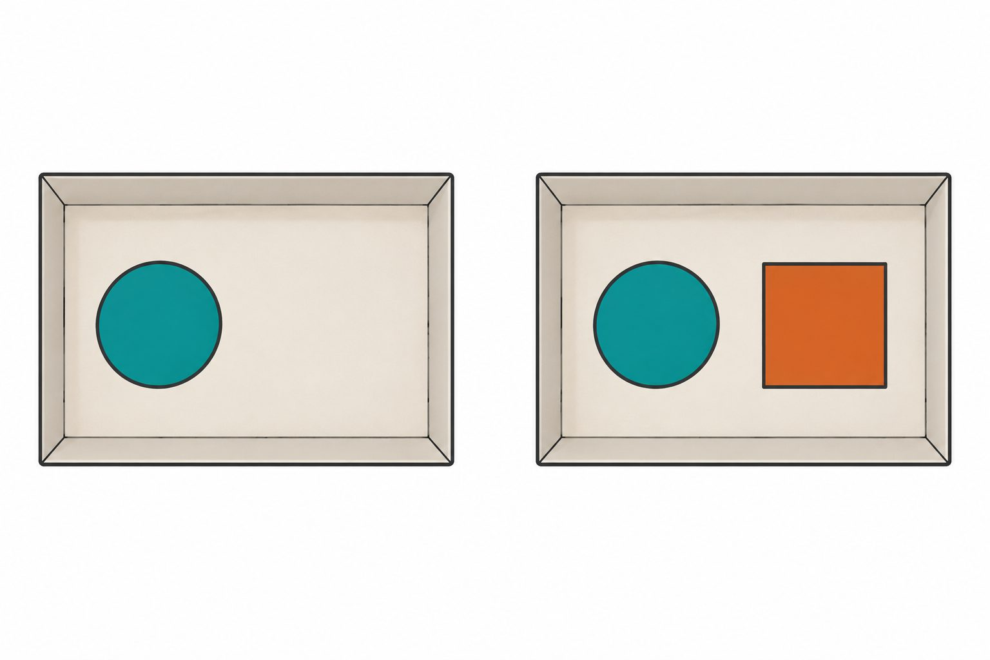
Put one square next to the circle. | Put one circle in the tray.
Put the cards in order on the mat on page 3. Then pack the set.
The shape and number matter. The colour does not.

Paper tray and shape cards
Keep the tray whole. Put the shape cards inside it.
Packing tray
Shape cards to cut. There is one spare square.
Circle | Square | Spare square
● | ■ | ■
Compare the packed set with the last picture. What is the same? What needs to change?

Step order and check
Place the two picture cards in order.
First | Next
Check the final pack
Check | Result or work reference
One circle | ________________
One square next to it | ________________
Any change made | ________________
Extra check C: a mock pack has one circle and two squares. What needs to change?
Extra check D: a mock pack has one circle and no square. What needs to change?

