Feelings in made-up stories
Every person and family in these stories is made up.
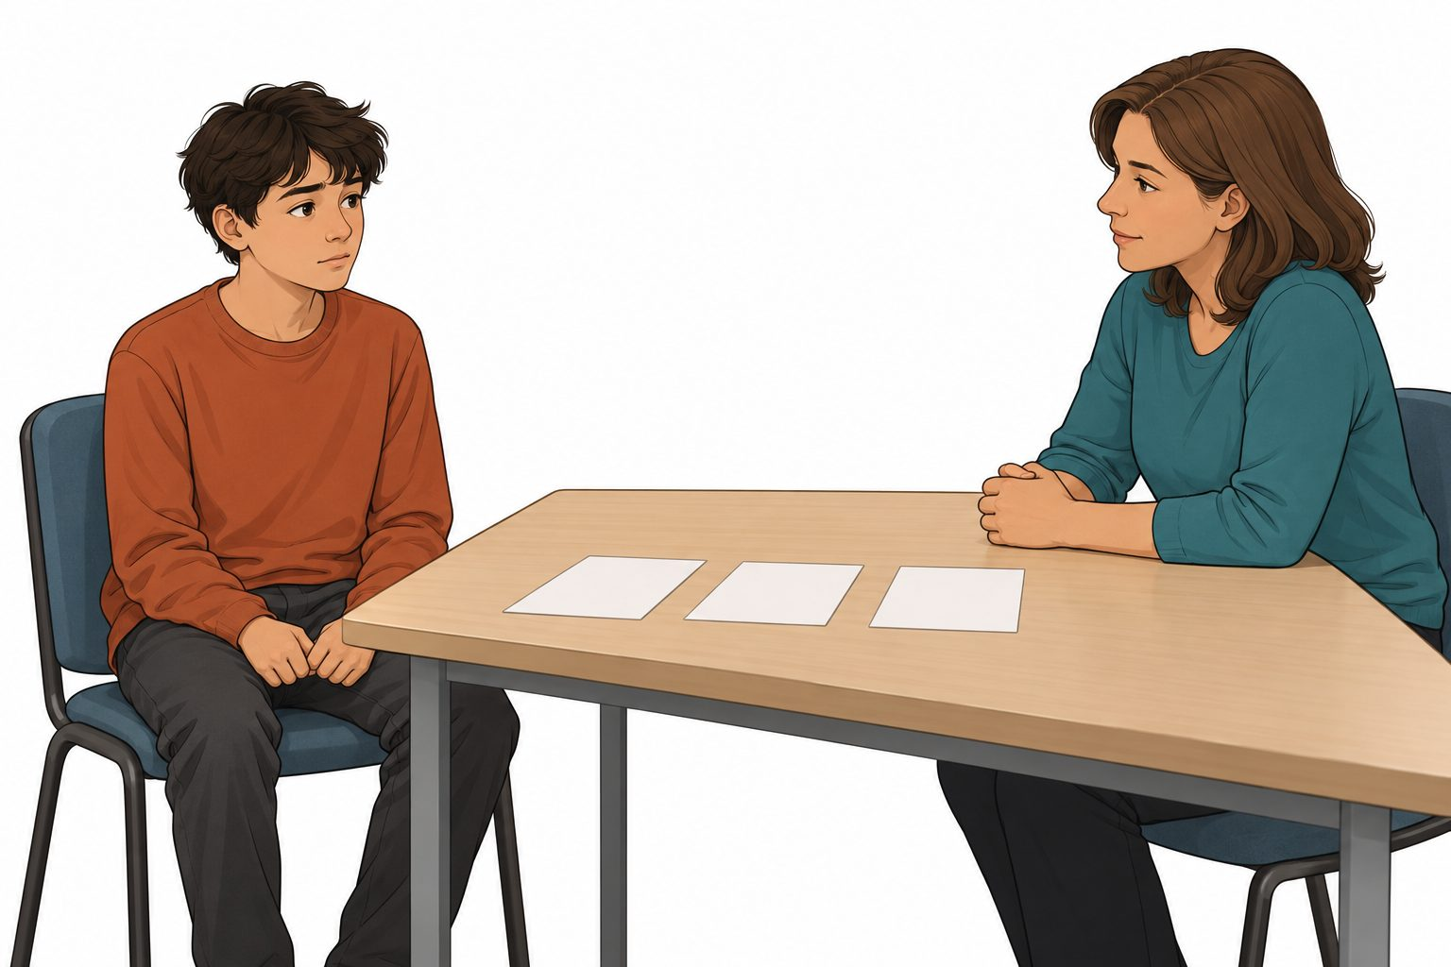
The story says the young person’s hands feel tight. The task feels hard to start. The person could ask for a pause or help.
A picture cannot prove a feeling. Different people may feel different things.

Cards for the fictional case
Story | Story
A. A young person says a task feels too much. Their hands feel tight. | B. A young person does not know the next step. Their shoulders feel tight.
C. A young person says they feel at ease. Their hands rest loosely. | D. A young person will try a new game. Their heart beats fast.
Choice cards to cut
Feeling words | Helpful acts
Calm or at ease | Pause for a short time
Tense or worried | Ask what the next step is
Unsure | Ask a trusted adult for help
Excited | Carry on if the person wants to
Which clue is in the story? Which act could help? Why?

A response to each story
Two stories. Two possible responses. A clue is a sign, not proof.
Case field | First story | Second story
Story card | ________ | ________
Possible feeling | ________ | ________
Clue stated in the story | ________ | ________
Helpful act | ________ | ________
Reason from the story | ________ | ________
If a young person still needs help, another trusted adult could help.
What could the young person do if the first adult is busy?
________________________________________________
E. A young person asks to pause. An adult gives time and checks what help is wanted.
F. A young person still needs help. The first adult is busy.
Every answer is about the made-up young person.

