Ask first and respect the reply
The diagrams and stories are not real people.
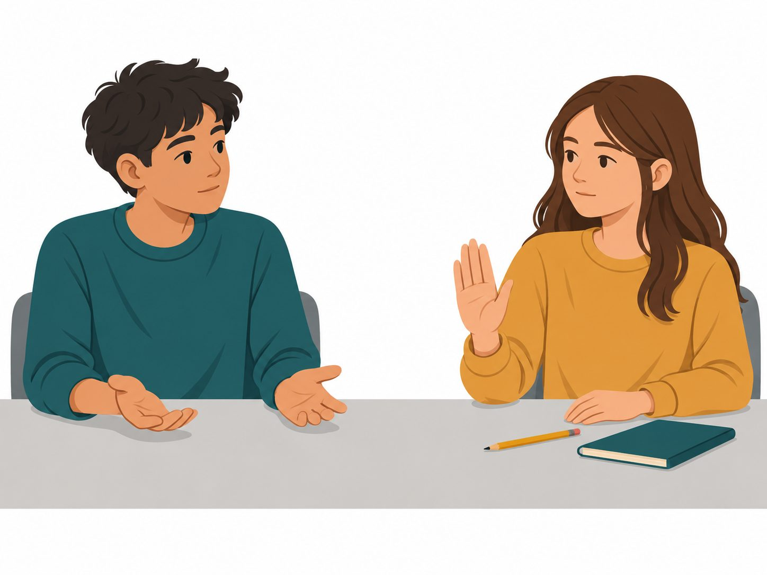
One young person wants to borrow the pencil. The other person says no in this story.
What could the first person ask? What should happen after no?
A request to choose | Another choice
Could the young person borrow the pencil for the task? | The young person will take the pencil now.

Cards for the fictional case
What should happen in each story? All the people are made up.
Story card | Story card
A. A young person wants to borrow a pen for a task. The owner says no. | B. A young person asks to sit nearby. The other person says they are not sure.
C. A young person agrees to have help with a model. Then they ask for the help to stop. | D. A young person offers help with a bag. There is no clear reply.
E. A young person asks to borrow a pen for one task. The owner freely points to yes on their aid. | F. A young person says no to lending an item. The other person keeps asking for a yes.
A choice can be spoken, pointed to, drawn or written. An adult can read the card.

A response for the fictional person
Request card | Request card
Could the person sit nearby? | Would the person like help with the bag?
Could the person borrow the pen for the task? | The person will take it without asking.
Reply | Respectful next step
No | Leave it or give space
Not sure or no clear reply | Wait and check
Stop or a changed mind | Stop the action
Request for the made-up young person
________________________________________________
Two different story choices
Record | First story | Second story
Story card | ________ | ________
Action chosen
Reason from the story
Every answer is about the made-up young person.

