Visual step cards
Autumn 2 · Week 2 · Lesson 1 · Monday 9 November 2026
I can learn a four-beat part and repeat it with a steady pulse.
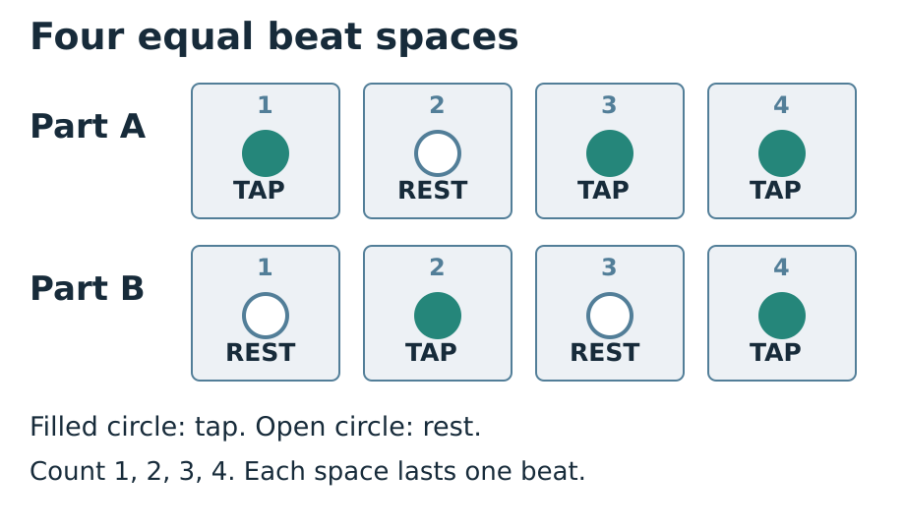
1. Read: Point to four boxes. Read TAP, REST, TAP, TAP.
2. Count: Wait for 1, 2, 3, 4. Start on the next 1.
3. Play: Play part A twice. Give each box one full beat.
4. Check: Hear one useful comment. Choose a next step and try again.
You can tap softly, point, sign, speak, draw or write. Ask for a pause or a quiet space. Follow the stop cue.

Words for our group piece
Autumn 2 · Week 2 · Lesson 1 · Monday 9 November 2026

pulse
Even beats that keep the music moving.

part
The pattern one player or group follows.

rest
One beat with no sound. Keep counting.

count-in
A count before we start together.

Words for my record
My part is ___ on beats ___.
________________________________________________________________
I kept the rest by ___.
________________________________________________________________
The listener noticed ___.
________________________________________________________________
Picture colours: navy headings; blue outlines and beat numbers; teal TAP circles; white REST circles and paper; grey beat spaces; red STOP reminder. Logo: navy background, mint green ring, cream M, amber star, black corners. Words, numbers and shapes give the meaning.

Knowledge organiser
Autumn 2 · Week 2 · Lesson 1 · Monday 9 November 2026
I can learn a four-beat part and repeat it with a steady pulse.
I can follow the count-in and start on beat 1.
I can keep each rest as long as a tap.
I can repeat my part twice without speeding up.
pulse — Even beats that keep the music moving.
part — The pattern one player or group follows.
rest — One beat with no sound. Keep counting.
count-in — A count before we start together.
Count every rest for one full beat. Watch the count-in and stop signal.
Picture colours: navy headings; blue outlines and beat numbers; teal TAP circles; white REST circles and paper; grey beat spaces; red STOP reminder. Logo: navy background, mint green ring, cream M, amber star, black corners. Words, numbers and shapes give the meaning.
My record: A_Take_Part.pdf · page 1 · Week 2 practice record

Read the part, keep the space
Autumn 2 · Week 2 · Lesson 1 · Monday 9 November 2026
Each box has one equal beat. Keep the silence as long as a tap.
Part A: 1 TAP · 2 REST · 3 TAP · 4 TAP.
Count-in: 1, 2, 3, 4. Start on the next 1.
Play A twice. Point through the rest on beat 2.
Ask: Did the silence last one full beat? Try one useful change.
My check or next step
________________________________________________________________
________________________________________________________________

Supported route
Autumn 2 · Week 2 · Lesson 1 · Monday 9 November 2026

Recall
Show a soft tap, then stop on the cue.
Point across four beat boxes at an even pace.

In your book
1. Use part A: TAP REST TAP TAP. Point and say it first.
2. An adult points to the beat numbers while you count in.
3. Tap softly or point for two repeats. Keep the rest for one beat.
4. Choose a picture to show one thing that stayed in time.
5. Respond to one next step and try the part again.
My words or sketch
________________________________________________________________
________________________________________________________________
________________________________________________________________

Check before you finish
Where is the rest in part A?
When do you start after the count-in?
What did you change or keep after the comment?
You can tap softly, point, sign, speak, draw or write. Ask for a pause or a quiet space. Follow the stop cue.
Prompt used __________ Support given __________________

Independent route
Autumn 2 · Week 2 · Lesson 1 · Monday 9 November 2026

Recall
Show a soft tap, then stop on the cue.
Point across four beat boxes at an even pace.

In your book
1. Read part A: TAP REST TAP TAP. Mark the rest in your book.
2. Wait for a four-count count-in, then start on the next 1.
3. Play two repeats while the pulse keeper points silently.
4. Ask a listener to check the rest and the repeat.
5. Note one next step, respond and replay with less help.
My words or sketch
________________________________________________________________
________________________________________________________________
________________________________________________________________

Check before you finish
Where is the rest in part A?
When do you start after the count-in?
What did you change or keep after the comment?
You can tap softly, point, sign, speak, draw or write. Ask for a pause or a quiet space. Follow the stop cue.
Prompt used __________ Support given __________________

Aspire route
Autumn 2 · Week 2 · Lesson 1 · Monday 9 November 2026

Recall
Show a soft tap, then stop on the cue.
Point across four beat boxes at an even pace.

In your book
1. Learn part A, then read part B: REST TAP REST TAP.
2. Explain where their rests and taps differ.
3. Rehearse either part for four repeats with a silent count-in.
4. Ask a listener to check whether the pulse stayed even.
5. Choose a change to your practice method and explain its effect.
My words or sketch
________________________________________________________________
________________________________________________________________
________________________________________________________________

Check before you finish
Where is the rest in part A?
When do you start after the count-in?
What did you change or keep after the comment?
You can tap softly, point, sign, speak, draw or write. Ask for a pause or a quiet space. Follow the stop cue.
Prompt used __________ Support given __________________

My part practice record
Autumn 2 · Week 2 · Lesson 1 · Monday 9 November 2026
Pupil code __________ Actual date __________
A_Take_Part.pdf · page 1 · Week 2 practice record
Show your four beat boxes and mark each TAP or REST
________________________________________________________________
________________________________________________________________
My part is ___.
________________________________________________________________
I kept the pulse by ___.
________________________________________________________________
The listener noticed ___.
________________________________________________________________
My next step was ___. On the next try ___.
________________________________________________________________
Pupil code __________ Actual date __________ Support used __________
An adult wrote my words: yes / no. I checked them: yes / not yet.
Record only what really happened. An adult may write your exact words and read them back.

Compare the two original parts
Autumn 2 · Week 2 · Lesson 1 · Monday 9 November 2026
Compare these two original class parts. They are teaching examples. Count each box for one equal beat. A: TAP REST TAP TAP. B: REST TAP REST TAP.
Both parts use ___ equal beats.
________________________________________________________________
The rest is on beat ___ in part A and beats ___ in part B.
________________________________________________________________
When both parts play, we tap together on beat ___.
________________________________________________________________
I can keep my part by ___.
________________________________________________________________
These are original class patterns. They are not works by named artists and do not count as an artist encounter. Compare what you can hear or show; do not invent a performance record.

My short book tasks
Autumn 2 · Week 2 · Lesson 1 · Monday 9 November 2026

Look back
Show a soft tap, then stop on the cue.
________________________________________________________________
Point across four beat boxes at an even pace.
________________________________________________________________
What could you do during a silent beat?
________________________________________________________________
Choose a comfortable way to join today.
________________________________________________________________

Look and choose
Read A: TAP REST TAP TAP. Read B: REST TAP REST TAP. Which part has just one rest?
My choice and reason
________________________________________________________________

At the end
Where is the rest in part A?
When do you start after the count-in?
What did you change or keep after the comment?
My next step
________________________________________________________________
Respond in the same colour, on the same page or usual mode.

TA brief
Autumn 2 · Week 2 · Lesson 1 · Monday 9 November 2026
GROW uses Independent as the starting route. Offer Supported and optional Aspire without changing the weekly outcome. Use a pair and a trio for five learners; rotate player, pulse keeper and listener so every pupil learns a part and has a personal record. Agree a quiet stop cue. Model following one instruction at a time: look, wait, play, stop. Quiet finger taps, silent pointing or signs are valid access modes; offer a quiet space and a pause. Do not require solos or a public audience. Scribe exact words or confirmed choices, read them back and allow corrections. Plan in any language before sharing in the chosen mode. Give one precise success and one NS next step. The pupil responds in the same colour, on the same page or usual mode, then tries the part again. Record R only when Voice and Audience are present, one NS has been set and the pupil has responded. Use VF / WS / I / NS / // / ? / E / R accurately.

Prompt ladder
1. Point to the relevant place or instruction.
2. Ask one short question.
3. Rephrase the instruction.
4. Provide a scaffold or a choice.
5. Model the first step only, then return the task.

Focus through the lesson
I do: Track eyes or pointer across all four boxes. Check access and stop cue.
We do: Observe whether rest 2 takes a full beat; point without playing over the pupil.
Independent: Record one individual attempt and actual prompt. Return the next action to the pupil after support.

One end question
How did you keep the rest in time when you repeated your part?
Give one next step. Respond in the same colour, on the same page or usual mode. Record R only after Voice and Audience are present, one NS is set, and the pupil responds.

Staff answers and checks
Autumn 2 · Week 2 · Lesson 1 · Monday 9 November 2026

Arrival
Soft action stops on the agreed visual cue; teach the cue if it is new.
Four equally spaced points; avoid rushing the final box.
Keep a small silent movement, point or count in the mind. A rest still has length.
Accept quiet tap, silent point, sign or directing a partner; check the pupil retains the musical choice.

Starter
A has one rest, on beat 2. B has two rests, on beats 1 and 3. In both parts every silent beat lasts as long as a tapped beat. Point through all four boxes to check.

Guided practice
Start after the count-in. Taps occur on 1, 3 and 4; beat 2 is silent for the same length. The next cycle begins one beat after beat 4. Accept a steady silent performance with accurate pointing.

Exit
Beat 2. It takes one full beat.
On the next beat 1 after the count-in finishes.
A specific actual response, such as following the pointer through rest 2, plus a further attempt. Do not fill a response for the pupil.
Accept pointing, quiet movement, speech, signs, drawing and checked scribing. Check the actual beat positions and part; participation alone does not show that a pulse or part was learnt.

