Our invented workplace and order
An invented small business prepares simple paper packs for customers. It has a supervisor, a preparer and a checker. It has no name, real employer, location or contact details. This is classroom simulation only.
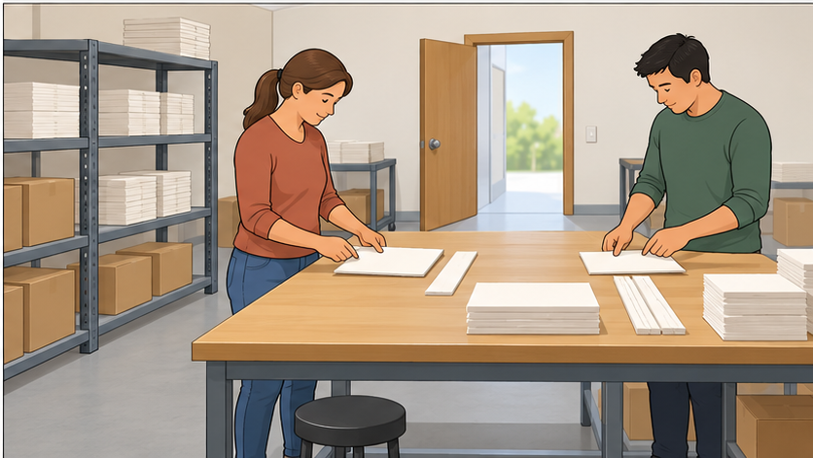

The order
Prepare two paper packs. Each pack needs one large card and one paper strip. Put the items beside each other. Check both packs against this order. Tell the checker when they are ready.

Roles for this task
Reader is the checker: read the order, then one numbered step aloud. Maker is the preparer: check meaning and do it. Both keep the written steps visible. Reset and swap; an adult can partner.
Use ready-cut paper only. No scissors, staplers, machines, food, money, customer data, live orders or deliveries. Accuracy, communication and support matter; speed is not assessed.

Written and spoken assembly steps
Make two paper packs. Use two large cards and two paper strips. No tools are needed.

Step 1
Place two large cards side by side.

Step 2
Put one paper strip beside each card, not on top.

Step 3
Check: each pack has one card and one strip.

Step 4
Tell the reader what is ready or needs a check.

Help if a step is unclear
If a step is unclear, pause. Re-read or ask the reader or adult to explain the step. Check the meaning before doing it.

Reader
Read the order, then one numbered step aloud. Wait for the maker to say or show the meaning. Re-read or use the agreed help if needed.

Maker
Keep the written steps visible. Say or show what the step means, ask if unclear, then do the step. Use your usual aid.

Check and swap
Together compare both packs with the written order. State any unfinished step honestly. Reset the same materials and swap reader and maker for round two. Each learner has their own record. An adult can take the other role.
Round 1: lesson 23–29 minutes. Round 2: 29–35 minutes. This is a guide, not a race. Pause or reduce repeats for access; record actual turns.

What makes an instruction clear
Use these six checks on the whole card, including the header and help line.
Check | Question
Goal | Does it say what to make?
Parts | Does it list what is needed?
Order | Are the steps numbered, with one main action at a time?
Exact words | Are the number and place clear?
Finish check | Does it say how to check the result?
Help | Does it say what to do if a step is unclear?
Choose Clear; Needs a change; Not checked yet. Keep your own judgement and one useful improvement in your book or Type instead.

Invented model
Unclear: “Put stuff there quickly.” Clearer: “Put one paper strip beside each large card.” The clearer line says what, how many and where. This is a model, not your completed checklist.

Short reflection
When I didn't understand I… Or use: Nothing was unclear today; a check that helped was… / I did not try this part yet; the help I need is…

Private help
Trusted adult or school help route. Point to HELP or ask privately. Use your usual aid; pass, pause and supported return are available.

