Our invented workplace and actual work
An invented small business prepares simple paper packs for customers. It has a supervisor, a preparer and a checker. It has no name, real employer, location or contact details. This is classroom simulation only.
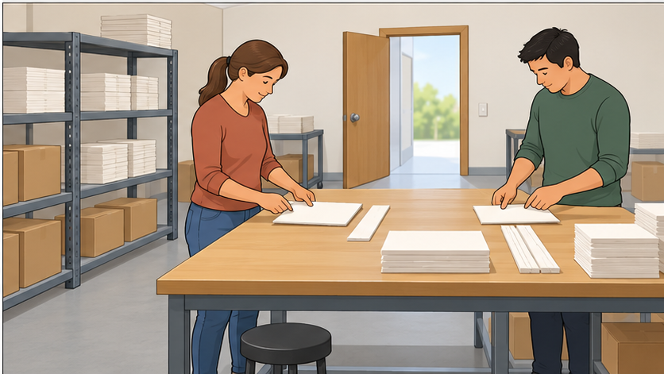

Use actual activity
Use the actual half-term workplace activity: the invented classroom simulation, or a real placement if one happened. Record actual activity date, task, role, mode and work reference. No employer, person or place names. Do not invent a placement or completed task. If no activity was completed, mark that and agree a supported follow-up; do not use a model as your own evidence.

Keep your own evidence
Find your books or saved work. Choose one actual item to start. The picture is context for the invented workplace; it is not proof you did a task. Mark any missing item and ask for supported follow-up. No new practical task is needed.

Four reflection cards

What I did
What task or role did I actually try? What work shows it?

What I learned
What did I learn from doing or checking the task?

What I would do differently
What would I change next time, and what help would be useful?

Which expectations I met
Which expectation fits my evidence? Keep any gap visible.

Portfolio items to find
Week | Actual work to look for
1 | Five-expectation self-assessment
2 | Risk-and-control card and report
3 | Actual task log, handover and reflection
4 | Reader/maker record, instruction checklist and reflection
5 | Customer-service checklist, actual roles and reflection
6 | Structured reflection, learner self-assessment and teacher review
Find your actual work or record a missing item; do not recreate it as if it happened. Use the four cards with your own work, not another learner’s response.

An invented reflection model
Invented example only, not learner evidence.

What the worker did
A worker read a step and checked one paper pack. The second pack still needed checking.

What the worker learned
Checking each pack against the order shows what is actually ready.

What the worker would change
Next time the worker will check or ask for help before calling the whole order complete.

Which expectations fit
Instructions and quality: one actual check. Asking for help with the next check is a planned next step, not yet observed evidence for Safety and help. Do not claim both packs were complete.
Only one check is stated. Asking for help is a proposed next step, not an observed action. The second item still needs a check. Do not copy this as your own experience.

Frames for your own work
I did… My evidence is…
I learned… because…
Next time I would… with…
This shows… The part not seen yet is…

Private help
Trusted adult or school help route. Point to HELP or ask privately. Use voice, usual aid, writing or exact scribe; read back and correct. Pass, pause and return with support. No personal employment story is needed.

