Teacher and cover guide
Week 7 Lesson 1 • 14–18 December 2026 • 40 minutes

Choose what you will share
[AWARD] [QUAL] route • Part D Share
I can choose what I enjoyed and what I learnt to do.
Part D preparation only. Look back at actual A–C records, select personal enjoyment and achievement, and plan communication for the owner’s December share. The real event date and audience remain for owner confirmation. No completed share is inferred.

Timed flow
Minutes | Stage | Teacher action
0–5 | Arrival | Retrieve A–C records; each learner points to actual work and one choice.
5–8 | Starter | Compare a bare object label with an account of enjoyment and learning.
8–14 | I do | Use the four-stage 60-second model, then revisit steps and four words.
14–22 | We do | Match enjoyment, learning and real examples on the labelled class model.
22–37 | You do | 22–28 choose; 28–34 form the own account and audience plan; 34–37 check/save/tidy.
37–40 | Exit | Ask the end question of each learner and locate D page 1.

Teaching both groups
One BUILD-band lesson serves BUILD and GROW. GROW starts with Independent. Supported offers scaffolds and Aspire optional depth. Use a pair and a trio, retaining each learner’s own choice and record. A trusted adult can be the practice listener. No forced public performance or recording.

Kit and room set up
Quantities for five learners and the adult model.
Item | Quantity
Existing individual A–C records and artworks | 5 sets; keep A and C objects distinct
D choice pages and Evidence Index | 5 D page 1 sheets; 5 existing indexes
ENJOY / LEARNT prompt cards | 5 pairs plus 1 adult model pair
Visual steps and word mats | 5 sets of each
Pencils and blank cue cards | 6 pencils; 15 cards
Class examples | 1 labelled colour sample and 1 paper relief sample
Sharing-mode choices | 5 sets: talk, sign, show, play a recording
School device if chosen | 1 device; work-only capture where permitted
Quiet work area | 1 private response space; 5 named trays

Before the lesson
Retrieve each learner’s existing A–C records and actual work before teaching. Check what is present and note any gaps without pre-judging a part. Set out five D page 1 sheets and prompt cards. Use a pair and a trio, with an individual choice for each pupil. Ask the owner for the intended December event date/audience; keep the planning field “to confirm” if unknown. Have a non-recorded route ready.

Save and tidy
Use minutes 34–37 to read choices back, check the learner agrees, and place the record on D page 1. Return each work to its own tray. Save only the selected records. Any separate audio or video will count towards the ten-file cap. Keep practice cue cards as class resources or combine their selected content into the existing D file.
Use work-only images when permitted. Follow school consent and device rules. No public upload, names in public files, cutting, heat or glue are needed for these lessons.

The sixty second demonstration
Point to the matching stage. The class example models the task; it is not pupil evidence.
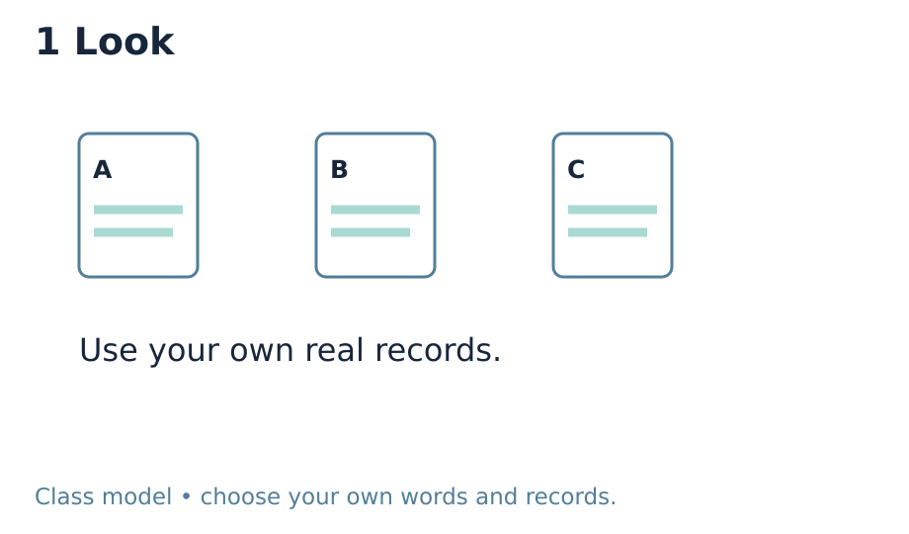 | 0–15 seconds Look  Point to the labelled class model and three example records. Say: “I look back. I use what is here. A gap stays a gap.” This is a made-up teaching example, not learner evidence.

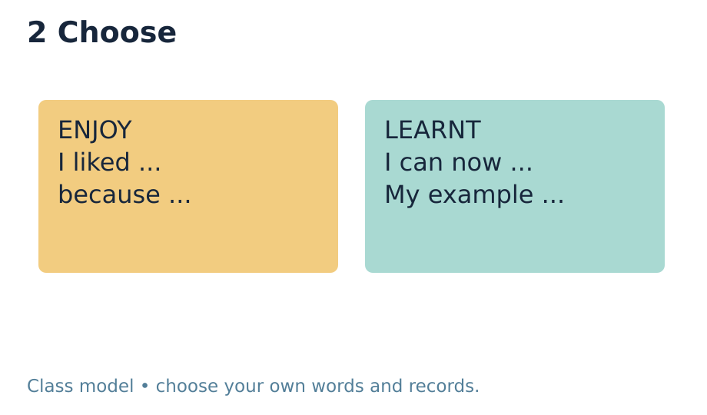 | 15–30 seconds Choose  Point to the colour sample. Say: “I enjoyed the colour test because I liked the new shades.” Place the ENJOY card beside it.

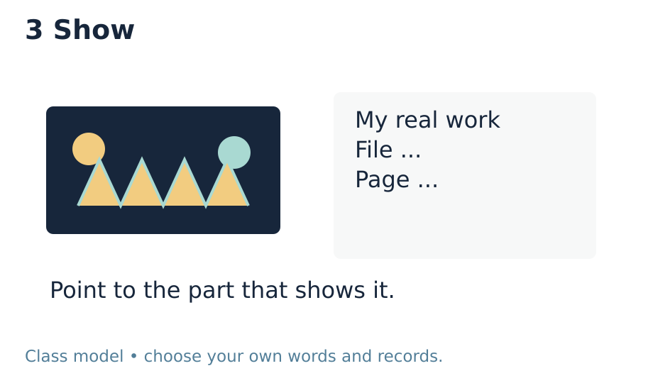 | 30–45 seconds Show  Point to the folded paper sample. Say: “I learnt to fix the tabs so the folds stand up.” Place the LEARNT card beside the join.

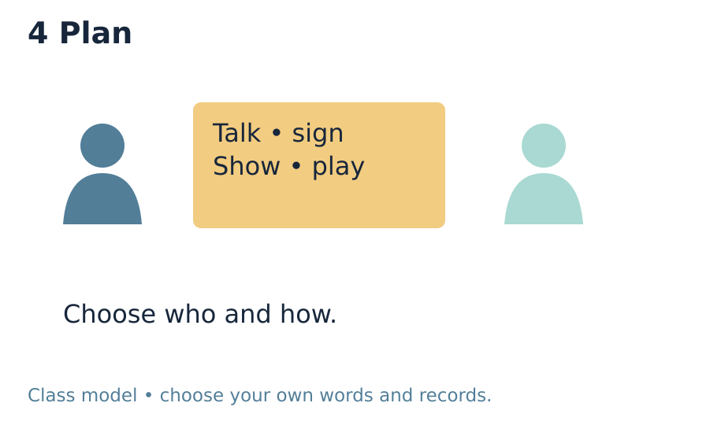 | 45–60 seconds Plan  Point to the audience and response-mode cards. Say: “I could show my work and use these words with one trusted adult.” Leave the event date unfilled until confirmed.

Check and respond
Common mistake | What to do
The pupil only names an object | Ask: “Which part did you like, and why?” Then ask what they learnt or achieved. A title alone does not communicate both.
An adult chooses the pupil’s view | Offer two real examples, wait, and ask for the pupil’s choice. Scribe exact words or confirmed choices and read them back. Do not supply a review.
A missing B experience is filled with a class model | Record the actual gap. Look back at available work without claiming an encounter. The model can explain the task but cannot become pupil evidence.

One question at the end
What did you enjoy, what did you learn, and where can you show it?

Evidence and part check
Part D is a personal account of enjoyment and achievement chosen by looking back at A–C. Keep both elements, pupil authorship, the example/file/page and intended audience/mode on D page 1. It is preparation, not proof of the actual December share. Mark absent B or C evidence as a gap in the Evidence Index; do not invent it. The actual sharing record belongs at D page 3 when it happens.
Selected evidence: D_Share.pdf • page 1. Read scribed words back. Record actual support and the learner’s response to feedback. Upload selected individual evidence to the evidence app the same day, labelled ART-BUILD-A2-W07-P1.
Use Pass / Attempted / Not attempted for each whole part only when assessed against real evidence. The sequence guide holds the final audit. The carried W5 encounter guide remains UNCONFIRMED; W7 does not create a booking or fill missing B evidence.

