Teacher and cover guide
Week 7 Lesson 2 • 14–18 December 2026 • 40 minutes

Rehearse and check your portfolio
[AWARD] [QUAL] route • Part D Share
I can practise my share and check that my records can be found.
Part D rehearsal plus portfolio completion audit. D page 2 records real practice and a response-led improvement. The index locates actual evidence and unresolved gaps. D page 3 stays for the actual December share; it is not completed by rehearsal.

Timed flow
Minutes | Stage | Teacher action
0–5 | Arrival | Retrieve D page 1; each pupil identifies enjoyment, achievement and real example.
5–8 | Starter | Distinguish rehearsal from actual sharing evidence.
8–14 | I do | Model the 60-second rehearsal/response/check sequence and four words.
14–22 | We do | 4 minutes practise the class model; 4 minutes open its index and count files.
22–37 | You do | 22–28 individual practice and response; 28–31 revise/retry; 31–34 audit files; 34–37 save and log gaps.
37–40 | Exit | Ask every learner the end question; confirm next actions and actual-share record is pending.

Teaching both groups
One BUILD-band lesson serves BUILD and GROW. GROW starts with Independent. Supported offers scaffolds and Aspire optional depth. Use a pair and a trio, retaining each learner’s own choice and record. A trusted adult can be the practice listener. No forced public performance or recording.

Kit and room set up
Quantities for five learners and the adult model.
Item | Quantity
D page 1 choices and actual work | 5 own sets; preserve the learner’s words
D rehearsal pages and index | 5 D page 2 sheets; 5 existing two-page indexes
Cue cards and word mats | 5 sets; 5 spare large-print cards
Model portfolio list | 1 set of five paper file cards and 2 optional clip cards
Pencils and response cards | 6 pencils; 5 “I heard / I saw” cards
School device and saved files | 1 or more authorised devices; check access before class
Work-only recording option | 1 device if chosen; no recording required
Private audience space | 1 quiet area and a trusted adult option
Storage and audit notes | 5 trays; 1 staff follow-up list

Before the lesson
Retrieve D page 1 choices, actual art and the existing five-file portfolio for each learner. Check devices can open PDFs and optional media. Label the session REHEARSAL. Set up pair/trio practice with rotating sharer, listener and pointer roles; each learner still needs an individual response and record. A quiet share with a trusted adult is valid practice. The owner’s December event date and actual audience remain to confirm.

Save and tidy
Use minutes 34–37 to save D page 2, locate each part in the index and record the actual file count. Put every unresolved gap on the staff action list with a named owner and review date. Close files and return art to trays. Keep originals until a merged copy has been checked; archive duplicates outside the submitted portfolio only with staff oversight. Do not delete evidence to reach ten.
Use work-only images when permitted. Follow school consent and device rules. No public upload, names in public files, cutting, heat or glue are needed for these lessons.

The sixty second demonstration
Point to the matching stage. The class example models the task; it is not pupil evidence.
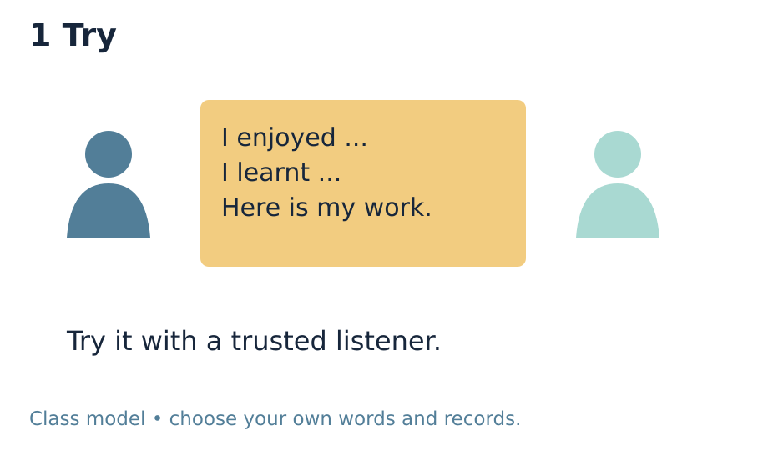 | 0–15 seconds Try  Use the class cue card. Say: “I liked the new shades. I learnt to fix tabs.” Point to the matching work. Tell pupils this is a practice model.

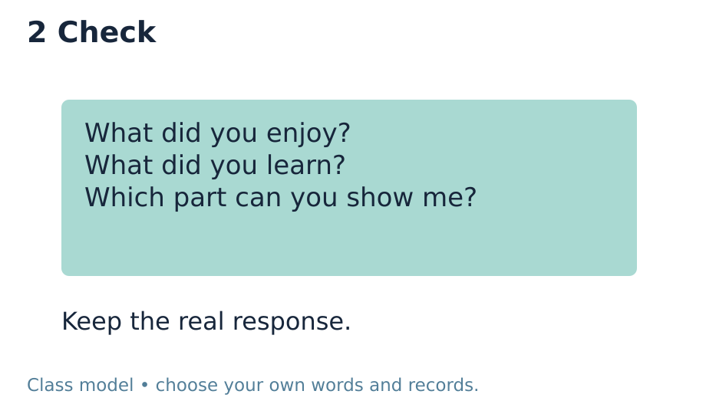 | 15–30 seconds Check  Ask the adult listener: “What did I enjoy and learn?” The listener says: “I heard the shades. Which bit is a tab?” This is a scripted model, not a pupil response.

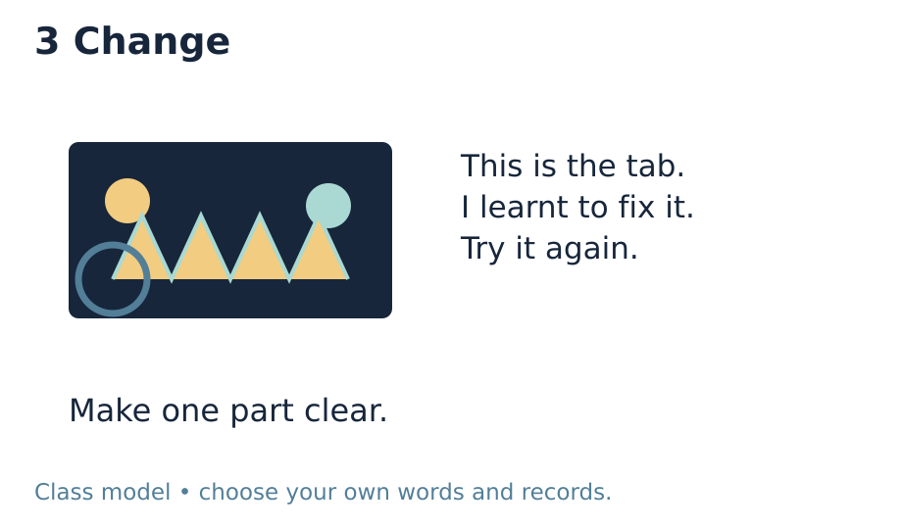 | 30–45 seconds Change  Point to the flat end of the strip. Say: “This is the tab I learnt to fix.” Try the short share again. Show how the audience response led to this change.

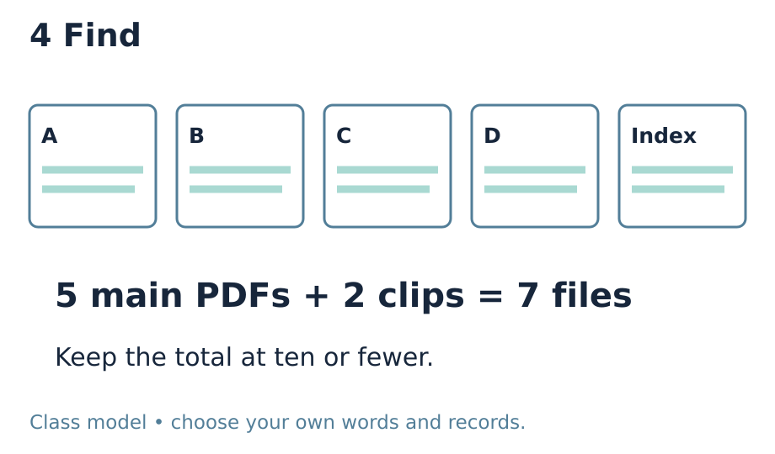 | 45–60 seconds Find  Open a sample index and the named page. Count five main files plus two optional clips: seven. Say: “I check that the page and clip open. A missing record stays a gap.”

Check and respond
Common mistake | What to do
Practice is recorded as the actual event | Label D page 2 rehearsal and record its actual date. Keep D page 3 for the real owner-confirmed share. A display or rehearsal alone does not prove D.
Ten files are mistaken for ten items of evidence | Count stored files, including the index and every separate clip, image or alternate version. Five cumulative PDFs leave at most five extra files. Use pages within the existing files; retain relevant evidence and log any gap.
A full checklist is treated as an automatic Pass | Open each cited file/page and check its contents. An adviser judges each whole part from real evidence. An unresolved B encounter or actual share remains unresolved.

One question at the end
What did your listener understand, and what still needs to be done?

Evidence and part check
D page 2 records the actual rehearsal, listener response, pupil’s chosen adjustment or reasoned retained feature, and another try. Audit A–D separately against the existing requirements. Use Evidence_Index pages 1–2 for verified file/page locators, real time totals, file count and gaps. Count the index among the five core PDFs and all separate media within ten. The actual December event must later record enjoyment and achievement, date, audience and receipt at D page 3. Do not prefill a part outcome.
Selected evidence: D_Share.pdf • page 2; Evidence_Index.pdf • pages 1–2. Read scribed words back. Record actual support and the learner’s response to feedback. Upload selected individual evidence to the evidence app the same day, labelled ART-BUILD-A2-W07-P2.
Use Pass / Attempted / Not attempted for each whole part only when assessed against real evidence. The sequence guide holds the final audit. The carried W5 encounter guide remains UNCONFIRMED; W7 does not create a booking or fill missing B evidence.

