Scene A The walking route
Invented paper-pack workplace. Look at the picture; do not act it out.
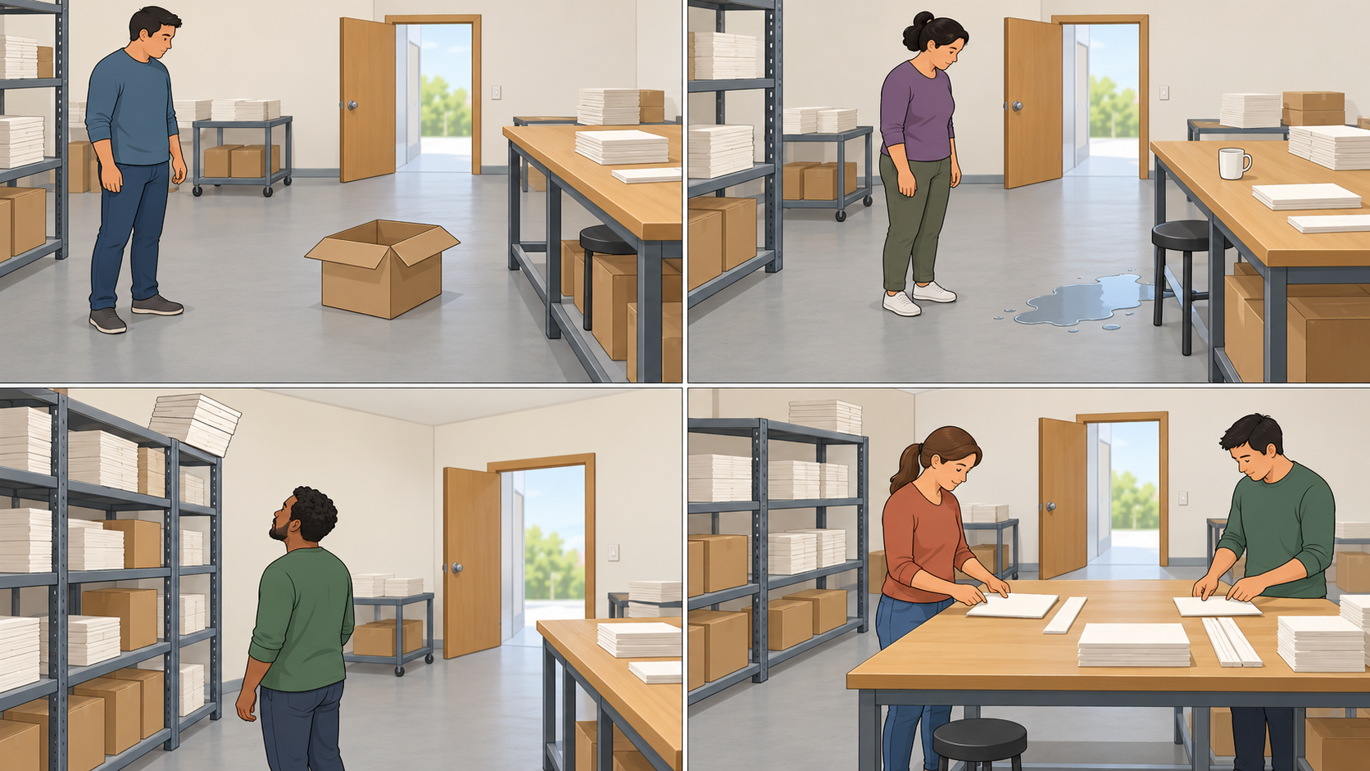

Notice and explain
What could cause harm? Who could be harmed and how? What should be kept clear or checked?

Report
“There is ... at ... . Someone could ... . I am keeping clear. Please check ... .” Tell the supervisor, played by an adult.
D is a comparison of controls, not proof of no risk. Other scenes have a main hazard; explain another visible concern if you notice one.

Scene B Beside the packing table
Invented paper-pack workplace. Look at the picture; do not act it out.

Notice and explain
What could cause harm? Who could be harmed and how? What should be kept clear or checked?

Report
“There is ... at ... . Someone could ... . I am keeping clear. Please check ... .” Tell the supervisor, played by an adult.
D is a comparison of controls, not proof of no risk. Other scenes have a main hazard; explain another visible concern if you notice one.

Scene C The high shelf
Invented paper-pack workplace. Look at the picture; do not act it out.

Notice and explain
What could cause harm? Who could be harmed and how? What should be kept clear or checked?

Report
“There is ... at ... . Someone could ... . I am keeping clear. Please check ... .” Tell the supervisor, played by an adult.
D is a comparison of controls, not proof of no risk. Other scenes have a main hazard; explain another visible concern if you notice one.

Scene D Controls in place
Invented paper-pack workplace. Look at the picture; do not act it out.

Notice and explain
What could cause harm? Who could be harmed and how? What should be kept clear or checked?

Report
“There is ... at ... . Someone could ... . I am keeping clear. Please check ... .” Tell the supervisor, played by an adult.
D is a comparison of controls, not proof of no risk. Other scenes have a main hazard; explain another visible concern if you notice one.

Safety sign shapes and words
Four common categories. Read shape, symbol and message together; colour is an extra clue.
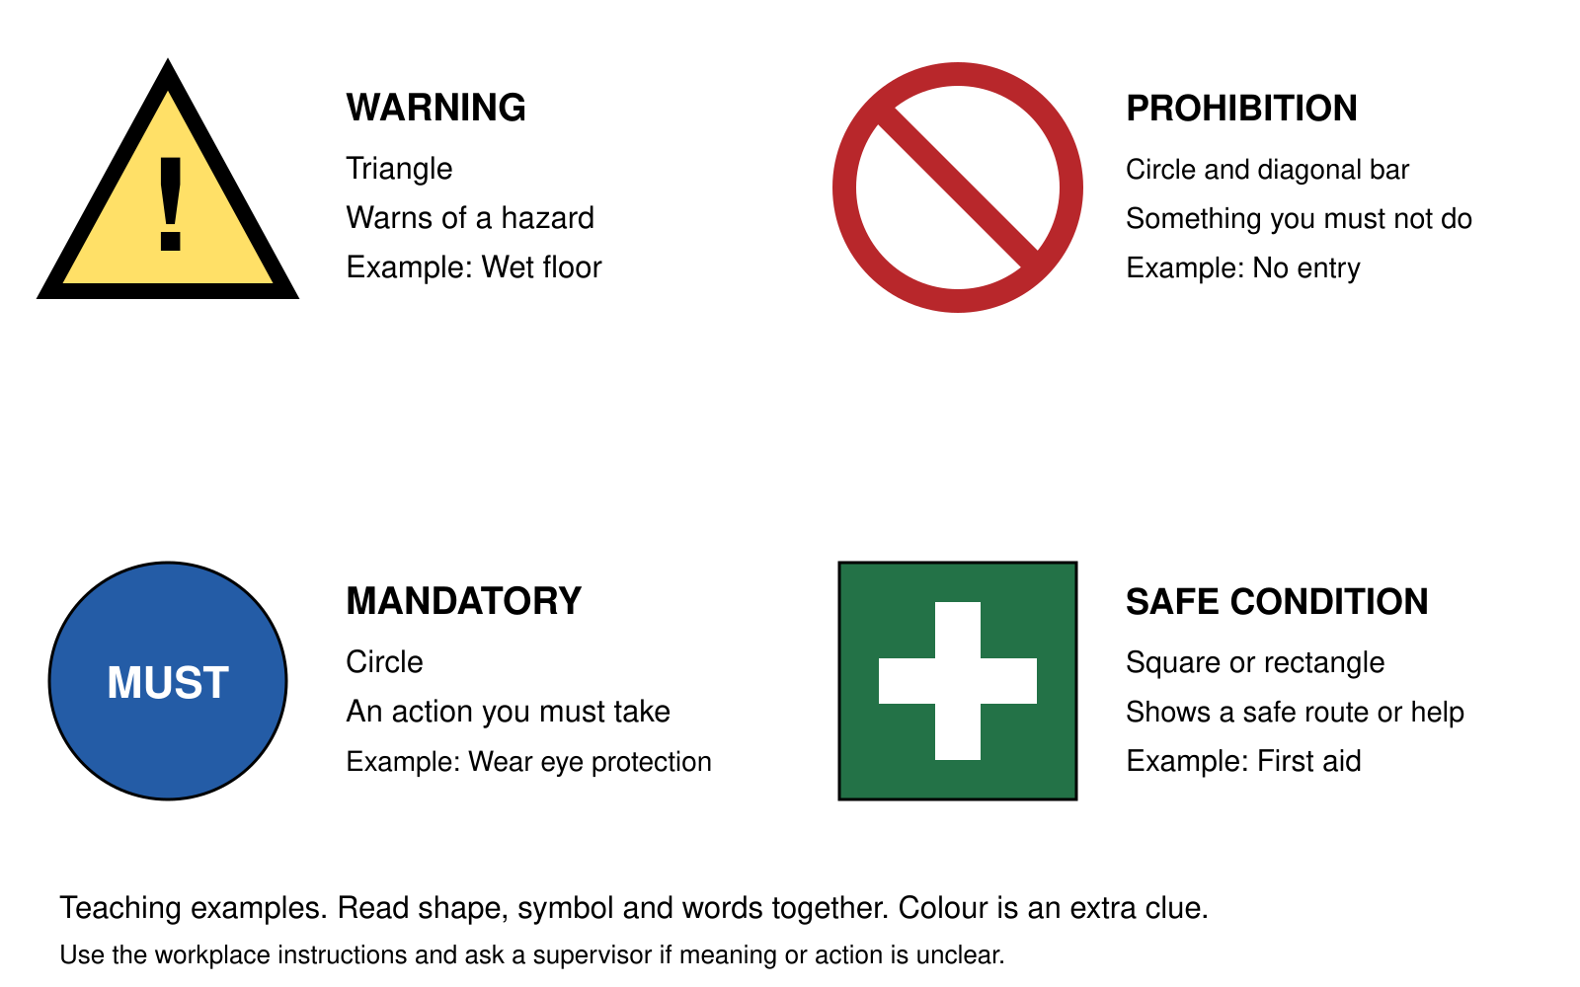
Type and shape | Meaning and example
Warning: Triangle | Warns of a hazard. Example: Wet floor.
Prohibition: Circle with a diagonal bar | Something you must not do. Example: No entry.
Mandatory: Circle | An action you must take. Example: Wear eye protection.
Safe condition: Square or rectangle | Shows a safe route or help. Example: First aid.
Simplified teaching examples, not signs for installation. Ask the supervisor if meaning or action is unclear. A warning does not remove a hazard. The eye-protection example does not add a PPE task to this lesson.

