Our invented workplace and order
An invented small business prepares simple paper packs for customers. It has a supervisor, a preparer and a checker. It has no name, real employer, location or contact details. This is classroom simulation only.
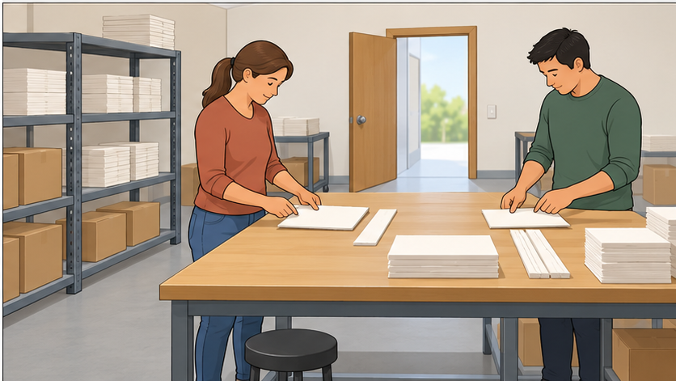

The order
Prepare two paper packs. Each pack needs one large card and one paper strip. Put the items beside each other. Check both packs against this order. Tell the checker when they are ready.

Roles and limits
The preparer arranges the materials. The checker reads the order and checks each pack. Agree roles, then swap after resetting the materials. An adult can take the other role if preferred.
Use ready-cut paper only. No scissors, staplers, machines, food, money, customer data, live orders or deliveries. Accuracy, communication and support matter; speed is not assessed.
Two classroom rounds reuse the materials. Keep actual progress; never call an unchecked pack ready.

Four task cards
Read one stage at a time. These cards guide the classroom simulation.

1 Set up
Read or hear the order. Check the two large cards and two strips, agreed space and roles. Ask if unsure.
Check: Preparer/checker roles agreed; written order and usual aid ready.

2 Make/check
Prepare two paper packs, each with one large card beside one strip. Check both against the order. Reset and swap roles for round two.
Check: Record what was actually prepared or checked; unfinished work stays visible.

3 Record
Keep your actual roles, task progress and any help or check still needed. Use counts only when you know them.
Check: Your own short log, with unknown or not tried where appropriate.

4 Hand over
Tell the next person what you did, what is ready and what still needs checking. Agree who takes the next step.
Check: A short accurate handover through your usual communication mode.

If a step is unclear
Pause, keep the task stable and ask the supervisor, played by an adult. Use the order, model and usual aid. No public performance is needed.

Timed job list and handover
Classroom shift guide only. Shift minute 0 is lesson minute 23. Times can pause or repetitions reduce for access. Speed is not assessed.
Stage | Shift min | Min | Job
1 Set up | 0–2 | 2 | Check materials, space and roles.
2 Make/check | 2–6 | 4 | Two short rounds, resetting and swapping roles.
3 Record | 6–9 | 3 | Keep actual roles, progress and anything unfinished.
4 Hand over | 9–12 | 3 | Say what is ready and what needs checking.
2 + 4 + 3 + 3 = 12 minutes. Stop the round safely, record real progress and hand over any unfinished check.

Invented model
One pack checked; the other still needs checking. Record that, then say: “One is ready; the other needs a check. Please check it before calling the order complete.” This is a model, not your evidence.

Handover frame
“I worked as ... . I did ... . This is ready ... . This still needs ... . The next person needs to ... .” Use voice, aid, writing or selected words.

Placement replacement
A school-arranged real placement replaces the simulation. Use the reflection sheet unchanged, with actual task/date/mode. Actual placement timing is arranged by school, not this list.

