Knowledge organiser
I can show one fact.
I can show what I used to find it.
I can name one next step.

I am learning to show a fact about bodies, food and rocks.
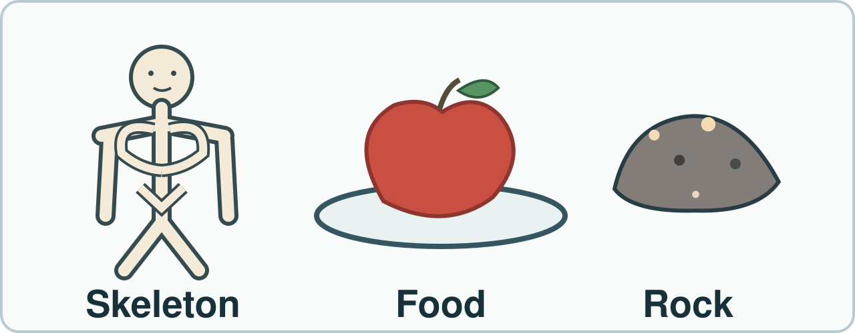
Point to the bones, food and rock. These are simple model pictures. They are not a new test result. Sizes do not match real life.
I can show one fact. I can show what I used to find it. I can name one next step.

Word page
I can show one fact.
I can show what I used to find it.
I can name one next step.

Word | It means | Example
skeleton | bones that help hold a body up | I point to the bone model.
nutrition | what a body gets from food to grow and stay well | An animal gets nutrition from food.
rock | a solid thing from the ground | I can test a safe rock.
evidence | what you saw or did that helps show a claim | My rock sort shows my rule.

Use a real model or real work. Point to what it shows. Keep your first words.

Arrival and starter
I can show one fact.
I can show what I used to find it.
I can name one next step.

Pick a safe model or card to look at.
Think back. Say, sign or point.
1. What stays the same in a fair water test?
2. Is a finished brick raw or made?
3. Where do animals get food?
You may point, sign, say or write your first ideas.

I do · model and check
I can show one fact.
I can show what I used to find it.
I can name one next step.

Watch one fact with one clue.
Watch: I point to the bone model. It shows a skeleton. The bones help hold the body up.
Show me: Which object can show a fact about a rock: a safe sample or a food picture?
Point to the bones, food and rock. These are simple model pictures. They are not a new test result. Sizes do not match real life.

We do · sort and explain
I can show one fact.
I can show what I used to find it.
I can name one next step.

Match a real model to a fact.
Our turn: I point to a safe rock. I felt a rough side. My fact is ____.
Talk, then sort.
Card | Choose a group
Bone model | Body / Food / Rock
Food-group picture | Body / Food / Rock
Safe rough sample | Body / Food / Rock

Supported: Point to one model. What can it show?
Independent: Match one fact to the model or action that supports it.
Aspire: Which fact needs a new check rather than a card?

We do 2 · choose and explain
I can show one fact.
I can show what I used to find it.
I can name one next step.

What best backs a claim about a rock surface?
A. A real safe sample you felt
B. A food picture
C. A word card only
All of us: A class claims a clean plastic lid floats. Which evidence could check the claim?
A. A photo of a different lid.
B. A guess from the lid colour.
C. A card about another rock.
D. A safe water test of that lid.
Show your choice and say why. You may use a point, card, board or sign. Take one quiet minute to reset.

Independent · Supported
I can show one fact.
I can show what I used to find it.
I can name one next step.

Show work you did about body, food or rock.
Say it first. You can plan in any language.
Point, sign, speak, draw, type, write, use a scribe or a staff-captured photo.
Show one fact about a body or rock.
Say: I show ____.
My fact | What I used
____________ | ____________
____________ | ____________

Choose one route within the full 8 minutes. Keep your own response.

Independent · Independent
I can show one fact.
I can show what I used to find it.
I can name one next step.

Show work you did about body, food or rock.
Say it first. You can plan in any language.
Point, sign, speak, draw, type, write, use a scribe or a staff-captured photo.
Show two facts. Tell how you found one.
Say: I know ____ as I saw ____.
My fact | What I used
____________ | ____________
____________ | ____________

Choose one route within the full 8 minutes. Keep your own response.

Independent · Aspire
I can show one fact.
I can show what I used to find it.
I can name one next step.

Show work you did about body, food or rock.
Say it first. You can plan in any language.
Point, sign, speak, draw, type, write, use a scribe or a staff-captured photo.
Pick your best real evidence. Why does it fit?
Say: This is good evidence as ____.
Go deeper: Pick a claim you cannot show. What could you check?
Evidence judge: Pick the best real result. Why does it fit?
My fact | What I used
____________ | ____________
____________ | ____________

Choose one route within the full 8 minutes. Keep your own response.

Practical model · safe steps and record
I can show one fact.
I can show what I used to find it.
I can name one next step.

Kit: Clean adult-checked model or rock, matching fact cards, tray
Choose one checked model or sample and match an observed fact to it.
Risk: A loose or rough model part could scratch or fall.
Safe: Use checked blunt models on a tray. Keep small parts together and wash hands after shared kit.
Use the kit your teacher has checked. A picture or adult-led model is a valid route.

My own evidence and next step
I can show one fact.
I can show what I used to find it.
I can name one next step.

My name __________ Date __________
My claim: __________________________________
My real model, work, page or date: __________________________
My clue and what it shows: _________________________________
What I cannot show yet: ___________________________________
The adult’s response: ______________________________________
My change, or why I kept it: _________________________________
Next check: _______________________________________________

Review and exit
I can show one fact.
I can show what I used to find it.
I can name one next step.

Hear one next step. Fix a part if you can.
Hear feedback (VF) and one next step (NS(+)). Edit one part (//).
Take one quiet minute to reset.
Tell an adult what you know and how.
Read it back: I am learning to show a fact about bodies, food and rocks.
My feedback was… I showed…
Next I need to… try one small fix.
How I know: I can show one fact. I can show what I used to find it. I can name one next step.
Tell your teacher. They will pick our next start.
Take one quiet minute before the next lesson.

Staff answers and checks
Starter: keep water amount and waiting time the same in a fair rock check. A finished brick is made. Animals get nutrition from food. Check actual taught coverage before retrieval.
Model: bones help support a body. The safe rock sample, not a food picture, can support a fact about that rock. A rough surface is an observation only if actually observed; the drawing is a simplified model, not a new result.
Sort in source order: Body, Food, Rock. Supported points to a model; Independent matches a fact to a model or action; Aspire names a fact that needs a new check. Keep the learner’s reason separate from shared sorting.
Step check: A, a real safe sample you felt. An adult-led observation is equally valid if touch is not chosen. Hinge: D, a safe water test of that lid. A uses a different lid; B guesses from colour; C uses an unrelated rock card. Hold all three or four first choices before hearing individual reasons.

Staff answers · task, limits and next move
Parallel check: a claim says a rock feels rough. A safe check of that rock fits; a picture of a different rock does not settle its feel. Re-model for an unsure learner. Secure learners choose a new matching clue while the adult checks the others.
Independent: Supported shows one fact about body or rock; Independent shows two facts and how one was found; Aspire picks the best real evidence and explains why it fits. Retain the deeper question: which claim cannot yet be shown and what could check it? Do not invent missing prior work.
Safe prepared kit is optional rehearsal. Use checked blunt models or samples on trays; no tasting, scraping or forced touch. A photo or adult handling directed by the learner is valid. The floating-lid hinge asks which test would help; no water practical is required.
Review: give actual VF and a specific NS(+). Keep the first response and the learner’s own edit or reason to keep it. Exit names the fact, clue and next step. A technician keeps records so another person can check the work. One page and pack cover both BUILD periods.

Staff guidance · group, access and feedback
BUILD: three to four learners. Use two pairs for four, or one trio for three. In a pair, one explains and one asks for the clue; swap. In a trio, the third checks the source, then rotate all roles. Each learner first chooses privately and keeps their own record. Hear every learner at the hinge. Re-model a shared error, or support an unsure learner while secure learners try a fresh check. Never use a percentage rule.
No cold calling or forced public reading. A learner may pass. Point, sign, speak, draw, type, write, direct an adult or use exact scribing. Read the task exactly when needed. Keep the science challenge and allow planning in any language. EAL is language, not SEN.
Use a stable tray or large cards and the agreed accessible input. Give processing time. Agree a quiet supervised pause and a brief first–then cue. Re-enter at the last completed step. Do not gather evidence while a learner is distressed.
Record actual VF, WS, I, NS(+), E, R, // and ? only when they occur. Keep deepest adult prompt separate from the pupil response. A real adult receives and names back the science. R requires the pupil’s response to an NS(+) next step and real Audience; never award it for a click or completion. Keep the pupil’s own wording and own-colour response.

Staff guidance · evidence and handover
Keep each first response, result or labelled explanation, the feedback and the pupil’s edit or justified decision to keep it. E requires an observable curriculum action on [SYS]. Use SCI-BUILD-A2-W07 for written, spoken, practical or photographic evidence. Record prompt level, response mode, support faded and what was independent.
At Independent agree actual adult roles and swap across the week. If one adult attends, use the actual staffing plan. Follow individual support and behaviour plans. Record access, regulation and curriculum actions against the learner’s own targets without recording a diagnosis as evidence.
If behind, preserve Show work you did about body, food or rock. and the safety teaching. After a secure check shorten repeated oral rehearsal. Record any change, reason and coverage impact. Pass checked understanding, deepest prompt and unresolved errors to Spring 1 Week 1. Do not replace incomplete individual work with a group product.
Evaluation: date taught; delivered as planned; criteria met; actual adaptations and reasons; changes to the scheme and coverage; evidence banked. Source evidence mapping remains [AWARD] [QUAL]; no unit or qualification award is claimed by this lesson.

TA brief · access, kit and safety
For three to four learners: two tray sets of checked blunt bone/rock models or picture cards, two matching fact-card sets, and four individual record sheets with pencils. Four work as two pairs; three as one trio. Rotate explainer, clue-checker and source-checker. Keep one record per learner.
Follow the local risk assessment. Keep blunt models and samples on trays. No tasting, scraping or forced touch. Wash hands after shared kit. Use pictures or adult handling when needed. No water test is needed for the hinge.
BUILD: three to four learners. Use two pairs for four, or one trio for three. In a pair, one explains and one asks for the clue; swap. In a trio, the third checks the source, then rotate all roles. Each learner first chooses privately and keeps their own record. Hear every learner at the hinge. Re-model a shared error, or support an unsure learner while secure learners try a fresh check. Never use a percentage rule.
No cold calling or forced public reading. A learner may pass. Point, sign, speak, draw, type, write, direct an adult or use exact scribing. Read the task exactly when needed. Keep the science challenge and allow planning in any language. EAL is language, not SEN.
Use the least prompt needed, then fade it. Keep prompts separate from the pupil’s response.

TA brief · prompt ladder and stage handover
1. Point to the relevant place / instruction.
2. Ask one short question: "What is it asking you to find?"
3. Rephrase the instruction in simpler language.
4. Provide a scaffold or limited choice.
5. Model the first step only, then return the task to the pupil.
Arrival: predictable start and private choice. Starter: hear first attempts before answers. I do: point to the model and let the learner track each step. We do: leave the missing step to the learner. Independent: protect an individual first try.
Review and Exit: the adult receives the learner’s own science, names it back and agrees a precise next move. Record the deepest prompt and what was independent. No physical prompting; pass and pause remain available.
Timing: Arrival 5 min, Starter 3 min, I do 5 min, We do 7 min, We do 2 5 min, Independent 8 min, Review 4 min, Exit 3 min. Total 40 minutes. Alternative route views share the same task time.

