My week in order
7 January 2027 | P3
White paper | You can point, write or ask an adult to write.
Route: Supported | My code ____
In your book: show three things you did this week. You can point, move cards or ask an adult to write.
1 Pick two things you did. Use the day strip.
2 Put them in order. Add one more thing.
3 Point or tell an adult. They can write your words.

Words
first, next, last, before, after
read, drew, played, walked, rested, packed

Start
Start: First I __. Next I __. Last I __.

Model
This is made up. Use your own week.
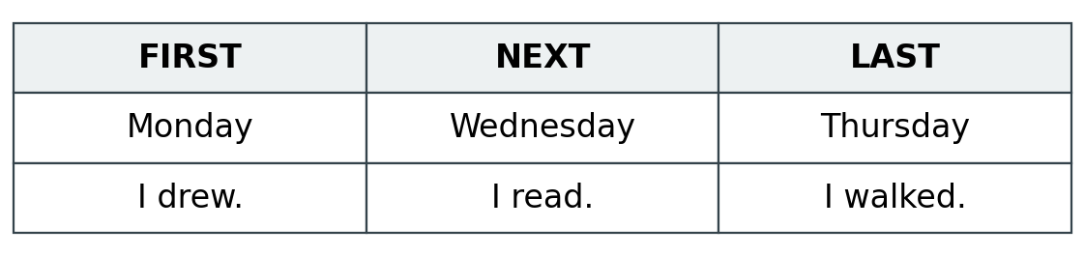

Finish
Three things. Days in order. First, next, last. Show an adult in a quiet way.

My week in order continued
7 January 2027 | P3
White paper | You can point, write or ask an adult to write.
Route: Independent | My code ____
In your book: show three things you did this week. You can point, move cards or ask an adult to write.
1 Pick three things you did this week.
2 Put a day with each one. Put them in order.
3 Put your order in your book. Use the words below.

Words
first, next, last, before, after
read, drew, played, walked, rested, packed

Start
Start: First I __. Next I __. Last I __.

Model
This is made up. Use your own week.

Finish
Three things. Days in order. First, next, last. Show an adult in a quiet way.

My week in order continued
7 January 2027 | P3
White paper | You can point, write or ask an adult to write.
Route: Aspire | My code ____
In your book: show three things you did this week. You can point, move cards or ask an adult to write.
1 Put three things you did in order.
2 Use before or after to tell how you know.
3 You may add one more thing if you know its day.

Words
first, next, last, before, after
read, drew, played, walked, rested, packed

Start
Start: First I __. Next I __. Last I __. I __ before I __.

Model
This is made up. Use your own week.
Model: I drew before I read.

Finish
Three things. Days in order. First, next, last. Show an adult in a quiet way.

