Days and events
7 January 2027 | P3
White paper | You can point, write or ask an adult to write.

Day strip
This week starts on Monday. Today is Thursday.
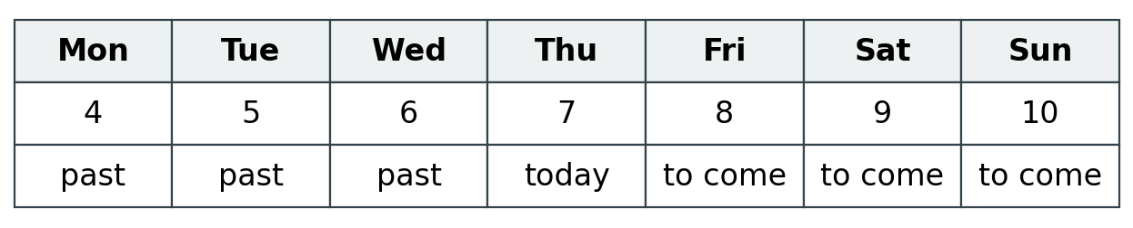
Day | Date
Monday | 4 January
Tuesday | 5 January
Wednesday | 6 January
Thursday | 7 January
Friday | 8 January
Saturday | 9 January
Sunday | 10 January
Words: first, next, last, day, week.
Start: First is __. Next is __.
Model: Monday comes before Thursday.
Friday, Saturday and Sunday are still to come.

Finish
Point to a day. Keep this strip in view. An adult can read a word for you.

Days and events continued
7 January 2027 | P3
White paper | You can point, write or ask an adult to write.

Starter cards
Made-up events. Cut the rows apart. Mix them up.
Day | Thing I did
Thursday | I drew.
Monday | I played.
Wednesday | I rested.
Words: first, next, last.
Start: First is __. Next is __. Last is __.

Model
Look at this made-up order.
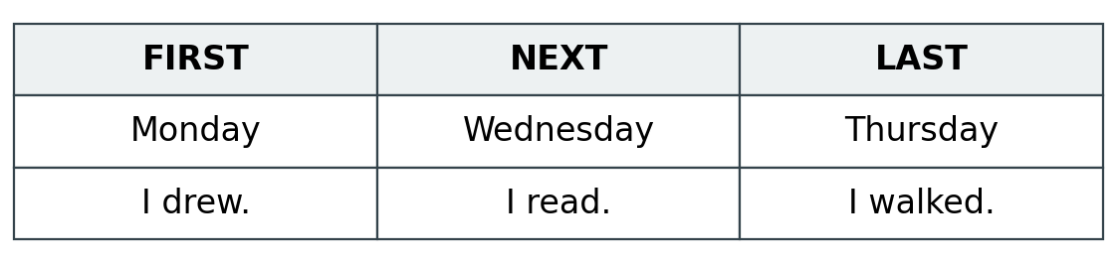

Choices for my own week
read | drew | played | walked | rested | packed
Or choose a safe thing you did. An adult can write it on a blank slip. Add its day. Do not guess a day.

Finish
First sort the three starter cards. Then use your own real events for your book.

