Help with my week
7 January 2027 | P3
Pink paper | You can point, write or ask an adult to write.

Ready starter
Start here. You can work in a quiet way.
1 Take the three starter cards.
2 Use the day strip to put them in order.
3 Point to first, next and last.

Words
first, next, last
Monday, Wednesday, Thursday

Start
First is __. Next is __. Last is __.

Model
This is a made-up week.
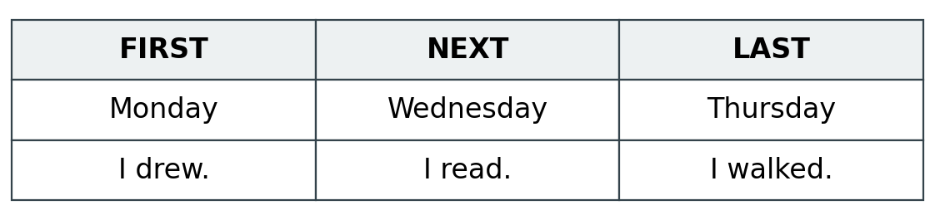

Finish
Three cards in day order. You can point. An adult can write your words.

Help with my week continued
7 January 2027 | P3
Pink paper | You can point, write or ask an adult to write.

An adult can write
Use this with any route. You choose the things and the order.
1 Pick a safe thing you did. Point to its day.
2 Put three things in order.
3 Show or say your words. An adult writes them.
4 Hear them back in a quiet way. Point to keep or change.

Words
first, next, last, keep, change
read, drew, played, walked, rested, packed

Start
First I __ on __. Next I __ on __. Last I __ on __.

Model
This is made up.

Finish
Your choices. Your order. Your words or points. Keep them in your book.

